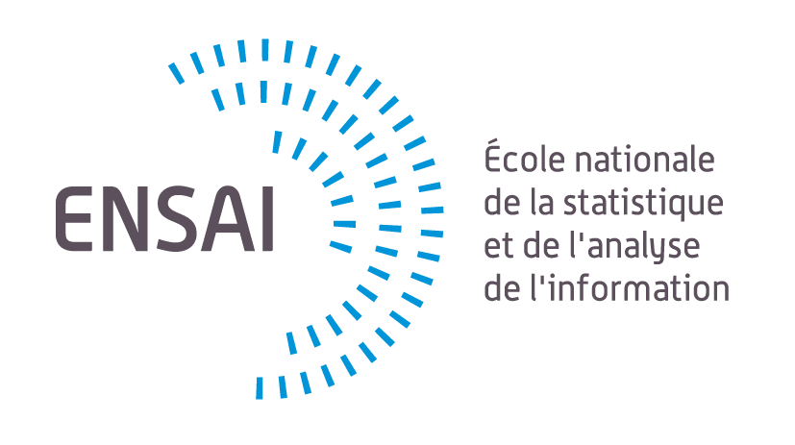

DANG, Ba Khuong
Non-confidential

GRADUATION INTERNSHIP REPORT

Centre Inria de l'Université Grenoble Alpes

LONGITUDINAL UNSUPERVISED ANOMALY DETECTION (UAD) WITH DIFFUSION MODELS

INTERNSHIP LOCATION :

CITY: Montbonnot COUNTRY: France

Academic Year 2024-2025

Internship Supervisor:

ENSAI Internship Advisor: François PORTIER

