Ex 1

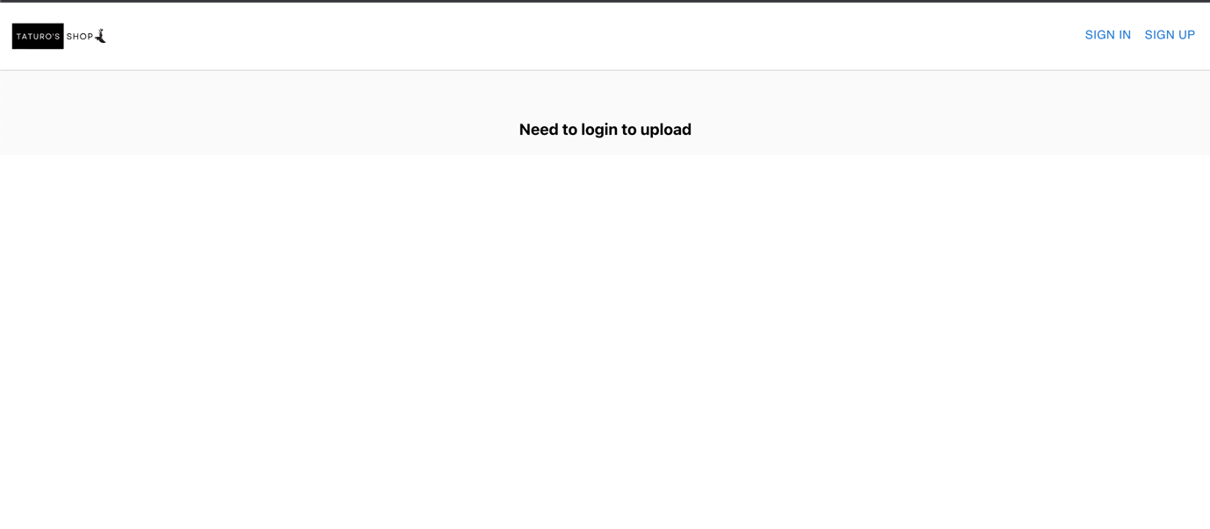

Ex2