Name: Khuong Viet Tai

MSSV: 19522151

Github: <https://github.com/khuongviettai/Practice_MSIS207>

Ex0

Ex0.1

Ex0.2

Ex0.3

Ex0.4

Ex1.0

Ex1.2

Ex1.3



Ex2.1

Ex2.2

Ex2.3

Ex3

Ex4.1

Ex4.2

Ex4.3

Ex4.4

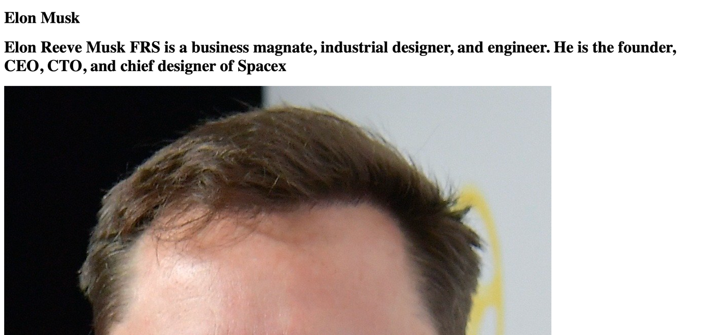

4.5

4.6

4.7

