**Dependancy Management using Gradle**

**Q6**. Override the Gradle Wrapper task to install a different version of gradle. Make sure that the task written in Q4 also executes with it.

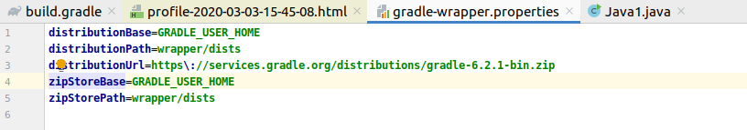

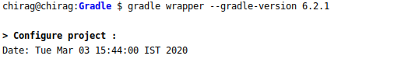

**Q7.**Run the gradle profile command and attach the resulting files.

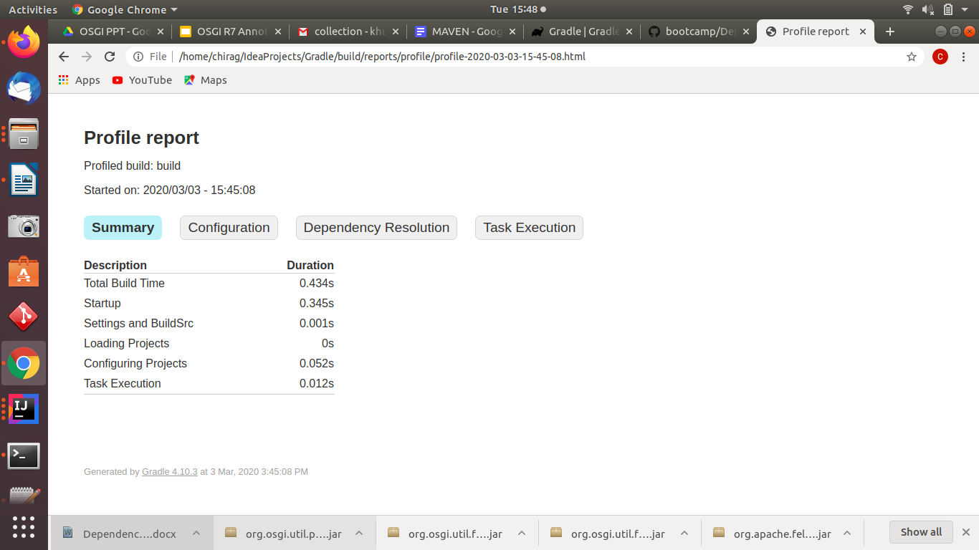

Command :

gradle build --profile