**1.How are inline and block elements different from each other?**

A block-level element always starts on a new line and takes up the full width available (stretches out to the left and right as far as it can).

The <div> element is a block-level element.

An inline element does not start on a new line and only takes up as much width as necessary.

This <span> element is an inline-level element.

**2.Explain the difference between visibility:hidden and display:none**

display:none means that the tag in question will not appear on the page at all (although you can still interact with it through the dom).

visibility:hidden means that unlike display:none , the tag is not visible, but space is allocated for it on the page.

**3. Explain the clear and float properties.**

The float property is used for positioning and formatting content e.g. let an image float left to the text in a container.

The float property can have one of the following values:

* left - The element floats to the left of its container
* right - The element floats to the right of its container
* none - The element does not float (will be displayed just where it occurs in the text). This is default
* inherit - The element inherits the float value of its parent

The clear property specifies what elements can float beside the cleared element and on which side.

The clear property can have one of the following values:

* none - Allows floating elements on both sides. This is default
* left - No floating elements allowed on the left side
* right- No floating elements allowed on the right side
* both - No floating elements allowed on either the left or the right side
* inherit - The element inherits the clear value of its parent

The most common way to use the clear property is after you have used a float property on an element.

**4. explain difference between absolute, relative,fixed and static.**

Static positioned elements are not affected by the top, bottom, left, and right properties.

An element with position: static; is not positioned in any special way; it is always positioned according to the normal flow of the page:

An element with position: relative; is positioned relative to its normal position.

Setting the top, right, bottom, and left properties of a relatively-positioned element will cause it to be adjusted away from its normal position. Other content will not be adjusted to fit into any gap left by the element.

An element with position: fixed; is positioned relative to the viewport, which means it always stays in the same place even if the page is scrolled. The top, right, bottom, and left properties are used to position the element.

A fixed element does not leave a gap in the page where it would normally have been located.

An element with position: absolute; is positioned relative to the nearest positioned ancestor (instead of positioned relative to the viewport, like fixed).

However; if an absolute positioned element has no positioned ancestors, it uses the document body, and moves along with page scrolling.

**5. Write the HTML code to create a table in which there are 4 columns( ID , Employee Name, Designation, Department) and at least 6 rows. Also do some styling to it.**

<!DOCTYPE HTML>

<html>

<head>

<title>TABLES</title>

</head>

</html>

<body style="background: #CD7171">

<table width="80%" style="margin: 10%", border=".5px">

<thead style="background: #ccaad0">

<tr>

<th>ID</th>

<th>Employee Name</th>

<th>Designation</th>

<th>Department</th>

</tr>

</thead>

<tbody style="background: #cccad0" style="text-decoration-color: #f2f2f2">

<tr>

<td>1</td>

<td>lakshay</td>

<td>trainee</td>

<td>android</td>

</tr>

<tr>

<td>2</td>

<td>chirag</td>

<td>software engineer</td>

<td>AMC</td>

</tr>

<tr>

<td>3</td>

<td>subarno</td>

<td>manager</td>

<td>ios</td>

</tr>

<tr>

<td>4</td>

<td>ashu</td>

<td>manager</td>

<td>AMC</td>

</tr>

<tr>

<td>5</td>

<td>anupam</td>

<td>tech lead</td>

<td>ios</td>

</tr>

<tr>

<td>6</td>

<td>rajat</td>

<td>trainee</td>

<td>FEEN</td>

</tr>

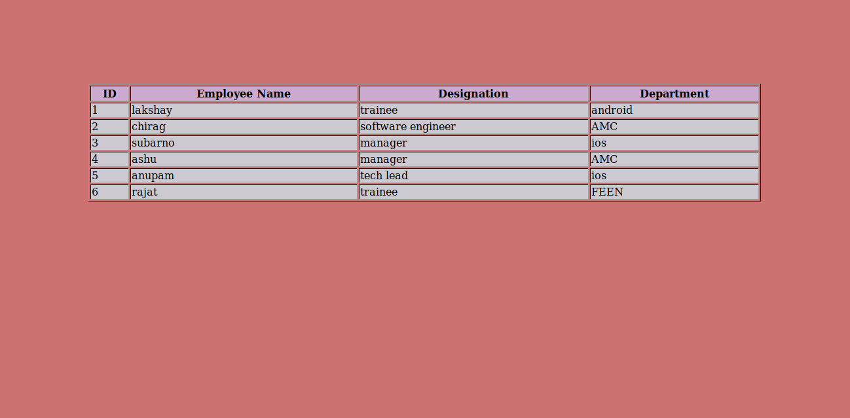

**6. Why do we use meta tags?**

The <meta> tag provides metadata about the HTML document. Metadata will not be displayed on the page, but will be machine parsable.

Meta elements are typically used to specify page description, keywords, author of the document, last modified, and other metadata.

**7. Explain box model.**

All HTML elements can be considered as boxes. In CSS, the term "box model" is used when talking about design and layout.

The CSS box model is essentially a box that wraps around every HTML element. It consists of: margins, borders, padding, and the actual content. The image below illustrates the box model:

**8. What are the different types of CSS Selectors?**

**CSS selectors are used to "find" (or select) the HTML elements you want to style.**

We can divide CSS selectors into five categories:

* Simple selectors (select elements based on name, id, class)
* Combinator selectors (select elements based on a specific relationship between them)
* Pseudo-class selectors (select elements based on a certain state)
* Pseudo-elements selector (select and style a part of an element)
* Attribute selector (select elements based on an attribute or attribute value)

**9. Define Doctype.**

A doctype or document type declaration is an instruction which tells the web browser about the markup language in which the current page is written.

**10. Explain 5 HTML5 semantic tags.**

<article> - Defines an article in the document

<aside> - Defines content aside from the page content like sidebar.

<footer> - Defines a footer for the document or a section

<header> - Defines a header for the document or a sectio>

<nav> - Defines navigation links in the document

<section> - Defines a section in the document

**11. Create HTML for web-page.jpg (check resources, highest weightage for answers)**

<!DOCTYPE HTML>

<html>

<head>

<title>Question 1</title>

<link rel="stylesheet" type="text/css" href="design.css">

</head>

<body class="body">

<header class="body_head">

<a href="Q1.html" style="text-decoration: none;"><h1 style="color: #000000">To The New</h1></a>

<div>

<ul class="menu">

<li class="menu_item">TEXT LINK</li>

<li class="menu_item">TEXT LINK</li>

<li class="menu_item">TEXT LINK</li>

<li class="menu_item">TEXT LINK</li>

<li class="menu_item">TEXT LINK</li>

</ul>

</div>

</header>

<div class="main">

<div class="main_img">

<p class="main_text">960x360px</p>

</div>

<p class="main_text2">VESTIBULUMACCUMSAN EGESTIBULUM EU JUSTO CONVALLIS AUGUE ESTAS AENEAN ELIT INTESQUE SED. FACILISPEDE ESTIBULUM NULLA ORNA NISL VELIT ELIT AC ALIQUAT NON TINCIDUNT NAMJUSTO CRAS.</p>

<br>

<p class="gallery_head">LATEST FROM GALLERY</p>

<HR>

<div class="card">

<div class="gallery">

<img src="black_background.png" width="215px" height="315px">

<div class="desc">IMAGE CAPTION HERE</div>

</div>

<div class="gallery">

<img src="black_background.png" width="215px" height="315px">

<div class="desc">IMAGE CAPTION HERE</div>

</div>

<div class="gallery">

<img src="black_background.png" width="215px" height="315px">

<div class="desc">IMAGE CAPTION HERE</div>

</div>

<div class="gallery">

<img src="black_background.png" width="215px" height="315px">

<div class="desc">IMAGE CAPTION HERE</div>

</div>

</div>

</div>

<footer class="footer">

<div class="cpyRight">Copyright &copy 2009-2017-All Rights Reserved-To the new</div>

<div class="footerDesc">Web layout by To the new</div>

</footer>

</footer>

</body>

**Styling :**

.body{

background: #333333;

padding-left: 5%;

padding-right: 5%;

}

.body_head{

/*margin-left:60px;*/

padding: 1% 10% 1% 10%;

}

.menu{

background: #000000;

color: #ffffff;

padding: 15px;

margin-right:9px;

margin-top: 10px;

/*margin-left: 0px;

padding-left: 0px;

margin-right: 60px;

/*display: inline-block;*/

}

.menu_item{

margin-right: 12px;

display: inline-block;

font-size: 11px;

}

.main{

/*margin-left: 10px;

margin-right: 10px;

/*padding: 0px 50px;*/

background: #ffffff;

padding: 2% 10% 30% 10%;

height: 100%;

}

.main_img{

background: #000000;

color: #000000;

width: 960px;

height: 360px;

display: flex;

align-items: center;

justify-content: center;

}

.main_text{

font-size: 20px;

color: #ffffff;

}

.main_text2{

padding: 2%;

font-size: 16px;

text-align: justify;

background:#ededed;

color: #706c61

}

.gallery_head{

font-size: 18px;

text-align: justify;

color: #706c61

}

div.gallery{

margin: 5px;

margin-bottom: 0px;

border-style: solid;

border-width: 0px;

float: left;

width: 215px;

height: 325px;

}

div.gallery img{

width: 100%;

height: 100%%;

}

div.desc{

padding: 5px;

margin-top: -5px;

text-align: center;

font-size: 14px;

background-color: #ededed;

}

.footer{

margin: 0px;

padding: 15px 8%;

background-color: #000;

color: #fff;

display: flex;

justify-content: space-between;

}

**12. Create HTML for form.png (check resources, highest weightage for answers)**

<!DOCTYPE html>

<html>

<head>

<title>Question 12</title>

<link rel="stylesheet" type="text/css" href="q12.css">

</head>

<body>

<div class="nav">

<div class="nav_title"><h1>To the New</h1></div>

<div class="nav_list">

<ul>

<li class="nav_item">Home</li>

<li class="nav_item">Quick help</li>

</ul>

</div>

</div>

<hr width="96%" style="margin-top: -25px">

<center>

<div class="formCard">

<div>Bug Report</div>

<form method="post" action="index.html" class="formMain">

<p>Title:*</p>

<input type="text" name="Title">

<p>Description:*</p>

<textarea></textarea>

<p>Operating System:</p>

<select class="formList" style="color: white; padding: 2%; border-width: 0px">

<option>WindowsXP</option>

<option>Windows7</option>

<option>Linux</option>

<option>MacOS</option>

</select>

<p>Product:*</p>

<select class="formList" style="color: white; padding: 2%; border-width: 0px">

<option>Formoid</option>

<option>Formoid1</option>

<option>Formoid2</option>

<option>Formoid3</option>

</select>

<p>Version:*</p>

<input type="text" name="version" style="width: 25%; height: 25px">

<p>License</p>

<input id="free" type="radio" name="free" value="free">

<label for="free"><span>&nbsp</span> Free</label>

<input id="business" type="radio" name="business" value="business" style="margin-left: 50%">

<label for="business" style="margin-left: 50%"><span>&nbsp</span> Business</label>

<p>Severity:</p>

<select class="formList" style="color: white; padding: 2%; border-width: 0px">

<option>Critical</option>

<option>Less Critical</option>

<option>Highly Critical</option>

<option>Not Critical</option>

</select>

<p>Attatchment:</p>

<input class="formFile" type="file" name="file">

</form>

<div style="margin-top: 5px; background-color: #d9d9d9;">

<input type="submit" name="Submit" class="btnSubmit">

</div>

</div>

</center>

</body>

</html>

**Styling :**

.nav{

display: flex;

justify-content: space-between;

padding: 2%;

color: #40e0d0;

}

.nav_item{

padding-left: 8px;

display: inline-block;

}

.formCard{

padding: 0px;

width: 380px;

border-style: solid;

border-color: #d9d9d9;

border-width: 2px;

border-radius: 5px

}

.formCard div{

text-align: left;

padding: 2% 5%;

background: #d9d9d9;

color: #ffffff;

font-size: 25px;

font-weight: bold;

font-family: sans-serif

}

.formMain{

text-align: left;

padding: 0% 5%;

}

.formMain p{

font-size: 18px;

padding-bottom: 0px;

margin-bottom: 0%;

font-family:sans-serif;

}

.formMain input, textarea, select{

position: relative;

margin: 1px;

border-style: solid;

border-radius: 5px;

border-width: 2px;

border-color: #d9d9d9;

width: 100%

}

.formList{

margin: 1px;

border-style: solid;

border-radius: 5px;

border-width: 2px;

border-color: #d9d9d9;

width: 100%

color:#fff;

background: #40e0d0;

width: 100%

padding: 2%}

.formList option{

margin: 1px;

border-style: solid;

border-radius: 5px;

border-width: 2px;

border-color: #d9d9d9;

width: 100%

color:#fff;

background: #40e0d0;

width: 100%

padding: 2%;

}

input[type="radio"]{

display: none;

}

input[type="radio"] + label span {

display: inline-block;

width: 10px;

height: 10px;

background: transparent;

vertical-align: middle;

border: 2px solid #d9d9d9;

border-radius: 50%;

padding: 2px;

margin:0 0px;

text-align: justify;

}

input[type="radio"]:checked + label span {

width: 10px;

height: 10px;

background: #d9d9d9;

background-clip: content-box;

text-align: justify;

}

input[type="Submit"]{

margin-left: 82%;

padding: 5px;

width: 20%;

background-color: #40e0d0;

color: #fff;

border-style: solid;

border-radius:5px;

border-width: 0px

}