1.

mkdir exercise

cd exercise

mkdir -p dir1/dir2/dir3

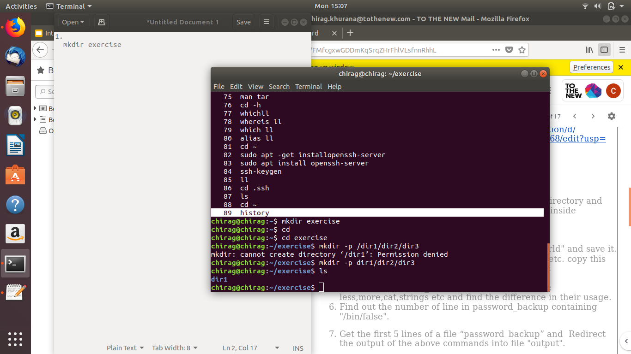

2.

cd exercise/

cd dir1/

cd dir2/

touch emptyfile1 emtyfile2

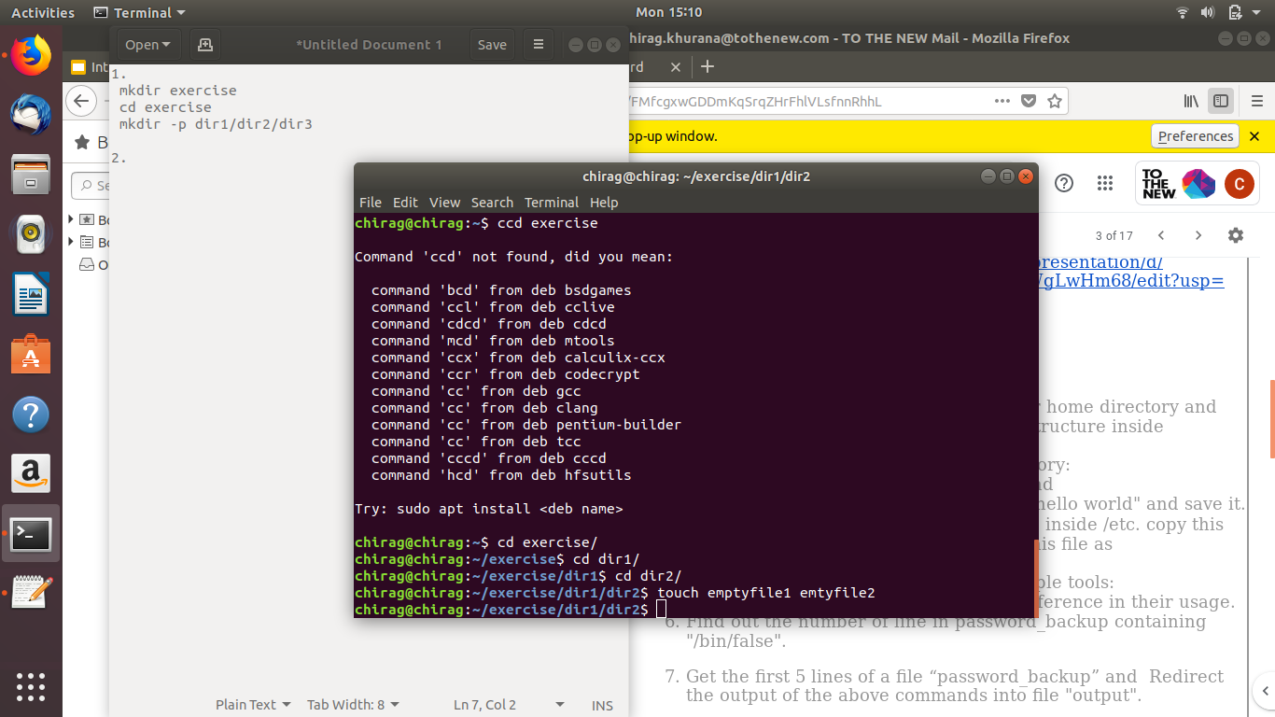

3.

Create a text file - file1.txt using gedit:

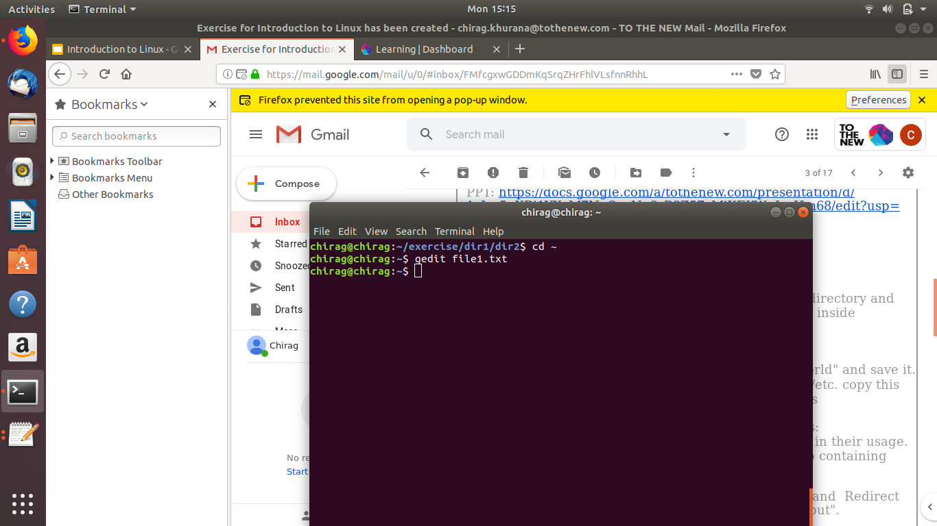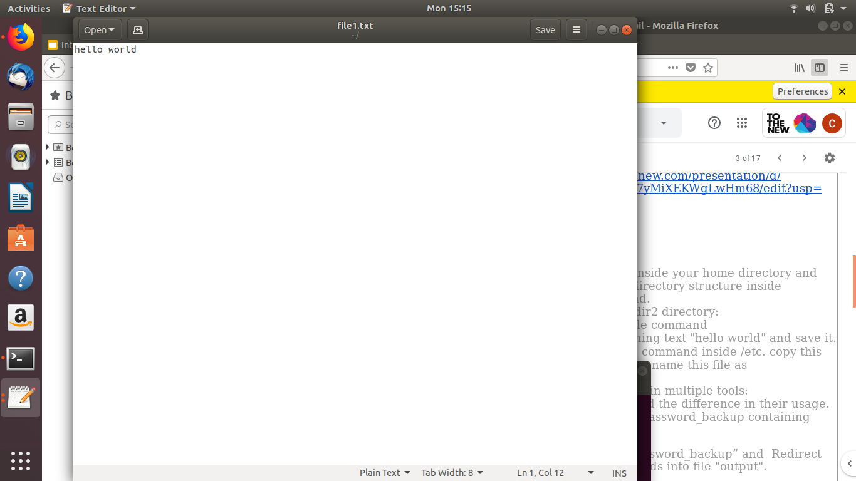

4.

sudo -s

find /etc -name passwd

cp passwd passwd_copy

mv passwd_copy passwd_backup

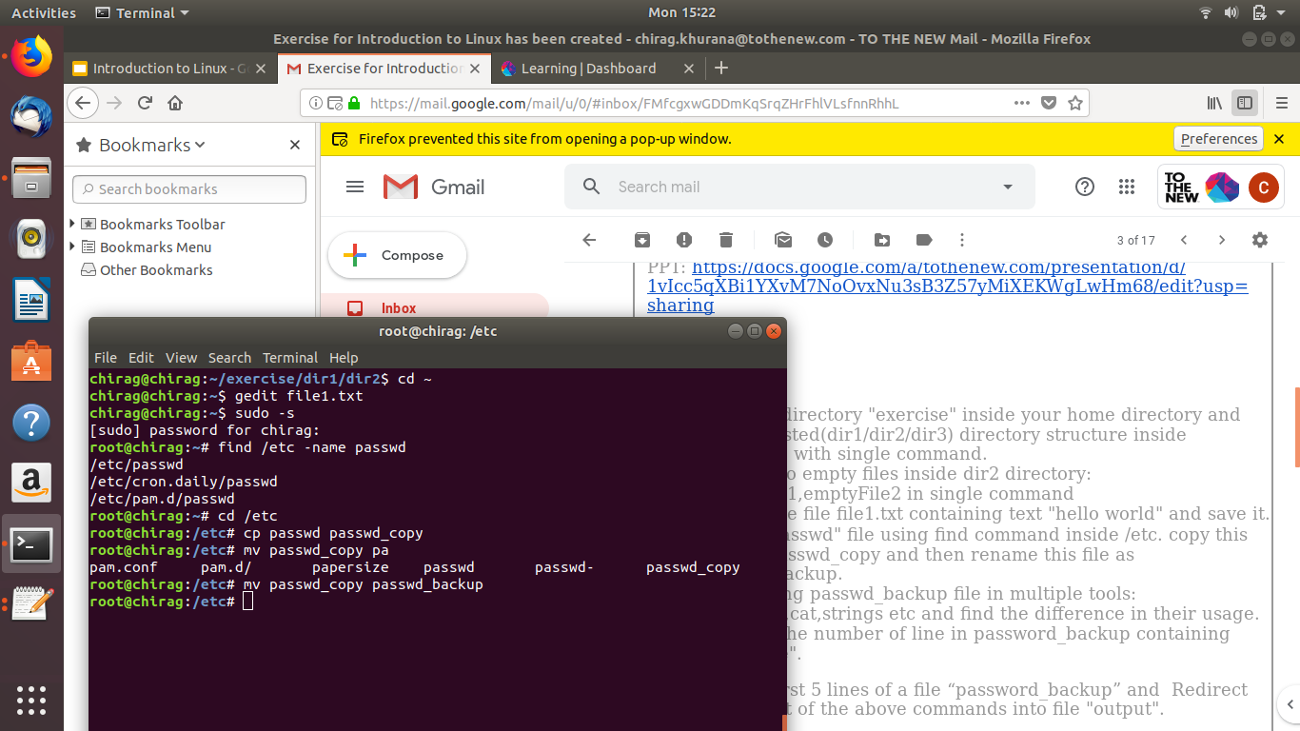

5.

less passwd_backup - faster , navigate through up down keys .

more passwd_backup - slower than less, navigate through spacebar .

cat passwd_backup - concatinate, shows whole file at a time without pipe.

strings passwd_backup - dedicated full file reader .

6.

grep -n "/bin/false" passwd_backup | wc -l

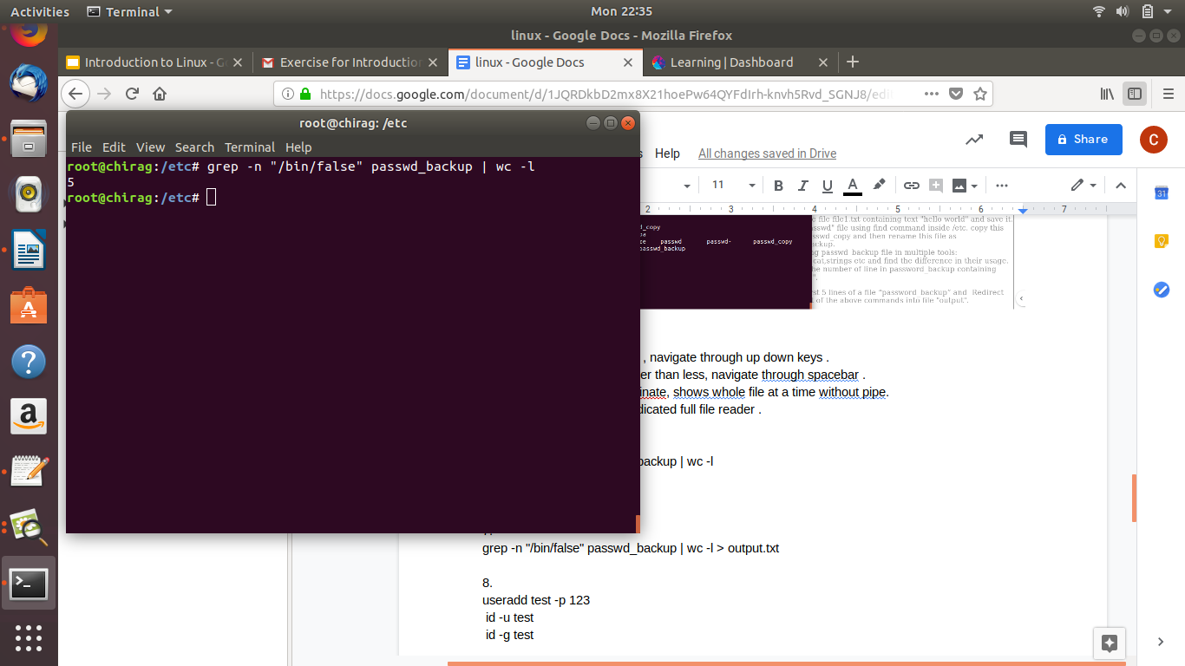

7.

head -5 passwd_backup > output.txt

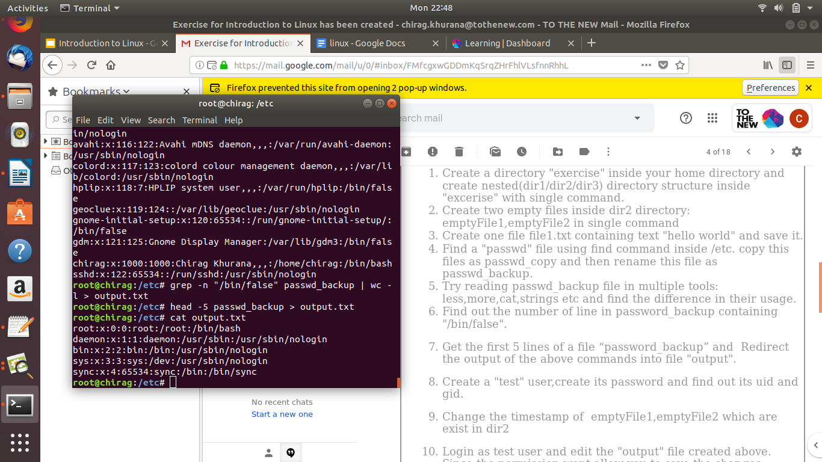

8.

useradd test -p 123

id -u test

id -g test

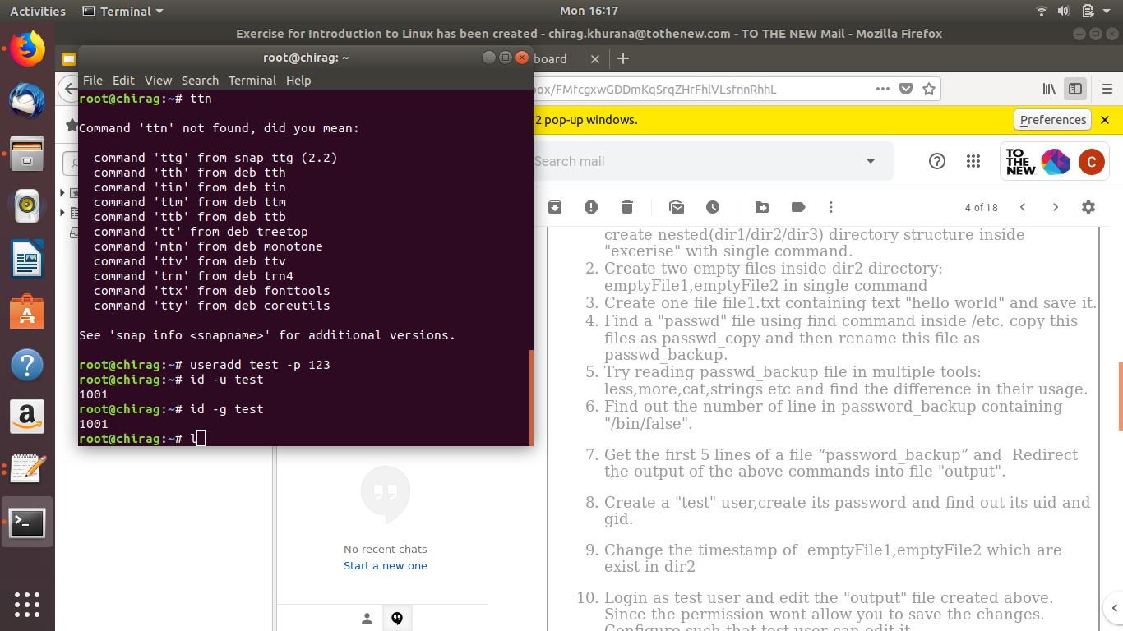

9.

touch -t 202002011000 ./emtyfile1 ./emtyfile2

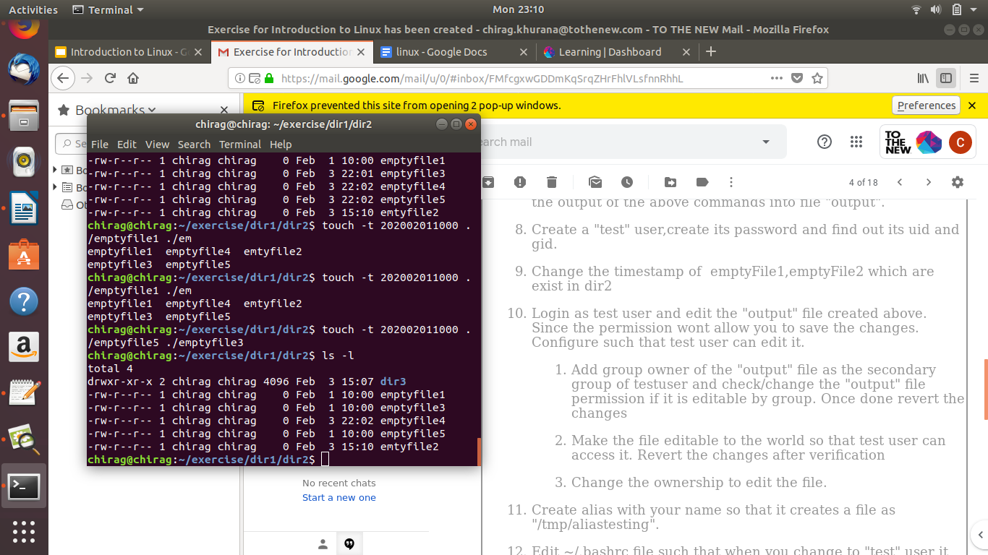

11.

alias chirag=”touch /tmp/aliastesting”

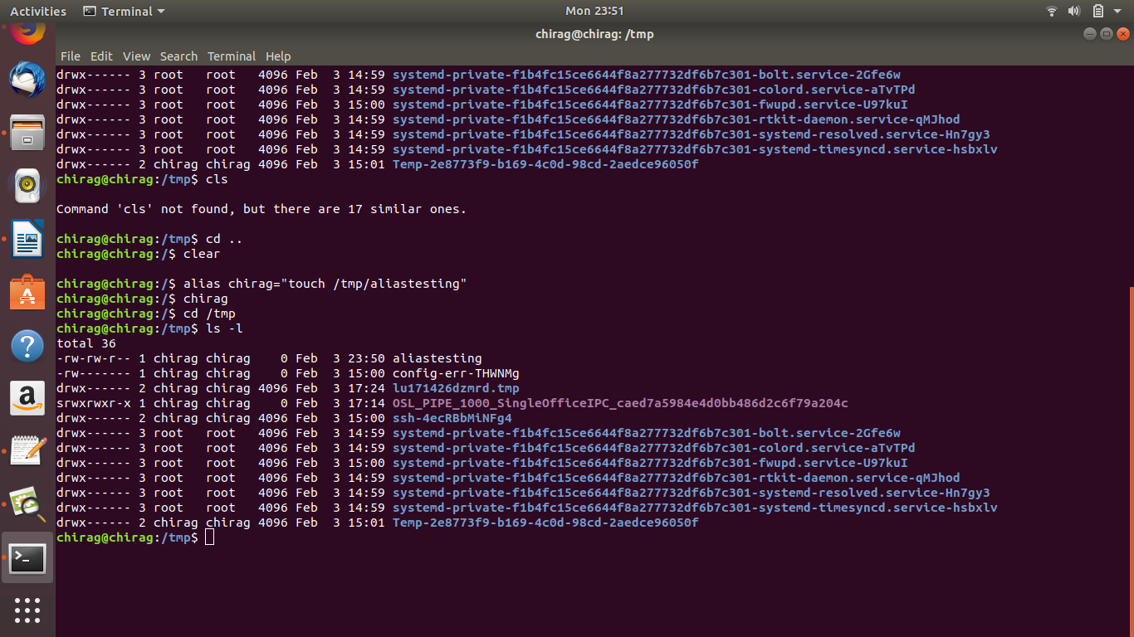

13.

apt-get install zip

14.

tar cvf file.tar output.txt passwd_backup

15.

scp root@chirag:/etc/file.tar test@chirag:file.tar

17.

cd /Desktop

wget https://images.pexels.com/photos/2224956/pexels-photo-2224956.jpeg

18.

By using man command.

for example to get usage help for ls , we use following command.

19.

ln -s/etc/services/tmp/ports-info

20.

We can use following commands :

e.g.1. : which xyz -: will find the file is executing from ( i.e. its $path )

e.g.2. : find / -name xyz -: will look for a filename named xyz