

|  |
| --- |
| **Assignment# 03_** |
|  |

|  |  |
| --- | --- |
| **Student ID:** | 17-Arid-5603 |
| **Name:** | KHURRAM SHAHZAD |
| **Class:** | BSCS 6th |
| **Course Title:** | Visual Programing |
| **Course Code:** | CS-692 |
| **Submitted To:** | Sir Imran Shehzad |
| **Date:** | 16/08/2020 |

**(For instructor’s use)** Total Marks: Obtained Marks:

1. **Provide the following information about your semester project. (10)**
   1. Project Title

College Management System

* 1. Introduction of project

In this project we register a teacher. We can also manage the all the data of students of the college. We can insert the student data and then we can manage the all the data of students by displaying all the record of the students.

* 1. Reason to choose the project

Choosing this project because there is need of a proper system for the management of college student record that college must have the record of all of their students their names roll number fee records all have in it so we need to built a system for college that have all the thing to manage the college student record so we choose this project.

* 1. Functional Requirements

Functional requirements are product features or functions that developers must implement to enable users to accomplish their tasks. So, it’s important to make them clear both for the development team and the stakeholders. Generally, functional requirements describe system behavior under specific conditions. For instance:

A search feature allows a user to hunt among various invoices if they want to credit an issued invoice.

**The functional requirements of this system are:**

* Register new students.
* Record the feed details of students.
* Register a new teacher.
  1. Non-Functional Requirements

Nonfunctional requirements describe how a system must behave and establish constraints of its functionality. This type of requirements is also known as the system’s quality attributes.

In this system, the authentication of the user is an important factor. In this system, user authentication will be done by login by user name and password and classified by user type. Users will get access to the system as permissions are classified for that type of user.The system has a consistent interface so that the system is easy to use and in the interface of our system buttons and forms are used to enter data related to a specific module.

* 1. Conclusion

The project entitled as College Management System is the system that deals with the issues related to a particular institution. This project is successfully implemented with all the features mentioned in system requirements specification. Awareness and right information about any college is essential for both the development of student as well as faculty. So, this serves the right purpose in achieving the desired requirements of both the communities. Our application provides appropriate information to users according to chosen services.

1. **Demonstrate your project using frontend screenshots. (10)**

**Example**

**1.Teacher Register**

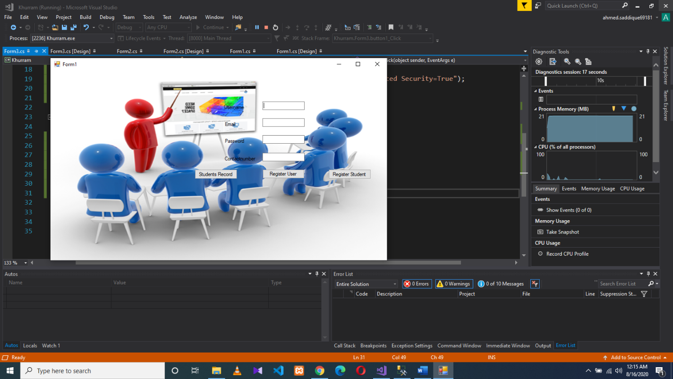

**2.Student Register**

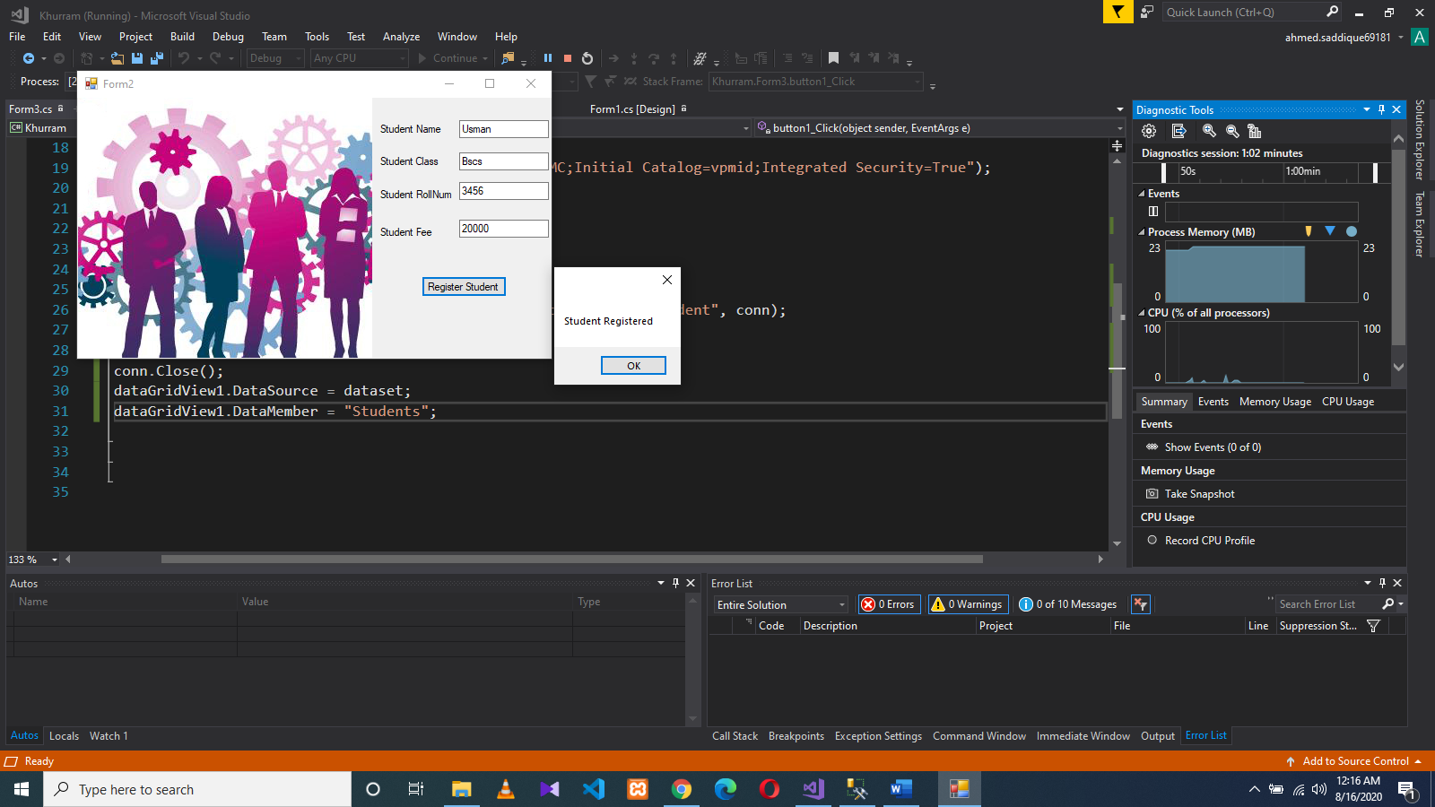

**3.Student Record**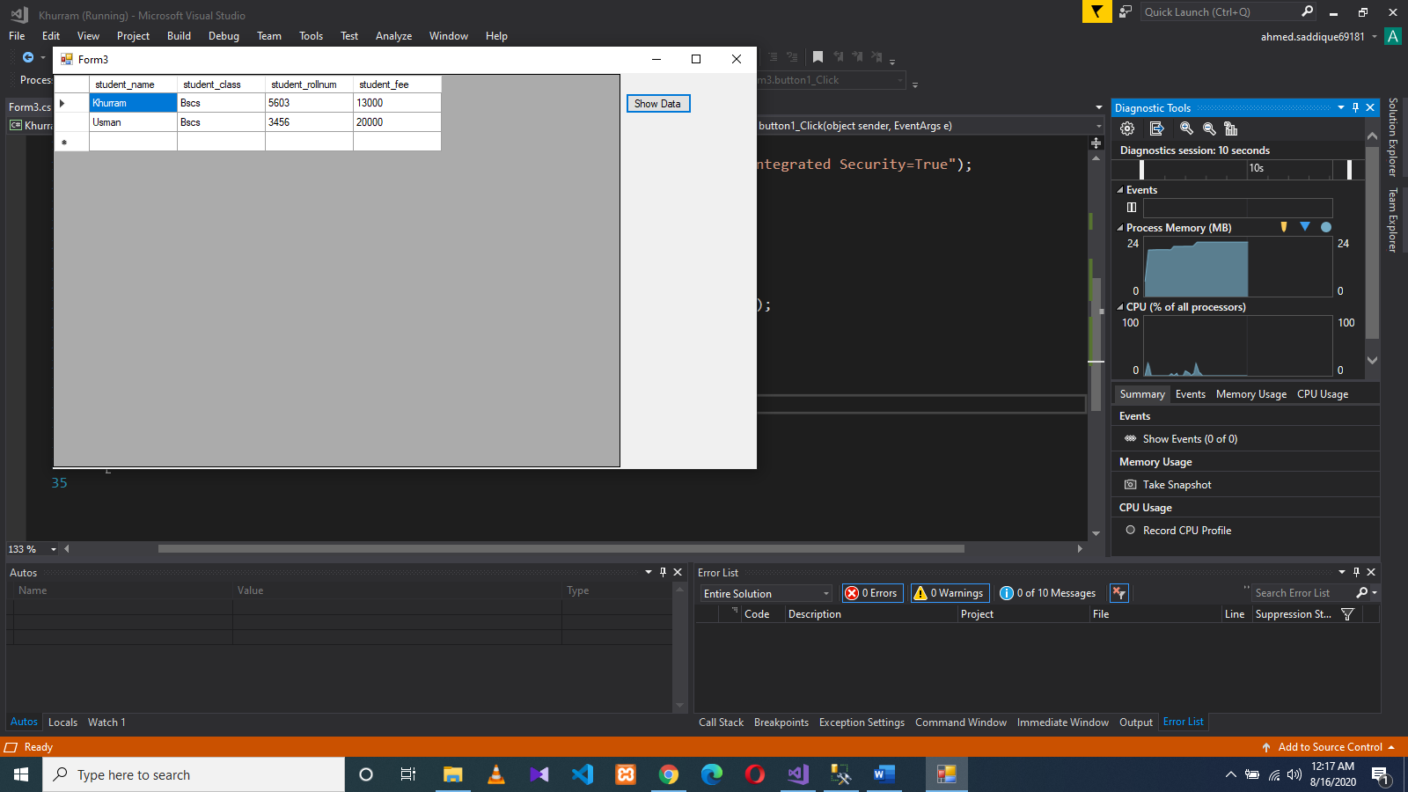

**Important!**

**Online presentation will be held to evaluate the semester project.**

**Assignment will be graded as zero for the Student who failed to defend his/her project in presentation.**

Good Luck