**Image Labeller**

Sam Shelley (s1146283) and Khurram Aslam (s????)

The image labeller asks the user to spend time completing a repetitive task for no compensation. Therefore the key focus throughout the development of this user interface is the reduction of tasks needed to identify and label and image and the implementation of as many accelerator keys as possible to accelerate the task.

Applying Alan Dix’s principles of learnability to the labeller we determined how best to improve upon and implement interface improvements/

**1. Predictability:**

The provided interface is very predictable. Clicking on a point on the image, always creates a point and draws a line to the previous point. Clicking the “New object” button consistently finishes the polygon. However, this button violates the Markov property in that it requires that the user create at least three points beforehand. The button also has poor operation visibility since it is perpetually enabled, when finishing the polygon is really only possible when the user has already created three or more points.

One solution might be to disable the button unless the user has created three or points, but this behavior is still non-intuitive since it is not clear whether you should press “New object” when you have draw a complete polygon with no gaps, or whether you should press the button to finish it to finish the gap.

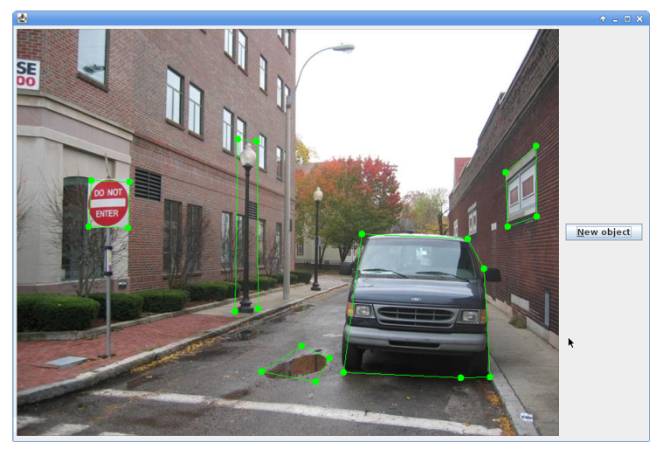

Furthermore, since the user will be interacting with the image to draw the polygon, his or her mouse will be pointed towards the image. The mouse will therefore be on average half of the width of the image away from the button. Fitt’s law demonstrates a negative correlation between the time it takes the user to move the mouse to a required location and the distance the object is from the starting point.

$$T=a+b\log_{2}{(D/W+1)}$$

In our version of the labeller, we remove the new object button, instead having the user complete a polygon by clicking the starting point. In doing so we reduce the clickable width to approximately ¼ of the original, but make up for it with a dramatic reduction in distance (remember that the user must travel to the finish object button, and then back again to the image). Therefore, assuming that we start in the center, we’ve reduced traveling distance by about ¼ as well. The real gain, however, is in the form of the improved predictability of actions (you now conduct all drawing by clicking on the image) and familiarity (which is discussed later)

**2. Synthesizability**

The goal of the interface is to create polygons around objects in the image and the interface provides immediate response to indicate whether or not the user is reaching that goal (it draws the next segment and point whenever the user clicks)

When a polygon is completed, a box immediately appears prompting the user for a label. This takes decision step away from the user, who focuses only on completing the image, and then immediately typing in the preferred label.

A task analysis proves the simplicity of the action set.

**3. Familiarity:**

There are two types of personas who will generally be using the labeller. One type of person could be Susan, a middle aged woman who has been asked to participate in the research project by her son who works at the University. Susan has had very little experience working with computers and approaches the interface with almost entirely fresh perspective.

For Susan, the concept of drawing will most clearly relate to drawing with a pen and pencil in the real world. The interface should thus make *affordances* for her past knowledge. If given a piece of paper with an image and told to draw polygons around the objects on the page, Susan would draw a continuous shape around the object and end at the starting point.

Finishing a polygon with a button click is thus non-intuitive. She might try completing the polygon by clicking on the start point, which is incorrect behavior (since this will create duplicate points). Therefore it makes sense to adapt the interface to her expectations.

The second persona is Max, who is comfortable with basic applications on his computer. He has solid knowledge of Microsoft Word and some basic drawing application. For Max, it is important to conform to existing to these existing applications. Paint and drawing applications typically allow the user to draw freeform shapes on the canvas. Therefore our version of the labeller affords the user this ability and enables freeform drawing of shapes. Moreover Max would, similar to Susan expect to identify objects by creating complete polygons around them, providing more justification for removing the new polygon button. Max is familiar with the concept of “undo” and “redo” and will intuitively use the shortcuts that apply to these actions when he makes a mistake. Therefore we have added these commands.

**4. Consistency**

In both menus for inputting labels, the shortcut for submit is “enter”.

**5. Generalizability**

Maybe task analysis?