Description

Intended User

Features

User Interface Mocks

Screen 1

Screen 2

Key Considerations

How will your app handle data persistence?

Describe any corner cases in the UX.

Describe any libraries you’ll be using and share your reasoning for including them.

Describe how you will implement Google Play Services.

Next Steps: Required Tasks

Task 1: Project Setup

Task 2: Implement UI for Each Activity and Fragment

Task 3: Your Next Task

Task 4: Your Next Task

Task 5: Your Next Task

**GitHub Username**: khurrams84

Property Portal

# Description

Use can add, edit and search property for rent and sale. I want to target the community which can search property easily without any long input.

# Intended User

Users who want to look property for sale or rent.

# Features

List the main features of your app.

* Add/Edit Property
* Save single picture for property
* Filter Property
* Login User information

# User Interface Mocks

## Screens

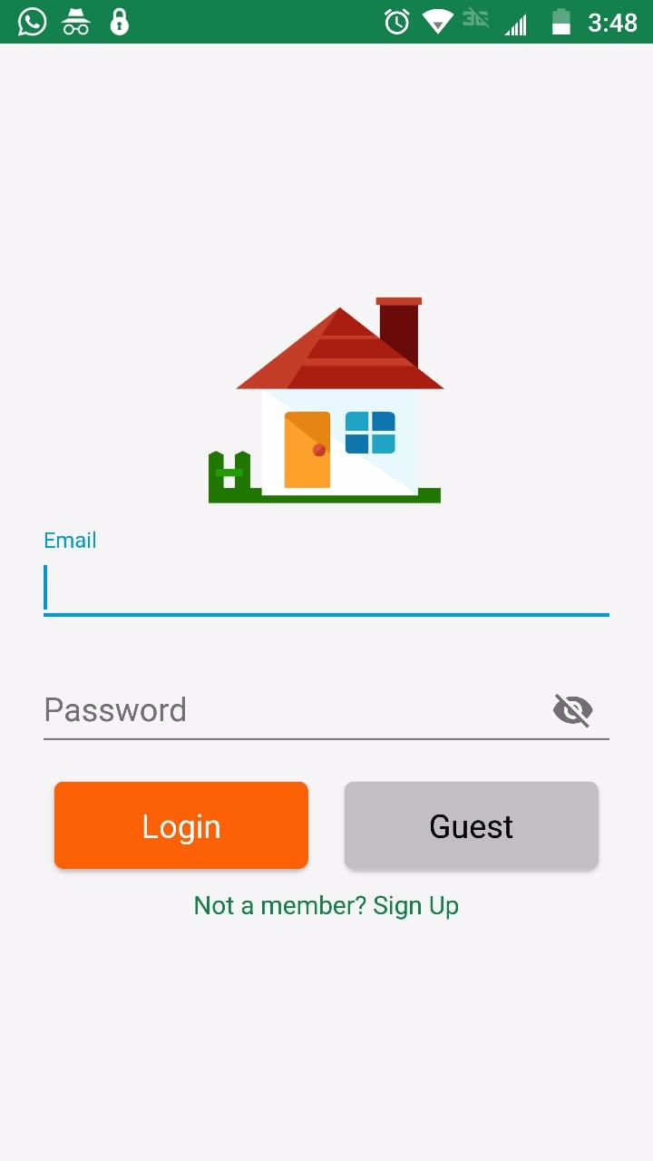

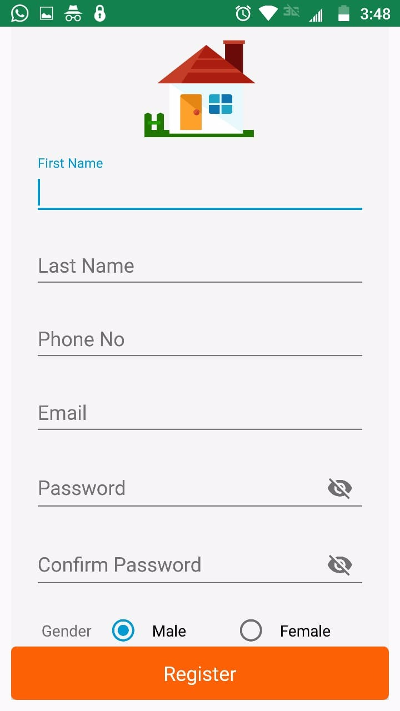

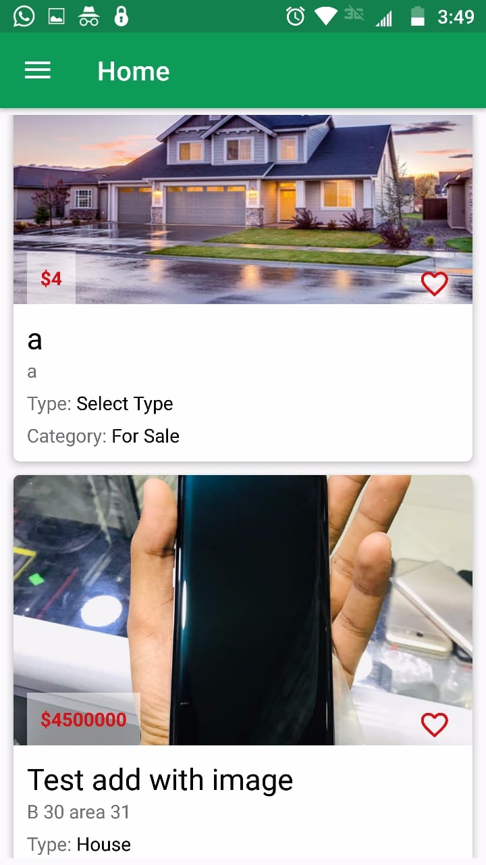

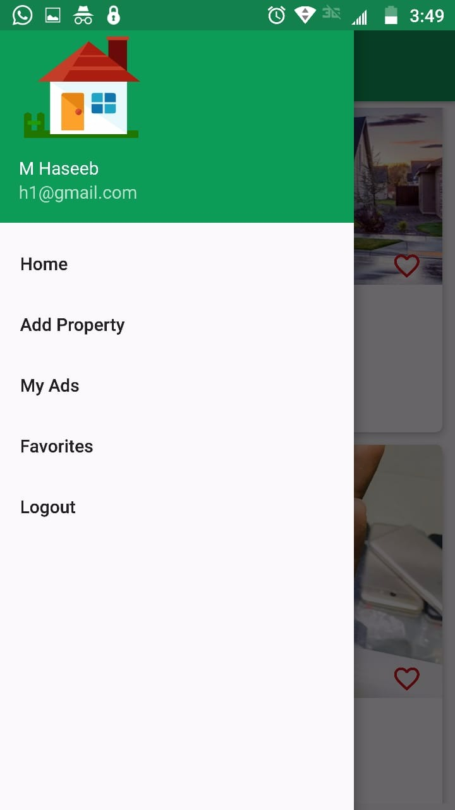

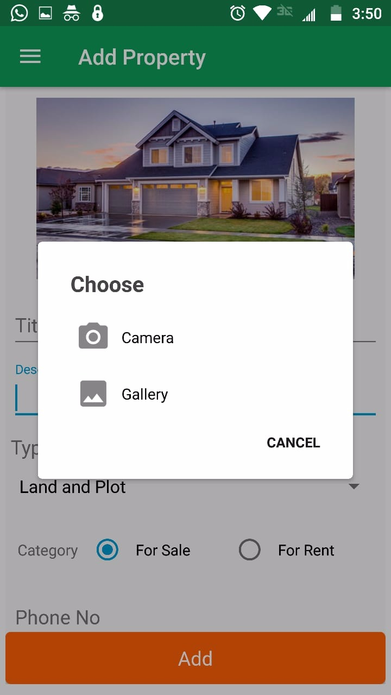

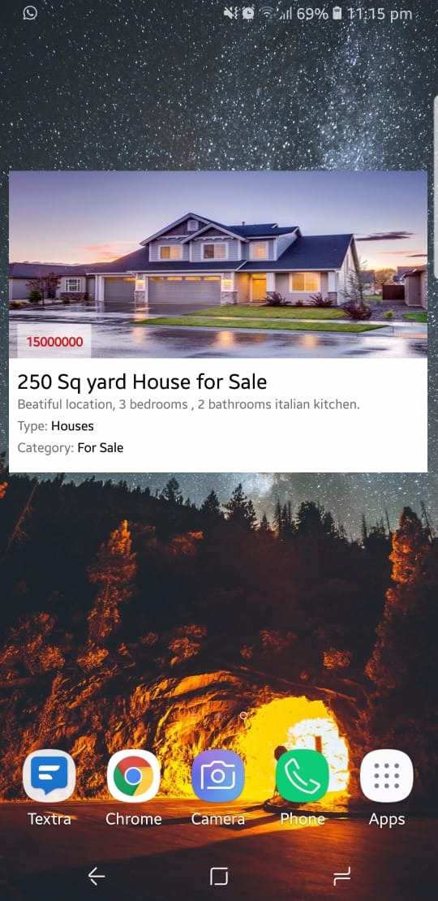

# Key Considerations

### How will your app handle data persistence?

App is going to use PHP based web service to hold the data. Room is also going to be used as local database for saved fovorites.

### Describe any edge or corner cases in the UX.

Using Glider for loading and caching image.

### Describe any libraries you’ll be using and share your reasoning for including them.

Retrofit for data download from php api

Glider for image processing

Room for local database to show the saved favorite properties

### Describe how you will implement Google Play Services or other external services.

Admob and Analytics will be used in this app.

# Next Steps: Required Tasks

## Task 1: Project Setup

Build API/Web Service in PHP for data persistence

## Task 2: Implement UI for Each Activity and Fragment

* Build UI for Login
* Buid UI for Add/Edit Property
* Build UI for Favorite List
* Build UI for Dashboard for login and anonymous user
* Build UI for searching the property

## Task 3: Your Next Task

Integrate with UI (all screens) with PHP webservice/api