- memo

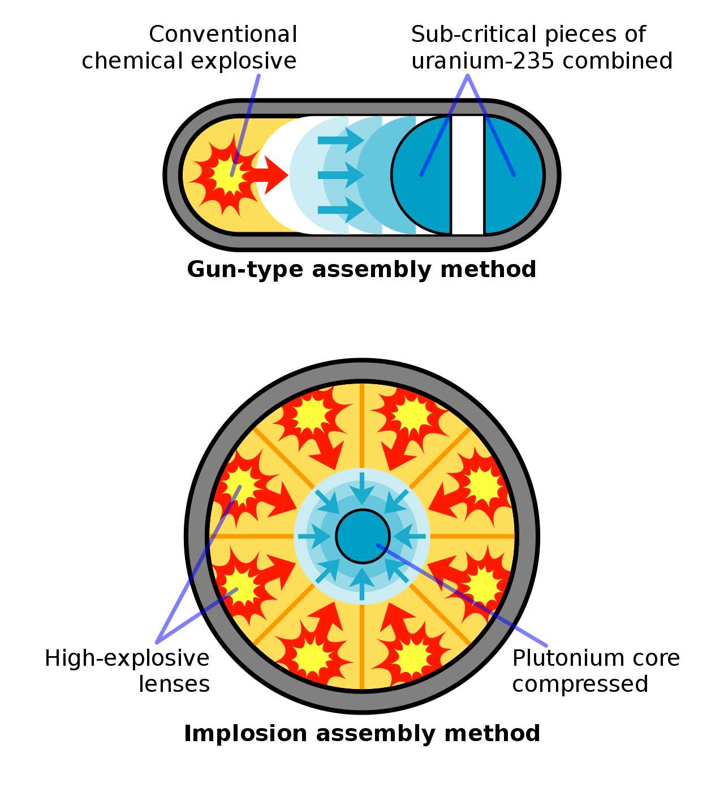

Critical mass is converged into single piece
Fission chain reaction begins.
Release of huge amount of energy = Explosion

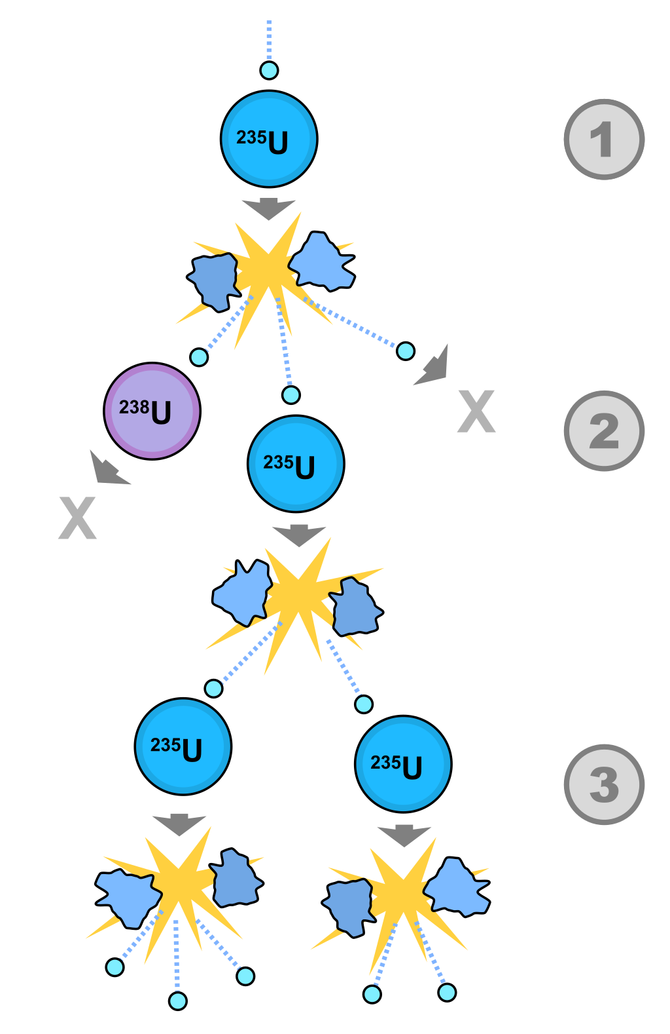
Neutron is captured by atom.
Atom breaks apart into multiple pieces.
Multiple new neutrons are emitted.
Energy release.
Cause other fissions
= chain reaction
Single fission reaction.

parameters / constants

variables

equations

Ncore: number density of neutron.
= Numbers/Vol

N0, U235: Nneutron=143, 9.48*10^20 [atoms / cm3]
→ (143*9.48*10^20) [neutrons / cm3] = (143*9.48*10^20)*10^6 [neutrons / m3]
https://www.nuclear-power.com/nuclear-power/reactor-physics/nuclear-engineering-fundamentals/neutron-nuclear-reactions/atomic-number-density/
https://en.wikipedia.org/wiki/Uranium-235

n: number density of nuclear = (mass number)/(4/3*pi*R^3)
R= 1.25 [fm] = 1.25*10^(-15) [m]
mass number, U235= 235
n= 235/(4/3*pi*(1.25*10^(-15))^3)

https://en.wikipedia.org/wiki/Nuclear_density

molecular weight of U235 = 235.04393
https://pubchem.ncbi.nlm.nih.gov/compound/Uranium-235

sigmaF: fission cross-section of fissile material.
U235, 1 [MeV]: 1.199 [Barns] = (1.199*10^(-28)) [m2]

sigmaEl: elastic-scattering cross section of fissile material.
U235, 1 [MeV]: 3.650 [Barns] = (3.650*10^(-28)) [m2]

vNeutron: average speed of neutron
emitted by fission: 1.4x10^9 [cm/sec] = 1.4x10^7 [m/sec]

nu: number of neutrons emitted per fission
2.43 [neutrons]
https://www.nuclear-power.com/nuclear-power-plant/nuclear-fuel/uranium/uranium-235/uranium-235-fission/

https://en.wikipedia.org/wiki/Nuclear_chain_reaction

dCore: critical radius

https://nuclearweaponarchive.org/Nwfaq/Nfaq4-1.html

Memo:
- 計算式のmmlファイルへの保存：計算式ボックスを左クリックで選択 → 右クリック → 「名前を付けてコピーを保存」 → 「MathML 2.0」を選択

