N.B I have used JWT for enforcing security here. For developing this project All standard practice is followed i.e Repository pattern, DI, IOC, OOP concepts, Query Specification pattern. MSSQL used for data storage.

1. Execute EMSScript.sql
2. API testing endpoints:

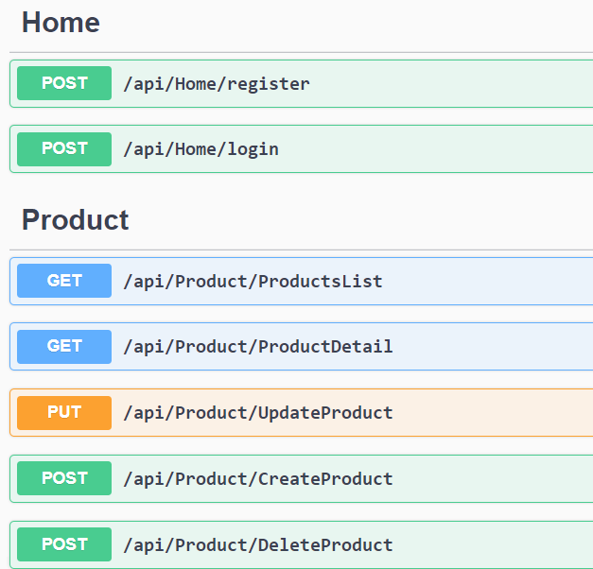

1. First Register or Login using Default Username and Password
   1. Username: admin
   2. Password: 123456
      1. Which was created by sql script.
2. 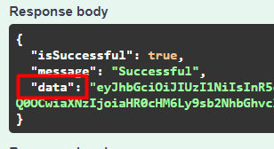 Authorize all API endpoints using token. We have to use data as our token
3. After Authorization we can use our CRUD (Create , Read , Update, Delete)

Angular Project:

1. Install npm
2. Go to properties of solution and select multiple startup projects as shown below.

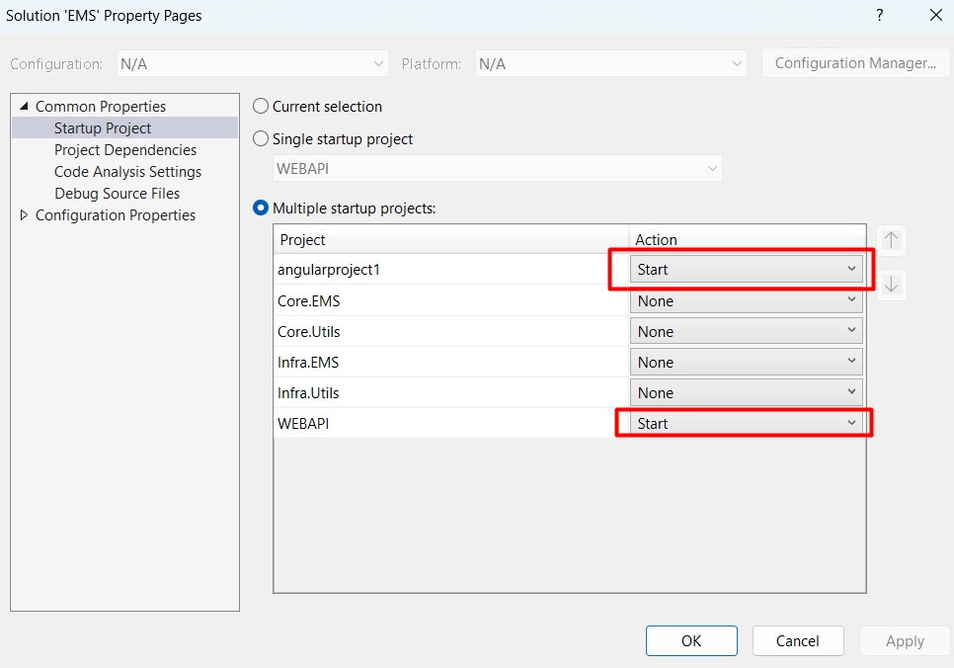

1. Start Application.
   1. In Login Page you can login using your registered user or use default credential
      1. Username: admin
      2. Password: 123456

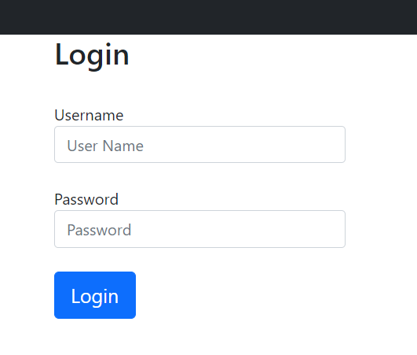

1. After login successful product crud page will appear

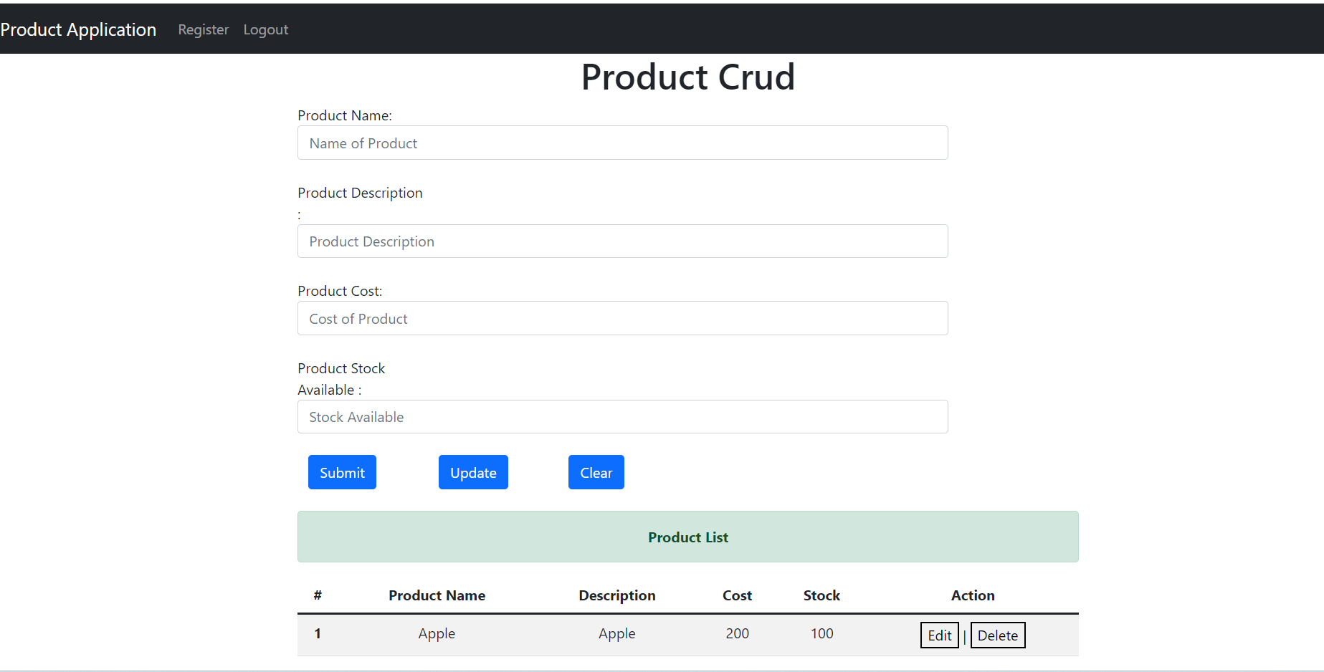

1. We can add update delete product here.
2. We can register new user for product management by clicking register tab.

