09.02.2025 yildan
№ 87-TG
Mikrokredit shartnomasiga
1-sonli ilova

TOʻLOV JADVALI

№ | Toʻlov muddati | Asosiy qarz qoldigʻi | Toʻlov miqdori soʻmda
№ | Toʻlov muddati | Asosiy qarz qoldigʻi | Asosiy qarz | Foizlar | Jami
1 | 05.03.2025 | 180000000 | 11,728,178.11 | 8,580,821.89 | 20,309,000
2 | 07.04.2025 | 168,271,821.89 | 11,180,830.07 | 9,128,169.93 | 20,309,000
3 | 05.05.2025 | 157,090,991.82 | 13,078,510.44 | 7,230,489.56 | 20,309,000
4 | 05.06.2025 | 144,012,481.38 | 12,970,281.65 | 7,338,718.35 | 20,309,000
5 | 07.07.2025 | 131,042,199.73 | 13,415,821.12 | 6,893,178.88 | 20,309,000
6 | 05.08.2025 | 117,626,378.61 | 14,701,605.53 | 5,607,394.47 | 20,309,000
7 | 05.09.2025 | 102,924,773.08 | 15,064,066.29 | 5,244,933.71 | 20,309,000
8 | 06.10.2025 | 87,860,706.79 | 15,831,714.64 | 4,477,285.36 | 20,309,000
9 | 05.11.2025 | 72,028,992.15 | 16,756,885.40 | 3,552,114.60 | 20,309,000
10 | 05.12.2025 | 55,272,106.75 | 17,583,252.20 | 2,725,747.80 | 20,309,000
11 | 05.01.2026 | 37,688,854.55 | 18,388,417.32 | 1,920,582.68 | 20,309,000
12 | 04.02.2026 | 19,300,437.23 | 19,300,437.23 | 951,802.50 | 20,252,239.73
13 | False | 0 | 0 | 0 | 0
14 | False | 0 | 0 | 0 | 0
15 | False | 0 | 0 | 0 | 0
16 | False | 0 | 0 | 0 | 0
17 | False | 0 | 0 | 0 | 0
18 | False | 0 | 0 | 0 | 0
19 | False | 0 | 0 | 0 | 0
20 | False | 0 | 0 | 0 | 0
21 | False | 0 | 0 | 0 | 0
22 | False | 0 | 0 | 0 | 0
23 | False | 0 | 0 | 0 | 0
24 | False | 0 | 0 | 0 | 0
25 | False | 0 | 0 | 0 | 0
26 | False | 0 | 0 | 0 | 0
27 | False | 0 | 0 | 0 | 0
28 | False | 0 | 0 | 0 | 0
29 | False | 0 | 0 | 0 | 0
30 | False | 0 | 0 | 0 | 0
31 | False | 0 | 0 | 0 | 0
32 | False | 0 | 0 | 0 | 0
33 | False | 0 | 0 | 0 | 0
34 | False | 0 | 0 | 0 | 0
35 | False | 0 | 0 | 0 | 0
36 | False | 0 | 0 | 0 | 0
 | JAMI |  | 180,000,000 | 63,651,239.73 | 243,651,239.73

*Mikrokredit bo‘yicha to‘lovlar to‘lov jadvalida ko‘rsatilmagan sanalarda to‘langan taqdirda, to‘lov summasi Mikrokredit shartnomasining 2.2.-bandiga muvofiq Mikrokredit qoldig‘iga hisoblangan foizlar summasiga o‘zgartiriladi.

«Mikromoliya tashkiloti» |  | «Qarz oluvchi»
«CLEVER MIKROMOLIYA TASHKILOTI» MChJ |  | YAXSHIYEV JAVLON JO‘RAYEVICH
Manzil: Toshkent shahri, Olmazor tumani, Sagbon ko'chasi, 30 boshi berk, 6-uy  H/r: 20216000705068380001  MFO: 01042 ATB “Kapitalbank” Sergeli filiali  STIR: 306365847  Tel.: +998 (93) 452-29-67,  +998 (93) 656-56-81 |  | Manzil: Бухарская область, Вабкентский район, Хажувон МСГ, Катта Хўжалар, дом 65  Pasport seriyasi va raqami: AD5173509,  Pasport muddati: OʻZBEKISTON RESPUBLIKASI IIB tomonidan ВАБКЕНТСКИЙ РОВД БУХАРСКОЙ ОБЛАСТИ yilda berilgan.  Tel.: +998 (93) 840-29-81  Tel.: +995 (93) 840-29-81
Xorazm viloyati Urganch filiali boshligʻi |  | __________J.J.YAXSHIYEV
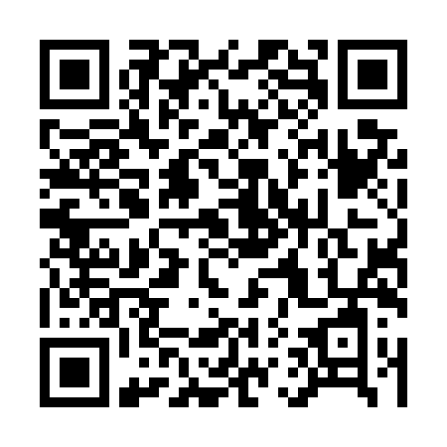 | Sharipov M.R. | __________ Mikrokredit shartnomasidan bir nusxa oldim

