16.01.2025 yildan
№ 876-XMS
Mikroqarz shartnomasiga
1-sonli ilova

TOʻLOV JADVALI

№ | Toʻlov muddati | Asosiy qarz qoldigʻi | Toʻlov miqdori soʻmda
№ | Toʻlov muddati | Asosiy qarz qoldigʻi | Asosiy qarz | Foizlar | Jami
1 | 03.02.2025 | 35000000 | 925,041 | 1,610,959 | 2,536,000
2 | 03.03.2025 | 34074959 | 967,618.36 | 1,568,381.64 | 2,536,000
3 | 01.04.2025 | 33,107,340.64 | 957,732.13 | 1,578,267.87 | 2,536,000
4 | 01.05.2025 | 32,149,608.51 | 950,539.90 | 1,585,460.10 | 2,536,000
5 | 02.06.2025 | 31,199,068.61 | 894,843.52 | 1,641,156.48 | 2,536,000
6 | 01.07.2025 | 30,304,225.09 | 1,091,360.36 | 1,444,639.64 | 2,536,000
7 | 01.08.2025 | 29,212,864.73 | 1,047,344.35 | 1,488,655.65 | 2,536,000
8 | 01.09.2025 | 28,165,520.38 | 1,100,715.81 | 1,435,284.19 | 2,536,000
9 | 01.10.2025 | 27,064,804.57 | 1,201,297.30 | 1,334,702.70 | 2,536,000
10 | 03.11.2025 | 25,863,507.27 | 1,132,993.45 | 1,403,006.55 | 2,536,000
11 | 01.12.2025 | 24,730,513.82 | 1,397,718.80 | 1,138,281.20 | 2,536,000
12 | 01.01.2026 | 23,332,795.02 | 1,346,986.32 | 1,189,013.68 | 2,536,000
13 | 02.02.2026 | 21,985,808.70 | 1,379,486.08 | 1,156,513.92 | 2,536,000
14 | 02.03.2026 | 20,606,322.62 | 1,587,544.52 | 948,455.48 | 2,536,000
15 | 01.04.2026 | 19,018,778.10 | 1,598,087.80 | 937,912.20 | 2,536,000
16 | 01.05.2026 | 17,420,690.30 | 1,676,897.50 | 859,102.50 | 2,536,000
17 | 01.06.2026 | 15,743,792.80 | 1,733,713.49 | 802,286.51 | 2,536,000
18 | 01.07.2026 | 14,010,079.31 | 1,845,091.90 | 690,908.10 | 2,536,000
19 | 03.08.2026 | 12,164,987.41 | 1,876,091.08 | 659,908.92 | 2,536,000
20 | 01.09.2026 | 10,288,896.33 | 2,045,515.75 | 490,484.25 | 2,536,000
21 | 01.10.2026 | 8,243,380.58 | 2,129,477.20 | 406,522.80 | 2,536,000
22 | 02.11.2026 | 6,113,903.38 | 2,214,392 | 321,608 | 2,536,000
23 | 01.12.2026 | 3,899,511.38 | 2,350,105.36 | 185,894.64 | 2,536,000
24 | 06.01.2027 | 1,549,406.02 | 1,549,406.02 | 91,690.92 | 1,641,096.94
 | JAMI |  | 35,000,000 | 24,969,096.94 | 59,969,096.94

*Mikroqarz bo‘yicha to‘lovlar to‘lov jadvalida ko‘rsatilmagan sanalarda to‘langan taqdirda, to‘lov summasi mikroqarz shartnomasining 2.2.-bandiga muvofiq mikroqarz qoldig‘iga hisoblangan foizlar summasiga o‘zgartiriladi.

«Mikromoliya tashkiloti» |  | «Qarz oluvchi»
«CLEVER MIKROMOLIYA TASHKILOTI» MChJ |  | EGAMBERDIYEV TO‘XTASIN INOYATOVICH
Manzil: Toshkent shahri, Olmazor tumani, Sagbon ko'chasi, 30 boshi berk, 6-uy  H/r: 20216000705068380001  MFO: 01042 ATB “Kapitalbank” Sergeli filiali  STIR: 306365847  Tel.: +998 (93) 452-29-67,  +998 (93) 656-56-81 |  | Manzil: г. Ташкент, Учтепинский район, кв. 25, Нуробод МСГ, 4- Дом, 34- Квартира  Pasport seriyasi va raqami: AD1582556,  Pasport muddati: OʻZBEKISTON RESPUBLIKASI IIB tomonidan ЦЕНТР ГОСУДАРСТВЕННЫХ УСЛУГ УЧТЕПИНСКОГО РАЙОНА Г. ТАШКЕНТА yilda berilgan.  Tel.: +998 (93) 840-29-81  Tel.: +995 (93) 840-29-81
Xorazm viloyati Urganch filiali boshligʻi |  | __________T.I.EGAMBERDIYEV
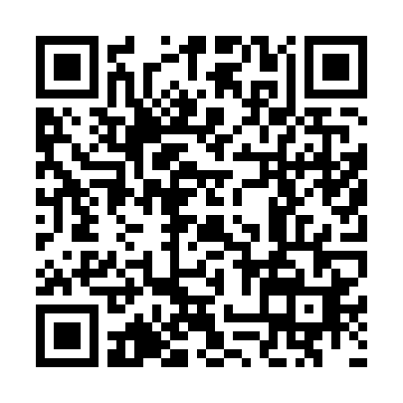 | Sharipov M.R. | __________ Mikroqarz shartnomasidan bir nusxa oldim

