O’ZBEKISTON RESPUBLIKASI AXBOROT TEXNOLOGIYALARI VA KOMMUNIKATSIYALARINI RIVOJLANTIRISH VAZIRLIGI MUHAMMAD AL-XORAZMIY NOMIDAGI TOSHKENT AXBOROT TEXNOLOGIYALARI UNIVERSITETI

**Deadline**

Bajardi: Nuriddinov Xurshidbek

**Toshkent – 2023**

**5 – Amaliy ish.**

**Mavzu:** DARAXTSIMON MA’LUMOTLAR TUZILMASI, GRAFLAR

1. 40,14,10,13,12,8,9,7,17,15,16,44,42,41,43,47

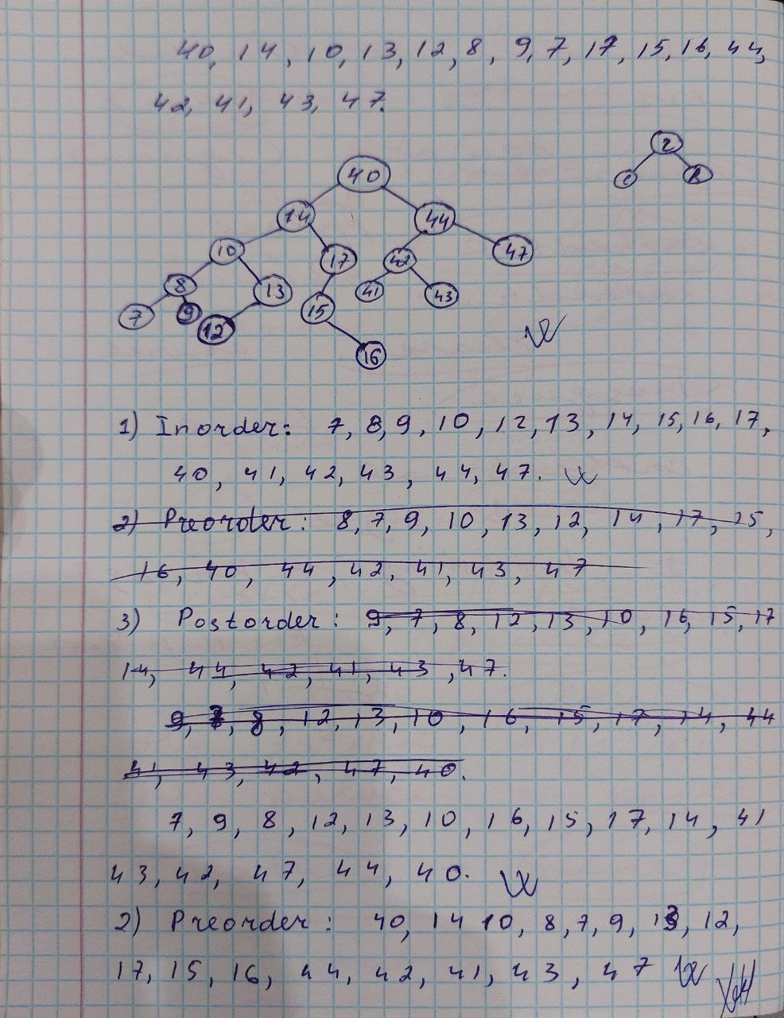

Dastur kodi:

#include <iostream>

using namespace std;

// Node struktura

struct Node {

int data;

Node* left;

Node* right;

Node(int val) {

data = val;

left = nullptr;

right = nullptr;

}

};

// Inorder

void inorder(Node* root) {

if (root == nullptr) {

return;

}

inorder(root->left);

cout << root->data << " ";

inorder(root->right);

}

// Preorder

void preorder(Node* root) {

if (root == nullptr) {

return;

}

cout << root->data << " ";

preorder(root->left);

preorder(root->right);

}

// Postorder

void postorder(Node* root) {

if (root == nullptr) {

return;

}

postorder(root->left);

postorder(root->right);

cout << root->data << " ";

}

int main() {

// Binar daraxt yaratish

Node* root = new Node(40);

root->right = new Node(44);

root->right->left = new Node(42);

root->right->left->right = new Node(43);

root->right->left->left = new Node(41);

root->right->right = new Node(47);

root->left = new Node(14);

root->left->right = new Node(17);

root->left->right->left = new Node(15);

root->left->right->left->right = new Node(16);

root->left->left = new Node(10);

root->left->left->right = new Node(13);

root->left->left->right->left = new Node(12);

root->left->left->left = new Node(8);

root->left->left->left->left = new Node(7);

root->left->left->left->right = new Node(9);

cout << "Inorder: ";

inorder(root);

cout << endl;

cout << "Preorder: ";

preorder(root);

cout << endl;

cout << "Postorder : ";

postorder(root);

cout << endl;

return 0;

}

Natija:

