Department of Information Technology
Academic Year: 2024-25 Name of Student: khushi anchalia Semester: VI Student ID: 23104214
Class / Branch / Div: TE- IT A/B/C Roll No. 1
Subject: MAD & PWA Lab Date of Submission: 21/1/26 Name of Instructor:

Experiment No.:2

Aim: To install and configure Flutter Environment.
Prerequisites: Android studio, flutter SDK .

Problem Statement: To develop a flutter UI for creating student-ID using basic widgets of flutter.
Software: Android studio, flutter SDK . Code:
import 'package:flutter/material.dart';

void main() { runApp(MyApp());
}
class MyApp extends StatelessWidget { @override
Widget build(BuildContext context) { return MaterialApp(
debugShowCheckedModeBanner: false, home: Scaffold(
appBar: AppBar( title: Text('ID Card'),
backgroundColor: Colors.blue,
),

body: Center( child: Card(
elevation: 6,
color: Colors.deepPurpleAccent, shape: RoundedRectangleBorder(
borderRadius: BorderRadius.circular(15),
),

child: Padding(

padding: EdgeInsets.all(20), child: Column(
mainAxisSize: MainAxisSize.min, children: [

// Photo

CircleAvatar( radius: 50, backgroundImage:
NetworkImage('https://encrypted-tbn0.gstatic.com/images?

q=tbn:ANd9GcSsmluIweDzM59mNeQ1rite7TeDovC9wvUT1w&s'),
),

SizedBox(height: 10),

// Name

Text(
'Miss. Star', style: TextStyle(
fontSize: 20,
fontWeight: FontWeight.bold,
),
),

SizedBox(height: 10),

// Roll No

Text('Roll No: 001'),

SizedBox(height: 10),

// Department
Text('Department: I.T.'), SizedBox(height: 10),

// College

Text('A.P.S.I.T College'),
],

),
),
),
),
),
);
}

}

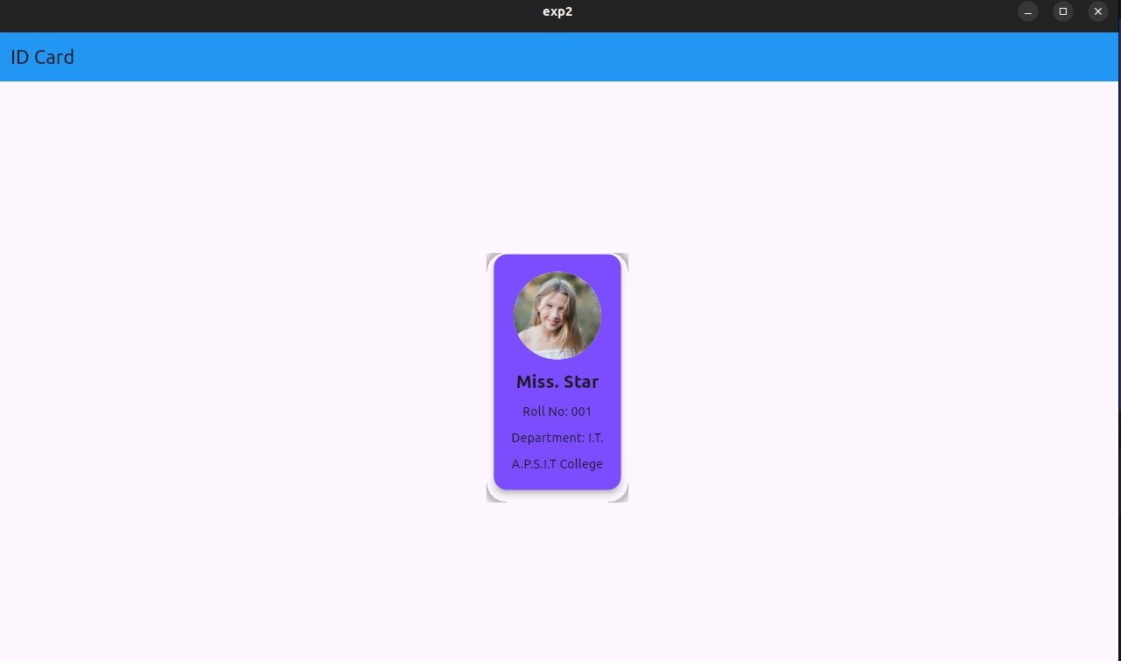
Output:

Conclusion: In this experiment we have created user interface by using flutter common widgets.

