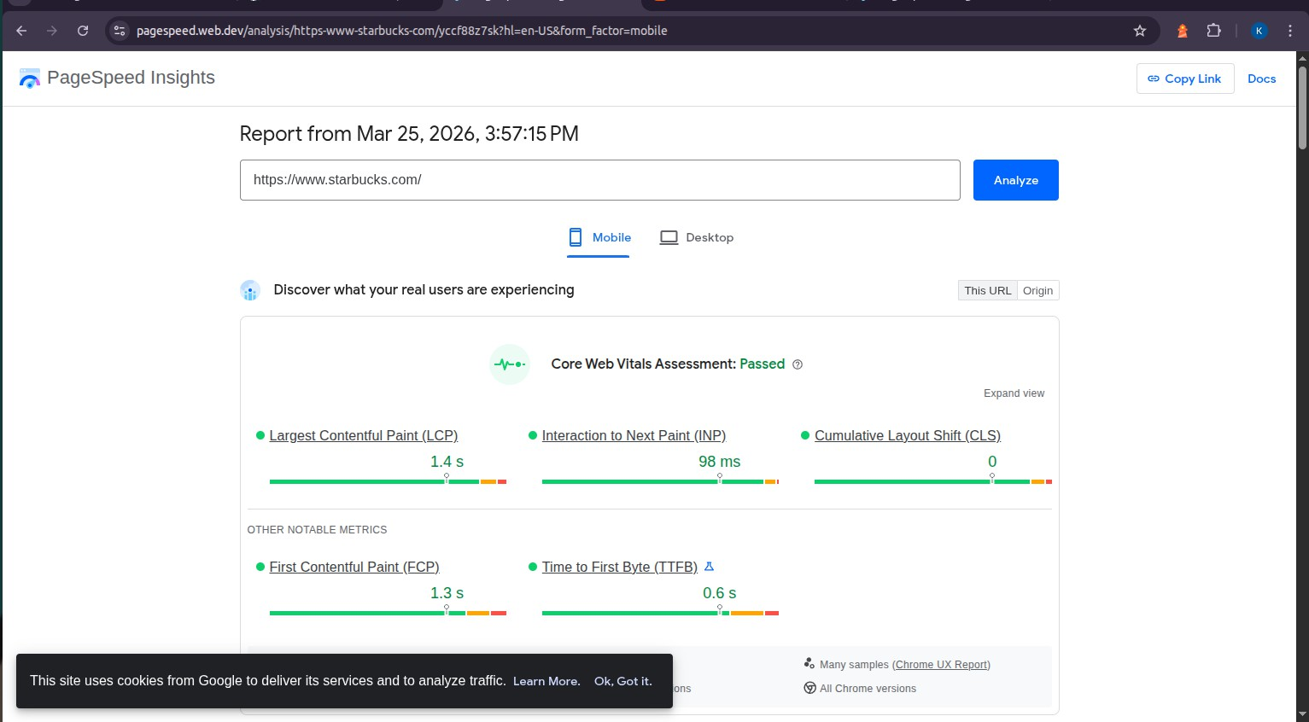

Department of Information Technology
Academic Year: 2024-25 Name of Student:khushi anchalia
Semester: VI Student ID:23104214
Class / Branch / Div: TE- IT A/B Roll No.1
Subject: MAD & PWA Lab Date of Submission: 25/3/26 Name of Instructor:Prof.Manjusha
Experiment No.:10
Aim: Make use of google Lighthouse PWA Analysis Tool to test the PWA functioning.
Prerequisites: HTML, JavaScript, JSON. Software: VS code, Browser, Lighthouse tool.
Problem Statement: Make use of google Lighthouse PWA Analysis Tool to test the PWA functioning of web application created in experiment:8
Code:
Run Lighthouse in Chrome DevTools
Lighthouse powers the Audits panel of Chrome DevTools. To run a report:
- Download Google Chrome for Desktop.
- In Google Chrome, go to the URL you want to audit. You can audit any URL on the web.
- Open Chrome DevTools.
- Click the Audits tab.
- Click Perform an audit. DevTools shows you a list of audit categories. Leave them all enabled.
- Click Run audit. After 30 to 60 seconds, Lighthouse gives you a report on the page.

Output: Starbuks:

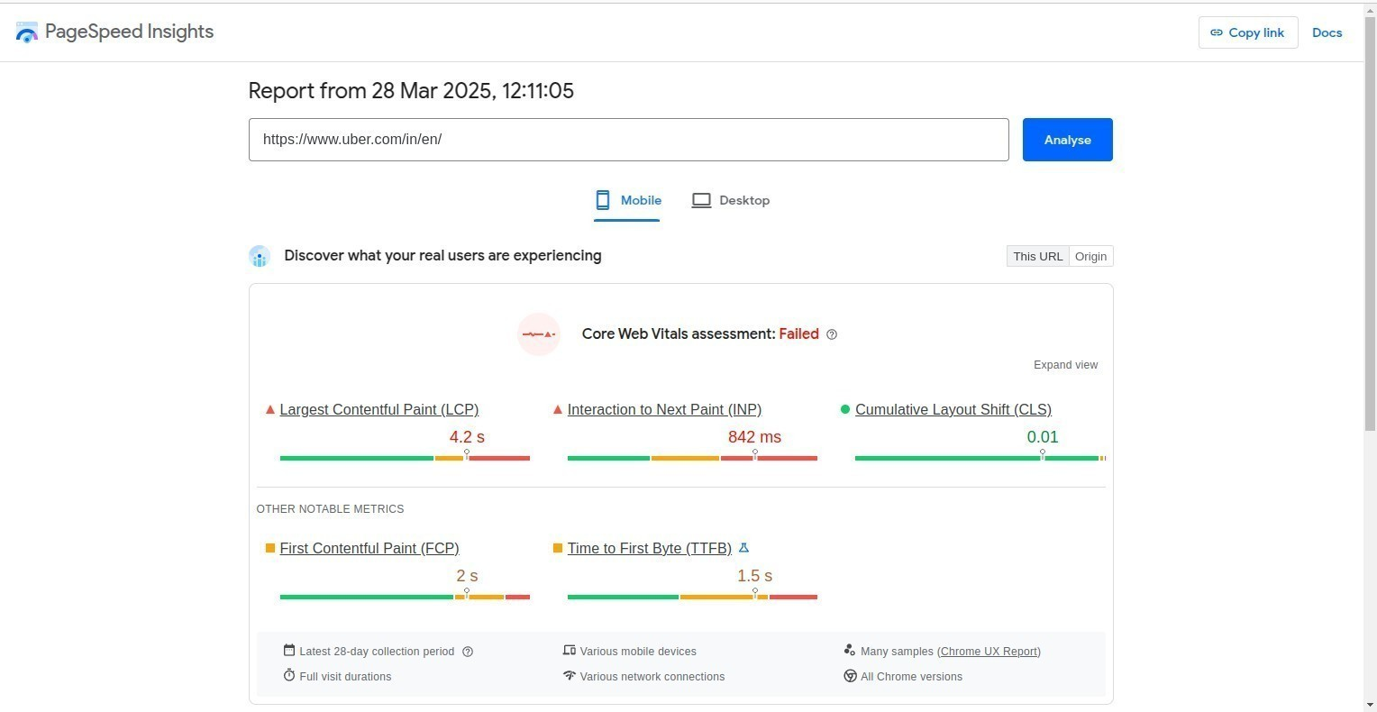

Ubar:
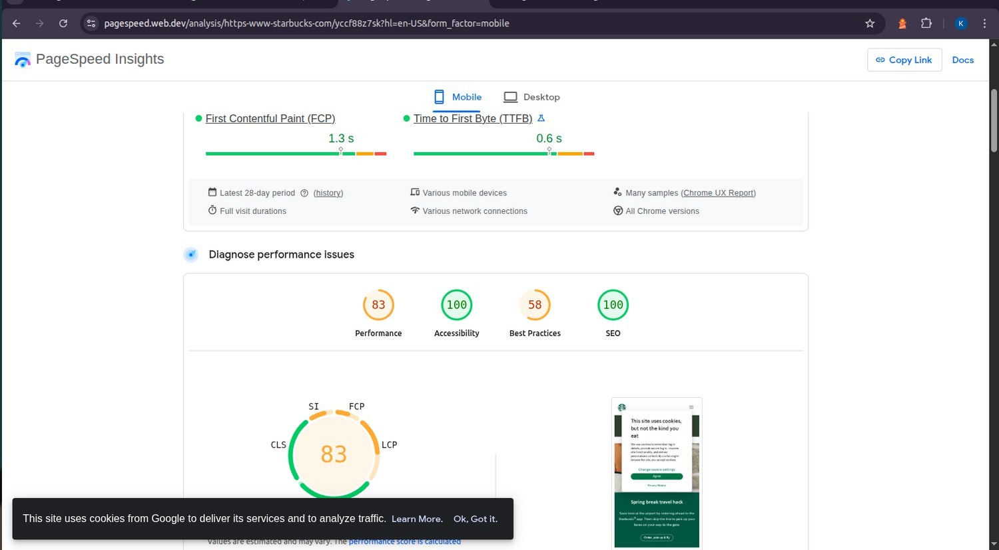

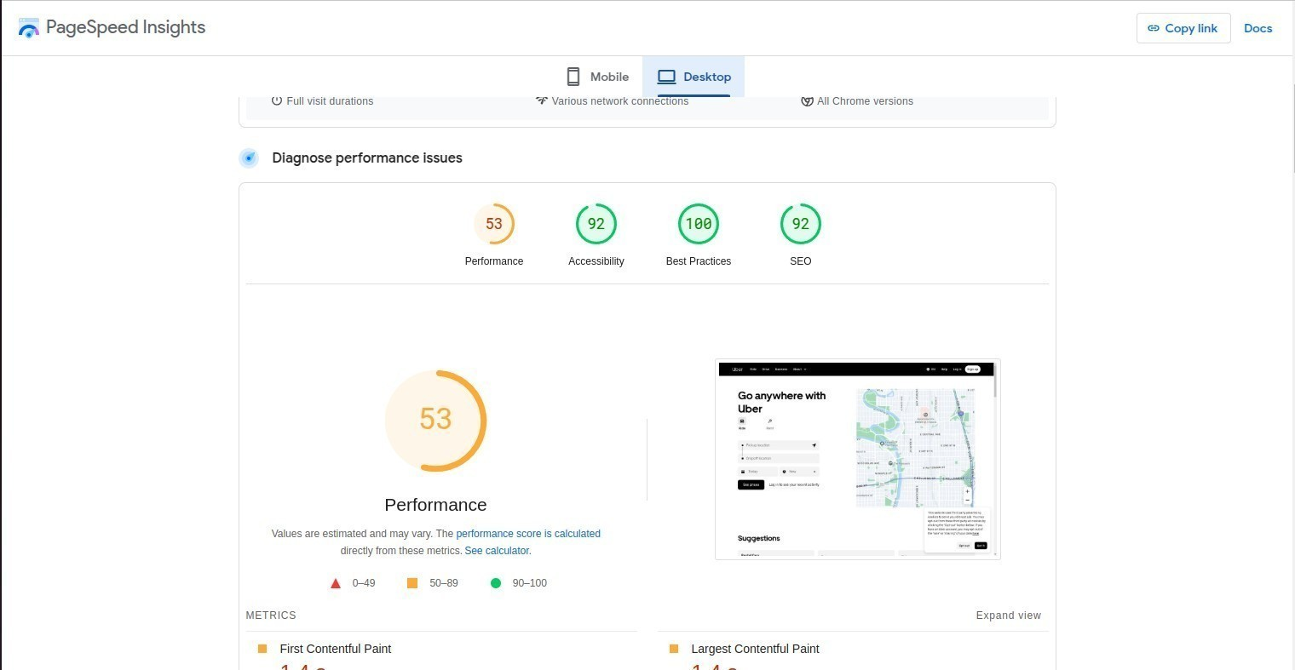

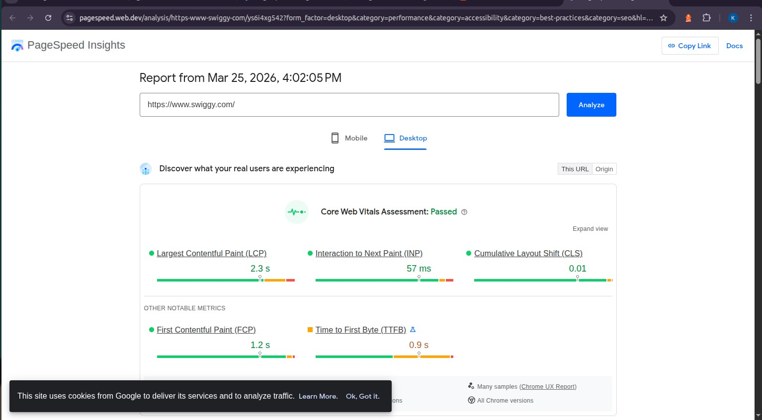
swiggy:

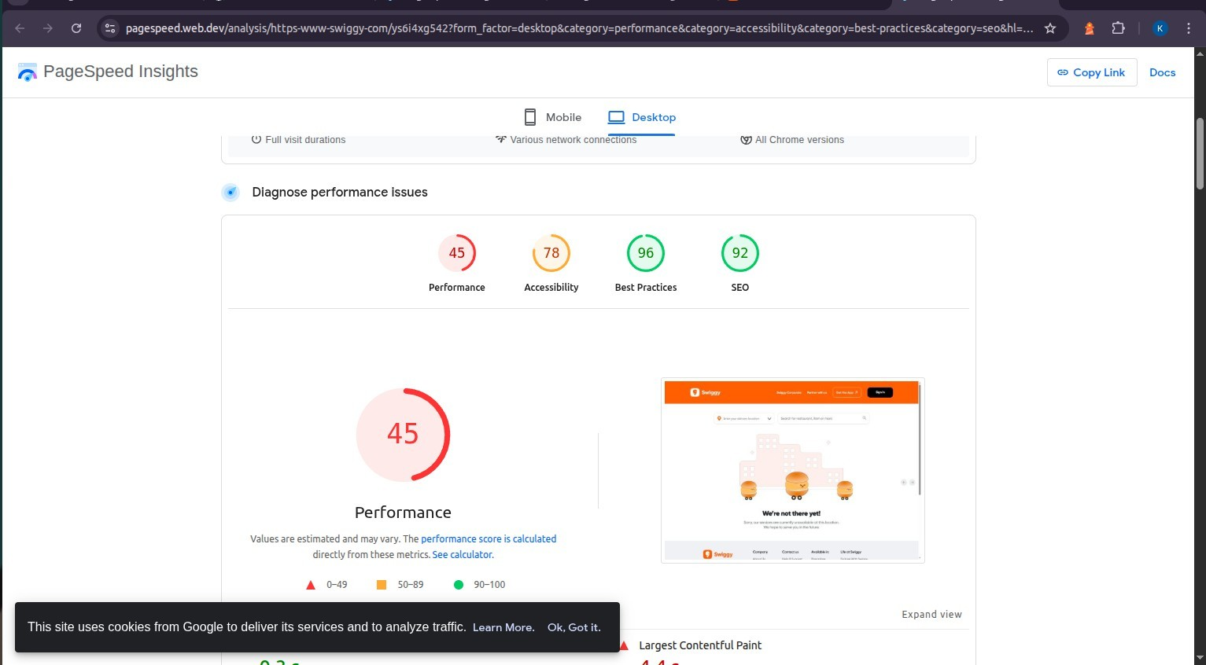

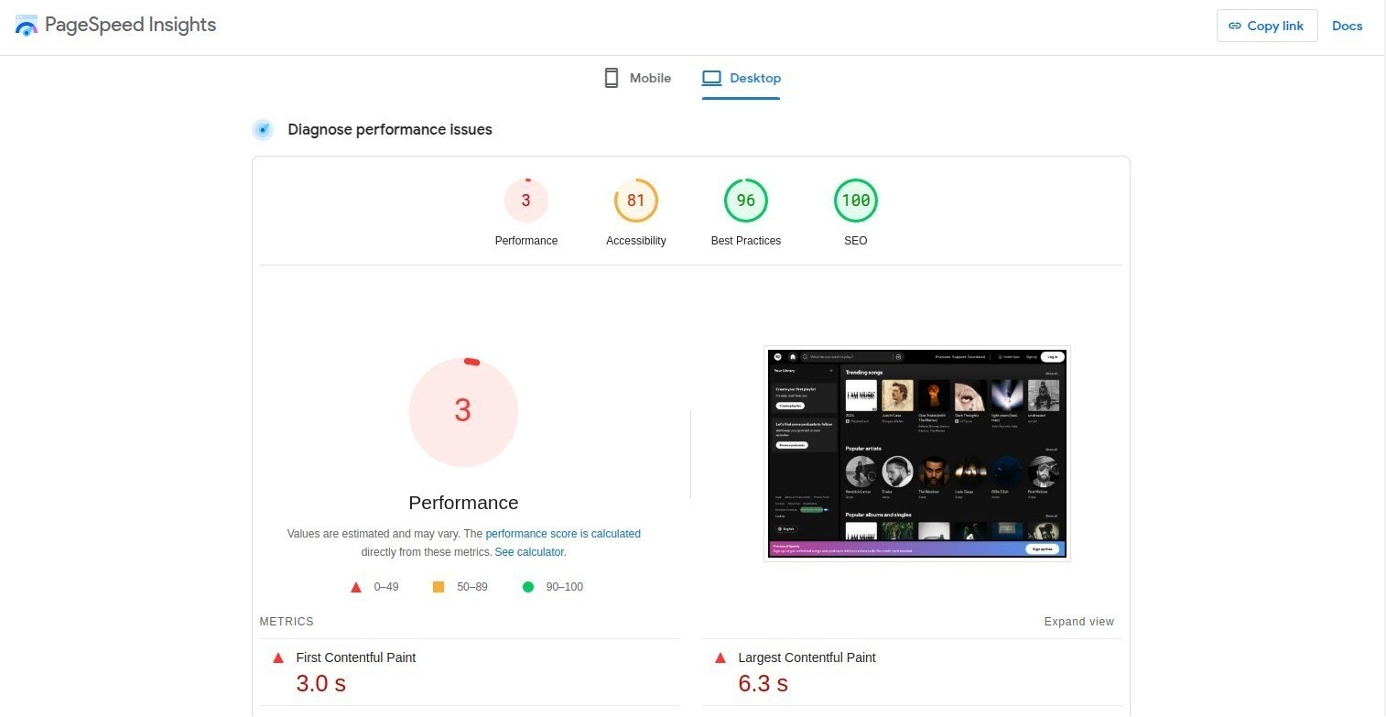
Spotify:

Conclusion: In this experiment we have use of google Lighthouse PWA Analysis Tool to test the PWA functioning and report analysis.

