Department of Information Technology
Academic Year: 2025-26 Name of Student:khushi anchalia
Semester: VI Student ID: 23104214
Class / Branch / Div: TE- IT A Roll No. 01
Subject: MAD & PWA Lab Date of Submission: 25/3/26 Name of Instructor: Prof. Manjusha Kashilkar

Experiment No.:3
Aim: To design a layout of Flutter App using layout widgets.

Prerequisites: Android studio, flutter SDK .
Problem Statement: To develop a flutter UI for creating List View using Layout widgets of flutter.
Software: Android studio, flutter SDK . Code:
import 'package:flutter/material.dart';

void main() => runApp(MyApp());

class MyApp extends StatelessWidget {
// It is the root widget of your application. @override
Widget build(BuildContext context) { return MaterialApp(
title: 'Flutter Demo Application', theme: ThemeData( primarySwatch: Colors.green,
),
home: MyHomePage(title: 'Complex layout example'),
);
}
}

class MyHomePage extends StatelessWidget { MyHomePage({Key? key, required this.title}) : super(key: key); final String title;

@override
Widget build(BuildContext context) { return Scaffold(
appBar: AppBar(title: Text("Product List")), body: ListView(
padding: const EdgeInsets.fromLTRB(3.0, 12.0, 3.0, 12.0), children: <Widget>[
ProductBox( name: "iPhone",
description: "iPhone is the top branded phone ever", price: 55000,
image: "iphone.png"), ProductBox(
name: "Android",
description: "Android is a very stylish phone", price: 10000,
image: "android.png"), ProductBox(
name: "Tablet",
description: "Tablet is a popular device for official meetings", price: 25000,
image: "tablet.png"), ProductBox(
name: "Laptop",

description: "Laptop is most famous electronic device", price: 35000,
image: "laptop.png"), ProductBox(
name: "Desktop",
description: "Desktop is most popular for regular use", price: 10000,
image: "computer.png"),
],
));
}
}

class ProductBox extends StatelessWidget { ProductBox(
{Key? key, required this.name,
required this.description, required this.price, required this.image})
: super(key: key); final String name;
final String description; final int price;
final String image;

Widget build(BuildContext context) { return Container(
padding: EdgeInsets.all(2),

height: 110, child: Card(
child: Row(
mainAxisAlignment: MainAxisAlignment.spaceEvenly, children: <Widget>[
Image.asset("assets/" + image), Expanded(
child: Container(
padding: EdgeInsets.all(5), child: Column(
mainAxisAlignment: MainAxisAlignment.spaceEvenly, children: <Widget>[
Text(this.name,
style: TextStyle(fontWeight: FontWeight.bold)), Text(this.description),
Text("Price: " + this.price.toString()),
],
)))
])));
}
}
Output:

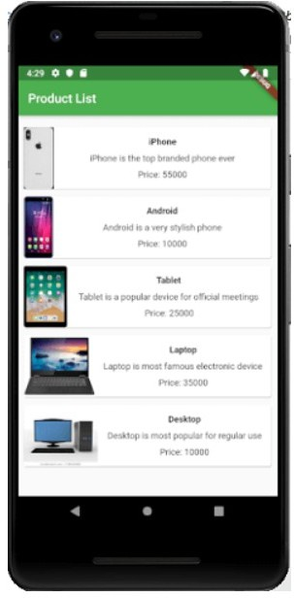

Conclusion: In this experiment we have designed a layout by using flutter various layout widgets.

