Department of Information Technology
Academic Year: 2024-25 Name of Student:khushi anchalia Semester: VI Student ID:23104214
Class / Branch / Div: TE- IT A/B/C Roll No.1
Subject: MAD & PWA Lab Date of Submission:11/2/26 Name of Instructor:

Experiment No.:5
Aim: To apply navigation and routing in Flutter App.

Prerequisites: Android studio, flutter SDK .
Problem Statement: To develop a flutter app with two screens, screen-1 should navigate to screen-2.
Software: Android studio, flutter SDK . Code:
import 'package:flutter/material.dart';

void main() { runApp(const MyApp());
}

class MyApp extends StatelessWidget {
const MyApp({Key? key}) : super(key: key);

@override
Widget build(BuildContext context) { return MaterialApp( debugShowCheckedModeBanner: false,
theme: ThemeData(primarySwatch: Colors.deepPurple), home: const HomeRoute(),
);
}
}

// --- SCREEN 1: HOME ---
class HomeRoute extends StatelessWidget {
const HomeRoute({Key? key}) : super(key: key);

@override

Widget build(BuildContext context) { return Scaffold(
body: Container(
decoration: const BoxDecoration( gradient: LinearGradient(
colors: [Colors.deepPurple, Colors.purpleAccent], begin: Alignment.topLeft,
end: Alignment.bottomRight,
),
),
child: Center( child: NavButton(
text: "Go to Screen 2", onPressed: () => Navigator.push( context,
MaterialPageRoute(builder: (context) => const SecondRoute()),
),
),
),
),
);
}
}

class SecondRoute extends StatelessWidget {
const SecondRoute({Key? key}) : super(key: key);

@override
Widget build(BuildContext context) { return Scaffold(
appBar: AppBar(title: const Text('Screen 2')), body: Center(
child: Column(
mainAxisAlignment: MainAxisAlignment.center, children: [
const Icon(Icons.rocket_launch, size: 80, color: Colors.deepPurple), const SizedBox(height: 20),
NavButton(
text: "Proceed to Screen 3", onPressed: () => Navigator.push( context,
MaterialPageRoute(builder: (context) => const ThirdRoute()),

),
),
],
),
),
);
}
}

class ThirdRoute extends StatelessWidget {
const ThirdRoute({Key? key}) : super(key: key);

@override
Widget build(BuildContext context) { return Scaffold(
appBar: AppBar(title: const Text('Screen 3'), backgroundColor: Colors.orange), body: Center(
child: Column(
mainAxisAlignment: MainAxisAlignment.center, children: [
const Icon(Icons.celebration, size: 80, color: Colors.orange), const SizedBox(height: 20),
NavButton(
text: "Back to Home", color: Colors.orange,
onPressed: () => Navigator.popUntil(context, (route) => route.isFirst),
),
],
),
),
);
}
}

class NavButton extends StatelessWidget { final String text;
final VoidCallback onPressed; final Color color;

const NavButton({ required this.text,

required this.onPressed, this.color = Colors.white, Key? key,
}) : super(key: key);

@override
Widget build(BuildContext context) { return ElevatedButton(
style: ElevatedButton.styleFrom( foregroundColor: Colors.deepPurple, backgroundColor: color,
padding: const EdgeInsets.symmetric(horizontal: 30, vertical: 15),
shape: RoundedRectangleBorder(borderRadius: BorderRadius.circular(20)),
),
onPressed: onPressed,
child: Text(text, style: const TextStyle(fontSize: 18, fontWeight: FontWeight.bold)),
);
}
}

Output:

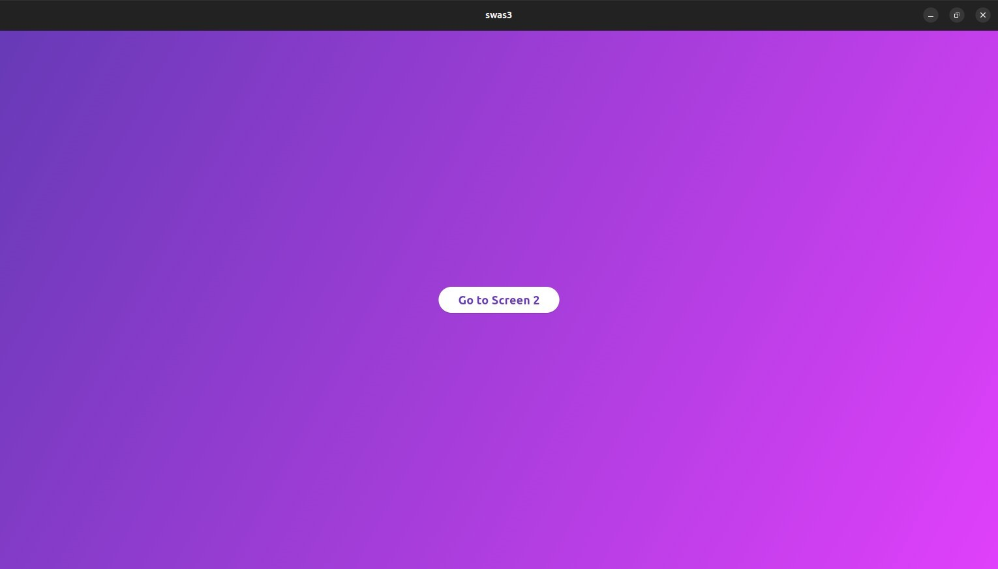

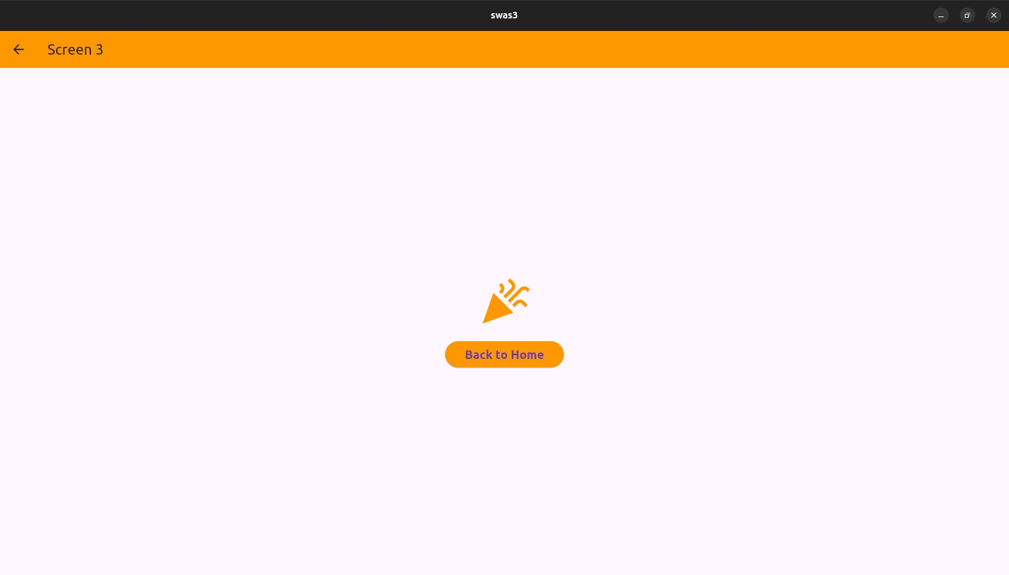
Conclusion: In this experiment we have learn use of navigation and routing in Flutter App .

