Full Name: ____Kadirov Khusan_U2110155__________

Tasks

1. Cleaning.

*Questions:*

* *How many rows have null values (if there is a null value, that’s also counted)?*
* *How many orders have been made (not including nulls)?*

*Tasks:*

1. *Show all of the null containing rows*

Code:

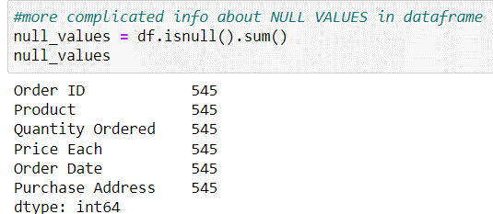

… 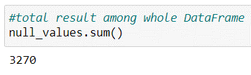

1. *Drop rows that contain any null values*

Code:

…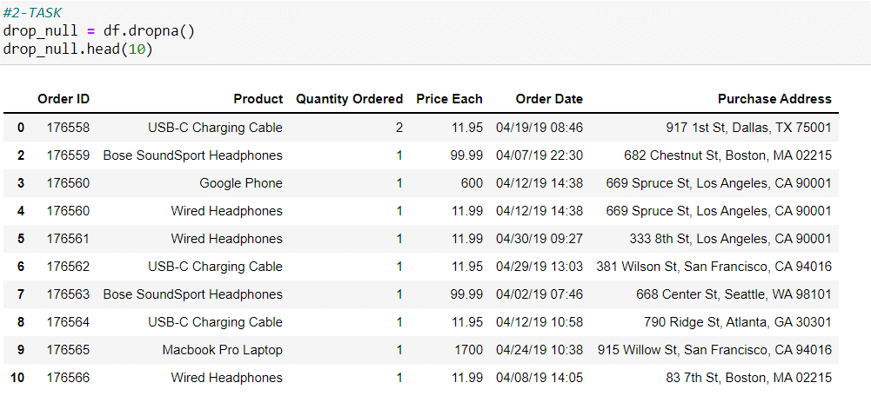

1. Restructuring the dataset.

*Tasks:*

1. *Using our (cleaned) dataset, create a new column that would contain only the months from the* ***Order Date*** *column.*

Code:

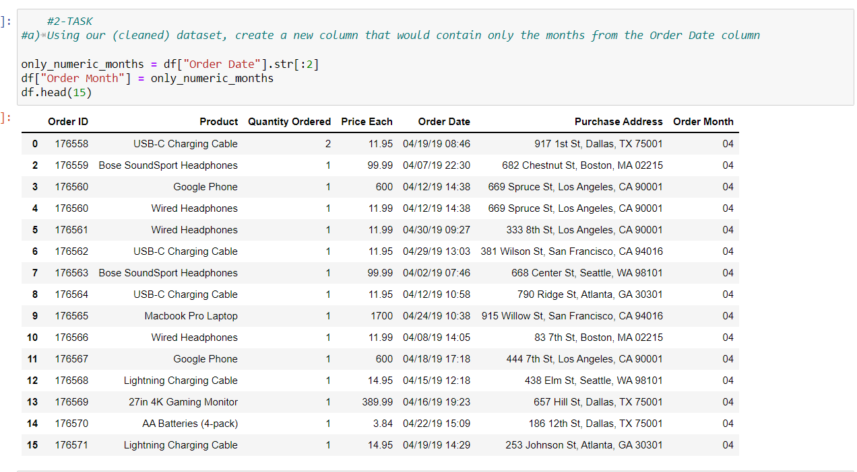

1. *Convert the month numbers into characters (f.e: 1 into January, 2 into February, and so on).*

Code:

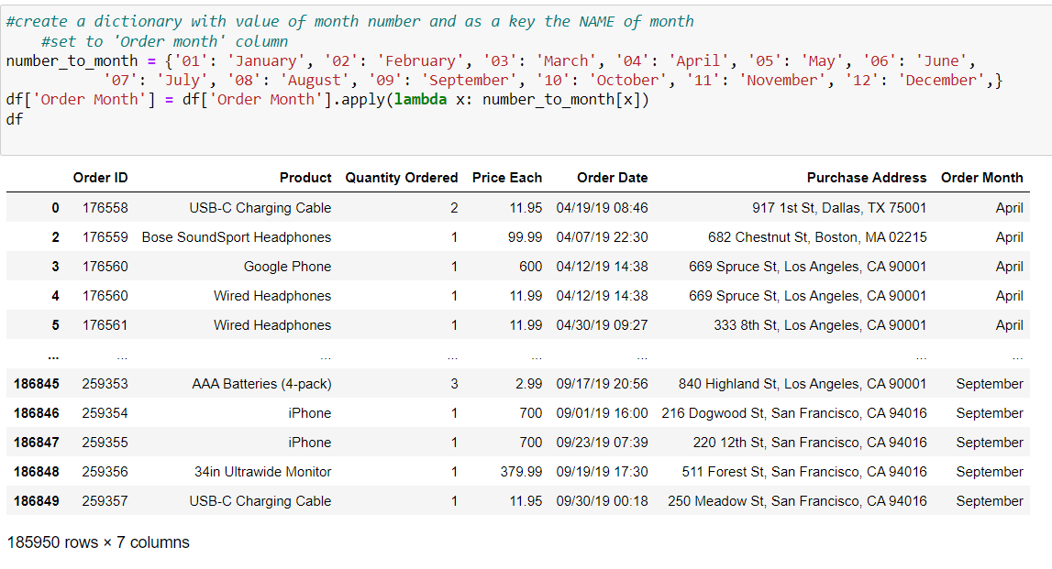

1. *Create a new column that would contain only the state names taken from the* ***Purchase Address*** *column.*

Code:

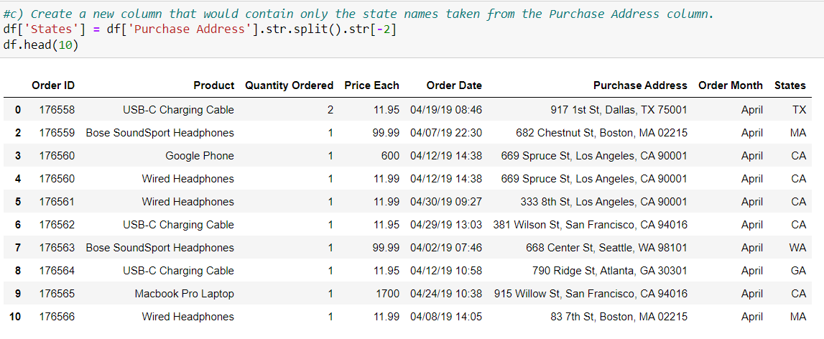

1. *Convert the* ***Quantity Ordered*** *column’s values into an integer type and the* ***Price Each*** *column’s values into a floating type.*

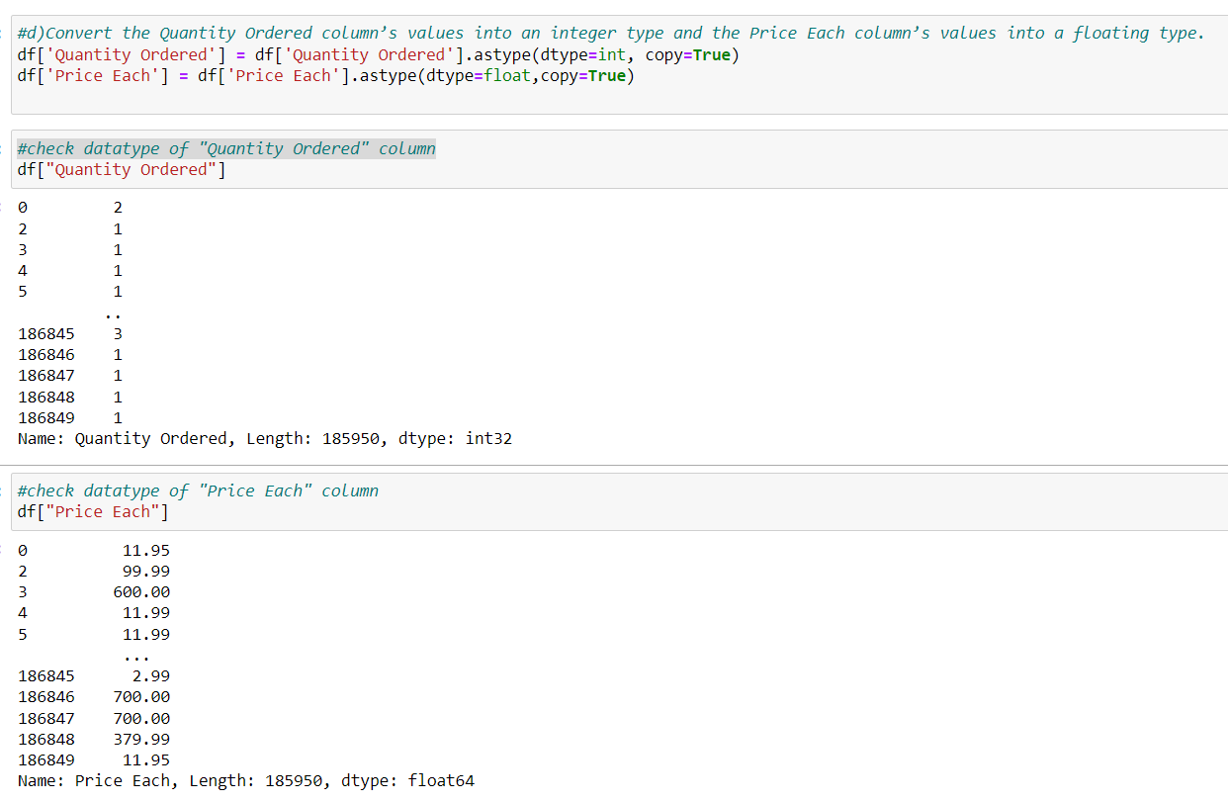

1. Get the useful information.

*Questions:*

1. *Which month has the highest number of sales (in amounts)? And how much was that?*

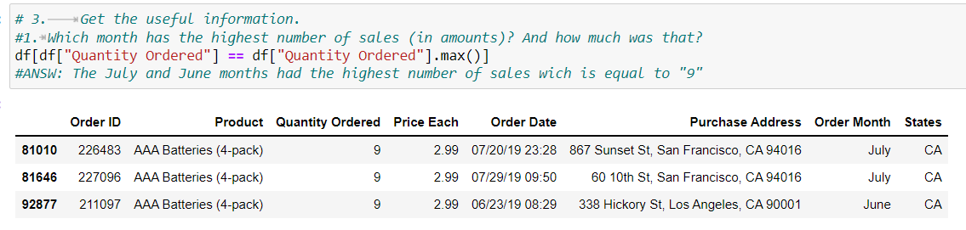

1. *Plot a bar plot that would represent the sales info for each month.*

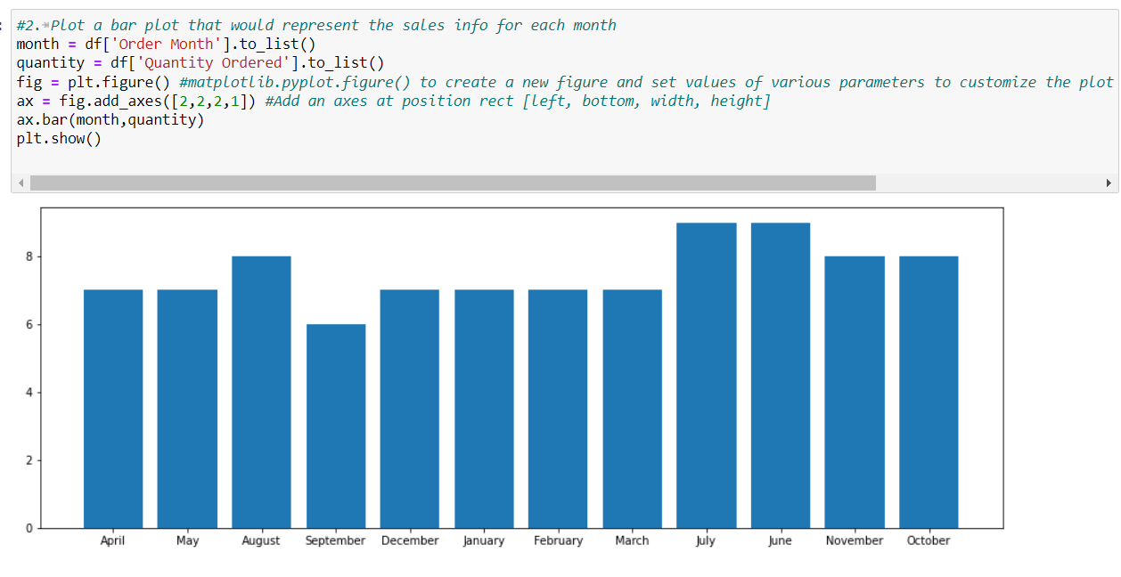

1. *Which state has ordered the least and which the highest?*

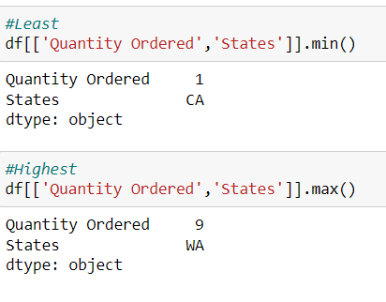

1. *At what time of the day the highest amount of money is spent on sales?*

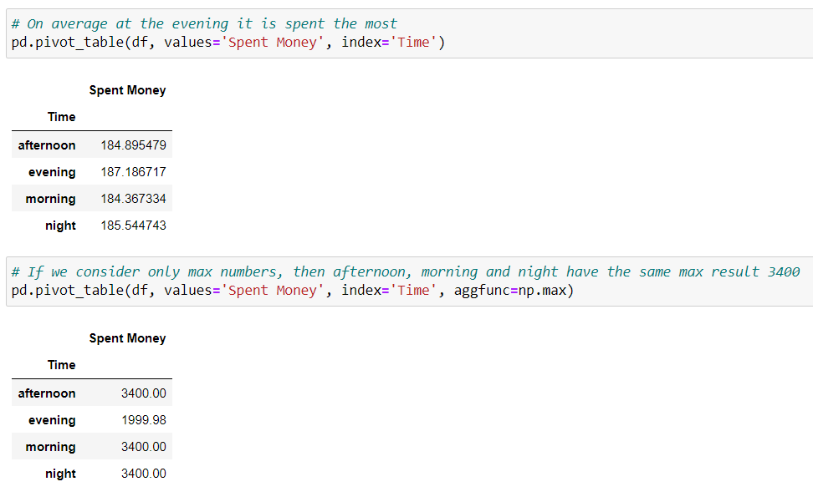

1. Time to plot.

*Tasks:*

1. *Plot the bar chart that represents different items bought on the x-axis and how many of them were sold on the y-axis.*

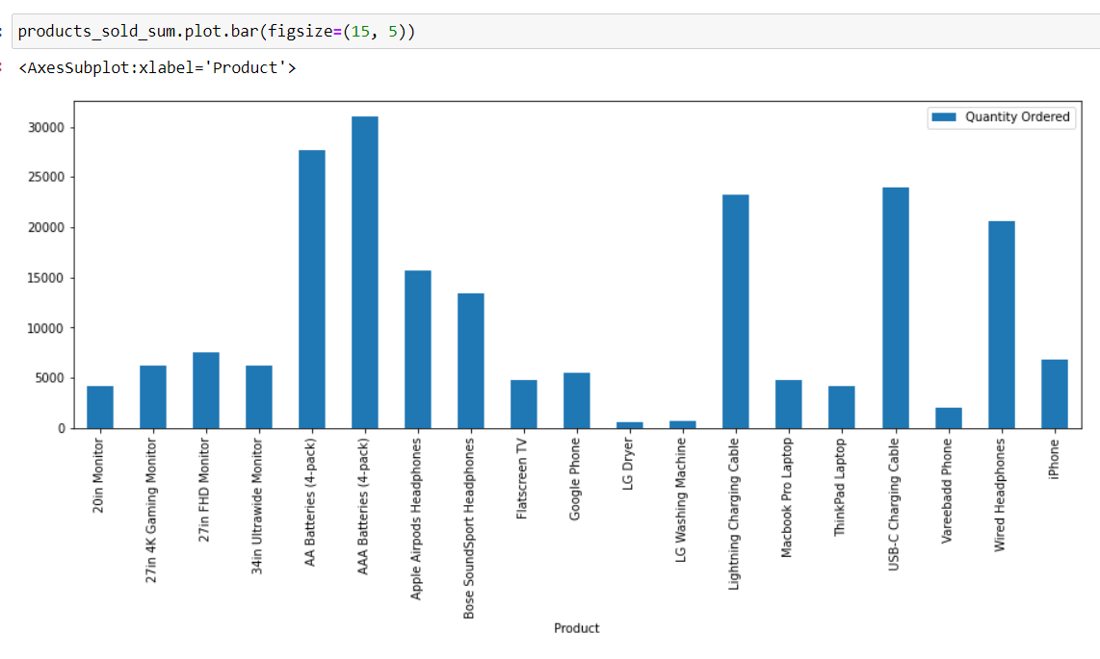

1. *Plot a pie char that represents each month as the piece of the pie, showing how much sales are generally done.*

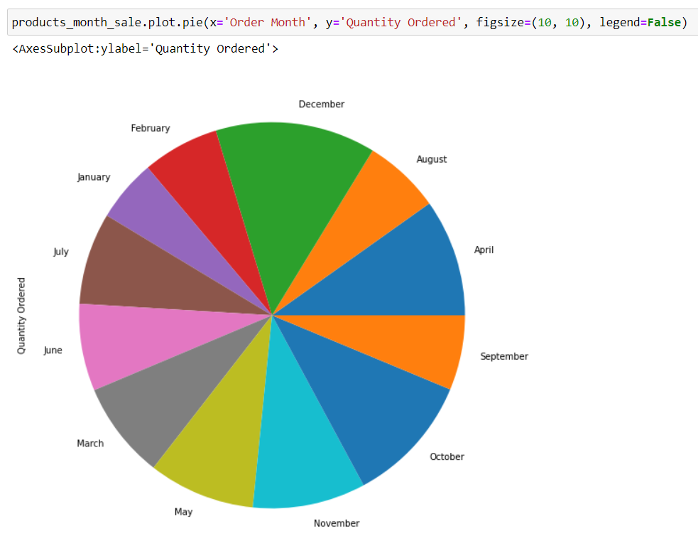

1. More info with the plots.

*Tasks:*

1. *Prove the answer to the question four in the third part (Get the useful information).*

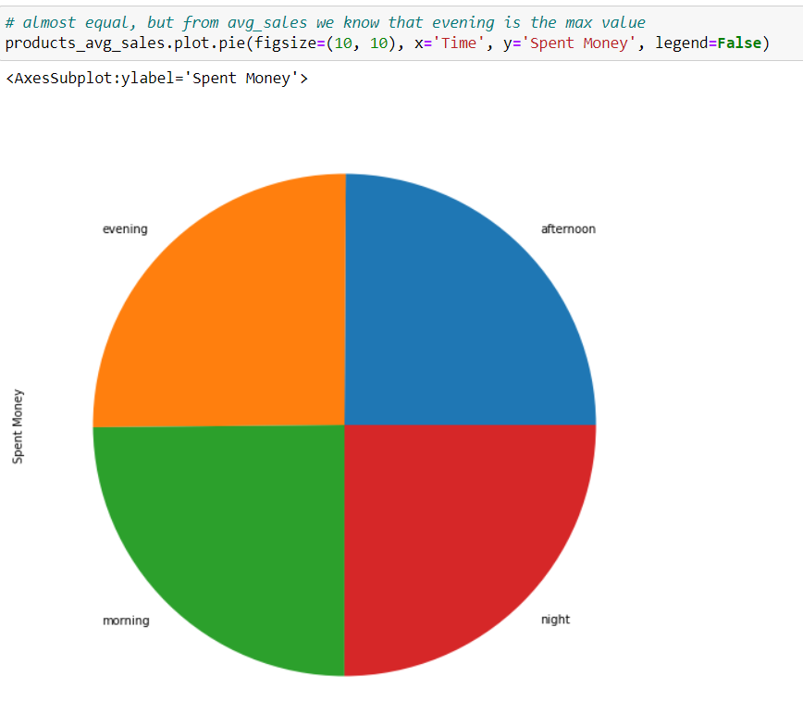

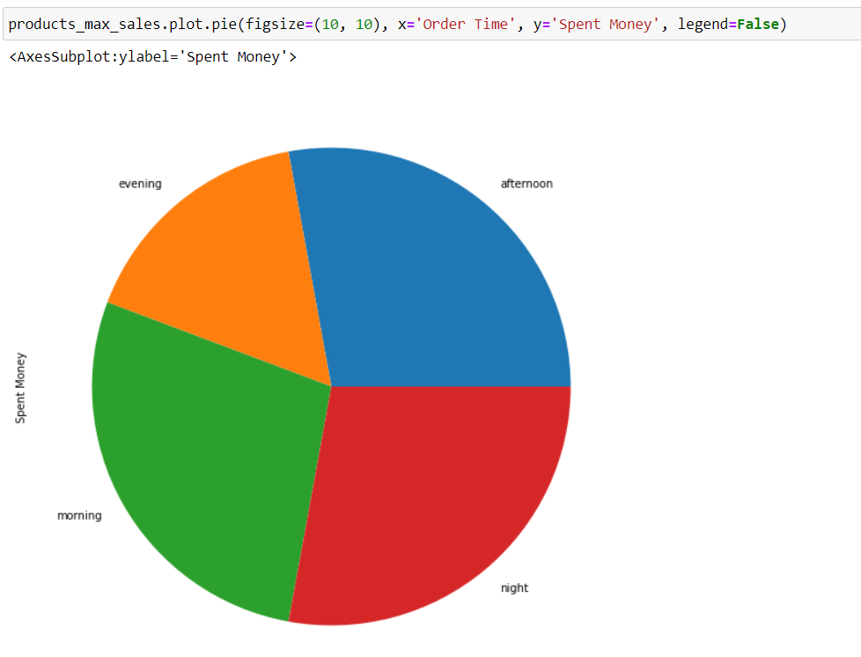

1. *Referring to the question 1 of the 4th part (Time to plot), plot that bar chart again but with adding a line chart inside onto it representing the price of each item.*

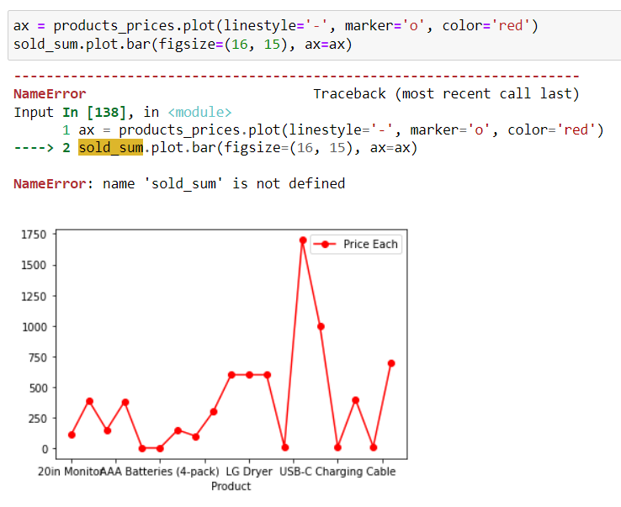

Score: __/5