SECTION 1:

*(Section 1 - Questions 1-10)*

**Questions 1 and 2**:  
*Complete the notes below.*  
Write **NO MORE THAN THREE WORDS** for each answer.

MIC HOUSE AGENCY — REPAIRS

Address:    Apartment 2, **(1)** ..............................................., Newton.  
Length of lease: one year.  
Date moved in: **(2)** ................................................................

**Questions 3-9:**  
*Complete the table below.*

Write -  
**A**  if the repair will be done immediately.  
**B**  if the repair will be done during the following week.  
**C**  if the repair will be done in two or more weeks.

|  |  |  |
| --- | --- | --- |
| **Item** | **Problem** | **When to be done** |
| washing machine | leaking |  |
| cooker | **(3)** .................................... | **(4)** ................................... |
| windows | **(5)** ................................... | B |
| **(6)** ................................. | flickers | **(7)** .................................... |
| **(8)** ................................. | torn | **(9)** .................................... |

**Question 10:**  
Write **NO MORE THAN THREE WORDS or A NUMBER** for each answer.

Workman to call between **(10)**............................. and .................................

SECTION 2:

*(Section 2 - Question 11-20)*

**Questions 11 and 12:**  
*Circle the correct letters****A-C****.*

**11.** At Rainforest Lodge there aren't any...  
   A.  telephones or TVs.  
   B.  newspapers or TVs.  
   C.  telephones or newspapers.

**12.** The guests are told to...  
   A.  carry their luggage to the cabin.  
   B.  go straight to the restaurant.  
   C.  wait an hour for dinner.

**Questions 13-15:**  
*Complete the table below.*  
Write **NO MORE THAN THREE WORDS** for each answer.

|  |  |
| --- | --- |
| **TOUR NAME** | **DETAILS** |
| Orchid and Fungi | walking tour |
| Four-Wheel-Drive | tour to the **(13)** …….………. |
| Fishing | to catch lunch |
| Crocodile Cruise | departs at **(14)** ……………….. daily |
| **(15)** …………………. | departs at sundown |

**Questions 16-20:**  
Write **NO MORE THAN THREE WORDS** for each answer.

What **THREE** items of clothing does the speaker recommend for the rainforest?

**16.**  .............................................................................

**17.**  .............................................................................

**18.**  .............................................................................

Which **TWO** things in the rainforest does the speaker give a warning about?

**19.**  .............................................................................

**20.**  .............................................................................

SECTION 3:

*(Section 3 - Questions 21-30)*

**Questions 21-25:**

*Circle the correct letters****A-C****.*

**21.** These sessions with a counsellor are...  
   A. compulsory for all students.  
   B. available to any students.  
   C. for science students only.

**22.** The counsellor says that new students have to...  
   A. spend more time on the college premises.  
   B. get used to working independently.  
   C. work harder than they did at school.

**23.** John complains that the resource centre...  
   A. has limited opening hours.  
   B. has too few resources.  
   C. gets too crowded.

**24.** The counsellor suggests to John that...  
   A. most other students can cope.  
   B. he needs to study all the time.  
   C. he should be able to fit in some leisure activities.

**25.**Before being able to help John the counsellor needs to...  
   A. talk with some of his lecturers.  
   B. consult his tutor.  
   C. get more information from him.

**Questions 26-30:**

*Complete the notes below.*

Write **NO MORE THAN THREE WORDS** for each answer.

**WRITING**

• Pay careful attention to the question

• Leave time to **(26)** ............................................

**LISTENING**

• Try to **(27)** ............................................ lectures

• Check notes with **(28)** ............................................

**READING**

• Choose topics of **(29)** ............................................

• Buy a good **(30)** .............................................

Section 4:

*(Section 4 - Question 31-40)*

**Questions 31-35**  
*Circle the correct letters****A-C****.*

**31.** John was first interested in the subject because of something...  
   A.  he had witnessed.  
   B.  he had read about.  
   C.  he had experienced.

**32.** The main research method was...  
   A.  interviews.  
   B. questionnaires.  
   C. observation.

**33.** Which pie chart shows the proportion of men and women respondents?

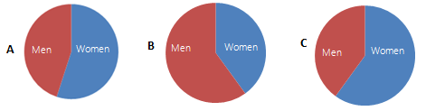

**34.** How many respondents were there?  
   A.  50-100  
   B. 100-150  
   C. 150-200

**35.** The most common type of road rage incident involved...  
   A. damage to property.  
   B. personal violence.  
   C. verbal abuse.

**Questions 36-40:**  
Which group gave the following advice?  
  
Tick Column **A** if it was mainly women.  
Tick Column **B** if it was mainly men.  
Tick Column **C** if it was both men and women.

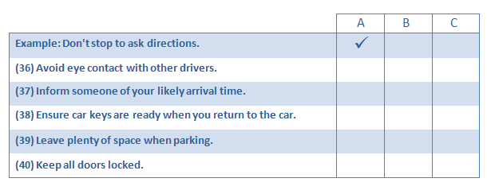

### Section 1:

(Section 1- Questions 1-10)

**Questions 1-10:**  
Complete the notes below.  
Write***NO MORE THAN THREE WORDS AND/OR A NUMBER*** for each answer.

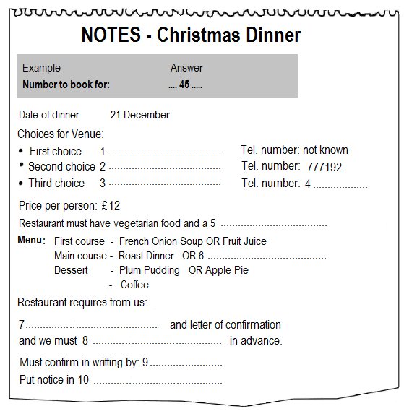

### Section 2:

(Section 2 - Question 11-20)

**Questions 11-13:**  
Complete the table below.  
Write ***NO MORE THAN THREE WORDS OR A NUMBER*** for each answer.

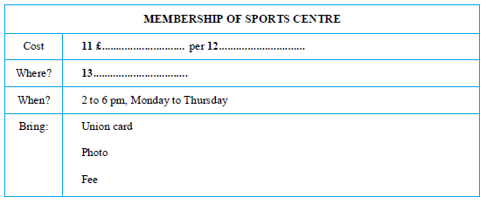

**Questions 14-16**:  
Complete the table below.  
Write ***NO MORE THAN THREE WORDS*** for each answer.

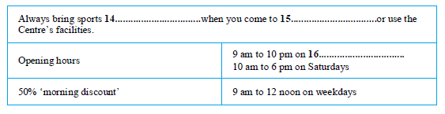

**Questions 17-20**:  
Look at the map of the Sports Complex below.  
Label the buildings on the map of the Sports Complex.

Choose your answers from the below list and write them against Questions **17-20**.

**Arts Studio  
Football Pitch  
Tennis Courts  
Dance Studio  
Fitness Room  
Reception  
Squash Courts**

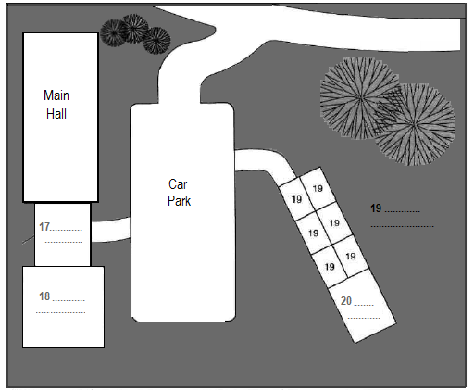

### Section 3:

(Section 3 - Questions 21-31)

**Questions 21-30:**

Complete the form below.  
Write***NO MORE THAN THREE WORDS AND/OR NUMBER*** for each answer.

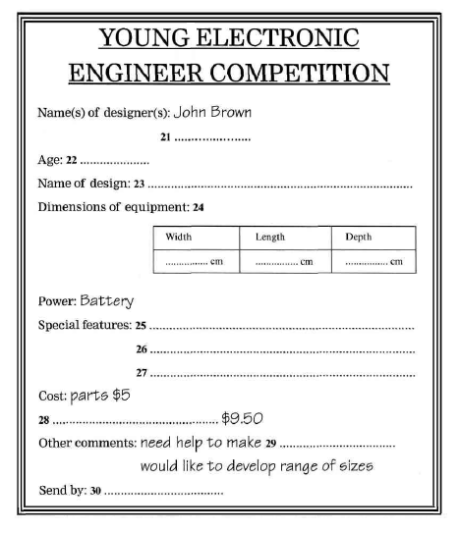

### Section 4:

(Section 4 - Questions 31-40)

**Questions 31-33:**  
Complete the table below.

Write***NO MORE THAN TWO WORDS*** for each answer.

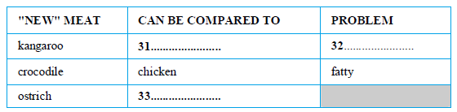

**Questions 34-36:**  
Complete the table below.  
Write ***NO MORE THAN THREE WORDS*** for each answer.

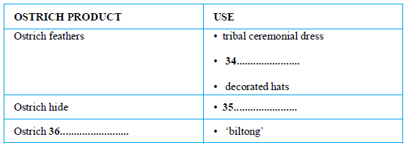

**Questions 37-40**:  
Choose the correct letters ***A-C.***

**37.** Ostrich meat  
   A has more protein than beef.  
   B tastes nearly as good as beef.  
   C is very filling.

**38.** One problem with ostrich fanning in Britain is  
   A the climate.  
   B the cost of transporting birds.  
   C the price of ostrich eggs.

**39.** Ostrich chicks reared on farms  
   A must be kept in incubators until mature.  
   B are very independent.  
   C need looking after carefully.

**40.** The speaker suggests ostrich farms are profitable because  
   A little initial outlay is required.  
   B farmed birds are very productive.  
   C there is a good market for the meat

### Section 1:

**(Section 1 - Questions 1-10)**

Questions 1 and 2

Complete the form below:  
Write ***NO MORE THAN THREE WORDS AND/OR A NUMBER*** for each answer.

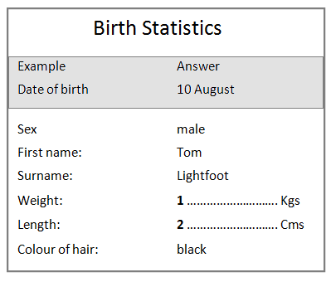

Questions 3-5  
Label the map.  
Choose your answers from the list below. Write the appropriate letters **A-E** on the map.

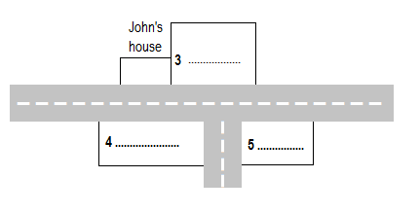

**A    State Bank  
B    St George’s Hospital  
C    Garage  
D    Library  
E    University**

Questions 6-10  
Write ***NO MORE THAN THREE WORDS OR A NUMBER*** for each answer.

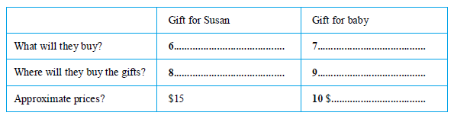

### Section 2:

**(Section 2 - Questions 11-20)**

Complete the table below.  
Write***NO MORE THAN THREE WORDS*** for each answer.

For the recommendation column, write  
**A**You**must**buy this.  
**B   Maybe**you should buy this.  
**C**You**should never**buy this.

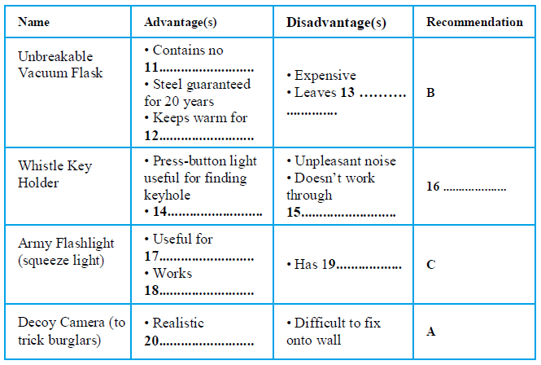

### 

### Section 3:

**(Section 3 - Questions 21-30)**

Questions 21-23  
Choose the correct letters ***A-C***.

**21.**Amina’s project is about a local  
A  school.  
B  hospital.  
C  factory.

**22.** Dr Bryson particularly liked  
A  the introduction.  
B  the first chapter.  
C  the middle section.

**23.** Amina was surprised because she  
A  thought it was bad.  
B  wrote it quickly.  
C  found it difficult to do.

Questions 24-26  
What suggestions does Dr Bryson make? Complete the table as follows.

Write **A** if he says **KEEP UNCHANGED**  
Write **B** if he says **REWRITE**  
Write **C** if he says **REMOVE COMPLETELY**



Information on housing **24** ...............................  
Interview data **25** ..................................  
Chronology **26** ................................

Questions 27-30  
Complete the notes below.  
Write ***NO MORE THAN THREE WORDS AND/OR A NUMBER*** for each answer.

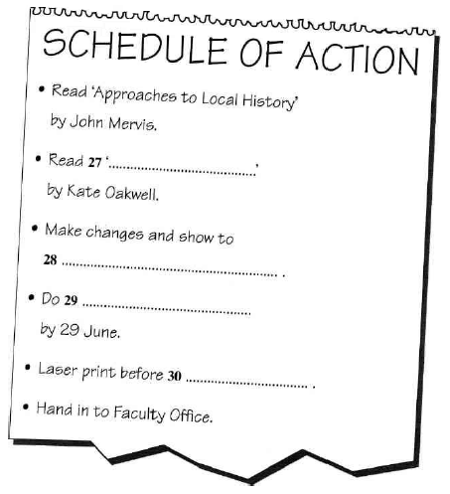

### Section 4:

**(Section 4 - Questions 31-40)**

Questions 31-34  
Write ***NUMBERS AND/OR NO MORE THAN FOUR WORDS*** for each answer.

**31.** Between what times is the road traffic lightest?  
.....................................................................................

**32.** Who will notice the noise most?  
.....................................................................................

**33.** Which day of the week has the least traffic?  
.....................................................................................

**34.** What will be the extra cost of modifying houses?  
.....................................................................................

Question 35  
Choose the correct letter ***A-D***.

The noise levels at the site can reach  
   A  45 decibels.  
   B  55 decibels.  
   C  67 decibels.  
   D  70 decibels.

Questions 36-38  
Complete the list showing where devices used in reducing noise could be fitted in the houses.

**Write -**  
**W**   for walls  
**D**   for doors  
**C**   for ceilings

Example                     Answer  
acoustic seals            **D**  
  
**36.** double thickness plaster board  ............................................  
**37.** mechanical ventilation  ...........................................................  
**38.** air conditioning ........................................................................

Questions 39 and 40  
Choose the correct letters ***A-D***.

**39.** Which is the correct construction for acoustic double glazing?

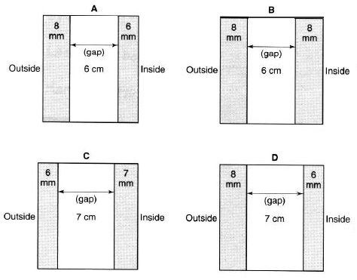

**40.** What is the best layout for the houses?

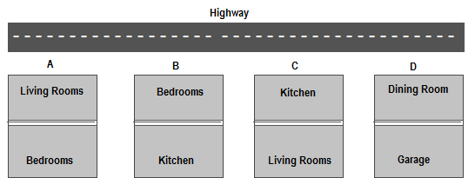

Конец формы