|  |  |
| --- | --- |
| Module code and name: | 6COSC014C-n - Internet of Things |
| Assessment: | Portfolio |
| Student ID: | 00011883 |
| Submission deadline: | 01.12.2023 |
| Wordcount | 2102 |
| Results date and type of feedback |  |
| Result (Pass or Fail) |  |
| **Feedback** | |
|  | |

Table of Contents

Introduction 3

Case Overview 3

Proposed Solution 4

Key Components of the Solution 5

Effectiveness of Implementation 5

Economizing Resources 7

Components Used in the IoT Smart Watering System 7

Communication Medium and Protocol 8

Power Calculations 9

Technology Used in IoT Smart Watering System Implementation 10

Possible Technologies 10

Selected Technologies 10

Demonstration of Results 11

Reflection 12

Extent 13

Future Work and Improvement Strategies 13

Personal Reflection 14

Future Plans 14

Appendixes 14

References 15

# Introduction

In recent years, the integration of Internet of Things (IoT) technologies has witnessed a profound impact on various sectors, presenting innovative solutions to address longstanding challenges. This report focuses on the implementation of an IoT-driven smart watering system, specifically designed for local flower markets in Uzbekistan. The endeavor aims to enhance the overall efficiency of flower cultivation by incorporating advanced sensors and automation technology.

## Case Overview

***Organization Description:***

The targeted organization encompasses local flower markets within Uzbekistan, catering to the diverse needs of floral enthusiasts and cultivators. These markets play a pivotal role in the floral industry, serving as hubs for the exchange and distribution of a wide array of flowers. Ranging from small-scale vendors to larger flower distributors, the organizational landscape reflects a dynamic mix of activities and participants.

***Organizational Size and Activities:***

The organization operates within the realm of floral trade, engaging in activities such as cultivation, distribution, and retail. The size of these entities varies, ranging from small family-owned stalls to larger commercial enterprises. The diversity in size and scale underscores the need for tailored solutions that can accommodate the unique requirements of each business within the floral ecosystem.

***Identified Problems and Needs:***

Through careful analysis of the current operational landscape, several challenges have been identified. Among these challenges are the limitations in the existing watering and irrigation processes, leading to inconsistent care for flowers (Cook and Papendick, 1972). The absence of real-time monitoring exacerbates the issue, as fluctuations in environmental conditions can adversely affect the quality and longevity of the flowers. These challenges necessitate a technological intervention to streamline the watering processes and ensure optimal conditions for flower cultivation (Brazel et al., 2023).

# Proposed Solution

The identified problems within the flower market ecosystem, including overwatering, underwatering, water conservation, unqualified gardening practices, lack of remote monitoring, weather adaptability, and the cost of energy, underscore the need for a comprehensive and efficient solution. The proposed solution involves the implementation of an automated water service system, integrated with a web application, step motor control, and advanced sensors. This holistic approach aims to address the identified issues and usher in a new era of precision and efficiency in flower cultivation.

## Key Components of the Solution

1. Web Application Interface: The system will be accessible through a user-friendly web application, providing stakeholders with remote control and monitoring capabilities. This ensures that flower market operators can manage the watering system from any location, facilitating real-time adjustments based on changing environmental conditions.

2. Step Motor Control: A step motor will be employed to regulate the flow of water, enabling precise control over watering processes. This eliminates the risks associated with overwatering or underwatering, as the system can be calibrated to deliver the exact amount of water required for optimal plant growth.

3. Sensor Technology: Integrated sensors will monitor surrounding conditions, including soil moisture, temperature, and humidity. These sensors will serve as the intelligence behind the watering system, dynamically adjusting watering schedules based on real-time data. Additionally, the system will provide early detection of issues, allowing for prompt intervention and preventing potential damage to the flowers.

## Effectiveness of Implementation

The proposed solution ensures a high level of effectiveness by addressing multiple facets of the identified problems.

***Water Conservation:***

By leveraging sensor data and precise control mechanisms, the system minimizes water wastage, only delivering water when necessary. This not only contributes to environmental sustainability but also significantly reduces the cost associated with excessive water consumption (Benyezza, Bouhedda and Rebouh, 2021).

***Energy Efficiency:***

The automated system, with its step motor control and sensor technology, optimizes energy usage. The precision in watering processes eliminates unnecessary energy expenditure, contributing to a more sustainable and cost-effective solution (Benyezza, Bouhedda and Rebouh, 2021).

***Human Factor Elimination:***

The system mitigates the risk associated with unqualified gardeners by automating the watering process. This ensures consistent and expert-level care for the flowers, regardless of the gardener's skill level.

***Remote Monitoring and Early Issue Identification:***

The web application interface allows for remote monitoring, providing flower market operators with real-time insights into environmental conditions and system performance. Early detection of issues enables proactive measures, preventing potential damage and optimizing flower quality (Salama et al., 2022).

***Data Analytics and Research Opportunities:***

The data collected by the system can be utilized for analytics, offering valuable insights into the optimal conditions for flower cultivation (Salama et al., 2022). This data-driven approach opens avenues for research and continuous improvement in flower market practices.

## Economizing Resources

The proposed solution optimizes resource utilization by requiring minimal ongoing resources. Spare parts and skilled workers involved in the initial setup and occasional maintenance constitute the primary resource requirements. For coursework purposes, available resources will be utilized, showcasing a practical and resourceful approach within the constraints of the given budget.

# Components Used in the IoT Smart Watering System

**Step Motor:**

Controls the flow of water by turning on and off the watering system. Selected for its precise control over water flow, allowing for accurate and controlled watering of plants.

**Power Supply (Laptop):**

Provides the necessary power for the entire system. Utilizing a laptop power supply ensures a stable and reliable source of power, readily available for most users.

**Sensors:**

*Water Sensor:* Measures the water level in the soil. *Capacitive Soil Moisture Sensor:* Determines the soil moisture content. Measures temperature and humidity in the environment. Combined data from these sensors provides comprehensive information about the surrounding conditions necessary for intelligent watering decisions.

**ESP8266 Module:**

Enables wireless communication and data exchange. Chosen for its compact size and Wi-Fi capabilities, allowing seamless integration into the IoT ecosystem. Provides the ability to send and receive data to and from the web application.

**Buzzer:**

Produces sound notifications for watering system activities. Alerts users to the system's actions, enhancing user awareness and facilitating quick response if needed.

**LED:**

Indicates the operational status of the system. Offers a visual cue to users, reassuring them that the system is actively monitoring and controlling the watering processes.

**Arduino Uno:**

Supplies additional analog pins for connecting sensors. Expands the analog input capacity of the ESP8266 module, allowing for the connection of multiple sensors without sacrificing precision in data collection.

*Wires, Resistors and other minor things was also utilized for making connections between modules.*

## Communication Medium and Protocol

The communication medium chosen for this project is Wi-Fi, facilitated by the NodeMCU ESP8266 module. Wi-Fi offers a reliable and widely accessible means of data transmission, making it suitable for remote monitoring and control. The HTTP protocol is utilized for data exchange between the web application and the IoT device, ensuring compatibility and ease of integration. Serial Communication applied for data and instructions exchange between Arduino and NodeMCU (ESP8266) to handle applied sensors and make proper calculations.

## Power Calculations

The following formula for Power will be used next: P = V * I, where V = Voltage, I = Current

**Step Motor:**

Voltage: V = 12V

Current: I = 0.5A

Power: P = V * I = 12V * 0.5A = 6W

**ESP8266 Module:**

V = 3.3V

I = 0.2A

P = 3.3V * 0.2A = 0.66W

**LED:**

V = 2V

I = 0.02A

P = 2V * 0.02A = 0.04W

*Approximate values indicated in the calculations.*

# Technology Used in IoT Smart Watering System Implementation

## Possible Technologies

**Database Options:** MySQL, MongoDB, SQLite

Various database options were available, each with its strengths and weaknesses. MySQL offers a structured relational database, MongoDB provides flexibility with a NoSQL approach, and SQLite is a lightweight embedded database (OpenGenus IQ, 2023).

**Web Platform:** *Possible:* React, Angular, Vue.js

Multiple frameworks for building web applications are available. React, Angular, and Vue.js are popular choices, each with its own advantages in terms of performance, scalability, and ease of development (Grosu, 2023).

**Communication Protocol:** *Possible:* MQTT, CoAP, HTTP

Different communication protocols can be employed for IoT projects. MQTT is lightweight and ideal for low-bandwidth scenarios, CoAP is designed for resource-constrained devices, and HTTP is widely used for web-based communication (Sharma, 2023).

## Selected Technologies

***Firebase Realtime Database.*** Firebase Realtime Database was chosen for its real-time synchronization and ease of use. It seamlessly integrates with web and mobile applications, making it an efficient choice for storing dynamic data like water system status, sensor values, and usage statistics. The NoSQL structure aligns well with the dynamic nature of IoT data.

***Web Platform (HTML, CSS, JS).*** A simple web platform using HTML, CSS, and JS was selected for the user interface. Given the nature of the project, a lightweight and straightforward implementation was preferred for faster development and deployment. This choice also facilitates compatibility with a wide range of devices.

***Communication Protocol (HTTP).*** HTTP was chosen for communication between the IoT device and the Firebase Realtime Database. This protocol is well-supported, widely adopted, and easily handled by web platforms. The simplicity and compatibility of HTTP align with the project's goal of creating a user-friendly and accessible system.

## Demonstration of Results

***Firebase Realtime Database.*** The Firebase Realtime Database successfully stores and updates data in real-time, providing a seamless experience for monitoring and control. Water system status, sensor values, and watering usage statistics are stored and retrieved with low latency, ensuring accurate and up-to-date information.

***Web Platform (HTML, CSS, JS).*** The web platform provides an intuitive user interface for monitoring and controlling the smart watering system. HTML, CSS, and JS collectively contribute to a responsive and user-friendly website, accessible from various devices.

***Communication (HTTP).*** HTTP communication ensures reliable data exchange between the IoT device and the Firebase Realtime Database. The use of HTTP facilitates seamless integration, allowing the web platform to interact with the database and update information in real-time.

# Reflection

***Limited Scalability.*** The current prototype is designed for small to medium-sized flower markets. Scaling up for larger agricultural settings may pose challenges, requiring adjustments in sensor density, data handling, and overall system robustness.

***Dependency on Wi-Fi.*** The system's reliance on Wi-Fi connectivity may pose limitations in remote areas or locations with inconsistent network coverage. Exploring alternative communication methods, such as cellular networks or mesh networks, could enhance system reliability.

***Power Dependency.*** The system's power source from a laptop may not be practical for long-term deployment in outdoor environments. Exploring alternative power solutions, such as solar or battery-powered options, can address this limitation and increase the system's autonomy.

***Sensitivity to Environmental Conditions.*** Extreme weather conditions, such as heavy rain or extreme heat, might impact the sensors' accuracy. The system could be further enhanced with weather-resistant enclosures and additional sensors for environmental monitoring.

***Web Application Simplicity.*** While the simplicity of the web application aids in user-friendliness, it may lack advanced features. Future iterations could include data visualization, historical trends, and user customization for a more comprehensive user experience.

## Extent

The prototype has successfully demonstrated the core functionalities of an IoT-driven smart watering system, achieving its primary goal of automating watering processes based on real-time data. The integration of sensors, the step motor, and the Firebase Realtime Database has resulted in a functional system that effectively monitors and controls watering activities.

## Future Work and Improvement Strategies

***Enhanced Sensor Array:***Integrate additional sensors, such as light sensors and pH sensors, to provide a more comprehensive understanding of the plant environment. This would enable more precise and nuanced control over watering conditions.

***Machine Learning Integration:*** Implement machine learning algorithms to analyze historical data and optimize watering schedules based on learned patterns. This adaptive approach can further improve the system's efficiency over time.

***Mobile Application Development:*** Expand the user interface by developing a dedicated mobile application. This would enhance accessibility and provide on-the-go monitoring and control capabilities for flower market operators.

***Localization and Language Support:*** Incorporate localization features and support for multiple languages in the web or mobile application to cater to diverse user preferences and market locations.

***Community Engagement:*** Establish a community engagement platform to gather user feedback and insights. This iterative process will enable continuous improvement and refinement of the system based on real-world user experiences.

## Personal Reflection

Building the smart watering system has been a valuable learning experience, providing fundamental knowledge in electronics, sensor integration, and system development. The hands-on approach has not only enhanced technical skills but has also cultivated a deeper understanding of the challenges and opportunities in IoT projects.

## Future Plans

With the goal of bringing the project to life using real resources, the next steps involve securing funding for materials, conducting field tests, and collaborating with local flower markets in Uzbekistan for real-world implementation. The intention is to refine and tailor the system to meet specific market needs, ultimately contributing to sustainable and efficient flower cultivation practices. The journey of transforming a prototype into a practical solution is an exciting prospect for future endeavors in the field of IoT and agriculture.

# Appendixes

All resources including Fritzing sketch, Arduino and NodeMCU (ESP8266) code, and Web Application source codes and files included in below indicated GitHub repository.

GitHub Repository: <https://github.com/khusanov-m/iot-web-app>

Deployed web application: <https://iot-web-app.vercel.app/>

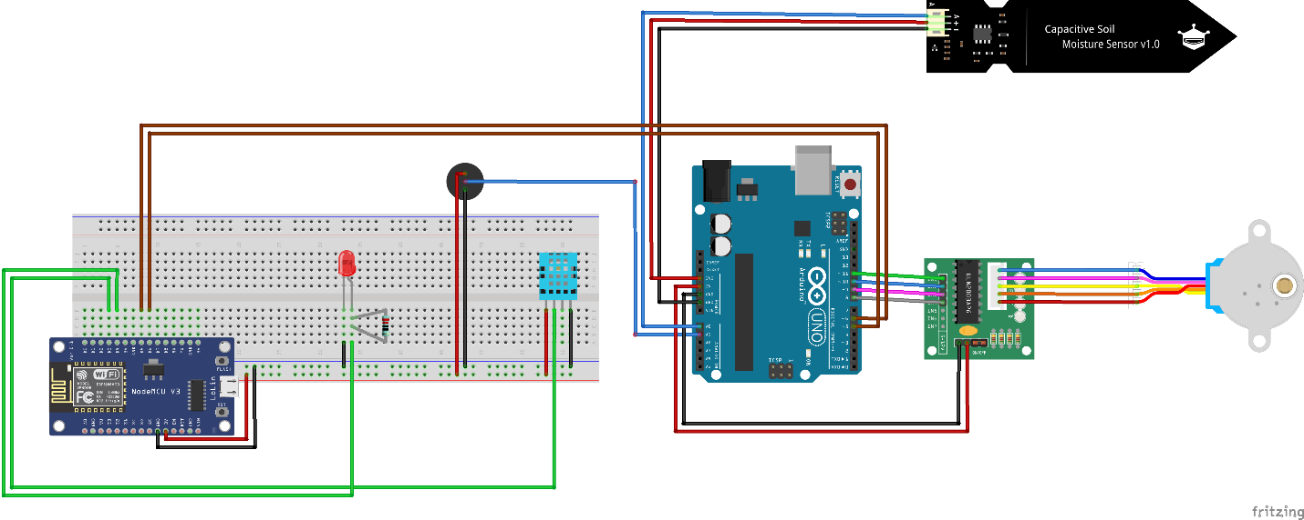

Project sketch [File with Fritzing sketch included in the archive (with .fzz extension)].

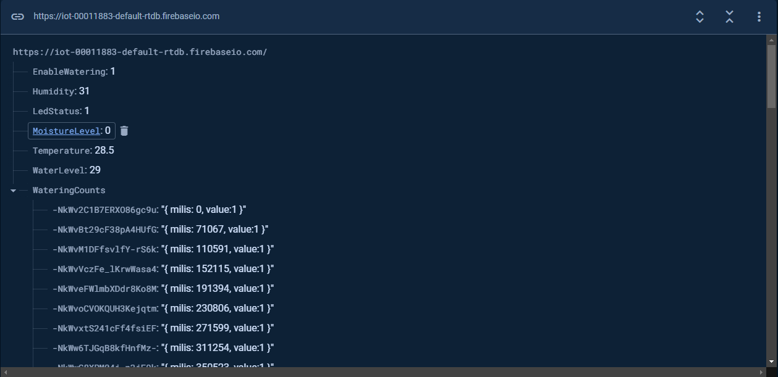

Real time firebase database data in testing mode

# References

Benyezza, H., Bouhedda, M. and Rebouh, S. (2021). Zoning irrigation smart system based on fuzzy control technology and IoT for water and energy saving. *Journal of Cleaner Production*, 302, 127001. Available from https://doi.org/10.1016/j.jclepro.2021.127001.

Brazel, S.R. et al. (2023). Overwatering may be as detrimental as underwatering in container-grown kale (Brassica oleracea L. acephala). *Scientia Horticulturae*, 316, 111961. Available from https://doi.org/10.1016/j.scienta.2023.111961.

Cook, R.J. and Papendick, R.I. (1972). Influence of Water Potential of Soils and Plants on Root Disease. *Annual Review of Phytopathology*, 10 (1), 349–374. Available from https://doi.org/10.1146/annurev.py.10.090172.002025.

Firebase. (2023a). Чтение и запись данных в Интернете | Firebase Realtime Database. *Firebase*. Available from https://firebase.google.com/docs/database/web/read-and-write?hl=ru#web-modular-api [Accessed 1 December 2023].

Firebase. (2023b). Установка и усиление; Настройка в JavaScript | Firebase Realtime Database. *Firebase*. Available from https://firebase.google.com/docs/database/web/start?hl=ru#web-namespaced-api [Accessed 1 December 2023].

freeCodeCamp. (2023). Arduino Course for Everybody. *www.youtube.com*. Available from https://www.youtube.com/watch?v=DPqiIzK97K0 [Accessed 1 December 2023].

Fritzing. (2023). Fritzing. *fritzing.org*. Available from https://fritzing.org/ [Accessed 1 December 2023].

Grosu, A. (2023). JavaScript Frameworks Face-off: React vs. Angular vs. Vue.js. *Medium*. Available from https://blog.stackademic.com/javascript-frameworks-face-off-react-vs-angular-vs-vue-js-6a6e00cf87b2 [Accessed 1 December 2023].

Ham, S.-W. and Jeong, J.-W. (2016). Impact of aisle containment on energy performance of a data center when using an integrated water-side economizer. *Applied Thermal Engineering*, 105, 372–384. Available from https://doi.org/10.1016/j.applthermaleng.2015.05.069 [Accessed 1 December 2023].

OpenGenus IQ. (2023). SQL vs SQLite vs NoSQL vs MySQL: A Comprehensive Comparison. *OpenGenus IQ: Computing Expertise & Legacy*. Available from https://iq.opengenus.org/sql-sqlite-nosql-vs-mysql/ [Accessed 1 December 2023].

Qian, J. et al. (2021). Belowground bud bank and its relationship with aboveground vegetation under watering and nitrogen addition in temperate semiarid steppe. *Ecological Indicators*, 125, 107520–107520. Available from https://doi.org/10.1016/j.ecolind.2021.107520 [Accessed 1 December 2023].

Радиолюбитель TV. (2016). ПОДКЛЮЧАЕМ ШАГОВЫЙ ДВИГАТЕЛЬ К ARDUINO [Уроки Ардуино #14]. *www.youtube.com*. Available from https://www.youtube.com/watch?v=jJQwmnyfw5k&t=150s [Accessed 28 November 2023].

Robotica DIY. (2020). Send Data From Arduino to NodeMCU and NodeMCU to Arduino Via Serial Communication. *www.youtube.com*. Available from https://www.youtube.com/watch?v=EfzZOiNBQmI&t=3s [Accessed 1 December 2023].

Salama, D.S. et al. (2022). AUTOMATED SYSTEMS AS A FACTOR AFFECTING ON FLOWERS PLANT HARVESTING. *Pnrjournal*, 13 (3), 1906–1917. Available from https://doi.org/10.47750/pnr.2022.13.s03.286.

Sharma, V. (2023). Selecting the Ideal IoT Protocol: MQTT vs CoAP vs HTTP. *Bytebeam*. Available from https://bytebeam.io/blog/choosing-the-right-iot-protocol-a-comprehensive-guide-on-mqtt-coap-and-http/ [Accessed 1 December 2023].

Win The cloud. (2020). Arduino Plant Watering System - Complete guide. *www.youtube.com*. Available from https://www.youtube.com/watch?v=JdvnfENodak [Accessed 16 November 2023].

Witri Ramadhani, Khairul Anshari and Prih Febtiningsih. (2023). The implementation of Internet of Things-based automatic plant watering equipment at sun flower ornamental plant shop. *Nucleation and Atmospheric Aerosols*. Available from https://doi.org/10.1063/5.0130610 [Accessed 29 November 2023].