**“****Advance Street Light System using IoT”**



Submitted in partial fulfillment of the requirement of the Degree of

(Bachelor of Engineering)

By

# Khusboo Patel Lalit Makar Vrushali Patil

Under the guidance of

## Prof. Priti Rumao

### (Computer Engineering) AET’s

**Atharva College of Engineering**

#### April 2020

**Declaration**

I declare that this written submission represents my ideas in my own words and where others' ideas or words have been included, I have adequately cited and referenced the original sources. I also declare that I have adhered to all principles of academic honesty and integrity and have not misrepresented or fabricated or falsified any idea/data/fact/source in my submission. I understand that any violation of the above will be cause for disciplinary action by the Institute and can also evoke penal action from the sources which have thus not been properly cited or from whom proper permission has not been taken when needed.

Khusboo Patel

Lalit Makar Vrushali Patil

#### Date:

**Project Report Approval for B.E.**

This project report entitled **“Advance Street Light System using IoT*”*** by ***Khusboo Patel, Lalit Makar, Vrushali Patil*** is approved for the degree of ***Bachelor of Engineering in Computer Engineering.***

Internal Examiner

.----------------------------------------------

----------------------------------------------

External Examiner

.------------------------------------------

.------------------------------------------

Date: Place:

College Seal



# AET’S

**ATHARVA COLLEGE OF ENGINEERING**

CERTIFICATE

*This is to certify that* **Khusboo Patel Lalit Makar Vrushali Patil**

*Have satisfactorily completed the requirements of the B.E Project Report*

On

### “Advance Street Light System using IoT.”

*As prescribed by the* ***University of Mumbai*** *Under the guidance of*

Guide

#### Prof. Priti Rumao

**Prof. Suvarna Pansambal Dr S.P. Kallurkar Project Coordinator Head (Computer Engineering) Principal**

**(April 2020) College Seal Date:**

INDEX

TABLE OF CONTENTS v

LIST OF FIGURES viii

LIST OF TABLES… xi

ABSTRACT xii

Table of Contents

[Chapter 1 Introduction](https://docs.google.com/document/d/1aS3tPkCg3o02E5DL7p7PIzlfOOaxpV3QYvME9Qz9vqs/edit#heading%3Dh.2xcytpi) [1](https://docs.google.com/document/d/1aS3tPkCg3o02E5DL7p7PIzlfOOaxpV3QYvME9Qz9vqs/edit#heading%3Dh.2xcytpi)

* 1. Need …………………………………………………………………………………2
  2. Basic Concept… 3
  3. [Applicatio](https://docs.google.com/document/d/1aS3tPkCg3o02E5DL7p7PIzlfOOaxpV3QYvME9Qz9vqs/edit#heading%3Dh.2bn6wsx)ns… 3
  4. Market Potential and competitive advantage 4

[Chapter 2 Review of Liter](https://docs.google.com/document/d/1aS3tPkCg3o02E5DL7p7PIzlfOOaxpV3QYvME9Qz9vqs/edit#heading%3Dh.qsh70q)ature 5

[Chapter 3 Report on Present Investigatio](https://docs.google.com/document/d/1aS3tPkCg3o02E5DL7p7PIzlfOOaxpV3QYvME9Qz9vqs/edit#heading%3Dh.3as4poj)n… 9

Chapter 4 Aim & Objective 13

4.1 Aim… 13

[4.2 Objective](https://docs.google.com/document/d/1aS3tPkCg3o02E5DL7p7PIzlfOOaxpV3QYvME9Qz9vqs/edit#heading%3Dh.147n2zr) 13

[Chapter 5 Problem Statement](https://docs.google.com/document/d/1aS3tPkCg3o02E5DL7p7PIzlfOOaxpV3QYvME9Qz9vqs/edit#heading%3Dh.3o7alnk) 14

Chapter 6 Proposed System 15

Chapter 7 Requirement Analysis (SRS) 19

* 1. [Functional requirements](https://docs.google.com/document/d/1aS3tPkCg3o02E5DL7p7PIzlfOOaxpV3QYvME9Qz9vqs/edit#heading%3Dh.41mghml) 19
  2. [Non-Functional requirements](https://docs.google.com/document/d/1aS3tPkCg3o02E5DL7p7PIzlfOOaxpV3QYvME9Qz9vqs/edit#heading%3Dh.2grqrue) 20

[Chapter 8 Scope](https://docs.google.com/document/d/1aS3tPkCg3o02E5DL7p7PIzlfOOaxpV3QYvME9Qz9vqs/edit#heading%3Dh.vx1227) 22

* + 1. [Feasibility](https://docs.google.com/document/d/1aS3tPkCg3o02E5DL7p7PIzlfOOaxpV3QYvME9Qz9vqs/edit#heading%3Dh.3fwokq0) …………..22
    2. [Operational Feasibility](https://docs.google.com/document/d/1aS3tPkCg3o02E5DL7p7PIzlfOOaxpV3QYvME9Qz9vqs/edit#heading%3Dh.3fwokq0) 22
    3. [Technical Feasibility](https://docs.google.com/document/d/1aS3tPkCg3o02E5DL7p7PIzlfOOaxpV3QYvME9Qz9vqs/edit#heading%3Dh.3fwokq0) 23
    4. [Economical Feasibility](https://docs.google.com/document/d/1aS3tPkCg3o02E5DL7p7PIzlfOOaxpV3QYvME9Qz9vqs/edit#heading%3Dh.3fwokq0) 23

[Chapter 9 Methodology](https://docs.google.com/document/d/1aS3tPkCg3o02E5DL7p7PIzlfOOaxpV3QYvME9Qz9vqs/edit#heading%3Dh.1v1yuxt) 24

* 1. Sensors…….… 24
  2. Working.… 27

[Chapter 10 Design Detail](https://docs.google.com/document/d/1aS3tPkCg3o02E5DL7p7PIzlfOOaxpV3QYvME9Qz9vqs/edit#heading%3Dh.2u6wntf) 28

* 1. [Data Flow Diagram](https://docs.google.com/document/d/1aS3tPkCg3o02E5DL7p7PIzlfOOaxpV3QYvME9Qz9vqs/edit#heading%3Dh.19c6y18) 28
  2. [Activity Diagram](https://docs.google.com/document/d/1aS3tPkCg3o02E5DL7p7PIzlfOOaxpV3QYvME9Qz9vqs/edit#heading%3Dh.19c6y18) 29
  3. Entity-Relationship Diagram 30
  4. Use Case Diagram… 31
  5. State Transition Diagram… 32
  6. Class Diagram……………………………………………………………………..34

Chapter 11 Implementation Plan 33

* 1. Hardware Requirements… 33
  2. Software requirements… 33
  3. Gantt Chart 33

Chapter 12 Testing 43

* 1. Unit Testing… 43
  2. White Box Testing 44
  3. Black Box Testing… 44
  4. Test Results… 45

[Chapter 13 Result & Analysis](https://docs.google.com/document/d/1aS3tPkCg3o02E5DL7p7PIzlfOOaxpV3QYvME9Qz9vqs/edit#heading%3Dh.1egqt2p) 53

[Chapter 14 Advantages and Limitations](https://docs.google.com/document/d/1aS3tPkCg3o02E5DL7p7PIzlfOOaxpV3QYvME9Qz9vqs/edit#heading%3Dh.3ygebqi) 70

* 1. [Advantages](https://docs.google.com/document/d/1aS3tPkCg3o02E5DL7p7PIzlfOOaxpV3QYvME9Qz9vqs/edit#heading%3Dh.2dlolyb) 70
  2. [Limitations](https://docs.google.com/document/d/1aS3tPkCg3o02E5DL7p7PIzlfOOaxpV3QYvME9Qz9vqs/edit#heading%3Dh.sqyw64) 71

Chapter 15 Applications and Future Enhancements 72

15.1 Applications……………………………………………………………………….72

15.2 Future Enhancements……………………………………………………………..73

Chapter 16 Conclusion 73

Chapter 17 References 74

[Chapter 18 Appendix](https://docs.google.com/document/d/1aS3tPkCg3o02E5DL7p7PIzlfOOaxpV3QYvME9Qz9vqs/edit#heading%3Dh.1rvwp1q) 75

Chapter 19 Publication details for Research Paper 1 76

* 1. [Research](https://docs.google.com/document/d/1aS3tPkCg3o02E5DL7p7PIzlfOOaxpV3QYvME9Qz9vqs/edit#heading%3Dh.2dlolyb) Paper Details… 76
  2. Literature Review Paper Details… 77

### List of Figures

Figure 1 Block Diagram 10

Figure 2 LDR Symbol… 11

Figure 3 Light Intensity Vs Resistance… 12

Figure 4 Ultrasonic sensor waves emission for calculating length… 16

Figure 5 NodeMCU… 16

Figure 6 Flowchart of implementation… 17

Figure 7 DFD… 17

Figure 8 Activity Diagram 18

Figure 9 E-R Diagram… 24

Figure 10 Use Case Diagram… 27

Figure 11 State Transition Diagram… 28

Figure 12 Class Diagram… 29

Figure 13 Gantt Chart 1 30

Figure 14 Gantt Chart 1…………………………………………………………………………31

Figure 15 Gantt Chart 2… 32

Figure 16 Gantt Chart 2… 39

Figure 17 Gantt Chart 2… 40

Figure 18 Device Status Graphs… 41

Figure 19 Light Intensity Graph of Led 1… 42

Figure 20 Light Intensity Graph of Led 7 53

Figure 21 Light Intensity Graph of Led 5 54

Figure 22 Splash Screen… 54

Figure 23 Home Screen… 54

Figure 24 Led Status Screen… 54

Figure 25 Led Intensity Screen… 55

Figure 26 IFTTT notification of LEDs. 55

Figure 27 IFTTT notification if LED 55

**List of Tables**

Table 1 Comaprison of Wireless Technology… 41

Table 2 Cost Analysis 42

Table 3 Test Cases for Unit Testing… 46

Table 4 Test Cases for White Box Testing… 47

Table 5 Test Cases for Black Box Testing… 48

# ABSTRACT

The main objective of the system is to reduce energy consumption. This is achieved by minimizing the unwanted use of energy consumed by street lights. This project incorporates LED lights, ultrasonic sensors and Wi-Fi based microcontroller NodeMCU. It is an automated system which detects presence of sunlight and acts accordingly. When the ultrasonic sensor detects movement on the road during the night, the lights glow up to their maximum intensity. Moreover as the object moves forward the trailing lights will reduce to 25-30% of their intensity i.e they go in the power saving mode. Unlike the traditional system which turns OFF the lights completely. Also, this system uses built-in Wi-Fi module which notifies the authorities about faulty lights.

# Chapter 1

## Introduction

Illumination of streets is an important factor in modern cities that is used to assess the development of a nation. It is a major part of a city’s infrastructure. Inclusion of street lights facilitates the safety concerns of pedestrians, vehicles, stray animals, etc. during night.

Classification of street lights can be done on basis of lamps used such mercury vapour light, as incandescent light, metal halide light, low pressure sodium light, high pressure sodium light fluorescent light, compact fluorescent light, induction light and LED light.

LED system due to its behaviour and advantages is considered a promising solution to modern street lighting. Except that, the advantages of LED are likely to replace the traditional street lamps such as the incandescent lamp, fluorescent lamp and high-pressure sodium lamps in future. Therefore, this paper highlights the energy efficient street lighting design using LEDs through intelligent sensor interfaces like LDR and IR for controlling and managing.

Instead of generally used street lamps such as High-Pressure Sodium Lamps, etc. this proposed system utilizes the latest technology for the sources of light as LED Lamps. As LED Lamps offers several advantages over other traditional technologies like energy saving due to high current luminous efficiency, low maintenance cost, high colour rendering index, rapid start up speed, long working life it is preferred [1].

### Need

Power is a necessity. An important component of power consumption worldwide is street lights. Global trends in street lighting show that 18-38% of the total energy bill goes towards street lighting. Also the world is moving towards building smart cities which should have an efficient street light system which is eco-friendly and cost effective.

### Basic Concept

The main objective of the proposed system is to design a smart light system which reduces the power consumption, increases the life span of street lights and also incorporates the mechanism of detecting the faulty street lights. No need to keep the street lights on at the maximum intensity for the entire night, this method ensures that the intensity of lights will be dependent on the presence of pedestrians or vehicles. There by decreasing the overall power consumption, and also maintenance becomes much easier due to fault detection mechanism.

### Applications

* It can be used in some clocks, alarms, and other electronic devices that are dependent on sunlight.
* We can used it outside of house, corridors or industry area, which helps to save power.
* In sea off-shore side we can use it as a dangerous sign.
* Photo resistors have many uses, most of which involve detecting the presence of light.
* Street lights use photo resistors to detect whether it is day or night and turn the light on or off accordingly.
* Photo resistors are also used in digital cameras to detect how much light camera sees and adjust the picture quality accordingly.
* Smoke detection.
* Automatic lighting control.
* Burglar alarm systems.
* Camera (electronic shutter).

### Market Potential and competitive Advantage

With smart city projects gaining enormous traction, urban planners are seen envisaging how best to harness the potential of IoT in various applications. The main intention is to better city infrastructure. We can use it in Automation companies, Manufacturing companies, Research organization and consulting companies. It can also be used in bigger parking areas.

* Maintenance cost is much low compared to conventional street light.
* Risk of accidents is very low.
* It is environmental friendly, no harmful emissions.
* Longer life compared to conventional street lights.
* Power consumption is much lower.
* LDRs are sensitive, inexpensive and readily available devices. They have good power and voltage handling capabilities, similar to those of a conventional resistor.

# Chapter 2

## Review of literature

* **Title:** Movement Sensing Street Light [1]

**Authors:** Gurav, Hardik Rathod, Heta Shah, Nilesh Rathod

**Publication:** International Journal of Advanced Technology in Engineering and Science

**Year:** 2014

#### Details:

Their proposed system uses an LDR which signal the microcontroller which in turn willinstruct the LEDs to glow on presence of any object on the road. If it is day time and there is movement on the road then the LEDs will not glow but if it is night time then the LEDs will be in dimmed state and as soon as any movement or presence of any object is detected by the IR sensor it will turn on the LED that is the street lamp.

* **Title:** Smart Street Light System with Energy saving function based on the Sensor Network [2]

**Authors:** Yusaku Fujii, NoriakiYoshiura, AkihiroTakita, NaoyaOhta

**Publication:** School of Computer and Information Science, University of South Australia, Adelaide, Australia

**Year:** 2010

#### Details:

Their system consists of an IR sensor which on detection of an object turns on the street light for a specific amount of time and as the object passes by turns off the lights completely. It also has a communication device such as a ZigBee module. It is used in the case that the distance between the lamp units and the sensor units are too large to communicate with each other.

* **Title:** Automated Street Light Controlling System [5]

**Authors:** N Sivaiah, Lakshmi P, Tejaswini, Manisha, Yasaswini **Publication:** P. G. Demidov Yaroslavl State University, Yaroslavl, Russia **Year:** 2012

#### Details:

Automatic Street Light controlling system is a simple and powerful concept, which uses the LDR sensor to sense the amount of sunlight in the environment. With the help of these LDR values street lights switching ON/OFF will be done automatically. It automatically switches ON the light when the sunlight goes below the visible region of our eyes. It automatically switches OFF the light under illumination by sunlight. The sensors and ADC module are successfully interfaced with raspberry pi.

* **Title:** Intelligent Automatic Street Light Control System [7] **Authors:** Vismita K, Valerie V, Fatima S, Jyoti K, Michelle V **Publication:** ISSC 2013, LYIT Letterkenny, June 20-21

**Year:** 2013

#### Details:

In this paper when light falls on LDR it sends the signal to the Raspberry Pi to turn off the light and this switch of the light even if the IR sensor has high output. The IR sensor will be basically used to turn ON and OFF the lights according to the presence of the objects during the night time. All the commands from the LDR and IR sensor will be sent to Raspberry Pi and the normal function will occur depending on the signals received from the sensors.

* **Title:** IOT based Dynamic Control of Street Lights for Smart City [8]

**Authors:** Snehal B, Komal G, Pradnya P, Dipali W, Pallavi A

**Publication:** 7 International Journal of Automation and Smart Technology

**Year:** 2017

#### Details:

Their system consists of control circuitry, internet and electrical devices. It also includes the client-server mechanism where a user can directly interact with the web-based application to monitor the Streetlight of any place from a single position. When we have to switch ON/OFF any streetlight, the server will send a notification to that Street controller to take necessary action. Street light controller will receive that information, and it will decode and find the particular streetlight which will set using relay circuit, the notification came it will then decode and finds the appropriate streetlight which needs to put ON/OFF using relay circuit. The entire street light lamps are connected to relay driver circuit.

## Chapter 3

* + 1. **Report on the Present Investigation**

Currently, within the whole world, enormous electric energy is consumed by the road lamps, which are automatically activate when it becomes dark and automatically close up when it becomes bright. This is the large waste of energy within the whole world and will be changed. Conventional street lights uses high intensity discharge lamps (HID), It leads to high energy consumption thus increasing demand and price for electricity. Due to high carbon emissions, climate changes occur. Also these lights have high maintenance cost, so we have to come up with a system that uses minimum power and also it should be environmentally friendly and cost effective.

Complications in Existing System:

• Lights gets completely on and off .So there is unnecessary wastage of power.

• No system for detection of faulty street lights.

• Existing system requires high maintenance.

### Aim

**Chapter 4**

* + 1. **Aim and Objectives**

The aim of our proposed system is to reduce power consumption worldwide and have an efficient lightening system which is environment friendly and cost effective. It aims to design and develop a Smartphone application to help maintain the streetlights. It has fault detection mechanism which alerts the authorities with the help of IoT.

### Objectives

The main objective of this project is to implement an IOT based Advance Street Light System. As the traffic decreases slowly during late-night hours, the intensity gets reduced progressively till morning to save energy and thus, the street lights switch on at the dusk and then switch off at the dawn, automatically. The process repeats every day. White Light Emitting Diodes (LED) replaces conventional HID lamps in street lighting system to include dimming feature. The intensity is not possible to be controlled by the high intensity discharge (HID) lamp which is generally used in urban street lights. LED lights are the future of lighting because of their low energy consumption and long life. LED lights are fast replacing conventional lights because intensity control is possible by the pulse width modulation. This proposed system uses an Arduino board. A programmed Arduino board is engaged to provide different intensities at different times of the night. This project is enhanced by integrating the LDR to follow the switching operation precisely. Also, a fault detection module is added which gives an alert message for maintenance purpose.

The main objectives are as follows:

* To avoid unnecessary Waste of light.
* Provide efficient, automatic and smart lightning system.
* Longer life expectancy and Energy Savings.

# Chapter 5

## Problem statement

The current system requires lights to be fully operational during the entire due to inadequate dimming technology. It leads to high energy consumption thus increasing demand and price for electricity. Due to high carbon emissions, climate changes occur. This system leads to lowering of lamp’s life and also makes maintenance really difficult.

Considering the above problems of conventional street light system it has become increasingly important to develop a radically new system that is both environmentally friendly and cost effective. This method ensures that the intensity of lights will be dependent on the presence of pedestrians or vehicles. Additional feature provided by our system is a message would be automatically generated in case of failure of the street lights, making maintenance easier.

# Chapter 6

## Proposed System

The proposed system is an automated system designed to increase efficiency as well as accuracy by automatically timed controlled switching of street lights. This project represents an upgraded cost effective solution for conventional street light system. The system architecture of advanced street light system is explained through a block diagram. It consists of micro-controller module i.e. NodeMCU which forms the crux of this circuit. This proposed system also consists of different sensors for sensing various parameters.

•**NodeMCU:** NodeMCU is a low-cost as well as open source lua based IoT platform. It includes software which runs on Wi-Fi module. It is implemented in C language.

•**Light sensor (LDR):** This senses the presence of natural light in the surrounding and helps in automatic switching of LED’s that is the street light when it gets dark. Also it is used to check the intensity of the street lights.

**•Ultrasonic sensors:** Ultrasonic sensor triggers ultrasonic waves. These waves triggered by the sensor head reflects back from the target to the sensor head and gives the time taken between emission and reception. This helps in calculating the distance and programming the system according to the required needs. It is used to detect movement on the road.

|  |  |  |  |
| --- | --- | --- | --- |
|  | **Zigbee** | **Bluetooth** | **Wi-Fi** |
| Data rate | 20,40,250 Kbps | 1Mbps | 11-54 Mbps |
| Security | 128-bit AES | 64 and 128 bit encryption | WEP, WPA, WPA2 |
| Range | 60 m | 10 m | 50-100 m |

**Table 1:** Comparison of Wireless Technology.

|  |  |  |  |  |
| --- | --- | --- | --- | --- |
| **Lamp type** | **No of columns** | **Maintenance cost** | **Installation cost/column** | **Energy(kWH)** |
| Sodium lamp | 52 | 560 | 500 | 237,700 |
| LED | 43 | 470 | 850 | 148,500 |

**Table 2:** Cost Analysis

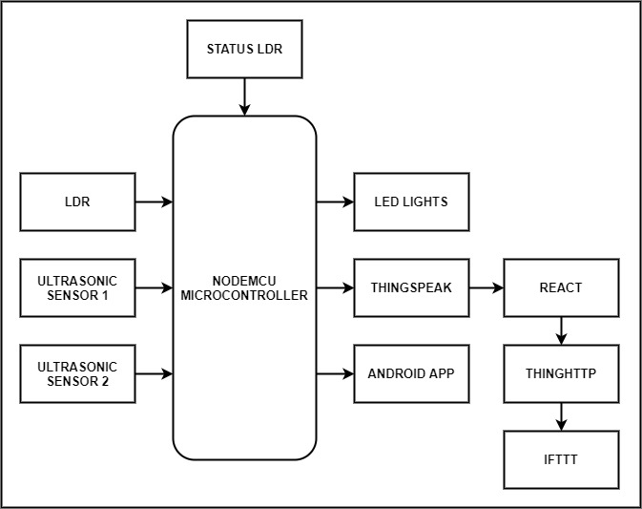

**Fig 1:** Block Diagram

Features to be fulfilled by our proposed system are:

* Automatic switching of street lights according to the requirements.
* Automatic fault recognition using sensors.
* Intensity control of LED lights on detection of human or vehicle or in idle state.
* Monitoring via wireless communication using built-in Wi-Fi module.

# Chapter 7

## Requirements Analysis (SRS)

### Functional Requirements:

Functional requirements may include calculations to be done, technical details, data processing and manipulation that needs to be done and other functionalities that define what the system needs to accomplish. It deals with the input, their behavior and the output of the system. Our system takes the light intensity of the vicinity as the input and changes the mode of the LED street lights accordingly. It has two variant modes namely normal and a power saving mode. It sends the data to the server which can be monitored from anywhere in the world. It also provides feedback when the street lights get damaged with notification alerts through the mobile application.

#### User Interface:

* + - * The user interface must be clear, concise and comprehensive. Instead of confusing the user, the user interface must give him a clear understanding of the information workflow.
      * The user interface must be easy to understand and allow the user to keep a track on the working status of the system.
      * The user interface must include different elements required specifically the live status of the lights, clear notifications, different colours to notify the status of the street lights and moreover user interface should be fault tolerant.

#### Hardware Requirements:

* + - * Node MCU
      * LED
      * LDR
      * Ultrasonic Sensor
      * Power Supply
      * Perf Board
      * Pin Headers
      * Connecting wires

#### Software Requirements:

* + - * Arduino IDE
      * MIT app Inventor 2
      * Thingspeak cloud
      * IFTTT
      * Thinghttp

### Non-Functional Requirements:

Non-functional Requirements define system attributes such as reliability, performance, maintainability, scalability, and usability. They serve as constraints on the design of the system across the different backlogs.

The proposed system must also perform up to the mark. The features and algorithms should do the required task efficiently and correctly and any malfunction must be notified immediately. The system should also be able to efficiently manage the modes of the street lights.

The quality of service can be measured by how efficiently the system is able to switch between the modes of the street lights depending on the conditions, is able to track the live status of the street light and how well it is able to accomplish the task of notifying in case of any malfunction.

#### Performance:

* + - * The system will provide quick responses to different tasks such as on, off, power saving mode as well as fault detection.

#### Availability:

* + - * All the data is stored on the ThingSpeak cloud server. So, the required information is readily available to the user on the server as well as on the mobile application.

#### Usability:

* + - * The user-interface is designed with taking the main factor of the modes of the street lights into consideration. The UI has elements such as different colour indications for the various modes as well as notification for fault detection. It gives the live working status of the street lights.

#### Portability:

* + - * The software platforms used in the system provide cross- platform support.
      * The same app can run on both android as well as iOS systems. The thingspeak cloud server can also be accessed via both the platforms.

#### Reliability:

* + - * The ultrasonic sensors can easily detect the external or deep objects using pwm which decreases noise thus increasing efficiency and correctness in the system.
      * Furthermore, the notification alert is designed in such a way that an alert is sent to emergency contact or the authority when the street lights get damaged. This ensures easy maintenance.

# Chapter 8

## Scope

### Feasibility:

* + - The current application design has functionalities which include switching of lights depending on the light intensity. It has two modes- normal and power saving mode. It uses the power efficiently. In this system, the data is sent to a server and can be monitored from anywhere in the world. It provides a feedback when the light gets damaged with the notification alert.
    - In the future versions, the system can make use of GSM module along with internet enabled micro-controller to provide alerts when there is no internet connection. The mobile application can be upgraded to cover a larger area.

#### Operational Feasibility:

* Operational feasibility is a measure of how well a proposed system solves the problems, and takes advantage of the opportunities identified during scope definition and how it satisfies the requirements identified in the requirements analysis phase of system development. In this feasibility we are trying to give more accurate and autonomous system to monitor street lights systematically.

#### Technical Feasibility:

Technical Feasibility involves the ability to develop a working model of the product. The proposed system is technically feasible on the android devices with operating system version 4.4 or above. It needs to have internet connectivity. This system requires cloud storage using thingspeak, Microsoft internet explorer 4.0 or Google chrome. All these features are available on the smart phones available today. Hence, this system is technically feasible.

#### 8.2.3 Economical Feasibility:

Economic Feasibility is the cost and logistic outlook for the business project or endeavor. Before the start of the project, an economic feasibility study must be done in order to know if the finished product has the capability of being cost-effective and economical. This system is economically feasible as only one time investment is needed to upgrade the system.

# Chapter 9

## Methodology

Software process models often represent a networked sequence of activities, objects, transformations, and events that embody strategies for accomplishing software evolution. Such models can be used to develop more precise and formalized descriptions of software life cycle activities. Prototype is a working model of software with some limited functionality. The prototype does not always hold the exact logic used in the actual software application and is an extra effort to be considered under effort estimation. Prototyping is used to allow the users evaluate developer proposals and try them out before implementation. It also helps understand the requirements which are user specific and may not have been considered by the developer during product design. Software prototyping is used in typical cases and the decision should be taken very carefully so that the efforts spent in building the prototype add considerable value to the final software developed.

**9.1.1 Sensors:**

**LDR:**

A Light Dependent Resistor (LDR) or a photo resistor is a device whose resistivity is a function of the incident electromagnetic radiation. Hence, they are light sensitive devices. They are also called as photo conductors, photo conductive cells or simply photocells.

They are made up of semiconductor materials having high resistance. There are many different symbols used to indicate a LDR, one of the most commonly used symbol is shown in the figure below. The arrow indicates light falling on it.

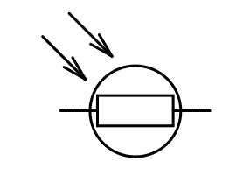

**Fig 2:** Light Dependent Resistor symbol

An LDR is a component that has a (variable) resistance that changes with the light intensity that falls upon it. This allows them to be used in light sensing circuits. The most common type of LDR has a resistance that falls with an increase in the light intensity falling upon the device

The resistance of an LDR may typically have the following resistances:

Daylight = 5000Ω

Dark = 20000000Ω

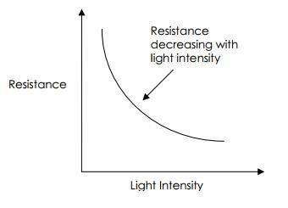

**Fig 3:** Light Intensity vs Resistance

When a light dependent resistor is kept in dark, its resistance is very high. This resistance is called as dark resistance. It can be as high as 1012 Ω and if the device is allowed to absorb light its resistance will be decreased drastically.

LDR sensor will be used to detect the time of the day (day or night).

**Ultrasonic:**

Ultrasonic / level sensors measure distance by using ultrasonic waves. The sensor head emits an ultrasonic wave and receives the wave reflected back from the target. ultrasonic / level sensors measure the distance to the target by measuring the time between the emission and reception.

This helps in calculating the distance and programming the system according to the required needs. It is used to detect movement on the road. An optical sensor has a transmitter and receiver, whereas an ultrasonic / level sensor uses a single ultrasonic element for both emission and reception. In a reflective model ultrasonic / level sensor, a single oscillator emits and receives ultrasonic waves alternately. This enables miniaturisation of the sensor head.

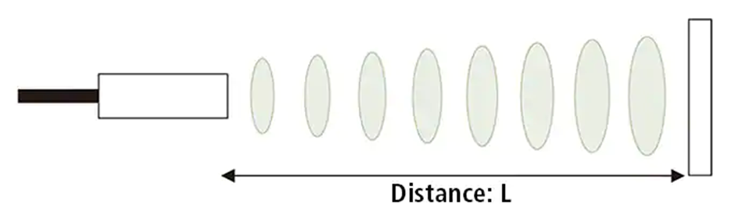

**Fig 4:** Ultrasonic sensor waves emission for calculating length

The distance can be calculated with the following formula:

**Distance L = 1/2 × T × C**

where L is the distance, T is the time between the emission and reception, and C is the sonic speed. (The value is multiplied by 1/2 because T is the time for go-and-return distance.)

**NodeMCU:**

NodeMCU is an open source IoT platform. It includes firmware which runs on the ESP8266 Wi-Fi SoC from Espressif Systems, and hardware which is based on the ESP-12 module. The term "NodeMCU" by default refers to the firmware rather than the development kits. The firmware uses the Lua scripting language.  It is based on the eLua project, and built on the Espressif Non-OS SDK for ESP8266. It uses many open source projects, such as lua-cjsonand SPIFFS.

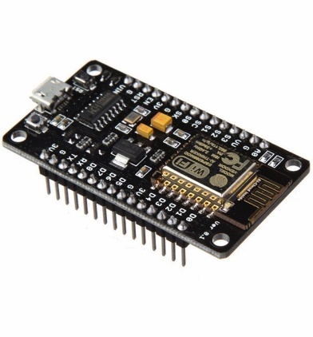

**Fig 5:** NodeMCU

**9.2 Working:**

This project will use NodeMCU as a microcontroller. It uses a single LDR for checking whether it is day time or night time. If it is day time then all the street lights are automatically switched off by the microcontroller. If it is night time then there are two modes of operation depending upon the status of ultrasonic sensor values. If the road is busy which means there is a necessity of light. In this case the lights will be operated at 100% intensity using PWM value as 1023. If the road is empty then there is less requirement of light hence in this case the lights will be operated at 30% intensity using PWM value as 300. The conditions of road will be monitored by ultrasonic sensors. The status of device or the light is checked using LDR. If the light was supposed to be on but if it is found to be off by LDR then this is a device failure and requires an alert. Alert will be given using ThingHTTP call by React to call an IFTTT Applet. All the data would be stored on Thing Speak cloud server. Two channels will be created on ThingSpeak. First channel will show the device status while second channel will show the Light Intensity Status of the device. The system can be monitored using the app that is created using MIT App Inventor 2 specifically for this purpose.

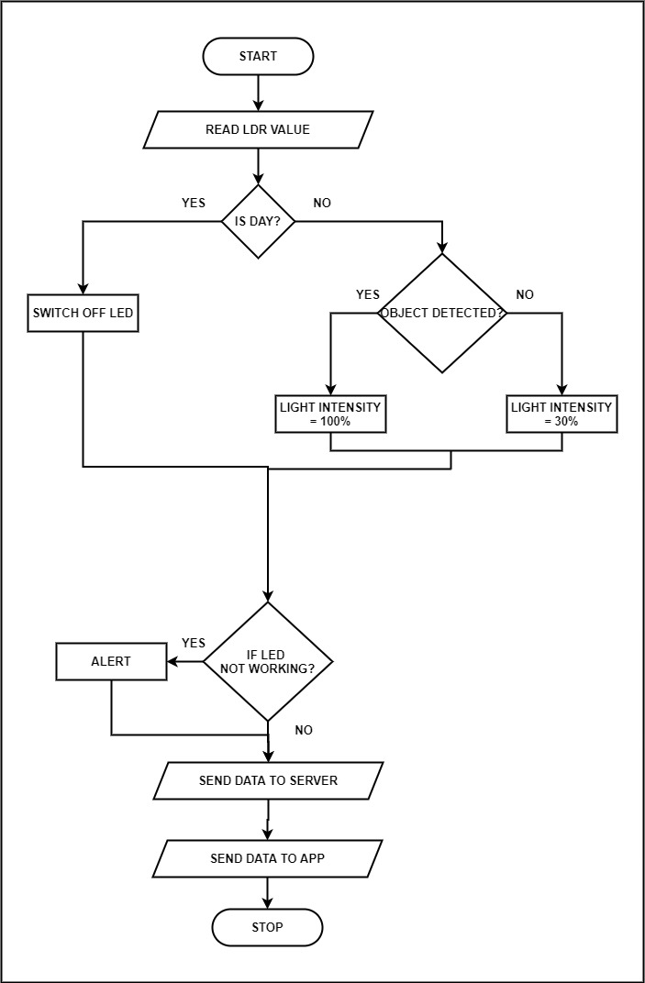

**Fig 6:** FlowChart of Implementation

The design details include:

* Data flow Diagram
* Activity Diagram

# Chapter 10

## Design Details

* Entity-Relationship Diagram
* Use Case Diagram
* State Transition Diagram
* Class Diagram

### Data Flow Diagram:

A Data-Flow Diagram (DFD) is a graphical visualization of the movement of data through an information system. DFDs are one of the three essential components of the structured-systems analysis and design method (SSADM). Data flow diagrams are almost always ideal tools for analysts who wish to analyze or depict the extent of information needed for a system, where that information will be stored, and how it will move throughout the system. Used properly, they are a potent tool in an analyst’s arsenal.

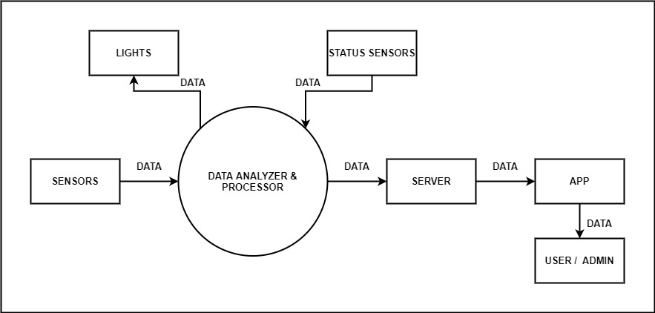

**Fig 7:** Data Flow Diagram

### Activity diagram:

An activity diagram is a behavioural diagram i.e. it depicts the behaviour of a system.

An activity diagram portrays the control flow from a start point to a finish point showing the various decision paths that exist while the activity is being executed. We can depict both sequential processing and concurrent processing of activities using an activity diagram. They are used in business and process modelling where their primary use is to depict the dynamic aspects of a system. An activity diagram is very similar to a flowchart.

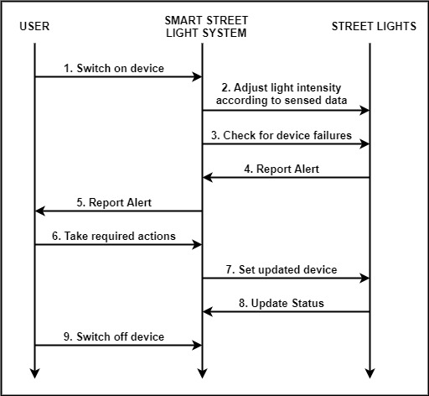

**Fig 8:** Activity Diagram

### Entity-Relationship Diagram:

An entity relationship diagram (ERD) shows the relationships of entity sets stored in a database. An entity in this context is an object, a component of data. An entity set is a collection of similar entities. These entities can have attributes that define its properties.

By defining the entities, their attributes, and showing the relationships between them, an ER diagram illustrates the logical structure of databases.

ER diagrams are used to sketch out the design of a database.

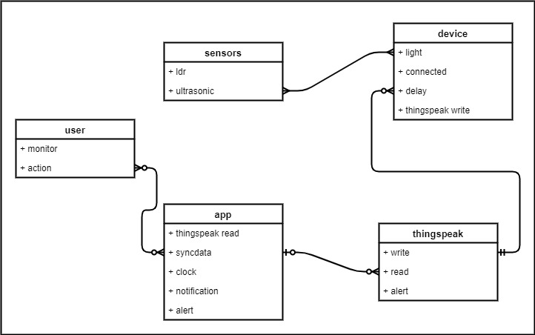

**Fig 9:** ER Diagram

### Use Case Diagram:

UML or use case diagram is the primary form of system/software requirements for a new software program underdeveloped. Use cases specify the expected behavior (what), and not the exact method of making it happen (how). Use cases once specified can be denoted both textual and visual representation (i.e. use case diagram). A key concept of use case modeling is that it helps us design a system from the end user's perspective. It is an effective technique for communicating system behavior in the user's terms by specifying all externally visible system behavior. It summarizes the relationship between actors, use cases and system.

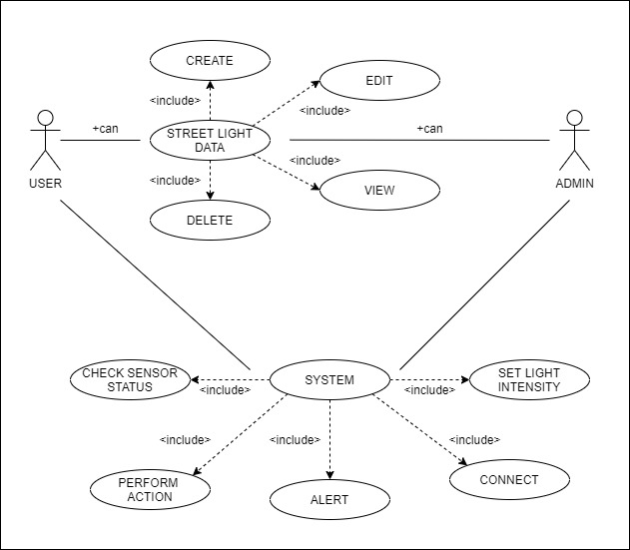

**Fig 10:** Use Case Diagram

### State Transition Diagram:

State-transition diagrams describe all of the states that an object can have, the events under which an object changes state (transitions), the conditions that must be fulfilled before the transition will occur , and the activities undertaken during the life of an object . State-transition diagrams are very useful for describing the behavior of individual objects over the full set of use cases that affect those objects. State-transition diagrams are not useful for describing the collaboration between objects that cause the transitions.

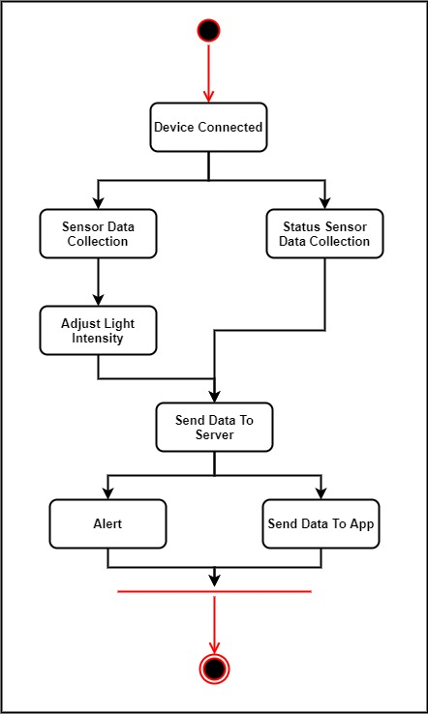

**Fig 11:** State Transition Diagram

### Class Diagram:

Class diagram is a static diagram. It represents the static view of an application. Class diagram is not only used for visualizing, describing, and documenting different aspects of a system but also for constructing executable code of the software application. Class diagram describes the attributes and operations of a class and also the constraints imposed on the system. The class diagrams are widely used in the modeling of object oriented systems because they are the only UML diagrams, which can be mapped directly with object-oriented languages. Class diagrams can also be used for data modeling.

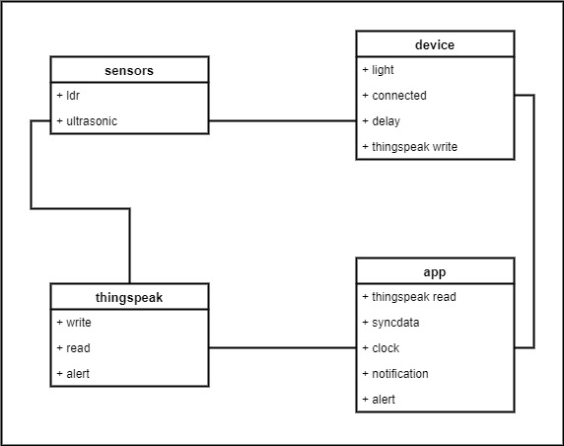

**Fig 12:** Class Diagram

# Chapter 11

## Implementation Plan

### Hardware requirements:

* + - Node MCU
    - LED
    - LDR
    - Ultrasonic Sensor
    - Power Supply
    - Perf Board
    - Pin Headers
    - Connecting Wires.

### Software requirements:

* + - ARDUINO IDE
    - MIT APP INVENTOR 2
    - THINGSPEAK CLOUD

The project uses low cost micro-controller NodeMCU to design an automatic street light control system. This micro-controller checks the value of the LDR and detects if it is day time or night time and accordingly switches the lights ON/OFF. If it is day time then all the street lights are automatically switched off by the microcontroller. If it is night time then there are two cases of operation depending upon the status of ultrasonic sensor values which detects movement on the road.

Case 1 (BUSY ROAD: In this case there is necessity of light on the road so the lights will be operated at 100% intensity using PWM value 1023.

Case 2 (Empty ROAD): In this case there is less requirement of light hence the lights will be operated at 30% intensity using PWM value 300.This is the power saving mode.

Fault detection system: In this the status of the light is checked using an LDR. If the light was supposed to be on but it is found to be off then there is a failure in the system and requires an alert message to be sent to the authority. For this purpose this system uses THINGSPEAK, an IoT application and API to store, retrieve data from things using HTTP and MQTT protocol over Internet. All the data will be stored on Thing Speak cloud server. An alert will be given using ThingHTTP call by React to call an IFTTT Applet. Two channels will be created on ThingSpeak, first channel will show the device status while second channel will show the Light Intensity Status of the device. MIT APP INVENTOR 2 is used which is a web application integrated development environment to create application software (apps) for two operating systems (OS): Android, and iOS. The system can be monitored using the app that is created using MIT App Inventor 2 which makes maintenance easier and more efficient.

### Gantt Chart:

#### Gantt Chart 1:

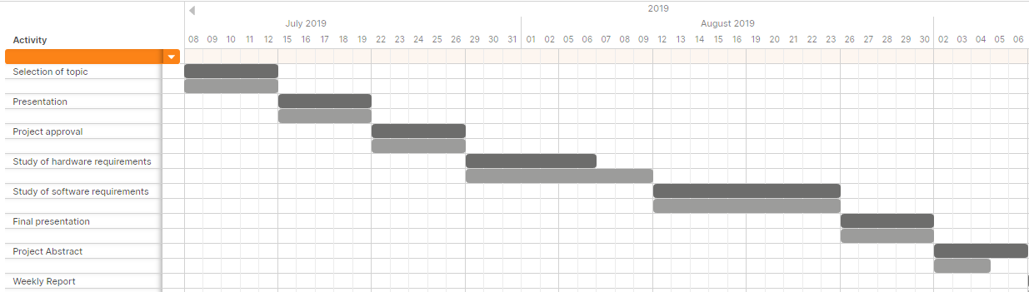

**Fig 13:** Gantt Chart 1

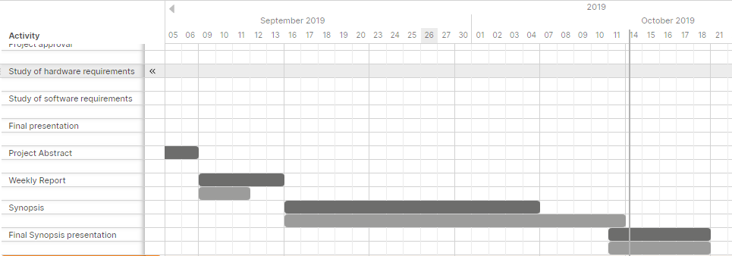

**Fig 14:** Gantt Chart 1

#### Gantt Chart 2:

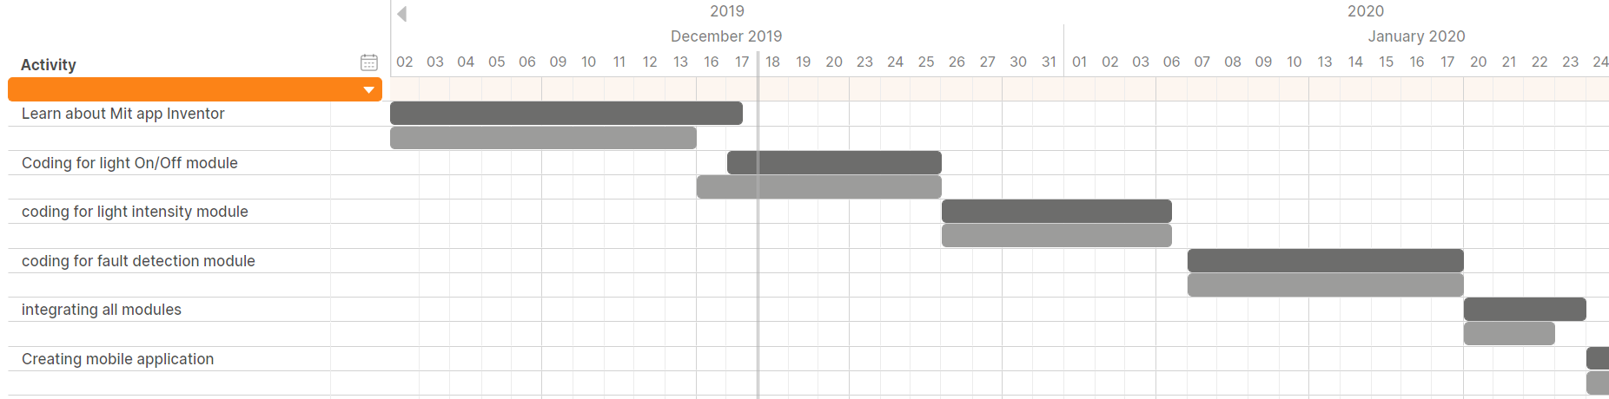

**Fig 15:** Gantt Chart 2

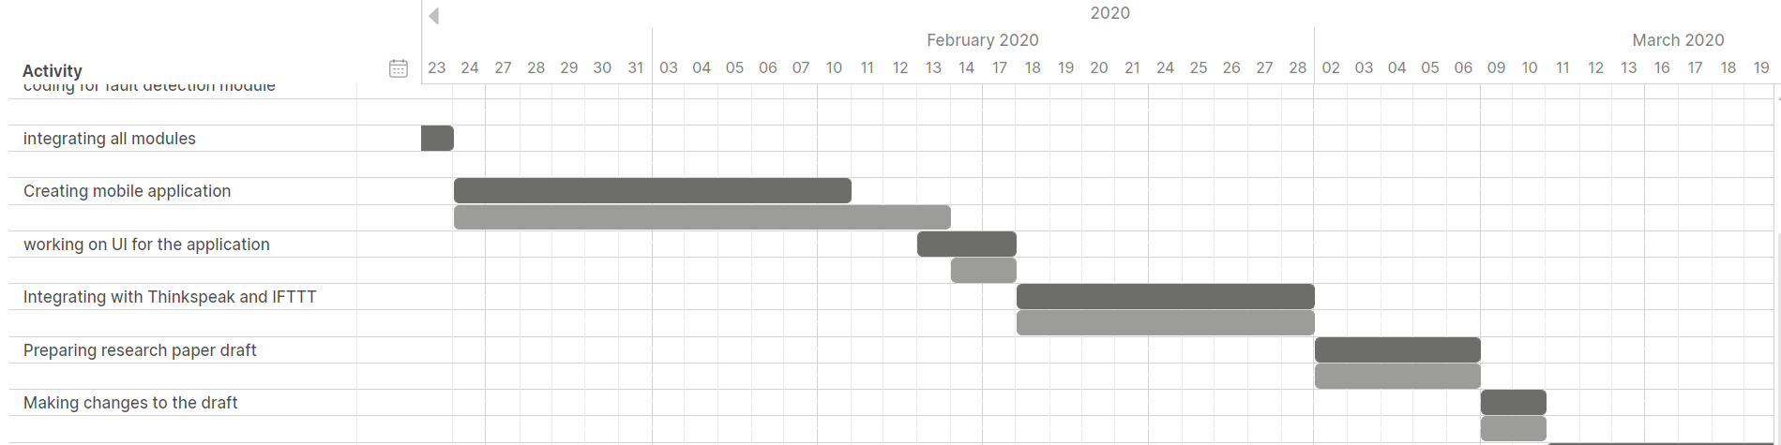

**Fig 16:** Gantt Chart 2

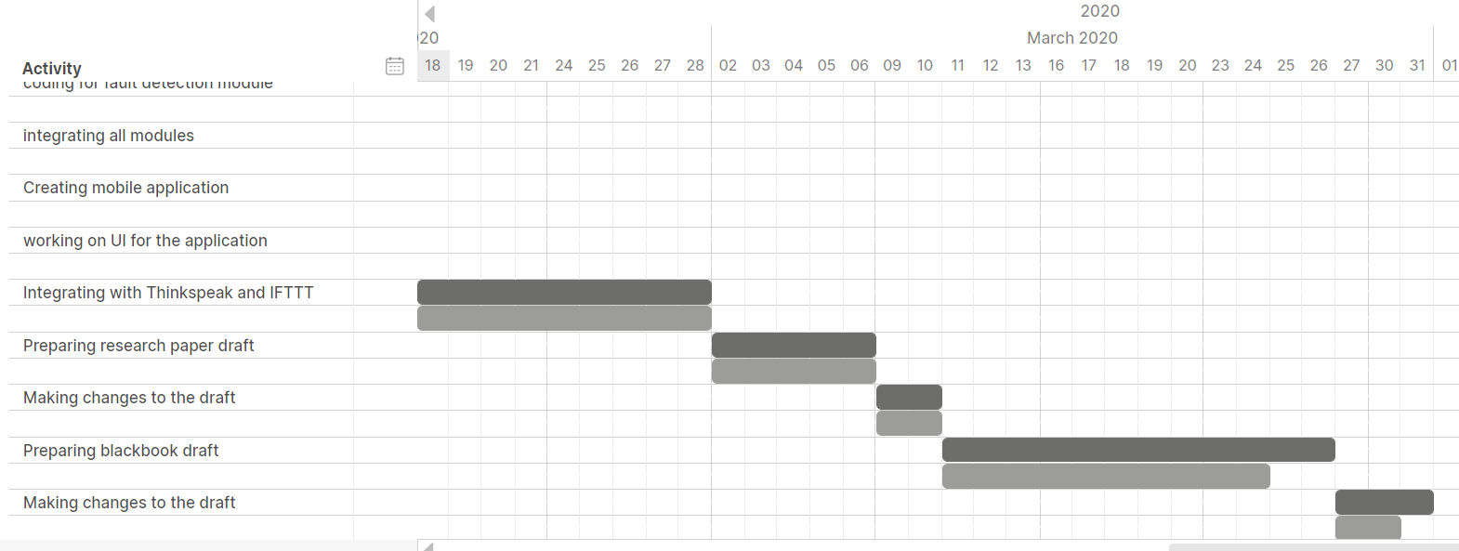

**Fig 17:** Gantt Chart 2

# Chapter 12

## Testing

When we are testing any software application it generally includes testing or verifying whether all the modules of the software are working properly, are the modules of the application free of Error? Whether there is an interfacing error within different modules? Testing is a step by step Process to verify the status of software. Testing software application requires designing a number of test cases to test all the modules under various possible circumstances.

### Unit Testing:

Unit Testing is a level of software testing where individual units/ components of a software are tested. The purpose is to validate that each unit of the software performs as designed. A unit is the smallest testable part of any software. It usually has one or a few inputs and usually a single output.

|  |  |  |  |  |  |
| --- | --- | --- | --- | --- | --- |
| **Test Case ID** | **Description** | **Test Case I/P** | **Actual Result** | **Expected Result** | **Test Case Criteria** |
| 1 | Open App | Press App Icon Button | App opens | App should open | P |
| 2 | Check Device Status | Press Device Status Button | Device Status displayed on new screen | Should display Device Status on new screen | P |
| 3 | Check Light Intensity Status | Press Light Intensity Status Button | Light Intensity Status displayed on new screen | Should display Light Intensity Status on new screen | P |
| 4 | Write Sensor Data from NodeMCU | Update Cloud Database | Data written to Database | Data should be written to Database | P |
| 5 | Read Sensor Data from Database | Refresh Cloud Database | Data read from Database | Data should be read from Database | P |
| 6 | Error message | Dialog Box | Error generated and displayed in dialog box | Error occurred should be displayed in a dialog box | P |
| 7 | Update PWM Value | LED | Intensity of LED Changes | Intensity of LED should change | P |
| 8 | Read LDR Value | LDR | LDR value read and displayed | LDR value should be read and displayed | P |
| 9 | Close App | Back Button | Dialog of whether to close the app occurs | Dialog of whether to close the app should occur | P |

**Table 3:** Test Cases for Unit Testing.

### White Box Testing:

**White Box Testing** is software testing technique in which internal structure, design and coding of software are tested to verify flow of input-output and to improve design, usability and security. In white box testing, code is visible to testers so it is also called Clear box testing, Open box testing, Transparent box testing, Code-based testing and Glass box testing.

|  |  |  |  |
| --- | --- | --- | --- |
| **Test Case ID** | **Description** | **Result** | **Test Case Criteria** |
| 1 | Check application, database and embedded c code and create appropriate test cases for unit testing and integration testing | Test cases created and application check done | P |
| 2 | Check application, database and embedded c code and check for errors and improvement in the code. | Errors checked and necessary improvement done in the code | P |

**Table 4:** Test Cases for White box Testing.

### Black Box Testing:

**Black Box Testing** is a software testing method in which the functionalities of software applications are tested without having knowledge of internal code structure, implementation details and internal paths. Black Box Testing mainly focuses on input and output of software applications and it is entirely based on software requirements and specifications. It is also known as Behavioural Testing.

|  |  |  |  |
| --- | --- | --- | --- |
| **Test Case ID** | **Description** | **Result** | **Test Criteria** |
| 1 | Check application and database by performing appropriate actions. | Database working propoerly | P |
| 2 | Check if they are providing appropriate errors message and validation of data in each step. | Receiving appropriate error messages | P |
| 3 | Check if they are working properly and updating the information properly. | Information is been updated properly | P |

**Table 5:** Test Cases for Black box Testing.

### Test Results:

Hence, we performed above test cases and can assure that the software and street light system is working properly as intended in the requirement and is ready to be deployed.

# Chapter 13

## Result and Analysis

After implementing the various features discussed, we obtained the following results:

### ThingSpeak Screens:`

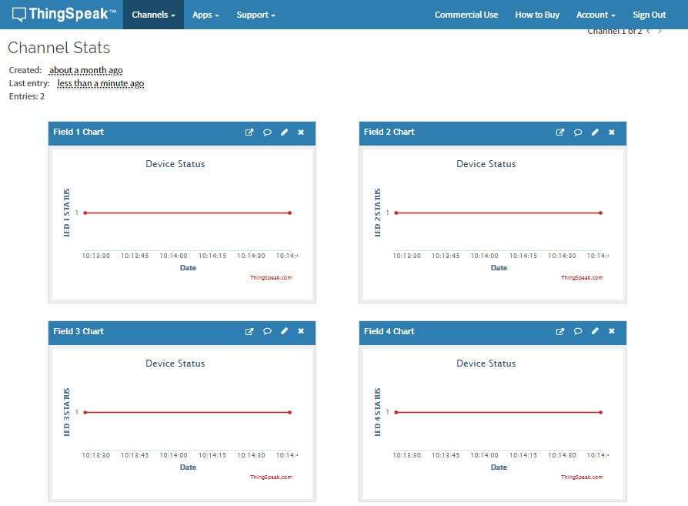

**Fig 18:** Device Status Graphs.

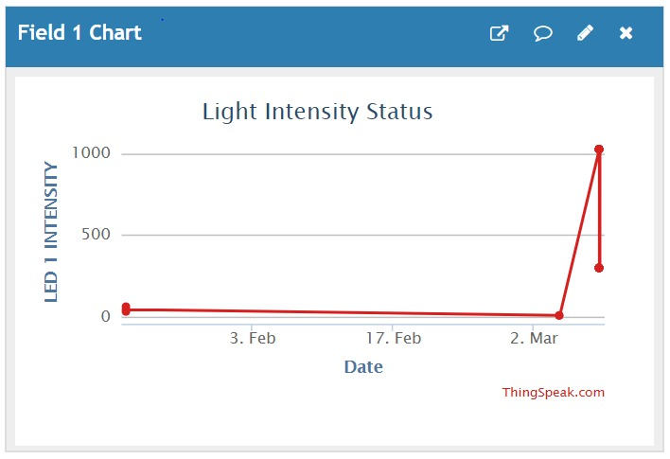

**Fig 19:** Light intensity Graph of LED 1.

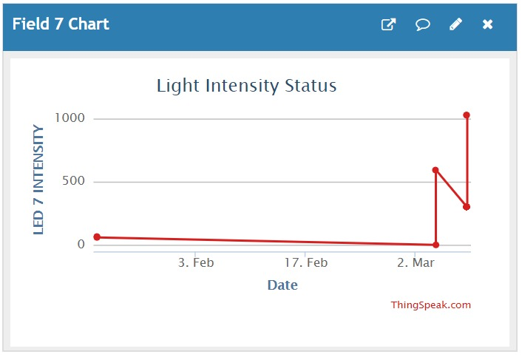

**Fig 20:** Light Intensity Graph of LED 7.

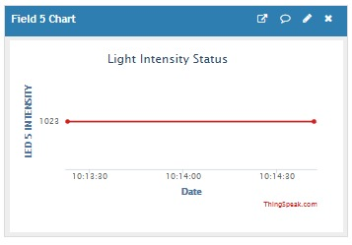

**Fig 21:** Light intensity Graph LED 5.

**Mobile Application Screens :**

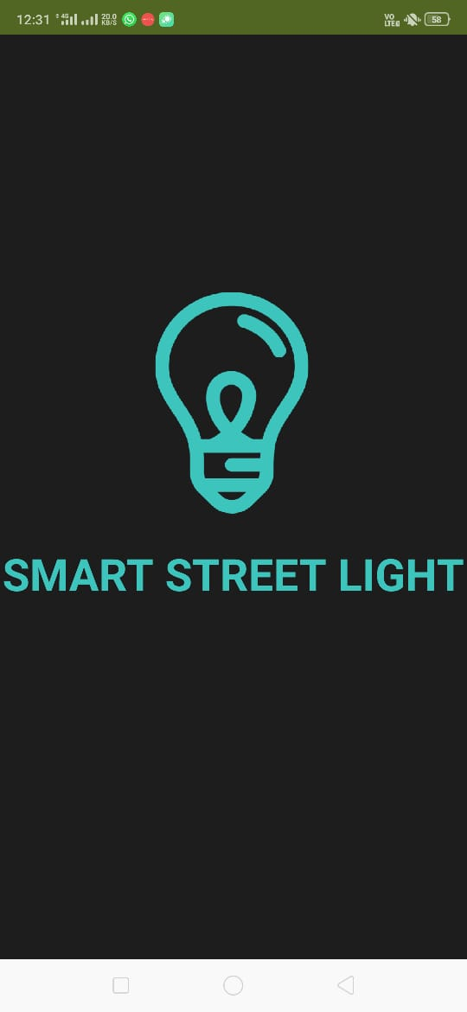

**Fig 22:** Splash Screen.

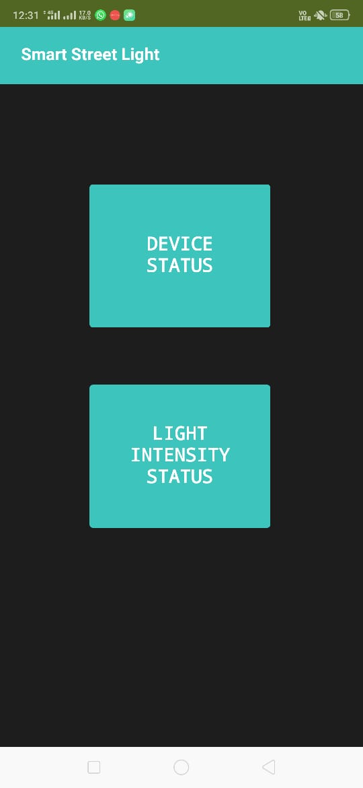

**Fig 23:** Home Screen.

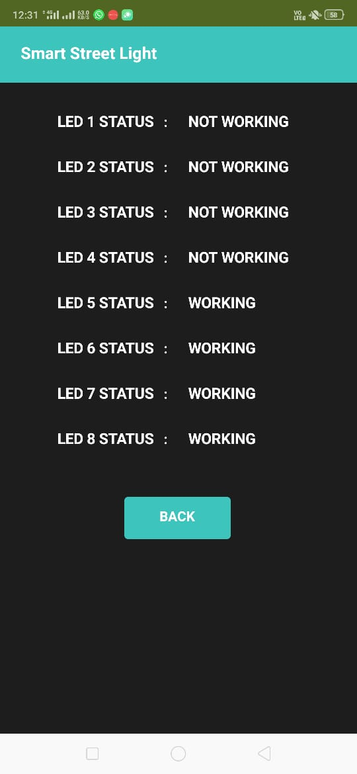

**Fig 24:** LED Status Screen.

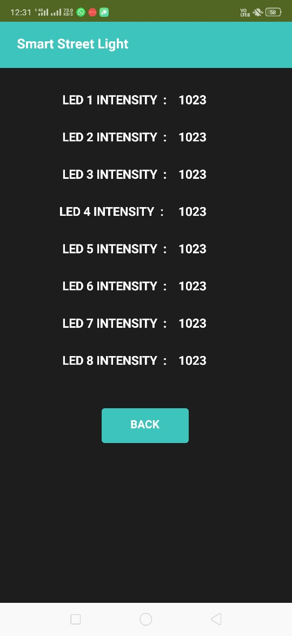

**Fig 25:** LED Intensity Screen.

**IFTTT Notification Screens:**

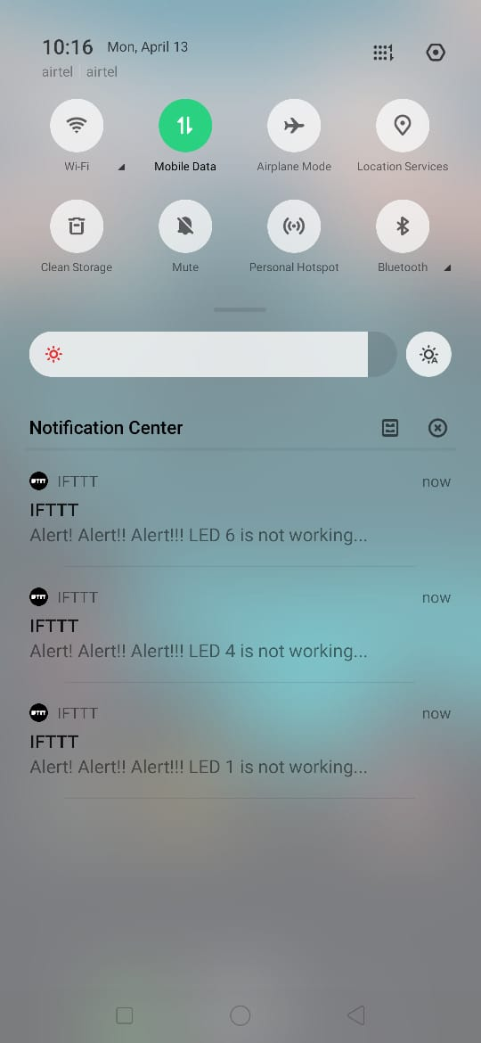

**Fig 26:** IFTTT notifications of LEDs.



**Fig 27:** IFTTT notification of LED.

# Chapter 14

## Advantages and Limitations

### Advantages:

* + - Maintenance cost is low as compared to conventional street light.
    - Intensity of street light can be controlled
    - Lowers the risk of accidents.
    - Environmental friendly as there is no harmful emission.
    - LEDs have longer life compared to conventional HID lamps.
    - Less power consumption.
    - It works automatically hence no need of human intervention.

### Limitations:

* + - Notification regarding failure is sent only when the device is connected to internet.
    - Requires an active internet connection for monitoring data.

# Chapter 15

## Applications and Future enhancements

### Applications:

* Smart Street Lights.
* Light Dimmer.
* Automation of Lights for Residential, Commercial and Factory Usage.

#### Future enhancements

* + - We can make use of GSM Module along with Internet enabled micro-controller to provide alerts even during no internet connection.
    - The app can be upgraded to cover a larger location.

# Chapter 16

## Conclusion

The main benefit of our project is power saving. This will in turn save tremendous amount of economy in the coming years. The project will be studied and designed using NodeMCU with built-in Wi-Fi module. This initiative will help us save energy and money and meet various other needs and develop our nation. In addition to this, another advantage it provides is less maintenance cost. This project is cost effective, pragmatic, practical and safe to travel at night time. The initial installation cost may be a disadvantage but with the bulk production of the module the overall cost can be reduced further. Due to the automatic message sent to the authorities, maintenance becomes easier. The proposed system is especially appropriate for street lighting in rural areas and specifically areas with low footfall count. The system is versatile, extendable and adjustable according to the needs of the user.

# Chapter 17

## References

1. Kavita A. Bajaj, Tushar S. Mote "Review on Intelligent Street Lightening System", IJSR , Volume 4 ,Issue 2, February 2015.
2. Kunjal Nanavati, Hemant Prajapati, Hemal Pandav, Krupali Umaria, Nilay Desai "Smart Autonomous Street Light Control System", IJSTE, Volume 2, Issue 10, April 2016.
3. Aman Singhal "Automatic Street Lights", IJAREM, Vol. 01, Issue 08, November 2015.
4. Surabhi Gurav, Hardik Rathod, Heta Shah Nilesh Rathod "Movement Sensing Street Lighting", IJRITCC, Volume: 6, Issue: 4,  April 2018 .
5. Snehal Bhosale, Komal Gaware, Pradnya Phalke, Dipali Wadekar, Pallavi Ahire "Iot Based Dynamic Control Of Street Lights For Smart City", IRJET, Volume: 04, Issue: 05,  May -2017.
6. Vismita Kolvekar, Valerie Vaz, Fatima Shaikh, Jyoti Kumari, Michelle Araujo E Viegas "Intelligent Automatic Street Light Control System", IJSRD, Vol. 4, Issue 11, May -2017.
7. Shagun Malhotra, Vivek Kumar “Smart Street Lighting System: An Energy Efficient Approach”, IJSR, Vol 5, February 2016.
8. Sankaran N, Arathy A, Arundhathy M, Revathy R, Athira M “A Comparative Approach of Energy Efficient Street Lighting Systems”, IJMTER, Vol 3, March 2016.
9. D Mondal, Rupali Diksha K, Shraddha K “Vehicle Movement using Street Light Detection”, IRJET, Vol 5, April 2018.

[10] Sivaiah, Lakshmi P, Tejaswini, Manisha, Yasaswini “Automated Street Light Controlling

System”, IRJET, Vol. 5, February 2018.

# Chapter 18

## Appendix

* 1. **CFD**- Control Flow Diagram
  2. **DFD** – Data Flow Diagram
  3. **E-R** – Entity Relationship
  4. **SRS**- Software Requirement specifications

# Chapter 19

## 19. Paper Publication Details

### Research Paper Details

**Title:** Advance Street Light System using IoT.

**Conference Name (Detail):** International Conference on Computing Technologies for transforming the Automated World (ICCTAW).

**Date of Publication:** 20-05-2020

**Journal Name:** Web of Science – International Journal of Future Generation Communication and Networking.

**Name of Authors:** Khusboo Patel, Lalit Makar, Vrushali Patil, Prof. Priti Rumao .

**Affiliation of authors:** Department of Computer Engineering, Atharva College of Engineering, Mumbai University, India.

### Literature Review Paper Details

**Title:** Review on Advance Street Light System using IoT.

**Conference Name (Detail):** International Conference on Computing Technologies for transforming the Automated World (ICCTAW).

#### Date of Publication:12-09-2020

**Journal Name:** UGC journal.

**Name of Authors:** Khusboo Patel, Lalit Makar, Vrushali Patil, Prof. Priti Rumao.

**Affiliation of authors:** Department of Computer Engineering, Atharva College of Engineering, Mumbai University, India.