INFOSEC SIG @ KJSSE FOTD #04 20/09/2026

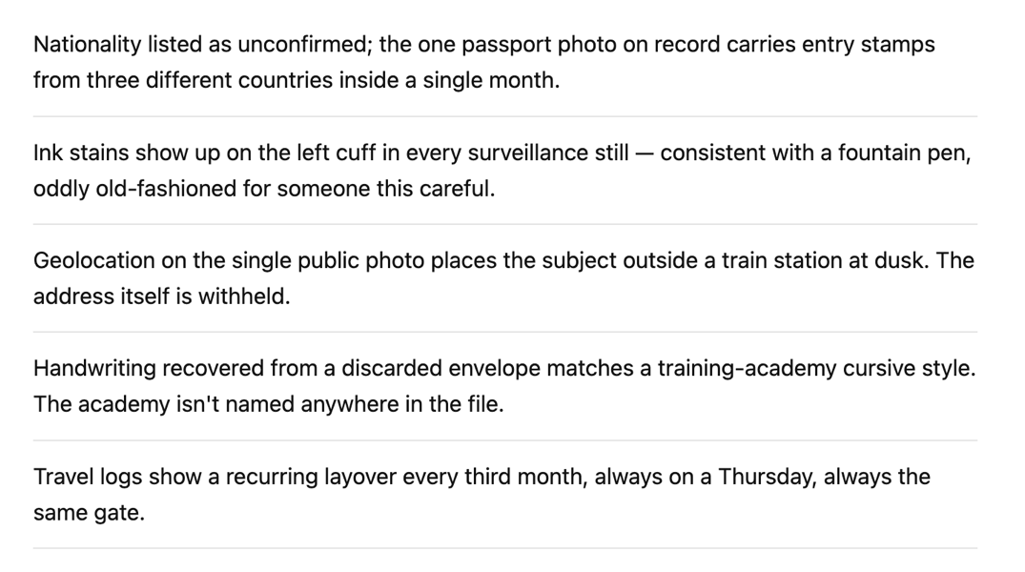
First Fragment: NIGHT (1st Letter of Each Sentence)
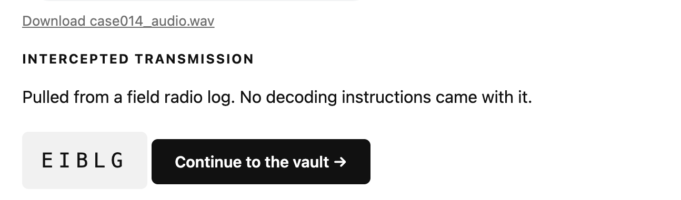
Use EIBLG as CIPHERTEXT, NIGHT as KEY
Using a Vigenère Cipher Decoder you will find RAVEN
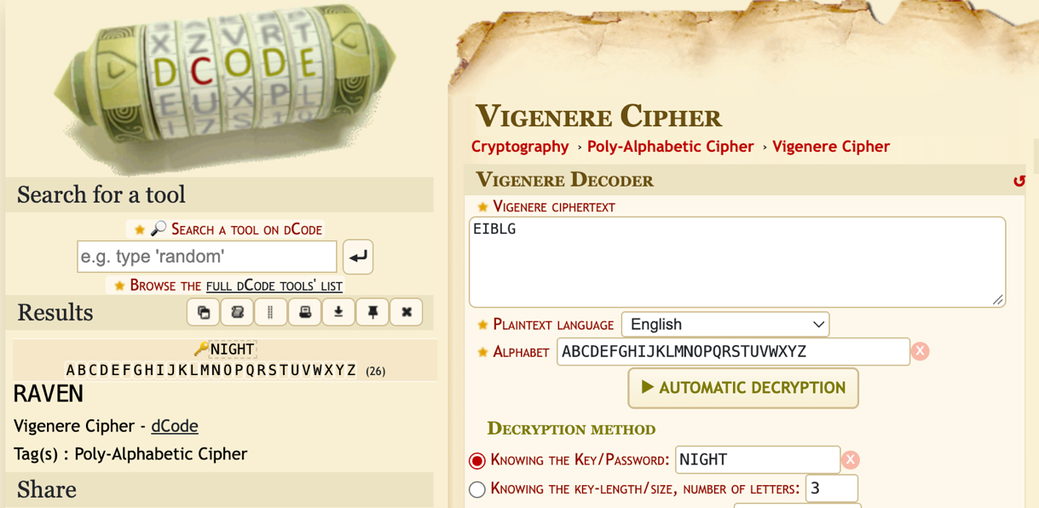
Second Fragment: RAVEN
Now the WAV File can be decrypted using an Audio Spectrogram Analyser.
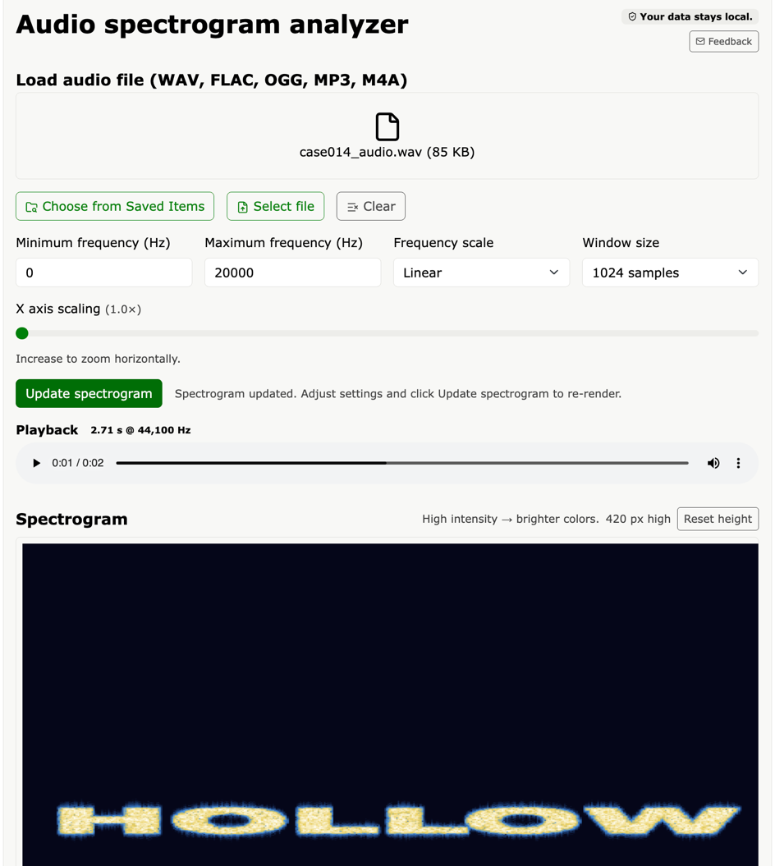

Third Fragment: HOLLOW

Input ‘NIGHTRAVENHOLLOW’ to get the flag.

Links:
https://www.dcode.fr/vigenere-cipher
https://www.boxentriq.com/steganography/audio-spectrogram

