WORKSHEET 3 SQL

**Refer the following ERD and answer all the questions in this worksheet. You have to write the queries using mysql for the required Operation.**

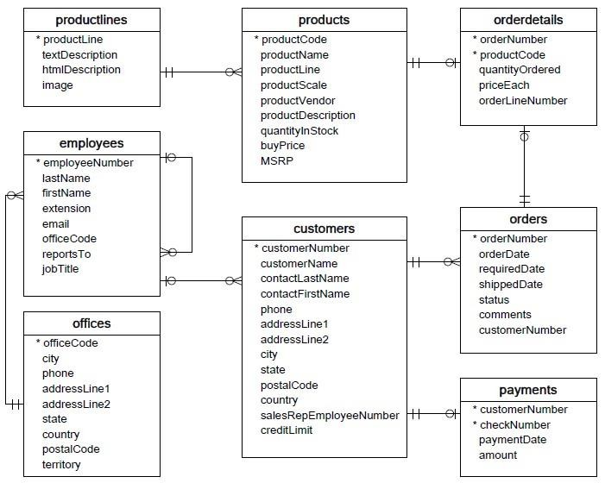

* **Customers**: stores customer’s data.
* **Products**: stores a list of scale model cars.
* **ProductLines**: stores a list of product line categories.
* **Orders**: stores sales orders placed by customers.
* **OrderDetails**: stores sales order line items for each sales order.
* **Payments**: stores payments made by customers based on their accounts.
* **Employees**: stores all employee information as well as the organization structure such as who reports to whom.
* **Offices**: stores sales office data.
  1. Write SQL query to create table **Customers.**
* **CREATE TABLE** Customers(customerNumber INT PRIMARY KEY, customerName TEXT, contactLastName TEXT, contactFirstName TEXT, phone INT, addressLine1 NVARCHAR(100), addressLine2 NVARCHAR(50), city TEXT, state TEXT, postalCode INT, country TEXT, salesRepEmployeeNumber INT, creditLimit INT)
  1. Write SQL query to create table **Orders.**
* **CREATE TABLE orders(**orderNumber INT PRIMARY KEY, orderDate DATE, requiredDate DATE, shippedDate DATE, status VARCHAR(20), comments NVARCHAR(100), customerNumber INT FOREIGN KEY(cusomerNumber) REFERENCES Customers(customerNumber))
  1. Write SQL query to show all the columns data from the **Orders** Table.
* SELECT * FROM orders
  1. Write SQL query to show all the comments from the **Orders** Table.
* SELECT comments FROM orders
  1. Write a SQL query to show orderDate and Total number of orders placed on that date, from **Orders** table.
* SELECT orderDate ,

COUNT(orderNumber) FROM orders GROUP BY orderDate ORDER BY COUNT(orderNumber) DESC

* 1. Write a SQL query to show employeNumber, lastName, firstName of all the employees from **employees**

table.

* SELECT employeeNumber, lastName, firstName FROM employees
  1. Write a SQL query to show all orderNumber, customerName of the person who placed the respective order.
* SELECT customerName FROM customers WHERE customerNumber = ( SELECT customerNumber FROM orders )
  1. Write a SQL query to show name of all the customers in one column and salerepemployee name inanother column.
* SELECT customerNames, saleRepEmployeeNumber FROM customers
  1. Write a SQL query to show Date in one column and total payment amount of the payments made on that date from the **payments** table.
* SELECT paymentDate,

COUNT(amount) FROM payments GROUP BY paymentDate ORDER BY COUNT(amount) DESC

* 1. Write a SQL query to show all the products productName, MSRP, productDescription from the **products**

table.

* SELECT productName, MSRP, productDescription FROM products
  1. Write a SQL query to print the productName, productDescription of the most ordered product.
* SELECT productName, productDescription , productCode, COUNT(DISTINT productCode) AS productordered FROM products WHERE productCode = (SELECT productCode FROM orderdetails WHERE productordered= MAX(productordered))
  1. Write a SQL query to print the city name where maximum number of orders were placed.
  2. Write a SQL query to get the name of the state having maximum number of customers.
* SELECT state, COUNT(Distinct, customerNumber) From customers GROUP BY state ORDER BY COUNT(DISTINCT, customerNumber)
  1. Write a SQL query to print the employee number in one column and Full name of the employee in the second column for all the employees.
* SELECT firstName+ ‘ ‘ + lastName AS fullName, employeeNumber From employees
  1. Write a SQL query to print the orderNumber, customer Name and total amount paid by the customer for that order (quantityOrdered × priceEach).
* SELECT ordersdetails.orderNumber, orderdetails.quantityOrdered, orderdetails.priceEach customers.customerName, FROM orders INNER JOIN customers INNERJOIN payments ON cutomers.customerNumber = orders.customerNumber = payments.customerNumber;

