WORKSHEET 4 SQL

**Refer the following ERD and answer all the questions in this worksheet. You have to write the queries using MySQL for the required Operation.**

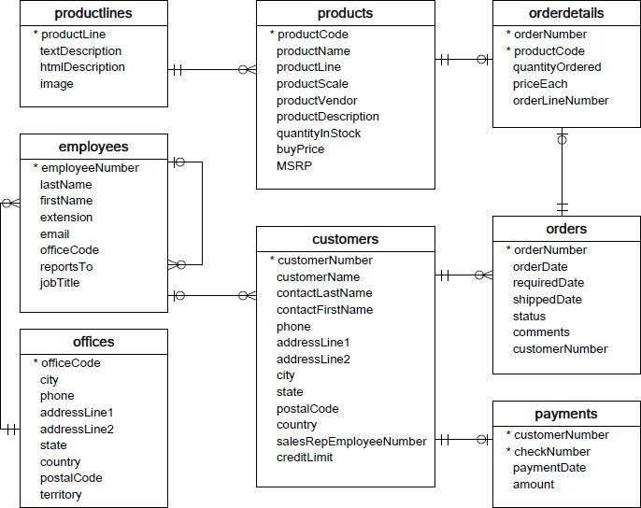

* **Customers**: stores customer’s data.
* **Products**: stores a list of scale model cars.
* **Product Lines**: stores a list of product line categories.
* **Orders**: stores sales orders placed by customers.
* **Order Details**: stores sales order line items for each sales order.
* **Payments**: stores payments made by customers based on their accounts.
* **Employees**: stores all employee information as well as the organization structure such as who reports towhom.
* **Offices**: stores sales office data.

**QUESTIONS:**

1. Write a SQL query to show average number of orders shipped in a day (use Orders table).

SELECT orderNumber FROM orders GROUP BY shippedDate , AVG(DISTINCT, orderNumber) AS avg_order ORDER BY avg_order DESC;

1. Write a SQL query to show average number of orders placed in a day.

SELECT orderNumber FROM orders GROUP BY orderDate , AVG(DISTINCT, orderNumber) AS avg_order ORDER BY avg_order DESC;

1. Write a SQL query to show the product name with minimum MSRP (use Products table).

SELECT MIN(MSRP) FROM products

1. Write a SQL query to show the product name with maximum value of stockQuantity.

SELECT productName, quantityInStock FROM products WHERE MAX(quantityInStock)

1. Write a query to show the most ordered product Name (the product with maximum number of orders).

SELECT productName FROM products WHERE productNumber = (SELECT productNumber From orderdetails WHERE MAX quantityOrdered)

1. Write a SQL query to show the highest paying customer Name.

SELECT customerName, customerNumber FROM customers WHERE customerNumber = (SELECT customerNumber FROM payments WHERE MAX(amount));

1. Write a SQL query to show cutomerNumber, customerName of all the customers who are from Melbourne city.

SELECT customerNumber, customerName FROM customers WHERE city = ‘Melbourne’.

1. Write a SQL query to show name of all the customers whose name start with “N”.

SELECT customerName FROM customers WHERE customerName like ‘N%’

1. Write a SQL query to show name of all the customers whose phone start with ‘7’ and are from city ‘LasVegas’.

SELECT customerName FROM customers WHERE city = ‘LasVegas’ and phone like ‘7%’

1. Write a SQL query to show name of all the customers whose creditLimit < 1000 and city is either “Las Vegas” or ”Nantes” or “Stavern”.

SELECT customerNames FROM customers WHERE creditLimit < 1000 and city= ‘LasVegas’ or ‘Nantes’ or ‘Stavern’.

1. Write a SQL query to show all the orderNumber in which quantity ordered <10.

SELECT orderNumber FROM orderdetails WHERE quantityordered <10

1. Write a SQL query to show all the orderNumber whose customer Name start with letter ‘N’**.**

**SELECT** orders.orderNumber, customers.customerName FROM customers INNER JOIN orders ON orders.customerNumber = customers.customerNumber WHERE customers.customerName like ‘N%’

1. Write a SQL query to show all the customerName whose orders are “Disputed” in status.

SELECT customerName FROM customers WHERE customerNumber= (SELECT customerNumber FROM orders WHERE status =’Disputed’)

1. Write a SQL query to show the customerName who made payment through cheque with checkNumber starting with H and made payment on “2004-10-19”.

SELECT customerName, customerNumber FROM customers WHERE customerNumber= (SELECT customerNumber FROM payments WHERE checkNumber like ‘H%’ and paymentDate ='2004-10-19’)

1. Write a SQL query to show all the checkNumber whose amount > 1000.

SELECT checkNumber FROM payments WHERE amount >1000