INTRODUCTION

Nutrition Management System is a software solution designed to assist individuals in making informed dietary choices based on their food consumption and nutritional requirements. The system uses Python for the front-end user interface and MySQL as the backend database to store and manage the data effectively. This system primarily helps users manage and track their daily nutrition by storing details such as calories, carbohydrates, proteins, fats, and sugar content of the food items they consume. Based on the inputted data, the system suggests relevant diet plans tailored to the individual’s health goals. The system provides suggestions for diet options like high-protein meals, balanced nutrition plans, and low-calorie alternatives for health-conscious users, or other suitable recommendations for those with poor eating habits or deficiencies in their diet.
The key features of the Nutrition Management System include:

- Personalized Diet Suggestions: Based on the nutritional data entered, the system suggests diet plans suited to different health levels (balanced, highprotein, low-calorie, or nutrient-deficient).
- Improvement Suggestions: For users with unhealthy eating habits or nutrient intake below a certain threshold, the system provides tips and resources on how to improve their diet, including suggestions for healthy alternatives, meal planning, and better eating practices.
- Motivational Support: The system encourages individuals to stay consistent with their nutrition goals by offering positive reinforcement and motivational health quotes, especially for those who may be struggling with poor dietary habits. This can motivate users to adopt healthier lifestyles and reach their full potential.
- Clear Breakdown of Nutritional Intake: The system calculates and displays the nutritional composition of foods, offering clear feedback on calorie and nutrient consumption, making it easier for users to understand their eating patterns and take actionable steps based on the information provided.
This Nutrition Management System aims to provide individuals with a personalized nutrition guidance tool, enabling them to make better decisions based on their dietary intake. It also serves as an automated and efficient way to manage nutrition data, reduce paperwork, and make health-related decisions more easily.

WORKING DESCRIPTION
1. Database Setup:
- A MySQL database named nutrition_management is created with three tables: users, food_plan, and food_nutrition_data.
- The users table stores user details such as name, email, and password.
- The food_plan table stores daily meal plans (breakfast, lunch, dinner, and snacks) created by the user.
- The food_nutrition_data table stores nutrition details such as calories, carbohydrates, fats, proteins, and sugar for different food items entered by the user.
- The system is designed to store and manage nutrition data, analyze dietary patterns, and provide personalized diet suggestions.
2. Password Authentication (optional – can be added for additional security):
- Before accessing the features, the user may need to authenticate using a password.
- Once authenticated, the system proceeds to the next steps, allowing users to track and manage their diet.
3. User Input for Food Details:
- The user is prompted to enter food details such as the food name and quantity.
- The system searches for the food item in the nutrition dataset (CSV file) and retrieves its nutritional values (calories, carbs, fats, protein, and sugar).
- Once the data is retrieved, it is stored in the food_nutrition_data table in the database.
- After successful entry, the system confirms the data with a message like
“Nutrition data saved successfully.”
4. Data Retrieval:
- After storing the nutrition details, the system retrieves the most recent food entry from the database.
- The retrieved food name and its nutritional values are displayed on the screen for confirmation.
- A pie chart is also generated to provide a clear visualization of the nutritional breakdown.
5. Diet Suggestion:
- Based on the nutritional data entered by the user, the system analyzes the balance of nutrients and provides suitable dietary recommendations.
- Examples of suggestions include:
  - Balanced Diet: If nutrients are proportionate, the system suggests maintaining the same dietary pattern.
  - High-Calorie Intake: The system advises lighter alternatives such as fruits, vegetables, or low-fat meals.
  - Low-Protein Diet: The system suggests including protein-rich foods like eggs, pulses, or dairy products.
  - High-Sugar Diet: The system advises cutting down on sugary foods and choosing healthier options.
6. Improvement Suggestions (for unhealthy eating habits):
- If the user’s diet is unbalanced or shows poor nutrition intake, the system suggests ways to improve dietary performance. These include:
- Balanced Meal Plans: Ensuring meals include all essential nutrients.
- Healthy Alternatives: Replacing junk food with nutrient-rich items such as fruits, vegetables, and whole grains.
- Expert Guidance: Seeking advice from a dietician if needed.
- Staying Motivated: Following motivational health tips and reminders to stay consistent with goals.

FUNCTIONS AND MODULES

👉 mysql.connector
- Used to connect Python with the MySQL database.
- Enables us to create tables (_{users}, _{food_plan}, and _{food_nutrition_data}) and perform operations like insert, update, delete, and fetch.
^{👉tkinter}
- Provides the Graphical User Interface (GUI) for the project.
- Used to create windows, labels, buttons, and input fields for users to interact with the system.
👉 tkinter.ttk
- Provides themed widgets like Combobox for better user interface design.
👉 tkinter.messagebox
- Displays pop-up messages such as warnings, errors, and success confirmations.

👉 csv
. Reads nutrition data and motivational quotes from external CSV files (_{NUTRITION_DATA.csv}, MOTIVATIONAL_QUOTES.csv).

👉 random
. Selects a random motivational quote from the CSV file to inspire users.

👉 matplotlib.pyplot
. Used to create pie charts that visually represent nutrition values like calories, carbs, protein, fat, and sugar.

👉 _{datetime}
- Captures the date and time when a food item or meal plan is saved to the database.

Key Functions in the Code
👉 connect_database()
- Establishes a connection with the _{nutrition_db} MySQL database.
- Returns a connection object to perform database queries.
👉 register_user()
- Registers a new user by saving their name, email, and password into the _{users} table.
- Ensures duplicate users cannot be added.
👉 load_quote()
- Loads motivational quotes from the CSV file.
- Randomly selects one to display in the application.
👉 get_food_info()
- Searches for a food item in _{NUTRITION_DATA.csv}.
- Returns nutrition values (calories, carbs, fat, protein, sugar) for the entered food.
👉 show_nutrition_chart()
- Displays a pie chart of the selected food’s nutritional values using Matplotlib.
- Helps users visualize their food composition.
👉 save_nutrition()
- Saves the searched food’s nutrition data into the _{food_nutrition_data} table for the logged-in user. Stores calories, carbs, fat, protein, and sugar along with a timestamp.
👉 sav_{e_plan()}
- Saves the user’s daily food plan (breakfast, lunch, dinner, snacks) into the _{food_plan} table.
- Useful for tracking daily meals.
👉 logout_user()
- Deletes a user’s account and all their associated data from the database.
- Ensures data privacy and cleanup when the user logs out permanently.

SOURCE CODE
➢ _{MySQL}:
import mysql.connector
#---CONNECT TO MYSQL & CREATE DATABASE---
conn = mysql.connector.connect(
host="localhost",
user="root",
password="my!dogs$eats9bones"
)
cursor = conn.cursor()
cursor.execute("CREATE DATABASE IF NOT EXISTS nutrition_db;")
cursor.execute("USE nutrition_db")

#---CREATE USERS TABLE---
cursor.execute("""
CREATE TABLE IF NOT EXISTS users(
name VARCHAR(100) PRIMARY KEY,
email VARCHAR(100),
password VARCHAR(100)
)""")

#---CREATE FOOD_PLAN TABLE---
cursor.execute("""
CREATE TABLE IF NOT EXISTS food_plan(
id INT AUTO_INCREMENT PRIMARY KEY,
name VARCHAR(100),
breakfast VARCHAR(100),
lunch VARCHAR(100),
dinner VARCHAR(100),
snacks VARCHAR(100),
date_logged TIMESTAMP DEFAULT CURRENT_TIMESTAMP,
FOREIGN KEY (name) REFERENCES users(name) ON DELETE CASCADE
)""")

#---CREATE NUTRITION_DATA TABLE---
cursor.execute("""
CREATE TABLE IF NOT EXISTS food_nutrition_data(
id INT AUTO_INCREMENT PRIMARY KEY,
name VARCHAR(100),
food_name VARCHAR(100),
calories FLOAT,
carbs FLOAT,
fat FLOAT,
protein FLOAT,
sugar FLOAT,
date_logged TIMESTAMP DEFAULT CURRENT_TIMESTAMP,
FOREIGN KEY (name) REFERENCES users(name) ON DELETE CASCADE
)""")

conn.commit()
cursor.close()
conn.close()
print("Database & Tables Created Succesfully!")

➢ Python:

# GUI
import tkinter as tk
from tkinter import ttk, messagebox
import csv
import random
import matplotlib.pyplot as plt
from datetime import datetime
import mysql.connector

# --- Database Connector ---
def connect_database():
return mysql.connector.connect(
host="localhost",
user="root",
password="my!dpgs$eats9bones",
database="nutrition_db"
)

# --- App Setup ---
root = tk.Tk()
root.title("Nutri Tracker")
root.geometry("1100x700")
root.configure(bg="mint cream")
root.resizable(False, False)

# --- Global Variables ---
latest_food = None
latest_values = []

# --- Register/Login Frame ---
tk.Label(root, text="Name:").place(x=20, y=20)
entry_name = tk.Entry(root, width=30)
entry_name.place(x=80, y=20)

tk.Label(root, text="Email:").place(x=400, y=20)
entry_email = tk.Entry(root, width=30)
entry_email.place(x=460, y=20)

tk.Label(root, text="Password:").place(x=800, y=20)
entry_password = tk.Entry(root, width=30, show="*")
entry_password.place(x=880, y=20)

def register_user():
name = entry_name.get().strip()
email = entry_email.get().strip()
password = entry_password.get().strip()

if not (name and email and password):
messagebox.showwarning("Missing Info", "Fill all fields.")
return

try:
conn = connect_database()
cursor = conn.cursor()
cursor.execute("INSERT INTO users (name, email, password) VALUES (%s, %s, %s)", (name, email, password))
conn.commit()
cursor.close()
conn.close()
messagebox.showinfo("Success", "User registered successfully!")
except mysql.connector.IntegrityError:
messagebox.showinfo("Info", "User already exists. Continue with existing account.")
except Exception as e:
messagebox.showerror("Database Error", str(e))

tk.Button(root, text="LOGIN", command=register_user, bg="green", fg="white", font=("Arial", 12)).place(x=0, y=60, width=1100, height=30)

# --- Quote Display ---
def load_quote():
try:
with open("MOTIVATIONAL_QUOTES.csv", "r", encoding="utf-8") as file:
quotes = [row[0] for row in csv.reader(file)]
return random.choice(quotes)
except:
return "Stay Healthy, Stay Strong!"

tk.Label(root, text=load_quote(), wraplength=800, justify="center", bg="light cyan",
font=("Georgia", 12, "italic"), fg="maroon", relief="groove").place(relx=0.5, y=100, anchor="n")

# --- Nutrition Data Frame ---
frame_nutrition = tk.LabelFrame(root, text="Nutrition Info", font=("Arial", 12), width=500, height=400)
frame_nutrition.place(x=50, y=160)

tk.Label(frame_nutrition, text="Your Name:").place(x=20, y=20)
entry_nutri_name = tk.Entry(frame_nutrition, width=30)
entry_nutri_name.place(x=150, y=20)

tk.Label(frame_nutrition, text="Food Name:").place(x=20, y=70)
entry_food = tk.Entry(frame_nutrition, width=30)
entry_food.place(x=150, y=70)

tk.Label(frame_nutrition, text="Quantity:").place(x=20, y=120)
combo_qty = ttk.Combobox(frame_nutrition, values=["50 g", "100 g", "150 g", "200 g"], width=27)
combo_qty.place(x=150, y=120)
combo_qty.set("100 g")

def get_food_info():
try:
with open("NUTRITION_DATA.csv", "r") as file:
for row in csv.reader(file):
if row[0].strip().lower() == entry_food.get().strip().lower():
return row[0], list(map(float, row[1:]))
except:
return None, None

def show_nutrition_chart():
global latest_food, latest_values
food, values = get_food_info()
if food and values:
latest_food = food
latest_values = values
plt.figure(figsize=(5, 4))
plt.pie(values, labels=["Calories", "Carbs", "Fats", "Protein", "Sugar"],
colors=["tomato", "gold", "steelblue", "orange", "lightyellow"],
autopct="%1.1f%%")
plt.title(f"{food.title()} Nutrition")
plt.show()
else:
messagebox.showinfo("Not Found", "Food not found in dataset.")

def save_nutrition():
if not latest_food or not latest_values:
messagebox.showwarning("Search Required", "Please search for food first.")
return
name = entry_nutri_name.get().strip()
if not name:
messagebox.showwarning("Missing Info", "Enter your name.")
return
try:
conn = connect_database()
cursor = conn.cursor()
cursor.execute("""
INSERT INTO food_nutrition_data
(name, food_name, calories, carbs, fat, protein, sugar, date_logged)
VALUES (%s, %s, %s, %s, %s, %s, %s, %s)
""", (name, latest_food, *latest_values, datetime.now()))
conn.commit()
conn.close()
messagebox.showinfo("Saved", "Nutrition data saved.")
except mysql.connector.Error as e:
messagebox.showerror("Error", f"Save failed: {e}")

tk.Button(frame_nutrition, text="SEARCH", command=show_nutrition_chart).place(x=150, y=250, width=200)
tk.Button(frame_nutrition, text="SAVE", command=save_nutrition, bg="green", fg="white").place(x=0, y=355, width=500)

# --- Food Plan Frame ---
frame_plan = tk.LabelFrame(root, text="Food Plan", font=("Arial", 12), width=450, height=400)
frame_plan.place(relx=600, y=160)

tk.Label(root, text="Name:").place(x=650, y=220)
entry_plan_name = tk.Entry(root, width=30)
entry_plan_name.place(x=750, y=220)

tk.Label(root, text="Breakfast:").place(x=650, y=260)
entry_breakfast = tk.Entry(root, width=30)
entry_breakfast.place(x=750, y=260)

tk.Label(root, text="Lunch:").place(x=650, y=300)
entry_lunch = tk.Entry(root, width=30)
entry_lunch.place(x=750, y=300)

tk.Label(root, text="Dinner:").place(x=650, y=340)
entry_dinner = tk.Entry(root, width=30)
entry_dinner.place(x=750, y=340)

tk.Label(root, text="Snacks:").place(x=650, y=380)
entry_snacks = tk.Entry(root, width=30)
entry_snacks.place(x=750, y=380)

def save_plan():
name = entry_plan_name.get().strip()
breakfast = entry_breakfast.get().strip()
lunch = entry_lunch.get().strip()
dinner = entry_dinner.get().strip()
snacks = entry_snacks.get().strip()

if not all([name, breakfast, lunch, dinner, snacks]):
messagebox.showwarning("Missing Info", "All fields are required.")
return

try:
conn = connect_database()
cursor = conn.cursor()
cursor.execute("""
INSERT INTO food_plan (name, breakfast, lunch, dinner, snacks, date_logged)
VALUES (%s, %s, %s, %s, %s, %s)
""", (name, breakfast, lunch, dinner, snacks, datetime.now()))
conn.commit()
conn.close()
messagebox.showinfo("Saved", "Food plan saved.")
except mysql.connector.Error as e:
messagebox.showerror("Error", f"Save failed: {e}")

tk.Button(frame_plan, text="SAVE PLAN", command=save_plan, bg="green", fg="white").place(x=0, y=353, width=450)

# --- Logout / Exit ---
def logout_user():
name = entry_nutri_name.get().strip()
if not name:
messagebox.showwarning("Missing Info", "Enter name to logout.")
return
confirm = messagebox.askyesno("Confirm Logout", f"Delete all data for '{name}'?")
if confirm:
try:
conn = connect_database()
cursor = conn.cursor()
cursor.execute("DELETE FROM users WHERE name = %s", (name,))
conn.commit()
conn.close()
messagebox.showinfo("Logged Out", "All user data deleted.")
except Exception as e:
messagebox.showerror("Error", f"Logout failed: {e}")

tk.Button(root, text="LOGOUT", bg="red", fg="white", font=("Arial", 12), command=logout_user).place(x=150, y=620)
tk.Button(root, text="STAY", bg="green", fg="white",font=("Arial",12), activebackground="yellow").place(x=580, y=620)
tk.Button(root, text="EXIT", bg="red", fg="white", font=("Arial", 12), command=root.destroy).place(x=880, y=620)
root.mainloop()

# MOTIVATIONAL QUOTES
import csv
quotes = [
["REAL FOOD DOESN'T HAVE INGREDIENTS. REAL FOOD *IS* INGREDIENTS"],
["THE FIRST WEALTH IS HEALTH"],
["DISCIPLINE IS CHOOSING BETWEEN WHAT YOU WANT NOW AND WHAT YOU WANT MOST"],
["A HEALTHY BODY HOLDS A HEALTHY SOUL AND MIND"],
["YOU DON'T HAVE TO EAT LESS, YOU JUST HAVE TO EAT RIGHT"],
["YOUR BODY IS A TEMPLE, BUT ONLY IF YOU TREAT IT AS ONE"],
["MAKE FOOD YOUR MEDICINE, NOT YOUR ENEMY"],
["A HEALTHY OUTSIDE STARTS FROM THE INSIDE"],
["FALL IN LOVE WITH TAKING CARE OF YOUR BODY"]]

with open("MOTIVATIONAL_QUOTES.csv", "w", newline="") as file: writer= csv.writer(file) writer.writerows(quotes)
print("done")

# NUTRITION DATA
import csv
nut= [
["FOOD", "CALORIES", "CARBS (%)", "FATS (%)", "PROTEIN (%)", "SUGAR (%)"],
["RICE", 130, 89.7, 1.0, 8.6, 0.3],
["DAL", 120, 57.1, 10.7, 32.1, 0.7],
["CHICKEN", 165, 0, 10.4, 89.6, 0],
["EGG", 155, 3.6, 39.6, 46.8, 4.0],
["MILK", 61, 34.6, 23.8, 23.1, 38.5],
["APPLE", 52, 53.8, 0.8, 1.2, 44.2],
["BANANA", 89, 63.9, 0.8, 3.1, 33.3],
["BREAD", 265, 72.1, 4.7, 13.2, 7.4],
["POTATO", 87, 90.1, 0.5, 8.6, 4.1],
["TOMATO", 18, 54.2, 2.8, 12.5, 36.1],
["CARROT", 41, 59.9, 1.2, 5.4, 28.2],
["SPINACH", 23, 42.6, 4.7, 34.3, 4.7],
["PANEER", 265, 2.6, 45.7, 39.1, 0.2],
["CURD", 61, 34.3, 24.1, 25.5, 34.3],
["BUTTER", 717, 0.1, 98.8, 1.1, 0.1],
["OIL", 884, 0, 100, 0, 0],
["CHAPATI", 120, 75.0, 12.5, 12.5, 0.8],
["SUGAR", 387, 0, 0, 0, 100],
["SALT", 0, 0, 0, 0, 0],
["PEANUTS", 567, 16.1, 73.2, 23.6, 4.5],
["ALMONDS", 579, 13.7, 72.3, 21.2, 4.4],
["OATS", 389, 66.3, 6.9, 16.9, 1.0],
["YOGURT", 59, 36.1, 23.7, 28.9, 11.3],
["SALMON", 208, 0, 55.2, 44.8, 0],
["TUNA", 132, 0, 2.3, 97.7, 0],
["TOFU", 76, 27.3, 32.9, 36.8, 3.0],
["LENTILS", 116, 59.3, 3.0, 35.2, 2.5],
["BROCCOLI", 34, 64.7, 11.8, 20.6, 2.9],
["CAULIFLOWER", 25, 70.6, 11.8, 17.6, 0],
["BURGER", 295, 37.1, 37.1, 25.8, 5.0],
["PIZZA", 266, 50.0, 31.3, 18.8, 4.0],
["FRENCH FRIES", 312, 52.0, 42.7, 5.3, 0.5],
["NOODLES", 436, 62.1, 34.5, 3.4, 2.8],
["CHIPS", 536, 51.0, 44.1, 4.9, 1.0],
["ICE CREAM", 207, 32.6, 32.6, 8.1, 26.7],
["CHOCOLATE", 546, 50.0, 40.0, 7.1, 25.0],
["SOFT DRINK", 41, 0, 0, 0, 100.0],
["CAKE", 350, 51.4, 30.6, 9.6, 8.4],
["COOKIES", 502, 55.0, 38.0, 7.0, 24.0]
]
with open("NUTRITION_DATA.csv", "w", newline="") as file:
writer= csv.writer(file) writer.writerows(nut) print("done")

OUTPUT
 
➢ GUI DESIGN:

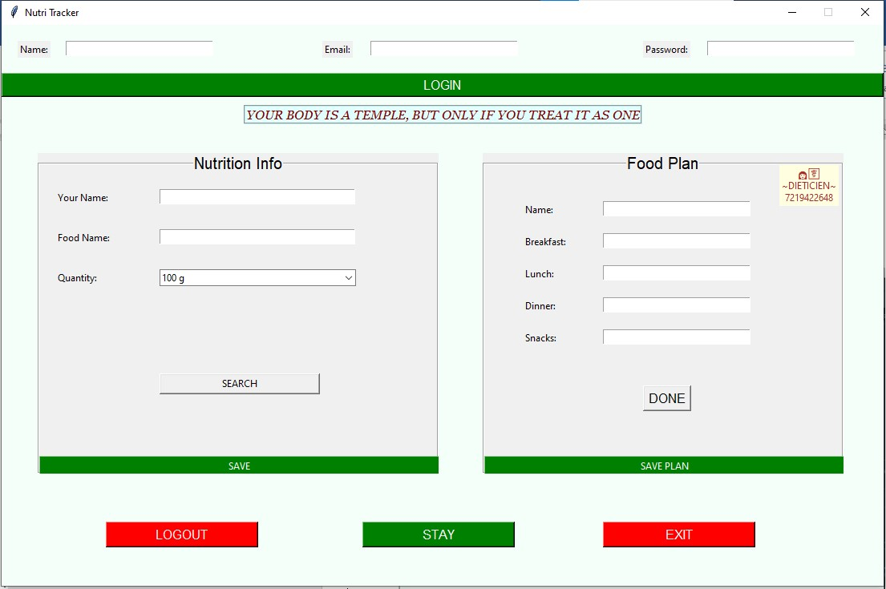

➢LOGGING USER:
- GUI
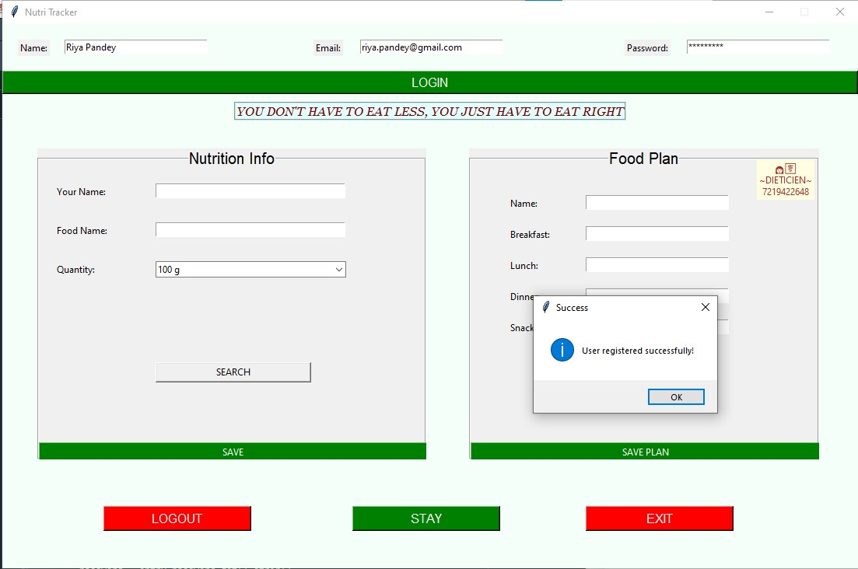

- MYSQL 

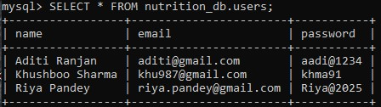

➢NUTRITION DATA:
- GUI
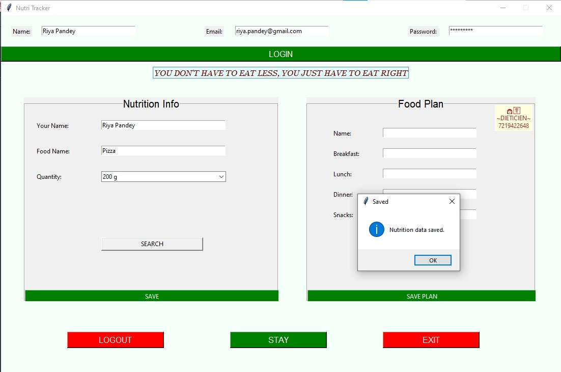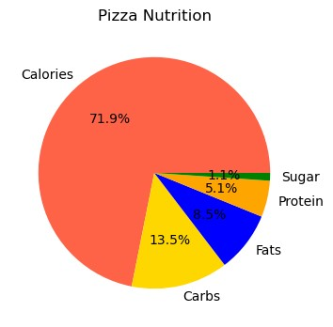

- MYSQL

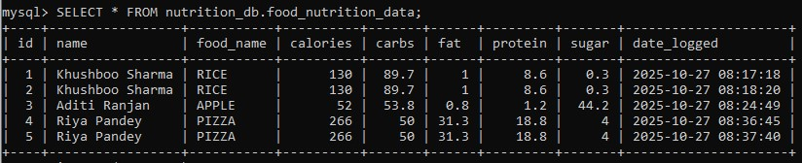

➢FOOD PLAN
- GUI
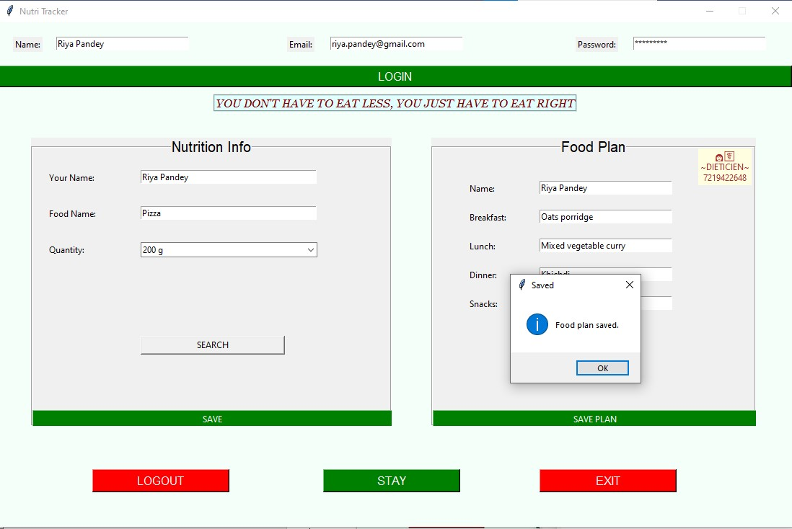

- MYSQL

➢LOGGING OUT USER:
- GUI

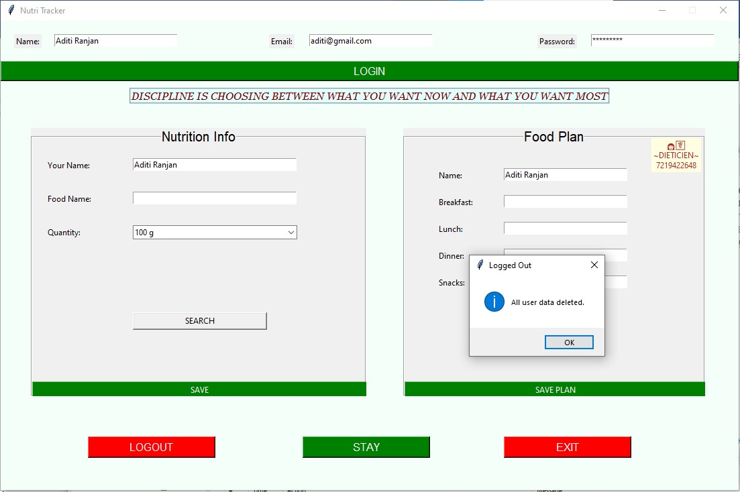

- MYSQL

# users Table

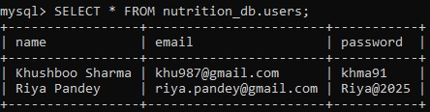

# food_plan Table

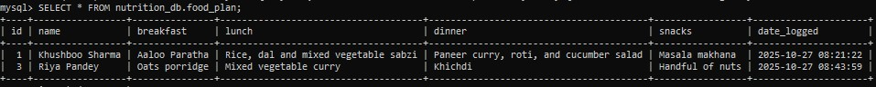

# food_nutrition_data Table

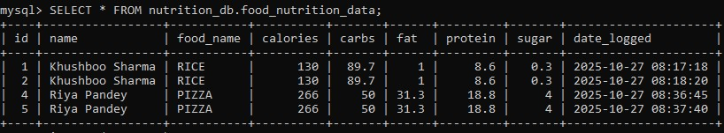

BIBLIOGRAPHY

➢ YOUTUBE: https://youtu.be/-

Q4lm8eYulw?si=PzKg2gBwdJAZp973

➢ Website: https://www.scribd.com

