NAME: KHUSHBU DURGE UIN: 661389838

**CS 478: SOFTWARE DEVELOPMENT FOR MOBILE PLATFORMS**

**HOMEWORK – 1**

**Q1.** Screen shot of SDK Manager with downloaded files: (for Nougat API-25 and Lolipop API-21)

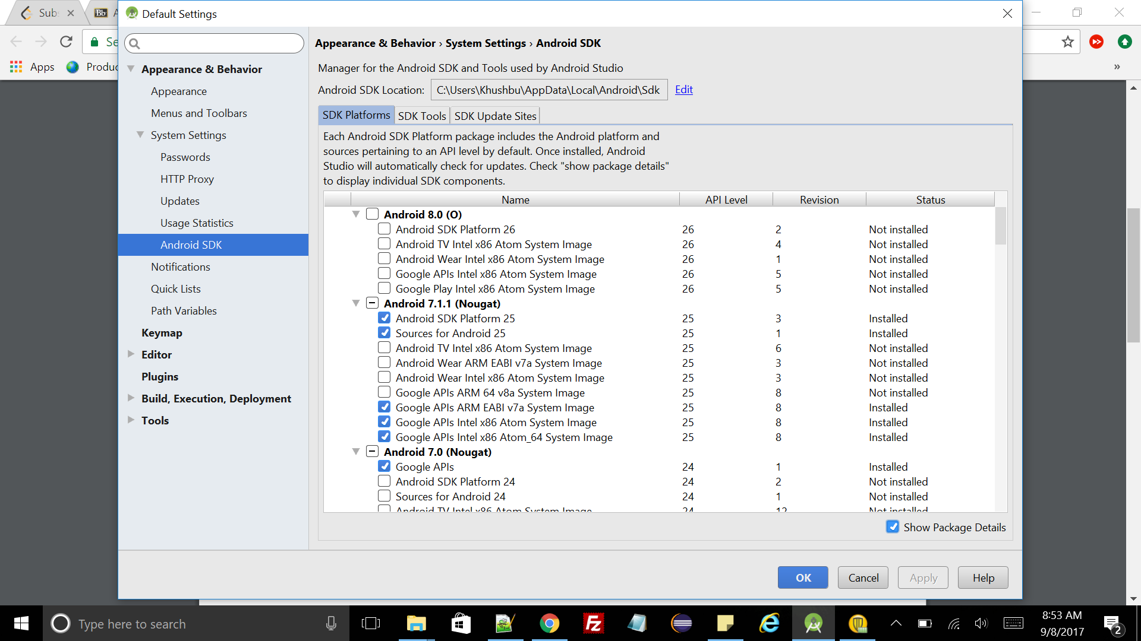

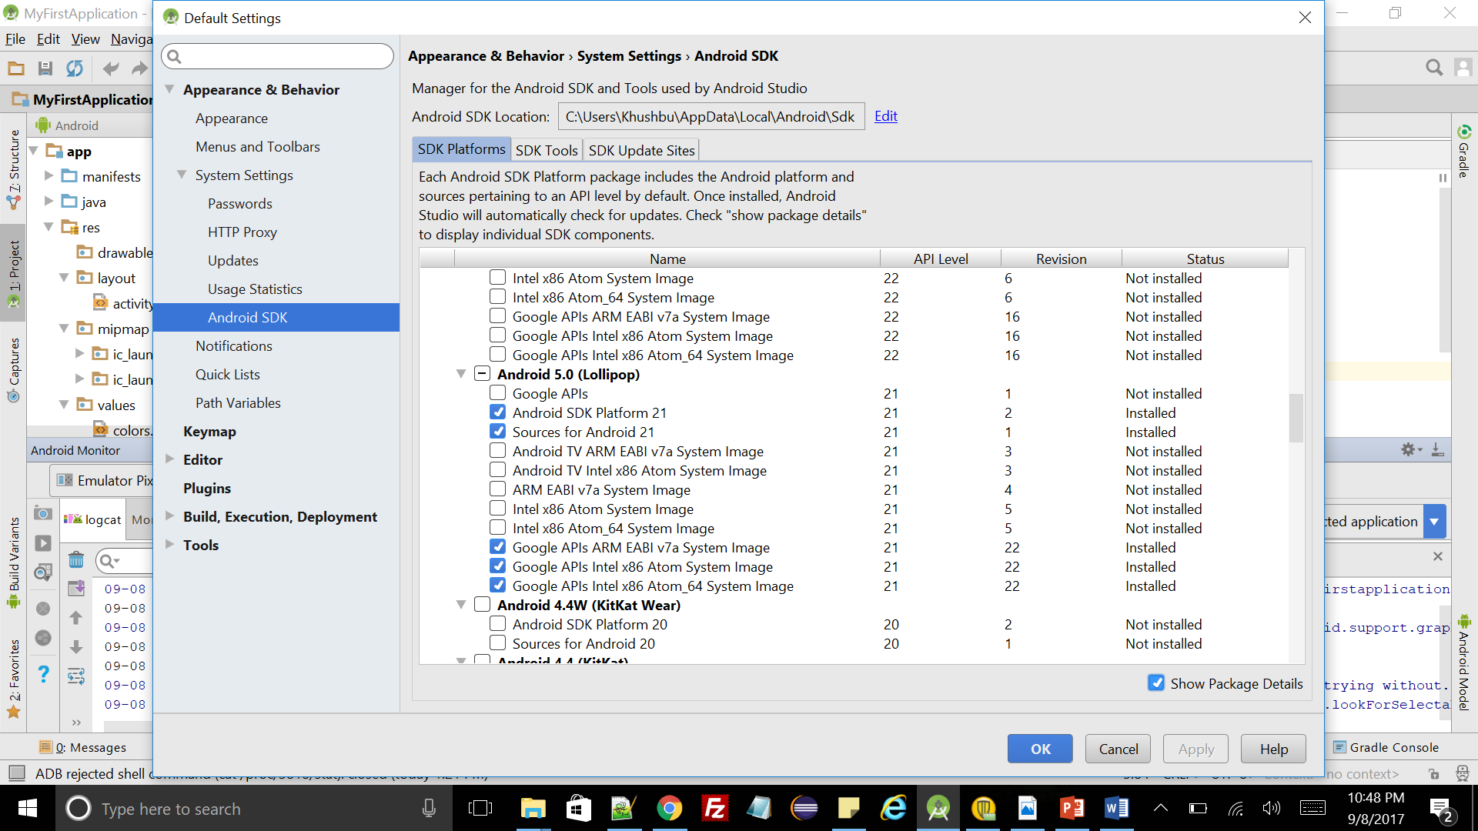

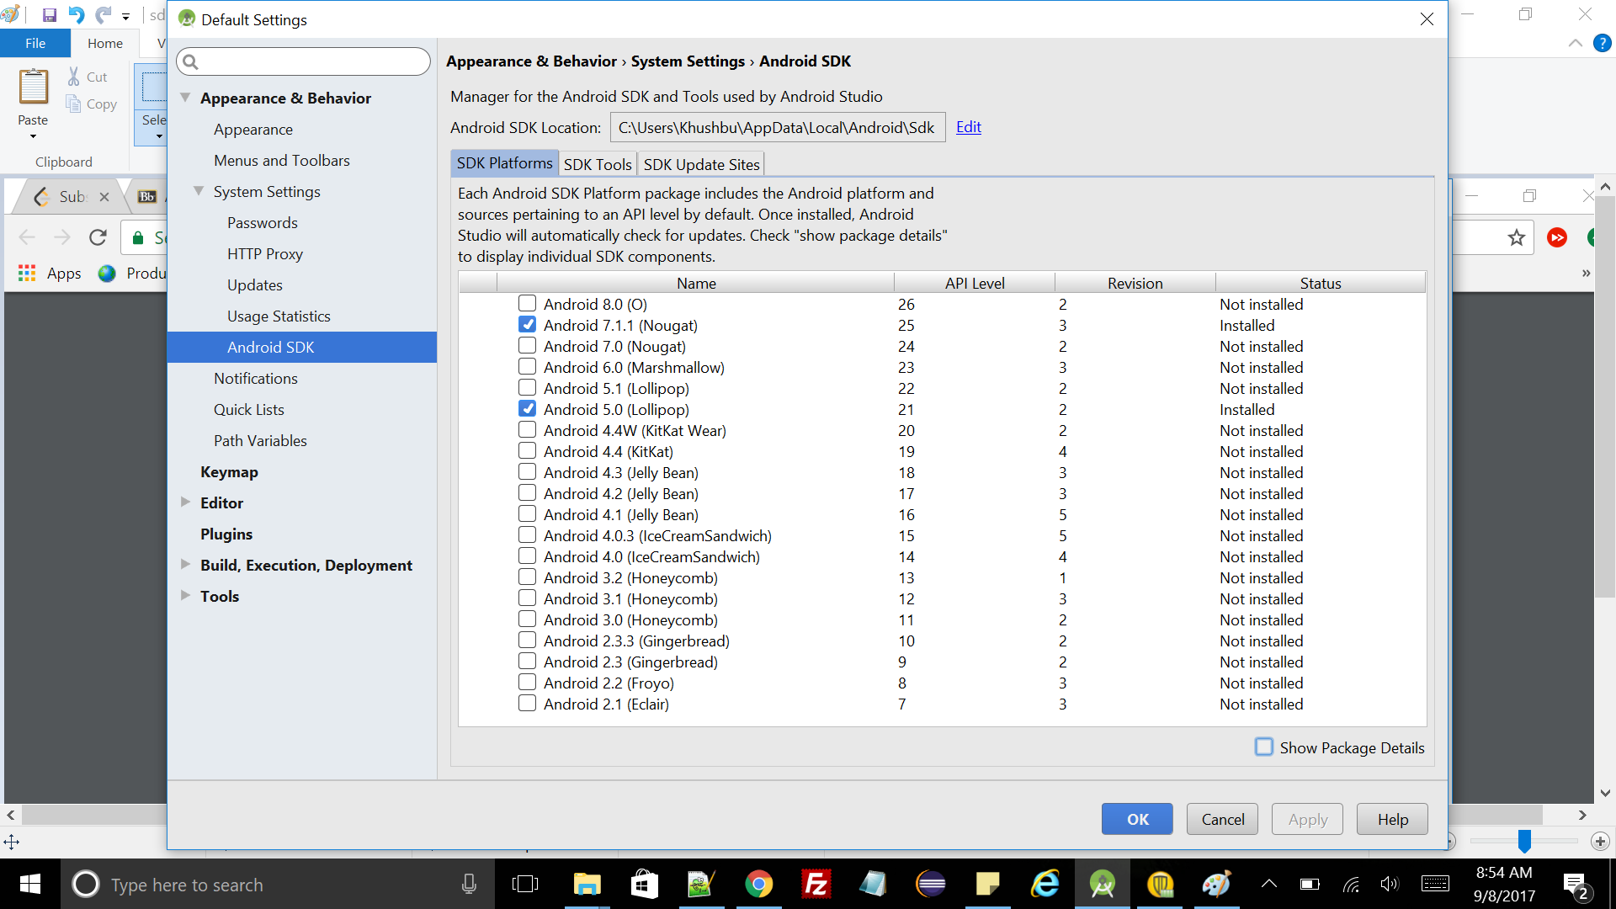

**Q2.** Screenshot of AVD display with Google Pixel XL(API-25) and Nexus 5X(API-21):

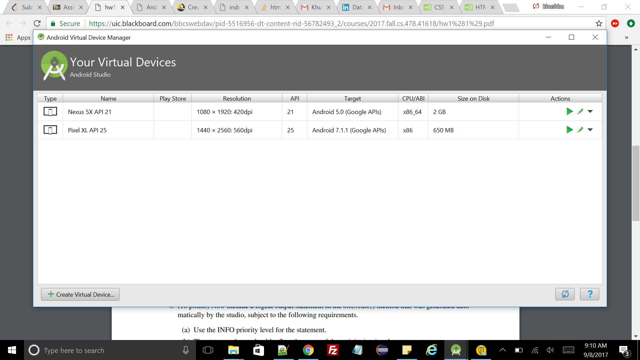

**Q3.** Screenshot of “My First Application” with an a) Google Pixel XL and b) Nexus 5X :

1. Google Pixel XL

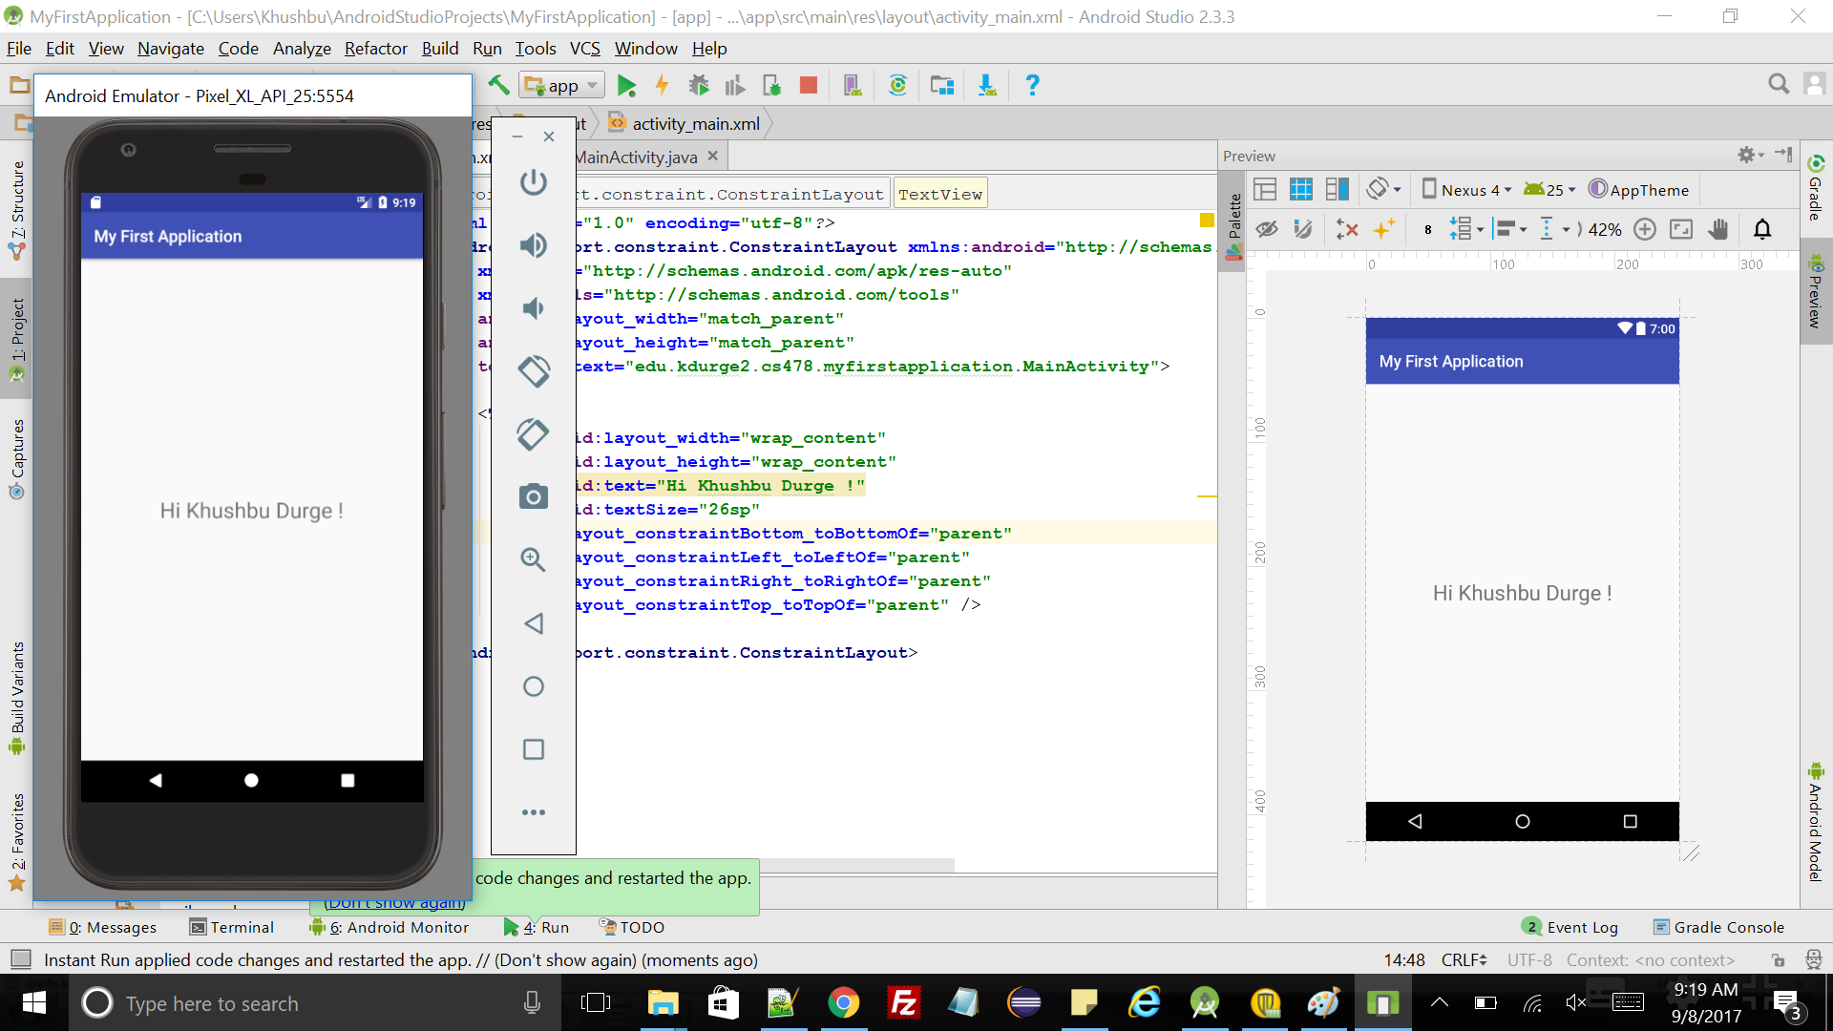

1. Nexus 5X:

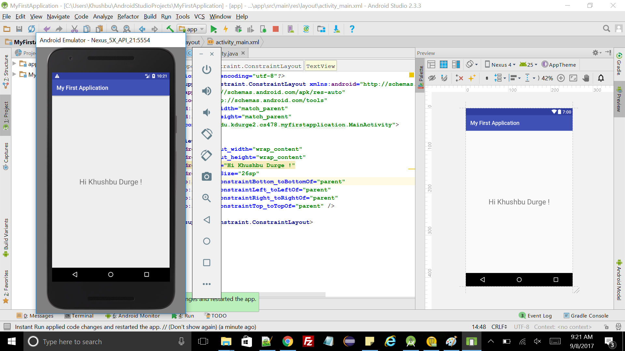

**Q4.** Screenshot of Logcat statement in onCreate() method with INFO priority level and tagname and message as “Main Activity:” and “Khushbu Durge was here!” respectively. **The statement in the Android monitor has been highlighted.**

