khushboo umrigar

Humber college | 205 humber college blvd, Toronto ontario canada m9w 5l7

Amazon Website

Assignment 1

## Description:

Amazon is online retailing website. Amazon sells their product worldwide. It has sellers from worldwide. Word Amazon defines A to Z. They sell A to Z products. Since Amazon has multiple sellers, for same product prices varies from sellers to sellers.

Amazon has different delivery option and is known for fast delivery of products.

## Database:

|  |  |
| --- | --- |
| categoryDB | |
| Column | Description |
| category | Unique ID |
| title | Name of the category |
| imgPath | Name of the image |

|  |  |
| --- | --- |
| productDB | |
| Column | Description |
| product | Unique ID |
| title | Name of the product |
| type | Type of the product (ex, sofa, chair) |
| description | Description contains the color and related information about the product |
| price | Price of the product |
| isFeatured | Contains Boolean value, true or false |
| imgPath | Name of the image |

## Website views.

### Home page

home page contains the navigation, promotional section (SALE), featured products, different categories and footer. Clicking on the logo brings you back to the home page. Featured products displayed from the database called prodcutDB & categories are also displayed from categoryDB. 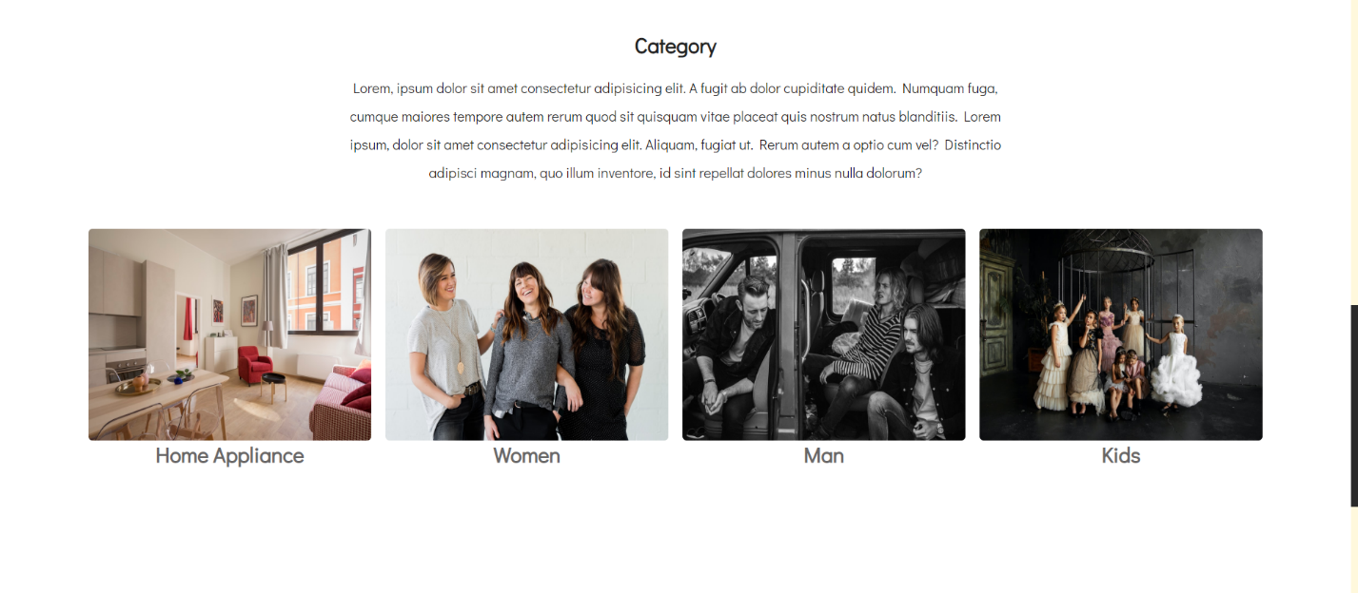

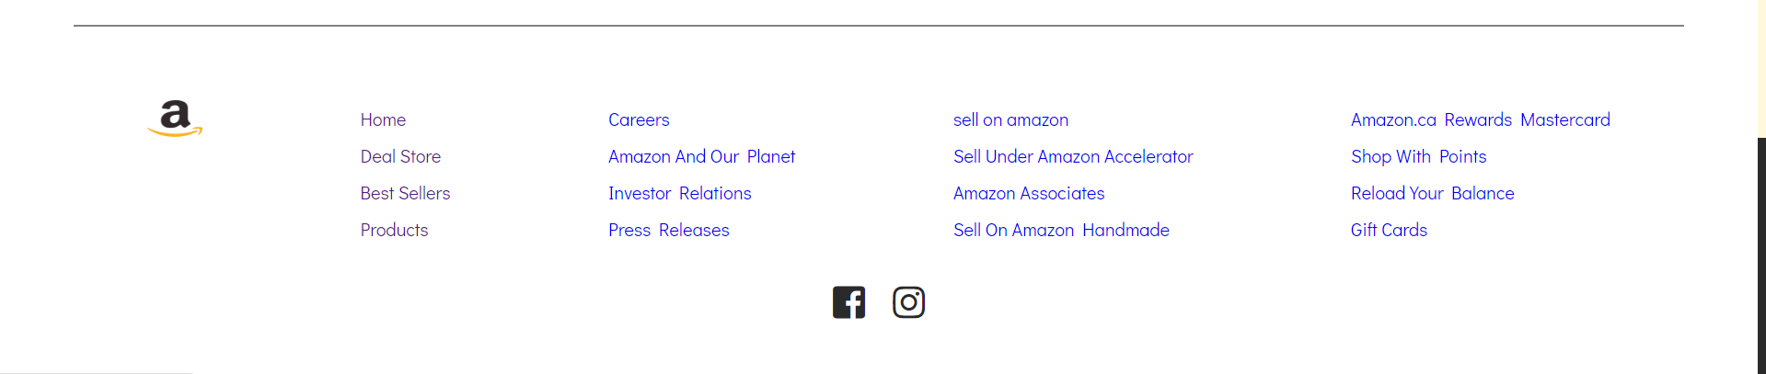

### Coming Soon page

This page is in progress.

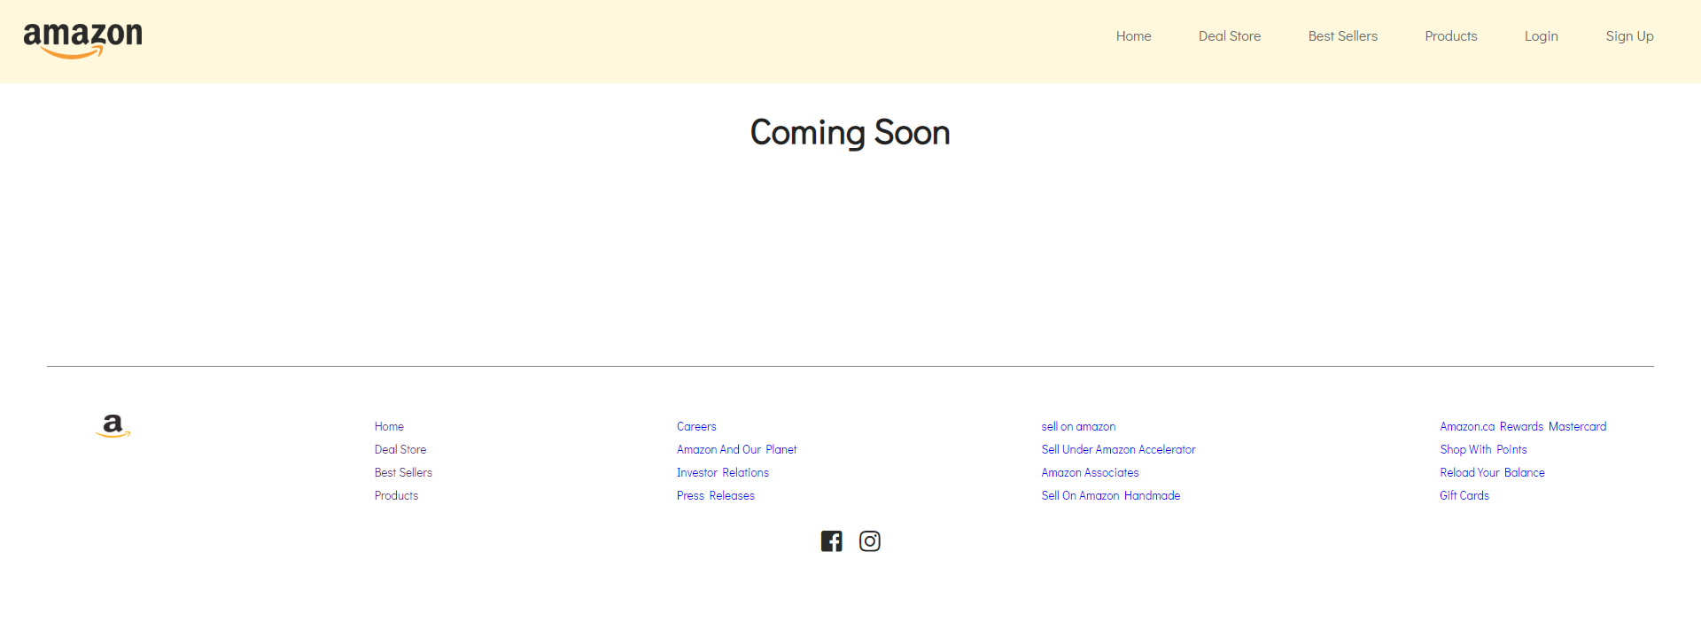

### Product Listing Page

Product listing page have image of the product, description, and price of the product. This data is coming from fake database created.

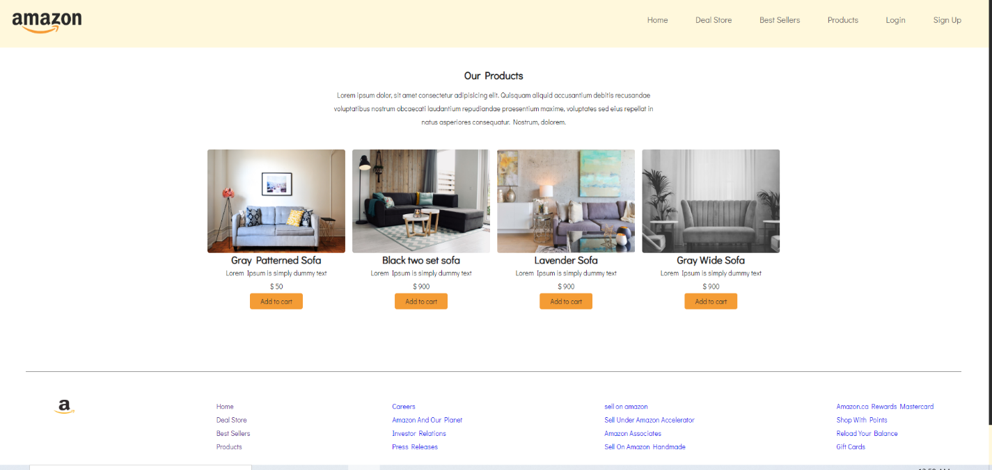

### Login Page

Login page for the registered users. This page is the dummy login page. This page does not contain any functionality for now.

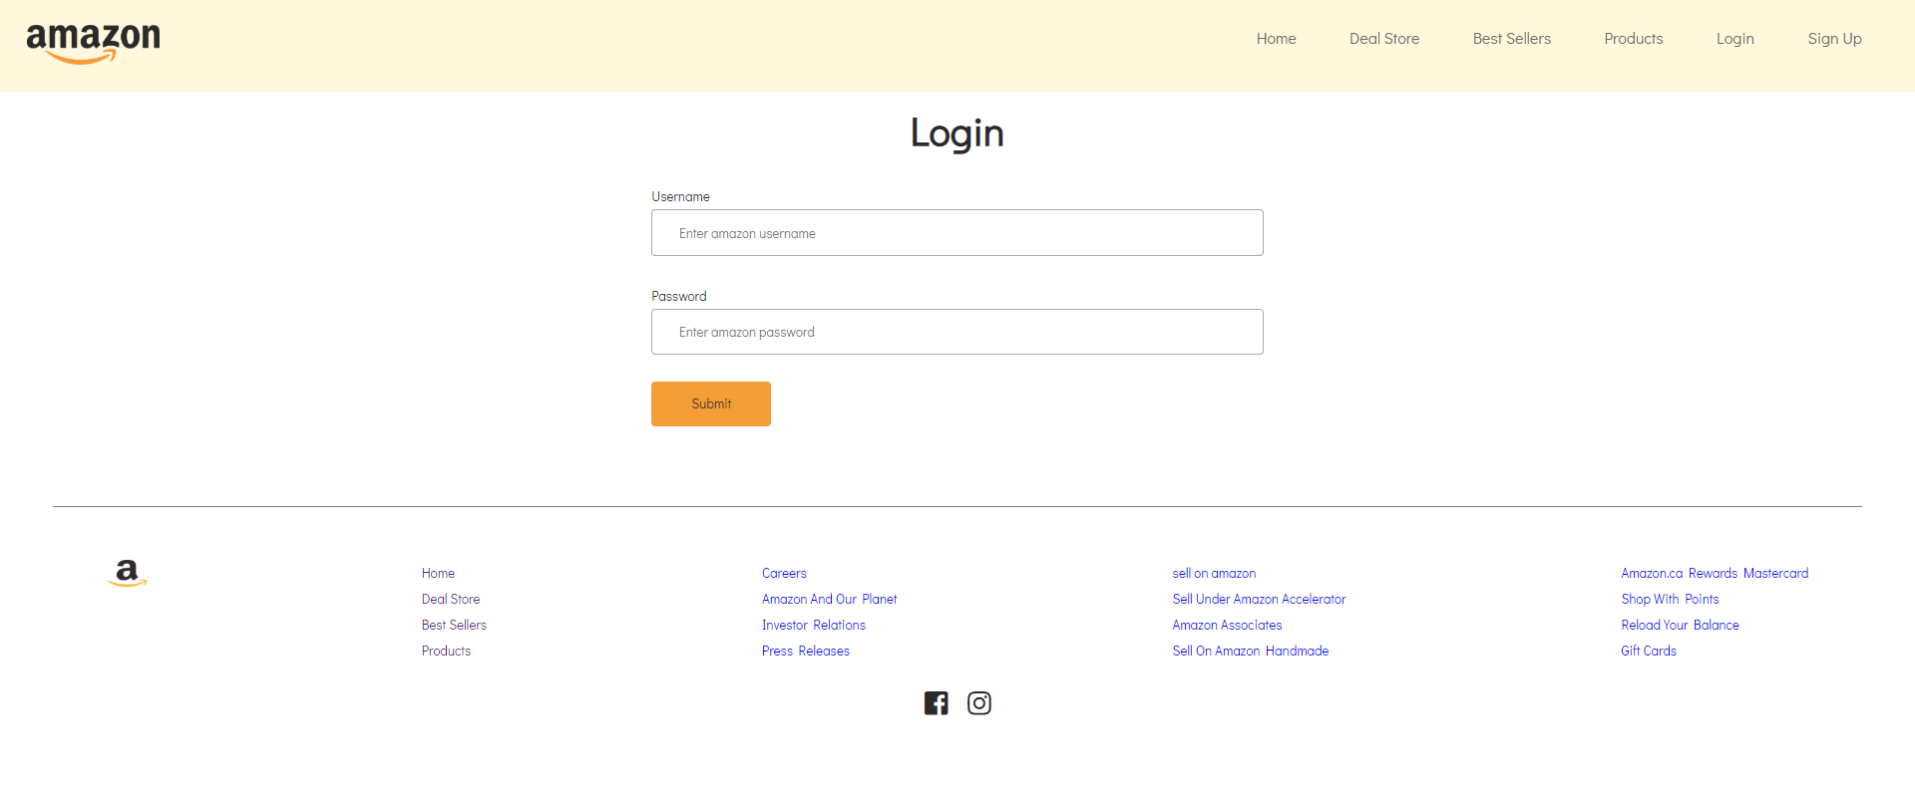

### Sign up Page

Sign up page for new users to become member of amazon. This page is the dummy registration page. This page does not contain any functionality for now.

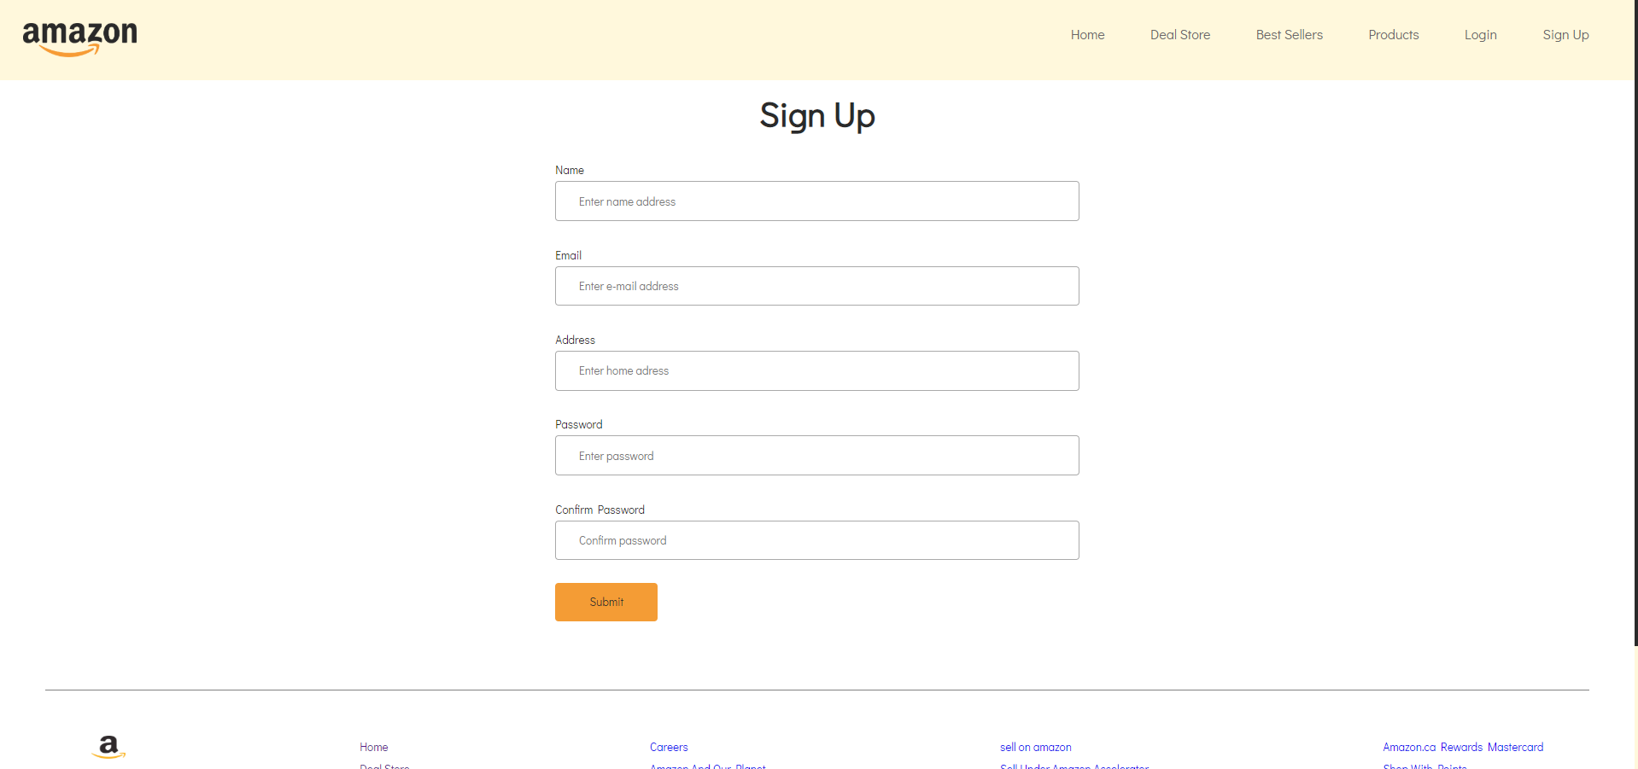

NOTE: appearance of the website may differ than the screenshot. Cause I am pushing the entire project before the deadline and I might change the UI of the website.