Name :- khushal dilipbhai vadher

Roll :- CE151

GitHub Link:-

<https://github.com/khushal-vadher/SDP>

main.dart

import 'package:flutter/material.dart';  
import 'package:my_first_flutter_android_project/pages/home.dart';  
void main() => runApp(MaterialApp(  
 home: Home(),  
));

home.dart

import 'package:flutter/material.dart';  
class Home extends StatefulWidget {  
 @override  
 State<Home> createState() => _HomeState();  
}  
class _HomeState extends State<Home> {  
 @override  
 Widget build(BuildContext context) {  
 return Scaffold(  
 body: SafeArea(child: Text('HOME SCREEN')),  
 );  
 }  
}

choose_location.dart

import 'package:flutter/material.dart';  
class ChooseLocation extends StatefulWidget {  
// const ChooseLocation({Key? key}) : super(key: key);  
 @override  
 State<ChooseLocation> createState() => _ChooseLocationState();  
}  
class _ChooseLocationState extends State<ChooseLocation> {  
 @override  
 Widget build(BuildContext context) {  
 return Scaffold(  
 body: Text('CHOOSE LOCATION SCREEN'),  
 );  
 }  
}

loading.dart

import 'package:flutter/material.dart';  
class Loading extends StatefulWidget {  
// const Loading({Key? key}) : super(key: key);  
 @override  
 State<Loading> createState() => _LoadingState();  
}  
class _LoadingState extends State<Loading> {  
 @override  
 Widget build(BuildContext context) {  
 return Scaffold(  
 body: Text('LOADING SCREEN'),  
 );  
 }  
}

home screen is display on the top of the devise

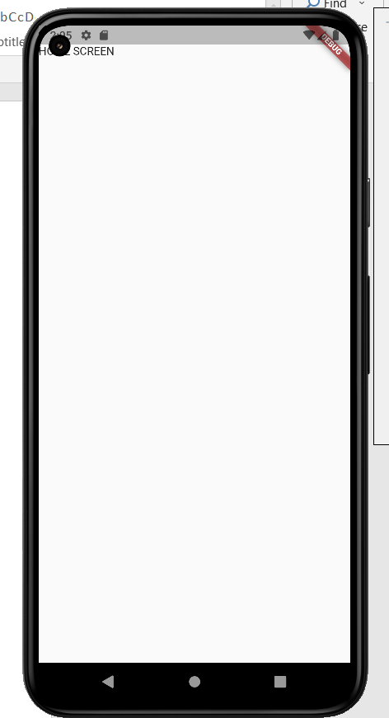

Test2:-

Main.dart

import 'package:flutter/material.dart';  
import 'package:my_first_flutter_android_project/pages/choose_location.dart';  
import 'package:my_first_flutter_android_project/pages/home.dart';  
import 'package:my_first_flutter_android_project/pages/loading.dart';  
void main() => runApp(MaterialApp(  
 initialRoute:'/home',  
 routes: {  
 '/': (context) => Loading(),  
 '/home':(context) => Home(),  
 '/location': (context) => ChooseLocation(),  
 }  
));

Home.dart

import 'package:flutter/material.dart';  
class Home extends StatefulWidget {  
 @override  
 State<Home> createState() => _HomeState();  
}  
class _HomeState extends State<Home> {  
 @override  
 Widget build(BuildContext context) {  
 return Scaffold(  
//test1  
// body: SafeArea(child: Text('HOME SCREEN'),)  
//test2  
 body: SafeArea(  
 child: Column(  
 children: [  
 TextButton.icon(  
 onPressed: (){  
 Navigator.*pushNamed*(context, '/location');  
 },  
 icon: Icon(Icons.*edit_location*),  
 label: Text('EDIT LOCATION'),  
 )  
 ],  
 ),  
 ),  
 );  
 }  
}

Choose_location.dart

import 'package:flutter/material.dart';  
class ChooseLocation extends StatefulWidget {  
// const ChooseLocation({Key? key}) : super(key: key);  
 @override  
 State<ChooseLocation> createState() => _ChooseLocationState();  
}  
class _ChooseLocationState extends State<ChooseLocation> {  
 @override  
 Widget build(BuildContext context) {  
 return Scaffold(  
 backgroundColor: Colors.*blueAccent*[2000],  
 appBar: AppBar(  
 backgroundColor:Colors.*deepOrangeAccent*,  
 title: Text('CHOOSE LOCATION'),  
 centerTitle: true,  
 elevation: 0,  
 ),  
 body: Text('CHOOSE LOCATION SCREEN'),  
 );  
 }  
}

Loading.dart

import 'package:flutter/material.dart';  
class Loading extends StatefulWidget {  
// const Loading({Key? key}) : super(key: key);  
 @override  
 State<Loading> createState() => _LoadingState();  
}  
class _LoadingState extends State<Loading> {  
 @override  
 Widget build(BuildContext context) {  
 return Scaffold(  
 body: Text('LOADING SCREEN'),  
 );  
 }  
}

