

**Video Training Document**

Contents:

I. Setup github account and push data: 3

I. Introduction of Video 7

II. Display Resolution 8

III. Frame per second 9

IV. Bit-depth 9

V. References 11

# Setup github account and push data:

1. For create github account visit <https://github.com/>
2. Bellow view will open, if already have account or have to create new account base on that select sign in or sign up respectively.

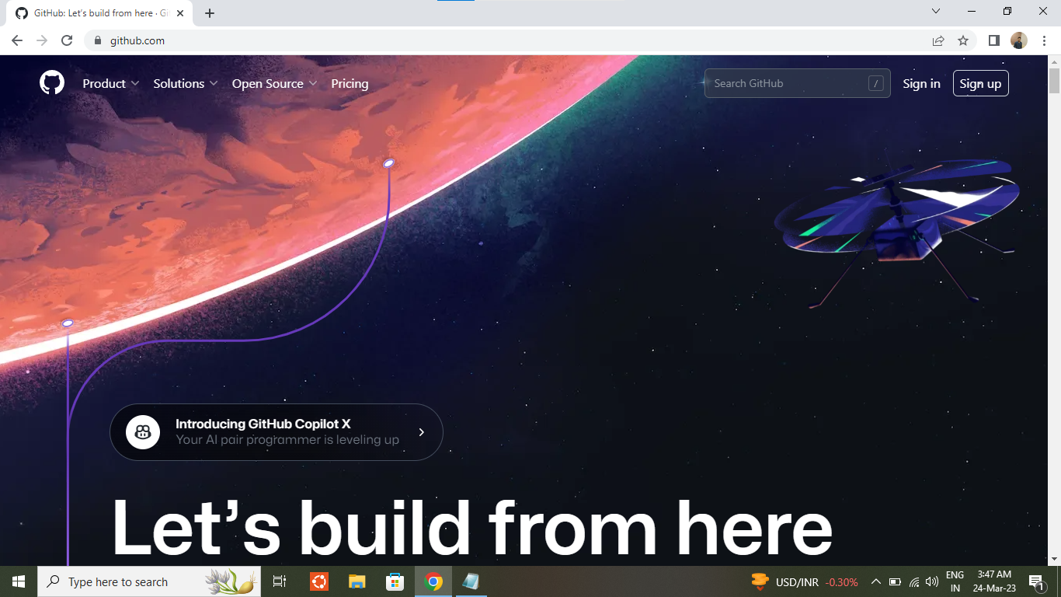

1. For create new account following details have to fill up.

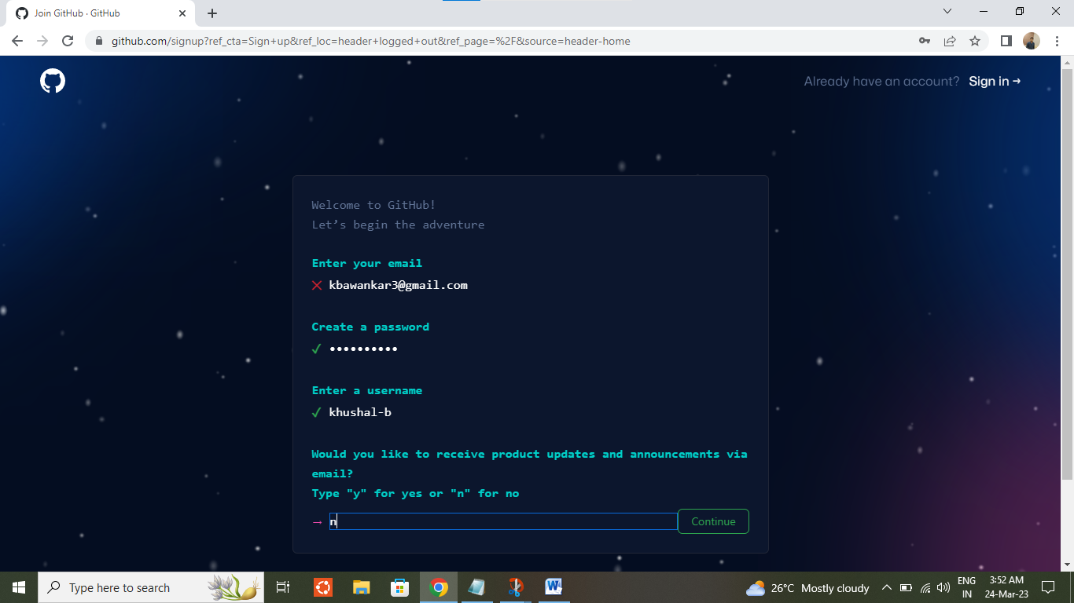

1. Click on solve puzzle for start verification.

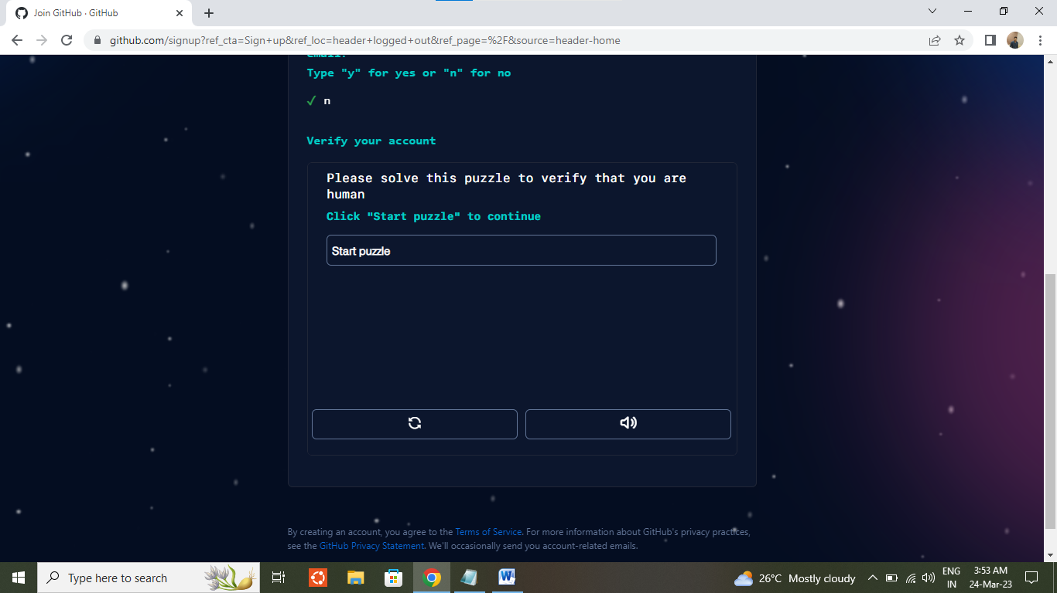

1. Once done above step click on create account. Account will be create.

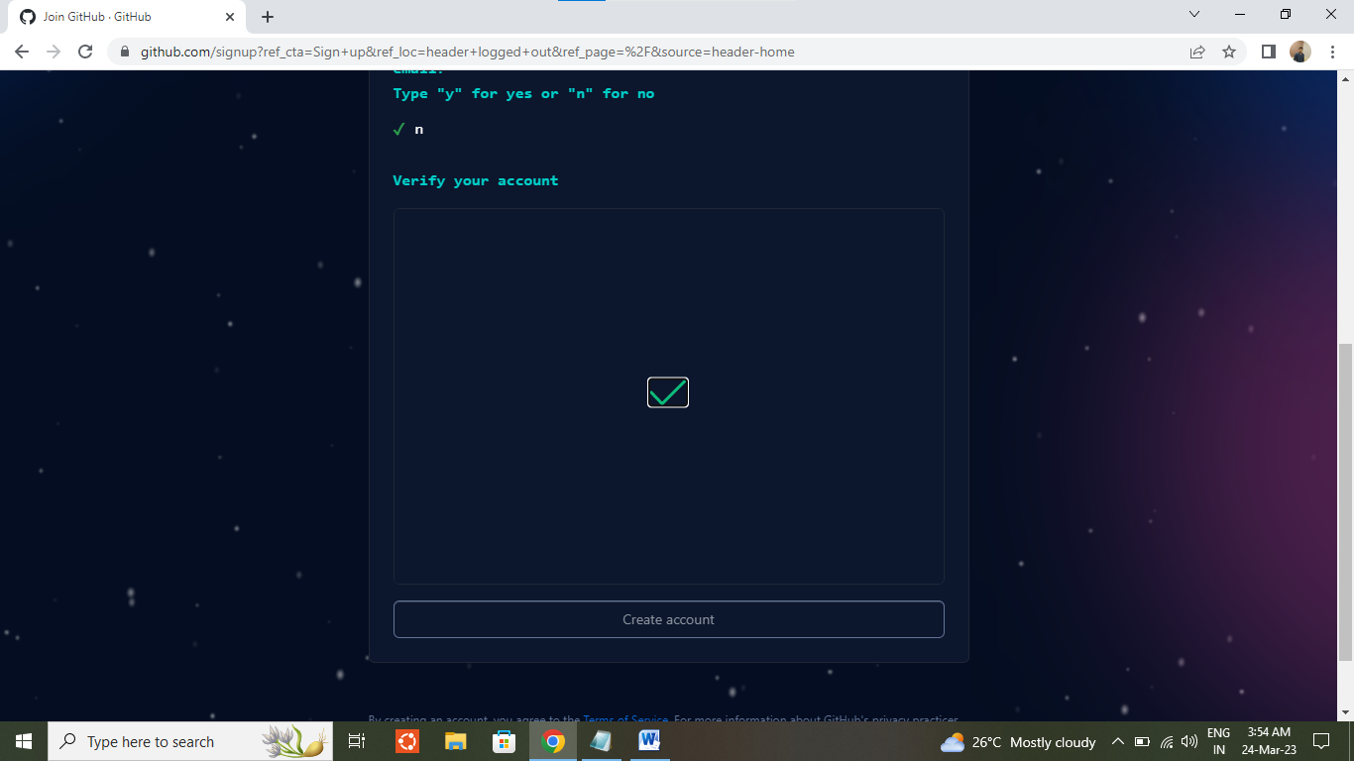

1. After login to the account below interface will be come out. For create repository select below option.

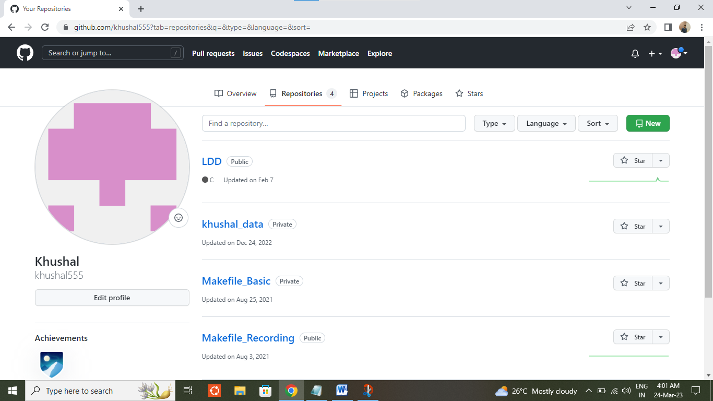

**1**

**2**

1. Enter repo name, select privacy as public or private as per requirement. Come at the end and select create repository.

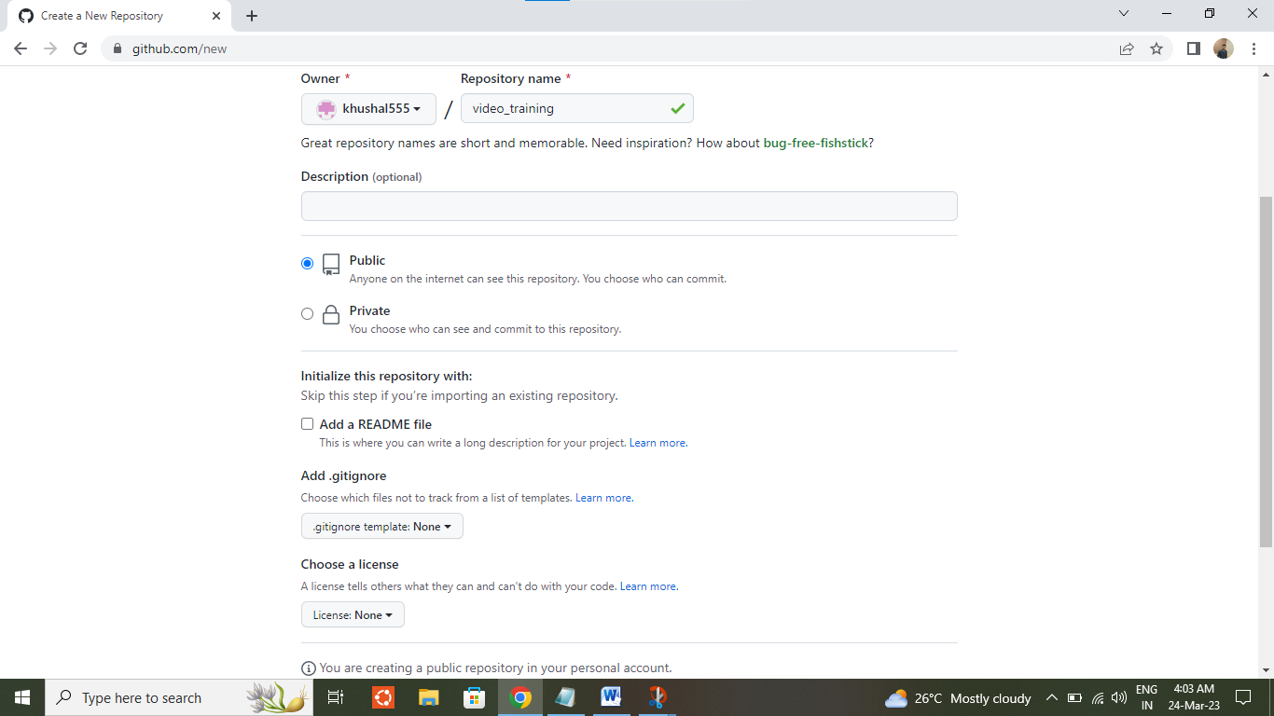

SSH url will be used for push or pull data from github account.

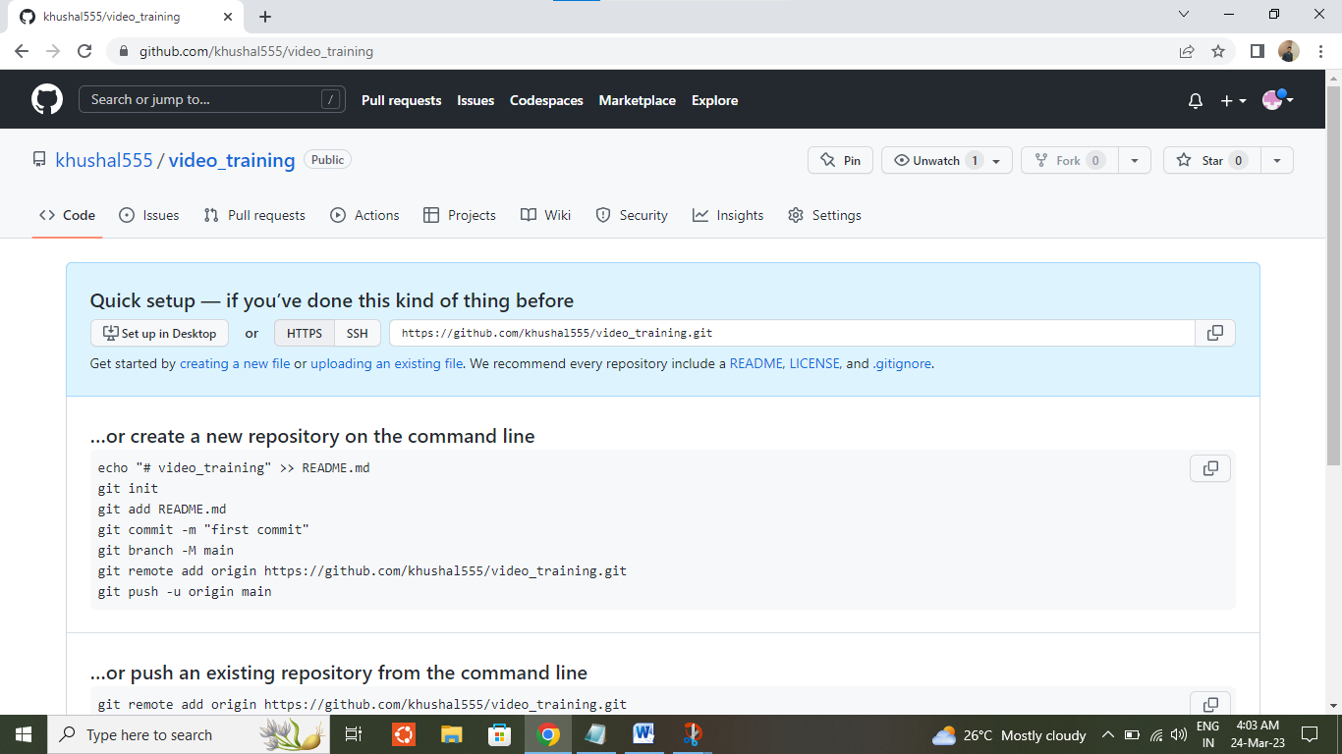

1. After add and commit the required file which has to push on github just add ssh by “git remote add” command. And then committed data can be push by “git push” command.

While push any data username and password, have to enter. This password will be a token number and can be generate by following <https://docs.github.com/en/authentication/keeping-your-account-and-data-secure/creating-a-personal-access-token> this page.

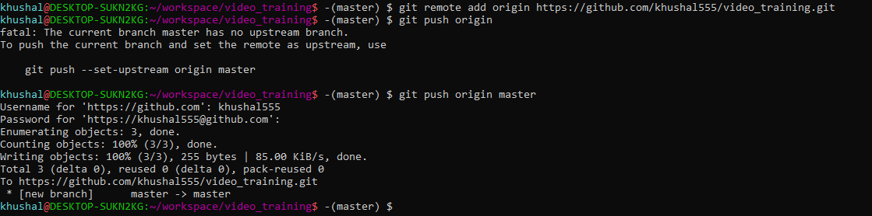

# Introduction of Video

Recording of an image or moving images is known as video.

Video is used to generate a steady source of still pictures as it is a series of electronic signals, which simulate movement.

It’s a technology for electronic capture, storage and transmission of images and motion picture.

Light waves of object passes through lens, that light converted into electrical signals using Charge Coupled Device (CCD). In cameras three CCD use for three different hue (R, G, and B).

Video follow three standards:

1. Luminance: Brightness of pixel.
2. Chrominance: Color information
3. Synchronization: Series of electronic pulses that control by time of each frame of video.

Video is categorized in two types.

1. Analog Video
2. Digital Video

|  |  |  |
| --- | --- | --- |
| Sr. | Analog Video | Digital Video |
| 1 | Digital signals are used for transition of data. At the end when its combine its known as composite video. | It is an electronic representation of moving visual images in the form of encoded digital data. |
| 2 | Have continues electrical signal. | Non-continues electrical signal. |
| 3 | Use many line per frames. | It has different frames. (P, B and I frame). |
| 4 | It’s a continues waveform | Composition of discrete bit |
| 5 | Analog video continues signal to capture footage on magnetic tape. | Digital video is made up of composition of bits, which can read by the processor. |
| 6 | Have varying signal. | Have square wave or clock signal. |
| 7 | Max value will be positive and min value will be negative. | Max value will be 5 volts and min value will be 0 volt. |
| 8 | Use mainly for audio and video transmission. | Use to suit for digital electronic devices. |
| 9 | Ex. Magnetic Tape | Ex: Mobile, PC, DVD. |

Analog video is prepared for digital transmission:

Sampling code -> Digitizing Modulation -> Source Encoding -> Multiplexing -> Channel

Sampling code = Image get sampled

Digitizing = Convert samples into digital data

Encoding = Convert to particular format

Multiplexing = Amplify data

Channel = Use for Transition part

Digital video follow progressive scan by Video Capture Card. This scan draws odd/even lines simultaneously.

NTSC, PAL, SECAM are analog video format use for broadcasting.

**Progressive Video:**Video sources that are listed with the letter **p** are called progressive scan signals. Examples of this would be 480p, 720p or 1080p. Progressive scan video content displays both the even and odd scan lines (the entire video frame) on the TV at the same time. A High Speed HDMI cable is required to transmit a video signal in 1080p.

**Interlaced Video:**  Video sources that are listed with the letter **i** are called interlaced. An example of this would be 480i or 1080i. Interlaced video displays even and odd scan lines as separate fields. The even scan lines are drawn on the screen, then the odd scan lines are drawn on the screen. Two of these even and odd scan line fields make up one video frame.

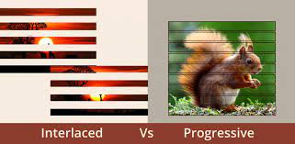

# Display Resolution

A computer screen uses millions of pixels to display images. These pixels are arranged in a grid horizontally and vertically. The number of pixels horizontally and vertically is shown as the screen resolution.

Screen resolution is typically written as 1024 x 768. This means that the screen has 1024 pixels horizontally and 768 pixels vertically.

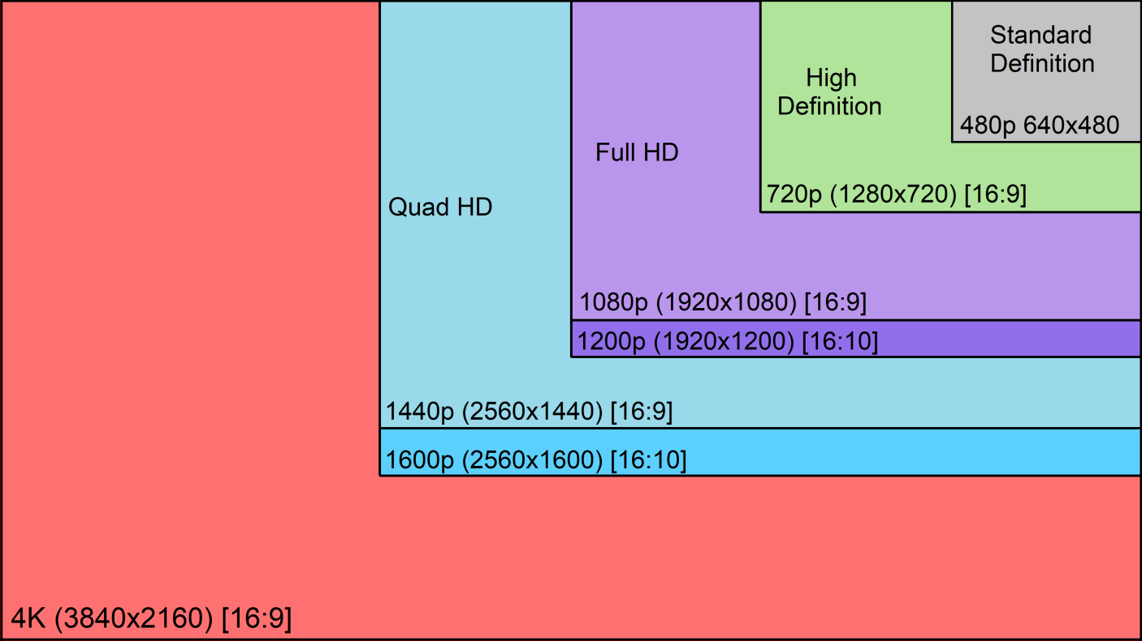

# Frame per second

The number of images consecutively displayed each second.24 FPS is the normal frame rate in video.

60 FPS and 120 FPS makes video slow and slow.

# Bit-depth

Bit depth refers to the color information stored in an image. The higher the bit depth of an image, the more colors it can store. The simplest image, a 1 bit image, can only show two colors, black and white. That is because the 1 bit can only store one of two values, 0 (white) and 1 (black). An 8 bit image can store 256 possible colors, while a 24 bit image can display over 16 million colors. As the bit depth increases, the file size of the image also increases because more color information has to be stored for each pixel in the image.

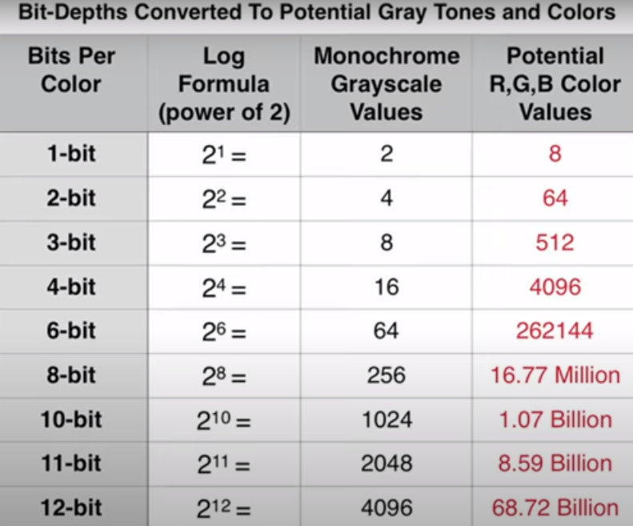

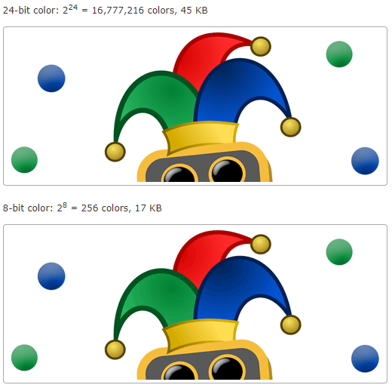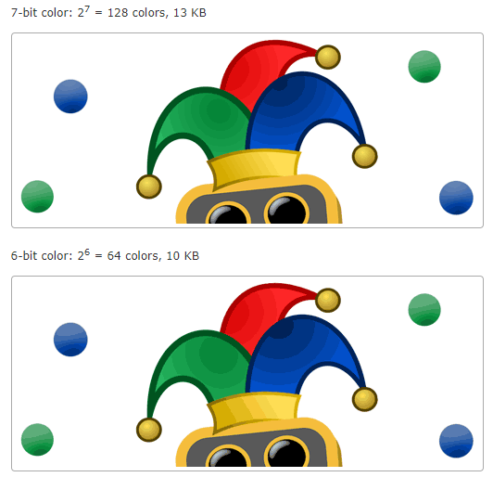

# References

Video Introduction

<https://www.javatpoint.com/what-is-video/>

<https://www.techtarget.com/whatis/definition/progressive-scan/>

Analog and Digital video

<https://prezi.com/6flndlf-ymhf/the-difference-between-analog-video-and-digital-video/>

<https://www.youtube.com/watch?v=iETz3glO4XE/>

<https://www.youtube.com/watch?v=ujQI65OU5HM/>

Display resolutions:

<https://etc.usf.edu/techease/win/images/what-is-bit-depth/>

<https://www.youtube.com/watch?v=ogYACMsBg5w/>

<https://support.humblebundle.com/hc/article_attachments/360008054853/Resolutions.png/>

FPS:

<https://www.youtube.com/watch?v=-RHGGVMkNwc/>

<https://www.youtube.com/watch?v=_XzGhc9mPVk&t/>