**Experiment 1.1**

**Student Name:** Khushal Grover **UID:** 22MCC20040

**Branch:** MCA CC and Devops **Section/Group:** 1/B

**Semester:** 1 **Date of Performance:**27-09-2022

**Subject Name:** Advanced Database Management

System. **Subject Code:** 22CAP-647

1. **Aim/Overview of the practical:**

Amber's conglomerate corporation just acquired some new companies. Each of the companies follows this hierarchy:

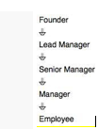

Given the table schemas below, write a query to print the company_code, founder name, total number of lead managers, total number of senior managers, total number of managers, and total number of employees. Order your output by ascending company_code.

**Note:**

The tables may contain duplicate records.

The company_code is string, so the sorting should not be numeric. For example, if the company_codes are C_1, C_2, and C_10, then the ascending company_codes will be C_1, C_2, and C_10.

**Sample Input**

Company Table:

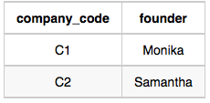

Lead_Manager Table:

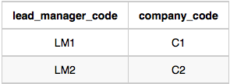

Senior_Manager Table:

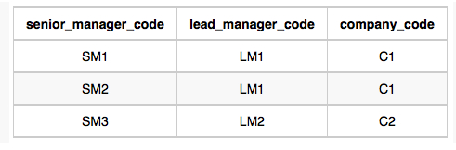

Manager Table:

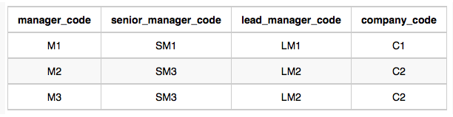

Employee Table:

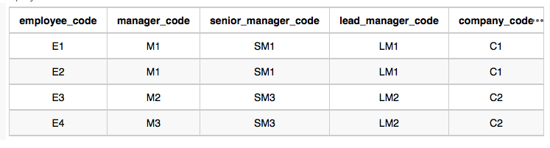

**Sample Output**

C1 Monika 1 2 1 2

C2 Samantha 1 1 2 2

1. **Code for experiment/practical:**
   1. **For Creating tables :**

create table Company(company_code varchar(10), founder varchar(30));

insert into Company values('C1', 'Neel');

insert into Company values('C2', 'Nitin');

insert into Company values('C3', 'Mukesh');

create table Lead_Manager(lead_manager_code varchar(10), company_code varchar(10));

insert into Lead_Manager values('LM1', 'C1');

insert into Lead_Manager values('LM2', 'C2');

insert into Lead_Manager values('LM3', 'C3');

insert into Lead_Manager values('LM4', 'C3');

create table Senior_Manager(senior_manager_code varchar(10), lead_manager_code varchar(10), company_code varchar(10));

insert into Senior_Manager values('SM1', 'LM1', 'C1');

insert into Senior_Manager values('SM2', 'LM1', 'C1');

insert into Senior_Manager values('SM3', 'LM2', 'C2');

insert into Senior_Manager values('SM4', 'LM3', 'C3');

insert into Senior_Manager values('SM5', 'LM3', 'C3');

create table Manager(manager_code varchar(10), senior_manager_code varchar(10), lead_manager_code varchar(10), company_code varchar(10));

insert into Manager values('M1', 'SM1', 'LM1', 'C1');

insert into Manager values('M2', 'SM2', 'LM1', 'C1');

insert into Manager values('M3', 'SM3', 'LM2', 'C2');

insert into Manager values('M4', 'SM3', 'LM2', 'C2');

insert into Manager values('M6', 'SM5', 'LM3', 'C3');

create table Employee(employee_code varchar(10), manager_code varchar(10), senior_manager_code varchar(10), lead_manager_code varchar(10), company_code varchar(10));

insert into Employee values('E1', 'M1', 'SM1', 'LM1', 'C1');

insert into Employee values('E2', 'M1', 'SM1', 'LM1', 'C1');

insert into Employee values('E3', 'M2', 'SM2', 'LM1', 'C1');

insert into Employee values('E4', 'M3', 'SM3', 'LM2', 'C2');

insert into Employee values('E6', 'M5', 'SM4', 'LM3', 'C3');

insert into Employee values('E7', 'M6', 'SM5', 'LM3', 'C3');

* 1. **Query to get desired output:**

select c.company_code, c.founder,

count (distinct Lead_Manager.lead_manager_code),

count (distinct senior_manager.senior_manager_code),

count (distinct manager.manager_code),

count (distinct employee.employee_code)

from Company c

join Lead_Manager on c.company_code = Lead_Manager.company_code

join Senior_manager on c.company_code = senior_manager.company_code

join manager on c.company_code = manager.company_code

join employee on c.company_code = employee.company_code

group by c.company_code, c.founder

order by c.company_code

1. **Output:**
   1. **Tables :**

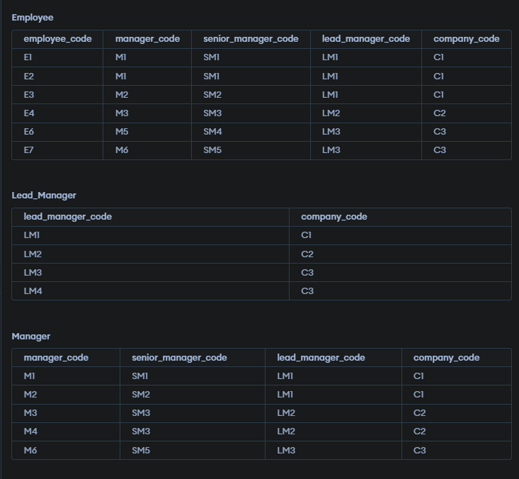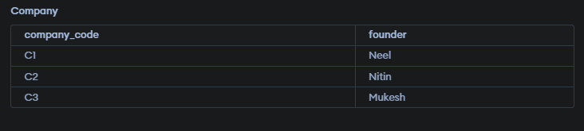

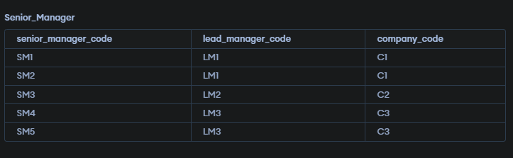

* 1. **Query Result:**

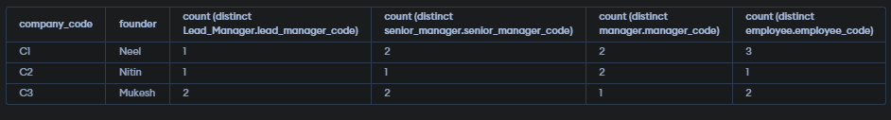

**Learning outcomes :**

**1. Inner Join**

**2. SQL Queries**