**Shri Ramdeobaba College of Engineering & Management, Nagpur Department of Computer Science & Engineering**

**Session: 2024-2025**

**Department: Computer Science and Engineering**

**Semester: V**

**Section: A**

**PROJECT SYNOPSIS**

**Title: Smart Resume Analyzer and Job Recommendation System**

**Member Details:**

| **Roll No.** | **Name and sign of Students** |
| --- | --- |
| 02 | Akshata Katole |
| 07 | Khushali Begde |
| 39 | Jatin Jasrotia |
|  |  |

**Problem Definition:**

Job seekers often have trouble finding job opportunities that align with their skills and experiences, while recruiters face challenges in filtering through large volumes of resumes to identify the best candidates. HR professionals also need an efficient way to manage job descriptions and match them with suitable candidates. This project aims to develop an intelligent system that automates resume analysis, ranks candidates based on their qualifications, and recommends suitable job openings. Additionally, HR professionals will be able to input job descriptions, view all eligible candidates after resume analysis, and streamline the recruitment process.

# Project Objectives:

1. **Resume Upload and Parsing:**

* Enable users to upload resumes in multiple formats.
* Extract key information from resumes including personal details, education, work experience, and skills.

1. **Intelligent Resume Analysis:**

* Implement NLP techniques to identify and categorize skills.
* Evaluate the relevance and quality of experiences and qualifications.

1. **Candidate Ranking and Eligibility Assessment:**

* Develop an algorithm to rank resumes based on predefined criteria.
* Assign eligibility levels to candidates for different job roles.

1. **Personalized Job Recommendations:**

* Match candidates with job openings based on their skill sets and eligibility.
* Provide tailored job suggestions to each user.

1. **Automated Resume Submission to Employers:**

* Forward eligible resumes to companies with matching job requirements.
* Maintain and update a database of employer requirements.

1. **HR Dashboard:**

* Allow HR professionals to enter job descriptions.
* Display a list of all eligible candidates based on the resume analysis and job descriptions provided.

1. **Automated Resume Submission to Employers:**

* Forward eligible resumes to companies with matching job requirements.
* Maintain and update a database of employer requirements.

# Proposed plan of work:

1. Planning and Requirements Gathering
2. Design and Development
3. Testing and Validation
4. Deployment and Maintenance

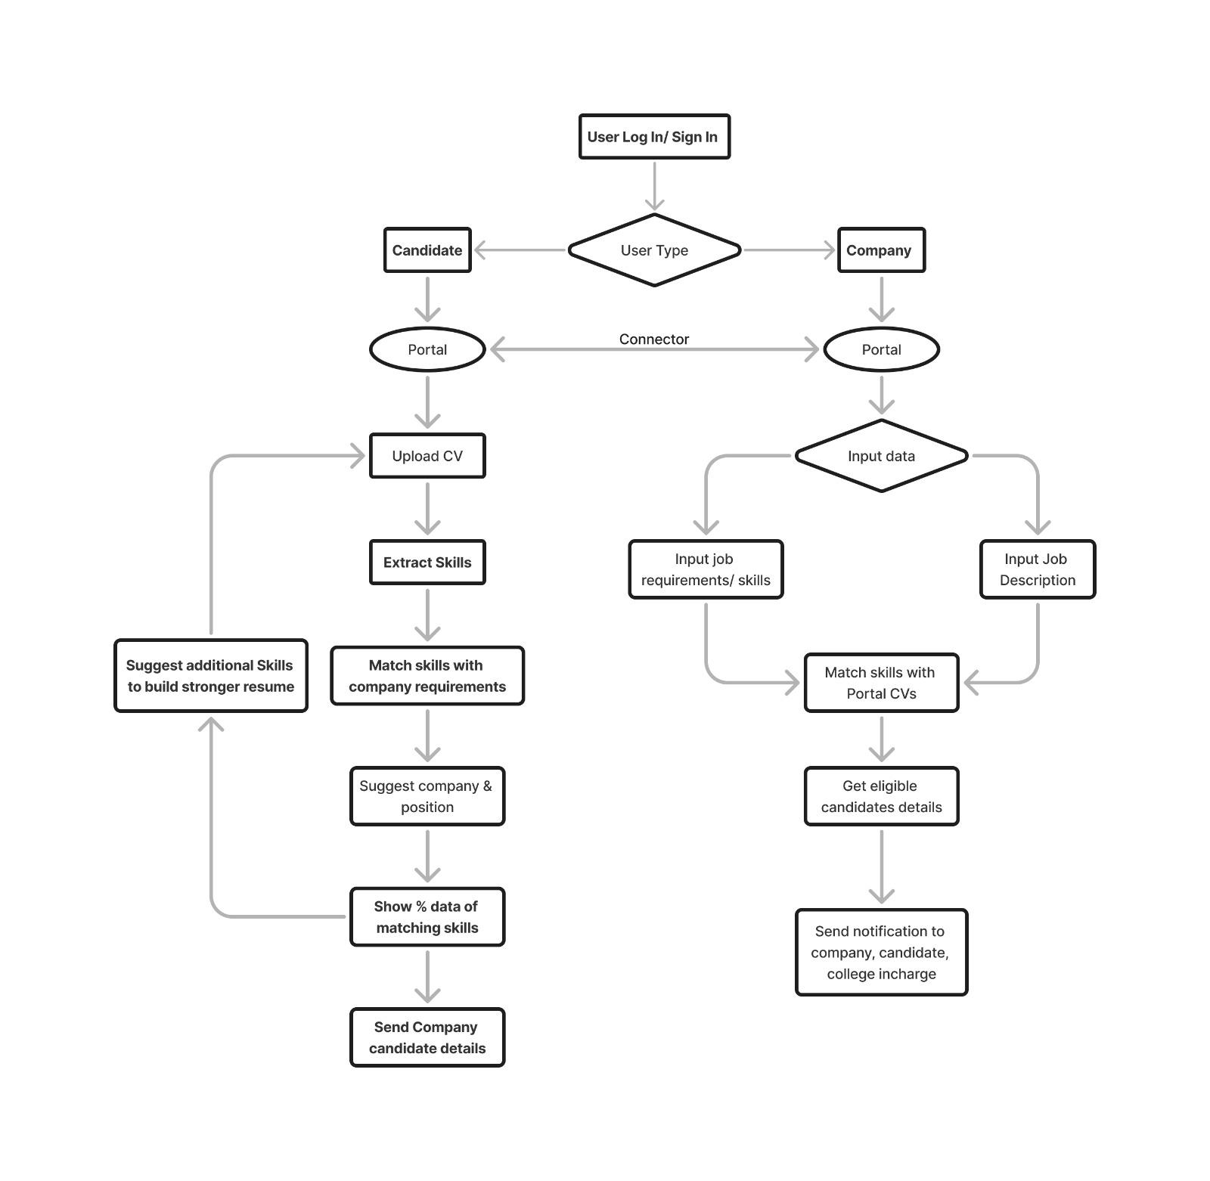

# Methodology:

1. **Agile Development:** Iterative development and continuous improvement.
2. **Data-Driven Approach:** Use real-world data for training and testing.

# Technology:

# Frontend: HTML, CSS, JavaScript (React or Angular)

# Backend: Node.js (Express) or Python (Django/Flask)

# Database: MongoDB or PostgreSQL

# ML/NLP: spaCy, NLTK, TensorFlow, Scikit-learn, NumPy, Pandas, PyTorch

# Cloud Services: AWS or Google Cloud

# Functional Specifications [Deliverables]:

1. Web-based platform for resume uploads and interaction.
2. Resume parsing engine to extract key information.
3. Analysis and ranking algorithm for resumes.
4. Personalized entry-level job recommendation engine.
5. System to forward eligible resumes to employers.
6. Interface for HR professionals to enter job descriptions and view eligible candidates.

# Project Scope:

# The project will deliver a web application for resume uploads, skill analysis, and job recommendations. It will also include features for automated resume submission and an HR dashboard for managing job descriptions and viewing eligible candidates. Future enhancements may involve increase in target audience, mobile app development, integration with job portals, and additional features for advanced resume filtering and candidate management.

**Approved by:**

Dr. Urmila Shrawankar

Professor and Director at School of Computer Science and Engineering