Real-Time Driving Perception Inference Optimization
Iterative Study Report · Batch 01 vs Batch 02
June 2025

1. Project Overview
This study benchmarks YOLO11n (Ultralytics nano detection model) across five inference runtimes on a 4K dashcam video clip. The goal is to quantify the real-time inference potential of each runtime under fair, reproducible measurement conditions and identify the optimal deployment path for edge/automotive perception systems.
Runtimes evaluated:
- PyTorch Eager: Baseline — standard model.forward() with no compilation
- torch.compile (default): TorchInductor kernel fusion; reduce-overhead excluded due to YOLO11n architecture constraints
- ONNX Runtime (CUDA EP): ONNX graph exported and executed on CUDA Execution Provider
- TensorRT FP32: Full-precision TRT engine built from ONNX
- TensorRT FP16: Half-precision TRT engine — maximum throughput target

2. Experimental Setup
Parameter | Value
Model | YOLO11n (Ultralytics) — 2.6M params
Input resolution | 640 × 640 (letterboxed from 3840 × 2160 source)
Video source | 4K dashcam clip (2,516 frames @ 30 FPS)
Hardware | NVIDIA T4 GPU (Google Colab)
PyTorch version | 2.x with CUDA 12
Confidence / IoU | 0.25 / 0.45 (NMS thresholds)
Warmup frames | 20 passes excluded from statistics
Frames measured | ~2,496 per runtime

3. Methodology Evolution
Two rounds of experiments were conducted. Batch 01 used a naive pipeline that introduced several systematic measurement biases. Batch 02 corrected all known issues before collecting the final results.

3.1 Batch 01 — Naive Baseline (Known Issues)
- I/O included in timing loop: cv2.VideoCapture.read() called inside the timed loop. Video I/O latency (mean ~52 ms) dominated every runtime equally, masking true inference differences.
- Warmup contamination: First 10–20 frames included in statistics. Frame 0 triggers CUDA kernel compilation / JIT warm-up, artificially inflating p99 and max values.
- ONNX running on CPU EP: onnxruntime-gpu was not installed; the session silently fell back to CPUExecutionProvider. Reported numbers reflect CPU inference, not GPU.
- No torch.compile runtime: Only 4 runtimes compared; torch.compile was absent entirely.
- Missing TRT FP16 raw timings: Only benchmark summary CSV available for TRT FP16 — no per-frame raw timings.

3.2 Batch 02 — Fixed Methodology
- I/O decoupled: All frames pre-buffered into RAM with letterbox applied during buffering (640×640 uint8, ~3.1 GB). Timed loop measures only preprocess → inference → postprocess.
- Warmup excluded: 20 forward passes before timing begins (enough for torch.compile to finish). benchmark.py strips the first 20 rows via --warmup-frames before computing statistics.
- ONNX on CUDA EP: onnxruntime-gpu installed; session verified to use CUDAExecutionProvider before run.
- torch.compile added: Full model compiled with mode="default" (TorchInductor). reduce-overhead excluded: YOLO11n anchor mutation and FPN skip connections are incompatible with CUDA Graphs static memory.
- Consistent CSV schema: All 5 runtimes produce identical CSV columns: frame, preprocess_ms, inference_ms, postprocess_ms, total_ms.

4. Results

4.1 Batch 01 — Naive Baseline (inference stage only shown)
Total latency dominated by I/O. Inference stage extracted below for partial comparison. ONNX numbers are CPU EP — not comparable to GPU runtimes.
Runtime | Inf Mean (ms) | Inf p50 | Inf p99 | Total Mean (ms) | Total FPS
PyTorch Eager | 20.93 | 18.53 | 44.59 | 78.80 | 12.7
ONNX (CPU EP) | 14.46 | 13.02 | 27.71 | 75.58 | 13.2
TRT FP32 | 8.72 | 8.17 | 15.27 | 73.13 | 13.7
TRT FP16 | 8.59 | 8.13 | 14.17 | 72.61 | 13.8
* Total includes I/O read (~48–56 ms mean) which inflates all runtimes uniformly.

4.2 Batch 02 — Fixed Methodology
Runtime | Pre (ms) | Inf Mean (ms) | Inf p50 | Inf p99 | Total Mean (ms) | Total FPS
PyTorch Eager | 2.59 | 11.83 | 10.53 | 20.53 | 15.96 | 62.7
torch.compile | 2.55 | 7.59 | 6.75 | 13.92 | 11.73 | 85.3
ONNX CUDA EP | 2.26 | 7.85 | 7.58 | 10.95 | 12.27 | 81.5
TRT FP32 | 2.09 | 4.37 | 4.28 | 6.20 | 8.31 | 120.3
TRT FP16 | 2.04 | 4.37 | 4.30 | 5.87 | 8.26 | 121.1

5. Batch 01 vs Batch 02 — Inference FPS Comparison
The table below compares inference-stage FPS (not total pipeline FPS) between batches for the runtimes present in both. Batch 01 numbers are inflated by warmup contamination on top of the I/O overhead already noted.
Runtime | B01 Inf Mean (ms) | B01 Inf FPS | B02 Inf Mean (ms) | B02 Inf FPS | Speedup (Inf)
PyTorch Eager | 20.93 | 47.8 | 11.83 | 84.5 | 1.8×
ONNX | 14.46 (CPU) | — | 7.85 (GPU) | 127.4 | CPU→GPU
TRT FP32 | 8.72 | 114.7 | 4.37 | 228.8 | 2.0×
TRT FP16 | 8.59 | 116.4 | 4.37 | 228.8 | 2.0×

PyTorch inference improved 1.8× purely from removing warmup-contaminated frames. TRT FP32/FP16 improved ~2× for the same reason. These gains are not from model or hardware changes — they reflect cleaner measurement methodology.

6. Key Findings
- TensorRT FP32 and FP16 are statistically equivalent: Mean inference: 4.370 ms vs 4.367 ms. FP16 offers no measurable latency benefit on a T4 for YOLO11n at this batch size. Both achieve ~120 FPS total pipeline throughput.
- torch.compile (default) beats ONNX CUDA EP on inference: 7.59 ms vs 7.85 ms mean inference. The compiled PyTorch graph is competitive with the ONNX runtime without requiring an ONNX export step.
- I/O was the dominant cost in Batch 01: Raw video read averaged 48–56 ms per frame — 60–70% of total reported latency. All Batch 01 FPS numbers are misleading as a measure of inference capability.
- Preprocess is now the floor at ~2 ms: With letterbox pre-applied, preprocess is purely BGR→RGB + normalize + GPU transfer. All runtimes spend 2.0–2.6 ms here — this is the shared lower bound.
- reduce-overhead is incompatible with YOLO11n: CUDA Graphs require static tensor memory addresses. YOLO11n's Detect head mutates self.anchors/self.strides on every forward pass, and the FPN/PAN neck uses skip connections via custom _predict_once routing — both incompatible with graph capture.
- TRT is the clear winner for deployment: At 8.3 ms total and 120+ FPS, TRT FP32/FP16 comfortably exceeds real-time requirements for automotive dashcam processing at 30 FPS.

7. Visualizations
[Plot not found: b02_fps_comparison.png]
Figure 2: Latency percentile distribution (p50 / p90 / p99)
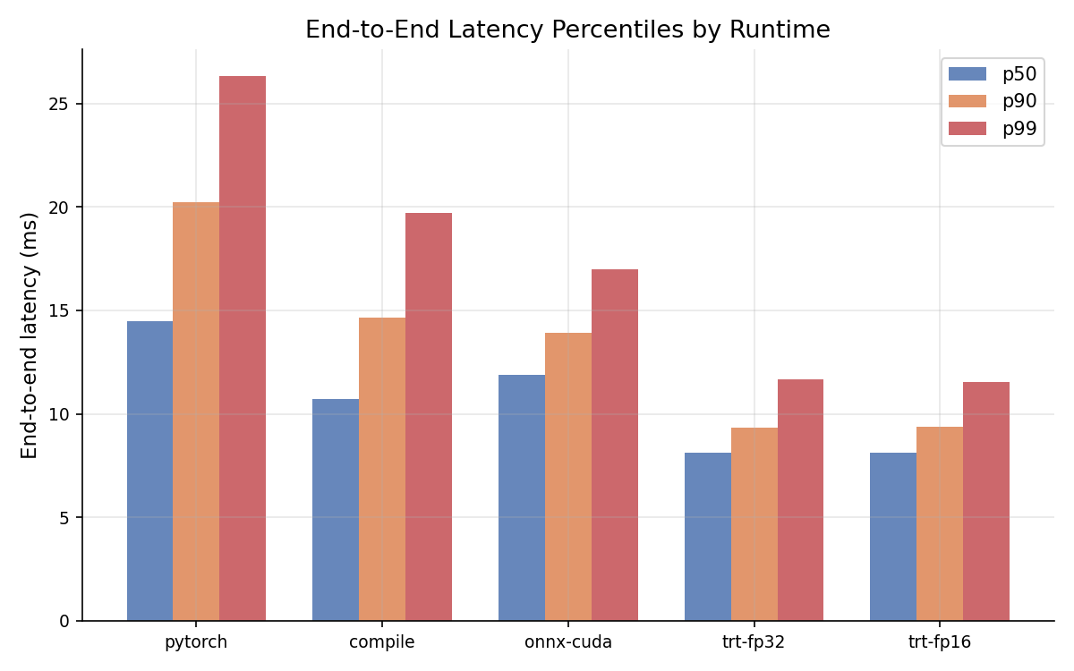

[Plot not found: b02_pipeline_breakdown.png]
[Plot not found: b02_latency_timeline_pytorch.png]

8. Next Steps (Batch 03)
- Batch size > 1: Test inference throughput at batch sizes 4, 8, 16 to measure GPU utilisation.
- Dynamic video input: Replace pre-buffered pipeline with real producer-consumer threading to simulate live dashcam I/O.
- INT8 quantisation: Build TRT INT8 engine with calibration dataset for further latency reduction.
- Multi-model pipeline: Add a second model (e.g., depth estimation) to measure co-inference scheduling cost.
- Model size comparison: Benchmark YOLO11s / YOLO11m to characterise the accuracy-latency tradeoff curve.

All experiments run on Google Colab T4 GPU · YOLO11n · COCO weights · June 2025

