## Front End Engineering-II

Project Report

Semester-III (Batch-2023)

Car-Rental Website

**Submitted To: Submitted By:**

Mrs. Vijaita Kashyap Khushal Sardana (2310990630) Harsh Chawla (2310992008)

Ishneet Singh (2310992019)

Karanvir Singh (2310992031)

**Department of Computer Science and Engineering**

## Chitkara University Institute of Engineering & Technology,

## Chitkara University, Punjab

**Abstract**

Generally, whenever people visit any tourist place or any popular sight-seeing place that are not very far from their homes they use car for travelling, but what if somebody doesn’t own a car or might be its not a good financial decision to own up a car which might be taken out once in a month but have to pay the EMI for whole month. All these problems led to making a profitable industry of rental car valuing USD 129 Billion Dollars growing with 8% CAGR which expects the value to grow up to USD 292 Billion Dollar Industry. And still when they reach out to local vendors for renting a car the process is very complicated. To tackle this problem and attain a share in global profits our team aligned towards a common goal and developed a solution, a website which will help them easily rent a car. This project outlines the development of a user-friendly car rental website. The website aims to provide a seamless experience for users looking to rent cars, featuring a clean design and hassle-free process. Our objective is to create a responsive and accessible platform using modern front-end technologies to build this project and add a value to society.

**Table of Content**

|  |  |  |
| --- | --- | --- |
| S No. | Content | Page No. |
| 1. | Introduction | 4-5 |
| 2. | Problem Definition & Requirements | 6-7 |
| 3. | Methodology | 8-9 |
| 4. | Contribution and Results | 10-16 |
| 5. | References | 17 |

**1. Introduction**

**1.1 Background**

In this modern world of Financial and Transport sector, convenience is the key. With the expansion of online services, consumers increasingly expect quick, easy, and efficient ways to meet their needs from the comfort of their homes. Renting a car is no exception to this trend. Whether for business travel, vacation, or everyday transportation needs, people want a hassle-free experience when it comes to renting a vehicle.

There are also people who don’t think its financially good to own a car and pay separately for its insurance, servicing, wear and tear and depreciating value considering them to rent instead of buying which makes the car rental business valued more than USD 129 Billion which could go up to USD 292 Billion Dollars by 2032.

The primary goal of this project is to develop a user-friendly car rental website that simplifies the process of finding and renting cars online. By leveraging modern web technologies, we aim to provide a seamless and enjoyable user experience. Our platform will feature an intuitive interface that allows users to easily search for available cars, compare options, and make reservations.

In addition to a straightforward booking process, our website will offer several features designed to enhance user satisfaction. These include detailed car listings with high-quality images and comprehensive descriptions, filtering options to help users find the perfect vehicle based on their preferences, and secure payment gateways to ensure a safe transaction process. We will also incorporate customer reviews and ratings to provide valuable insights into the quality and reliability of the cars and services offered.

Another key aspect of our project is ensuring the website is responsive and accessible on all devices, including desktops, tablets, and smartphones. This ensures that users can rent a car anytime, anywhere, without any inconvenience.

Overall, our aim is to create a car rental website that stands out in the market by offering a superior user experience, multiple features, and reliable service. By doing so, we hope to meet the evolving needs of modern consumers and make the car rental process as easy and enjoyable as possible

**1.2 Objectives**

The main objectives of this project are:

* To design a responsive and accessible car rental website.
* To ensure the website is user-friendly and easy to navigate.
* To integrate features such as car listings, booking functionality, and user-specific account interface.
* To provide high-quality images and detailed descriptions of cars.
* To ensure scalability in future aspects of developing the project.

**1.3 Significance**

This project is significant because it addresses the growing demand for online car rental services. As more people turn to the internet for their transportation needs, there is a clear need for a reliable and user-friendly platform. By providing such a platform, we can significantly enhance customer satisfaction. Our website will simplify the rental process, making it easier for users to find and book the perfect vehicle for their needs.

This is especially important in today’s fast-paced world where convenience is key. A well-designed car rental website can save users time and effort, allowing them to quickly compare options, check availability, and make reservations with just a few clicks. Moreover, by offering features like detailed car descriptions, customer reviews, and secure payment options, we can build trust and reliability with our users. Overall, this project aims to create a seamless and enjoyable experience that meets the evolving demands of modern consumers.

**2. Problem Statement and Requirement**

**2.1 Problem Statement**

The current car rental process can be inconvenient and time-consuming, with many users finding it difficult to navigate existing websites. There are also people who don’t think its financially good to own a car and pay separately for its insurance, servicing, wear and tear and depreciating value considering them to rent instead of buying which makes the car rental business valued more than USD 129 Billion. There is a need for a modern, responsive platform that simplifies the rental process and enhances the user experience.

**2.2 Software Requirements**

To build this project, we will use:

* HTML5: For structuring the content and elements of the web pages.
* CSS3: For styling and layout design, ensuring the website is visually appealing and responsive.
* Bootstrap: For implementing responsive design elements and components efficiently.
* JavaScript: For adding interactivity and dynamic content to the website.
* React.js: For building a modular, scalable, and maintainable front-end architecture.

Development Tools and Environments:

● Visual Studio Code: As the primary integrated development environment (IDE)

for coding.

● Git: For version control and collaboration with team members.

● GitHub: For repository hosting and project management.

**2.3 Hardware Requirements**

No specific hardware requirements are necessary beyond a standard computer for development and testing purposes.

However the developing computer should have the following specification:

● Processor: Intel i5 or equivalent (minimum), Intel i7 or equivalent (recommended)

● RAM: 8GB (minimum), 16GB (recommended)

● Storage: 256GB SSD (minimum), 512GB SSD (recommended)

● Display: Full HD resolution (1920x1080) or higher

**Data Sets**

We are using a fictional data set of cars, including details such as make, model, year, rental price, and availability for the early deployment and testing stage of website.

**3. Proposed Design / Methodology**

**Schematic Diagram Description**

**3.1 Homepage**

* + Header
    - Logo
    - Navigation Menu (Home, About, Rent, Top Picks, Login/Signup)
  + Main Content
    - Search Bar (Location, Pickup Date, Return Date)
    - Featured Cars Section
    - Promotional Banners
  + Footer
    - Links (Privacy Policy, Terms of Service, Social Media Links)

**3.2 Car Listings Page**

* + Header
    - Logo
    - Navigation Menu
  + Main Content
    - Car Listings (Thumbnail, Car Details, Rent Now Button)
  + Footer
    - Links

**3.3 Car Details Page**

* + Header
    - Logo
  + Main Content
    - Car Image
    - Car Details (Make, Model, Year, Price, Features)
    - Booking Form (Pickup Date, Return Date, Personal Details, Payment)
  + Footer
    - Links

**3.4 Booking Confirmation Page**

* + Header
    - Logo
    - Navigation Menu
  + Main Content
    - Booking Summary (Car Details, Rental Period, Total Cost)
    - Confirmation Message
    - Download/Print Receipt Button
  + Footer
    - Links

**4. Contribution and Results**

**4.1 Renting Page**

The renting page has been developed in a manner that it includes CTA (Call to Action) to compel user to rent the car of their need.

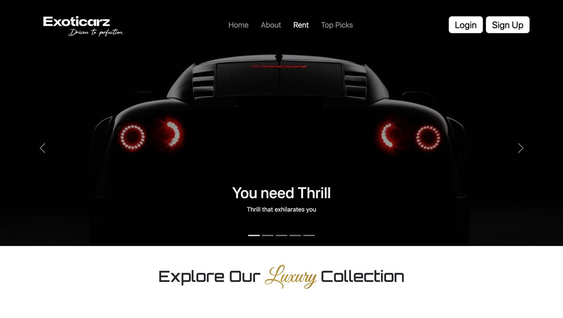

Figure 1 Renting Page-1

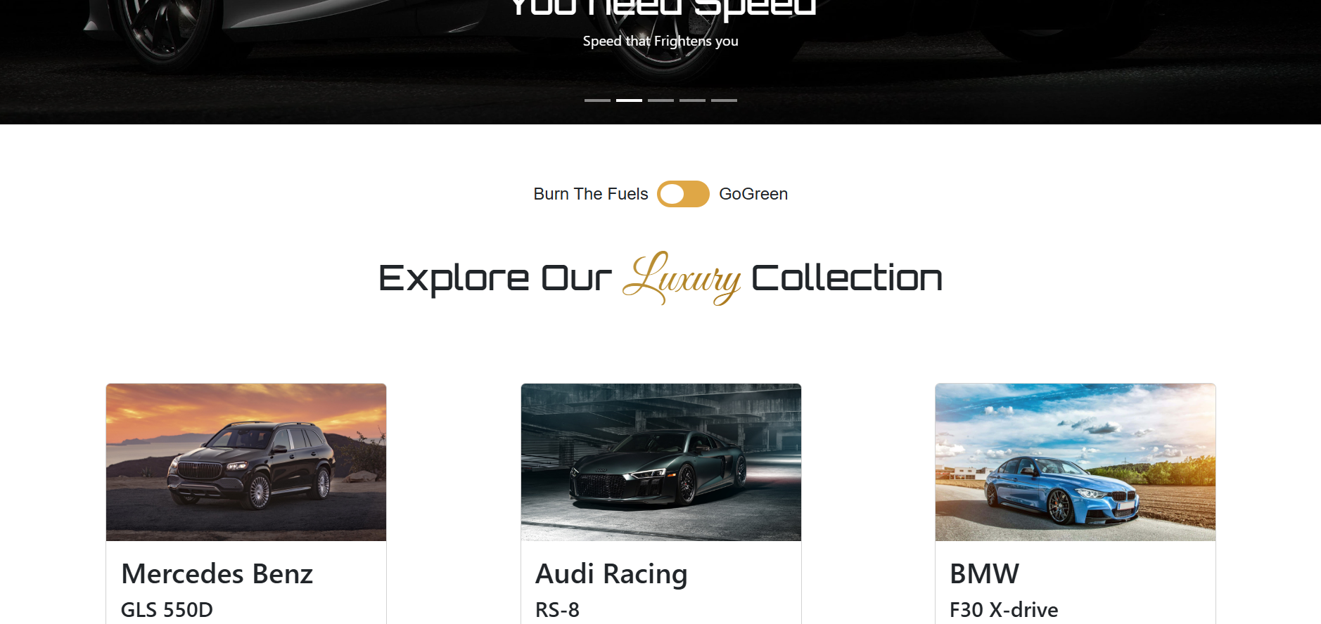

Figure 2 Gas Cars Collection

With a toggle we can switch to Electric Cars.

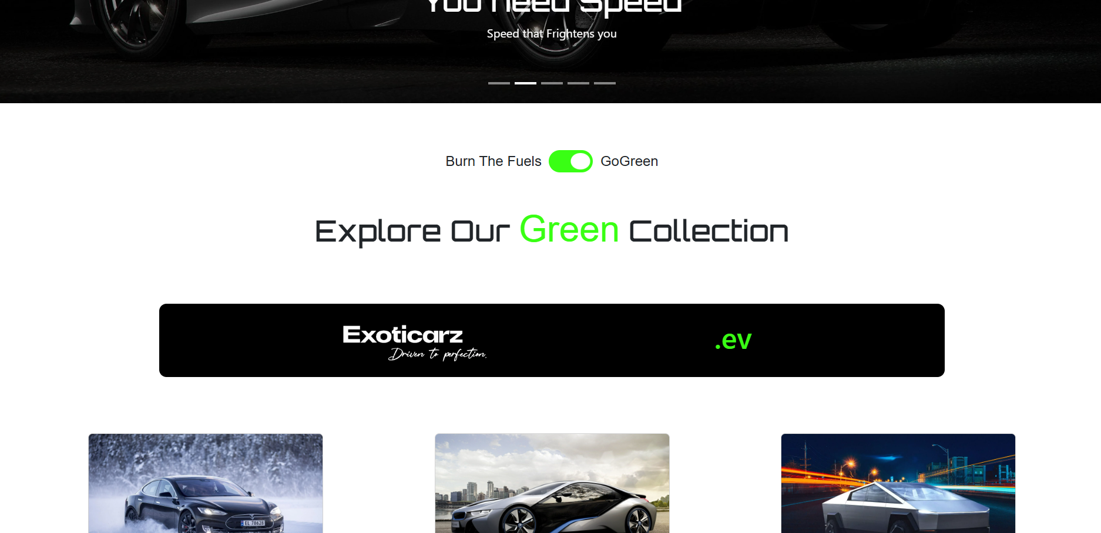

Figure 3 Collection Segment

**4.2 Car Booking Page**

This page shows the specifications and an image of Car listed in Rent Page.

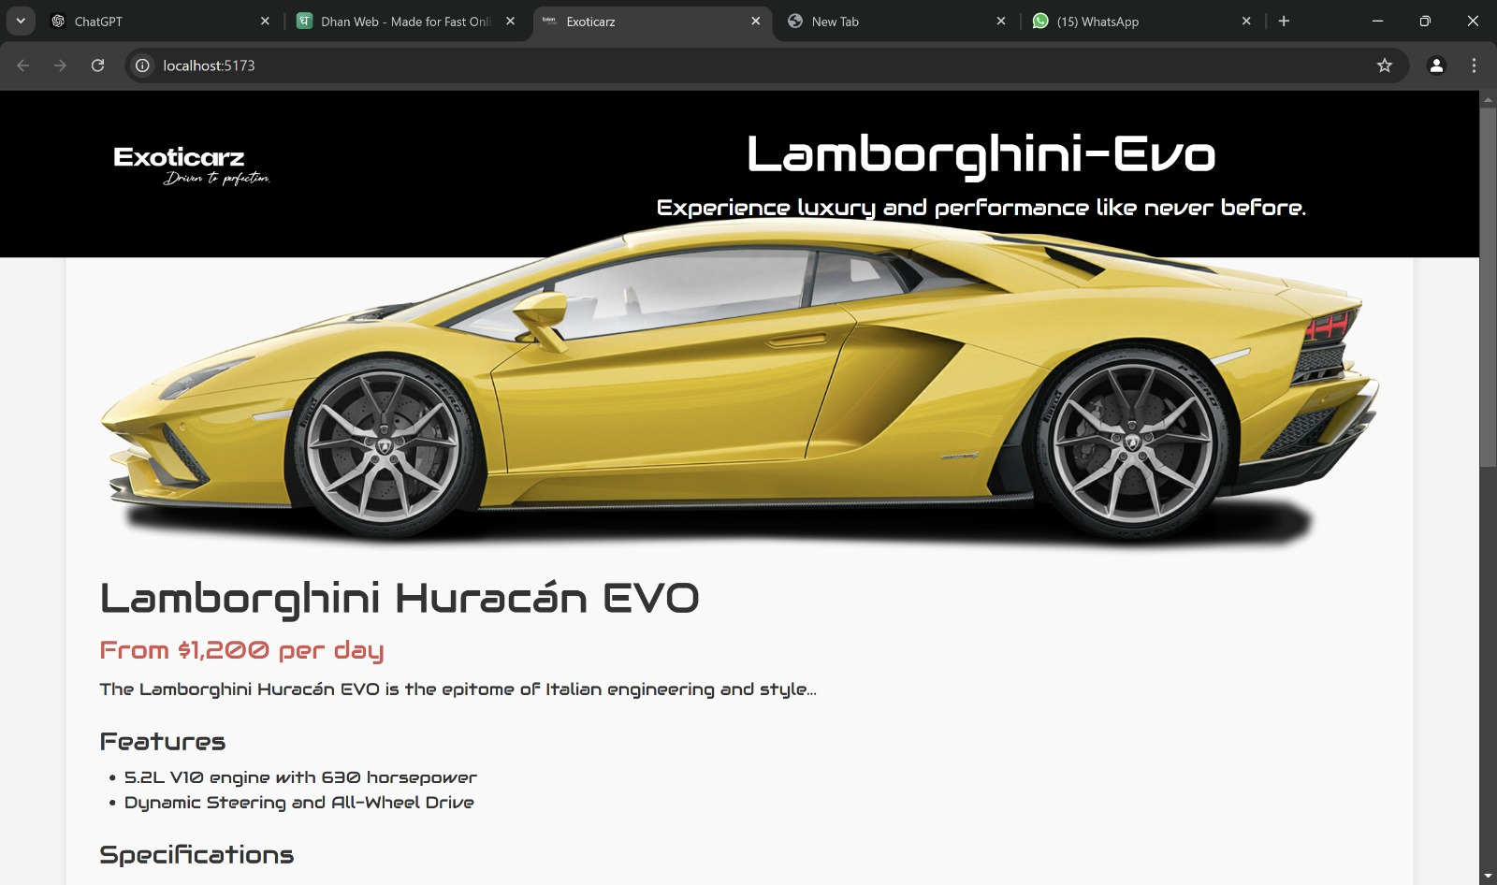

Figure 4 Car Booking Page

A form is provided to collect information of user to book a car.

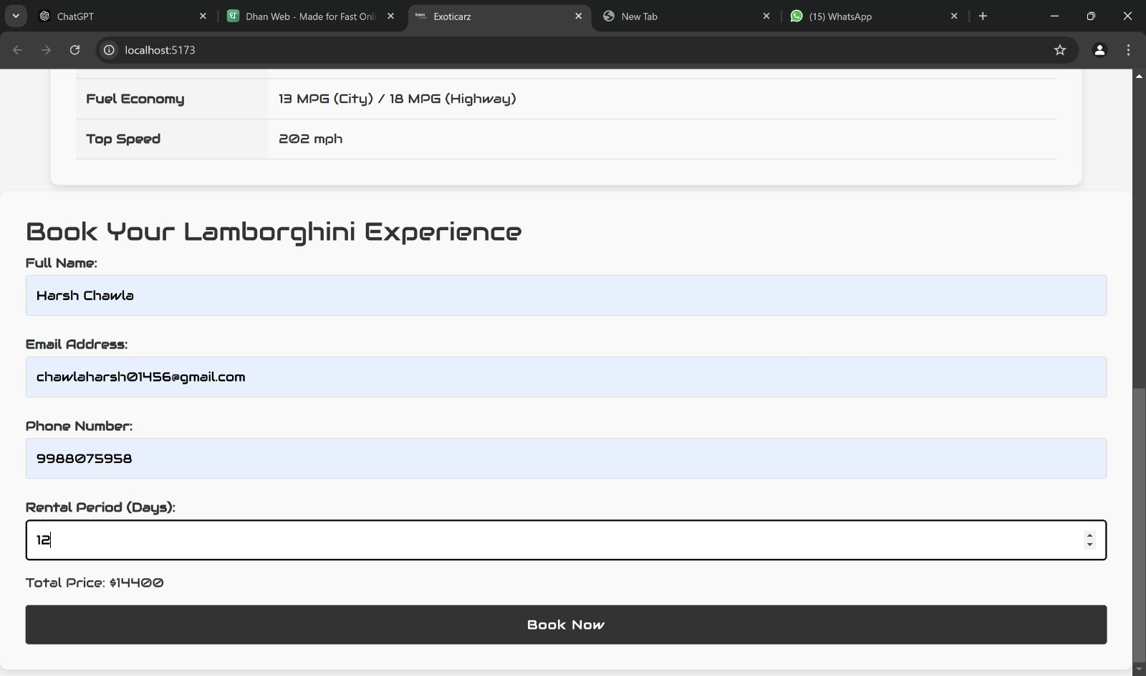

Figure 5 Car Booking Form

Then a Confirmation Page is shown with further details for booking.

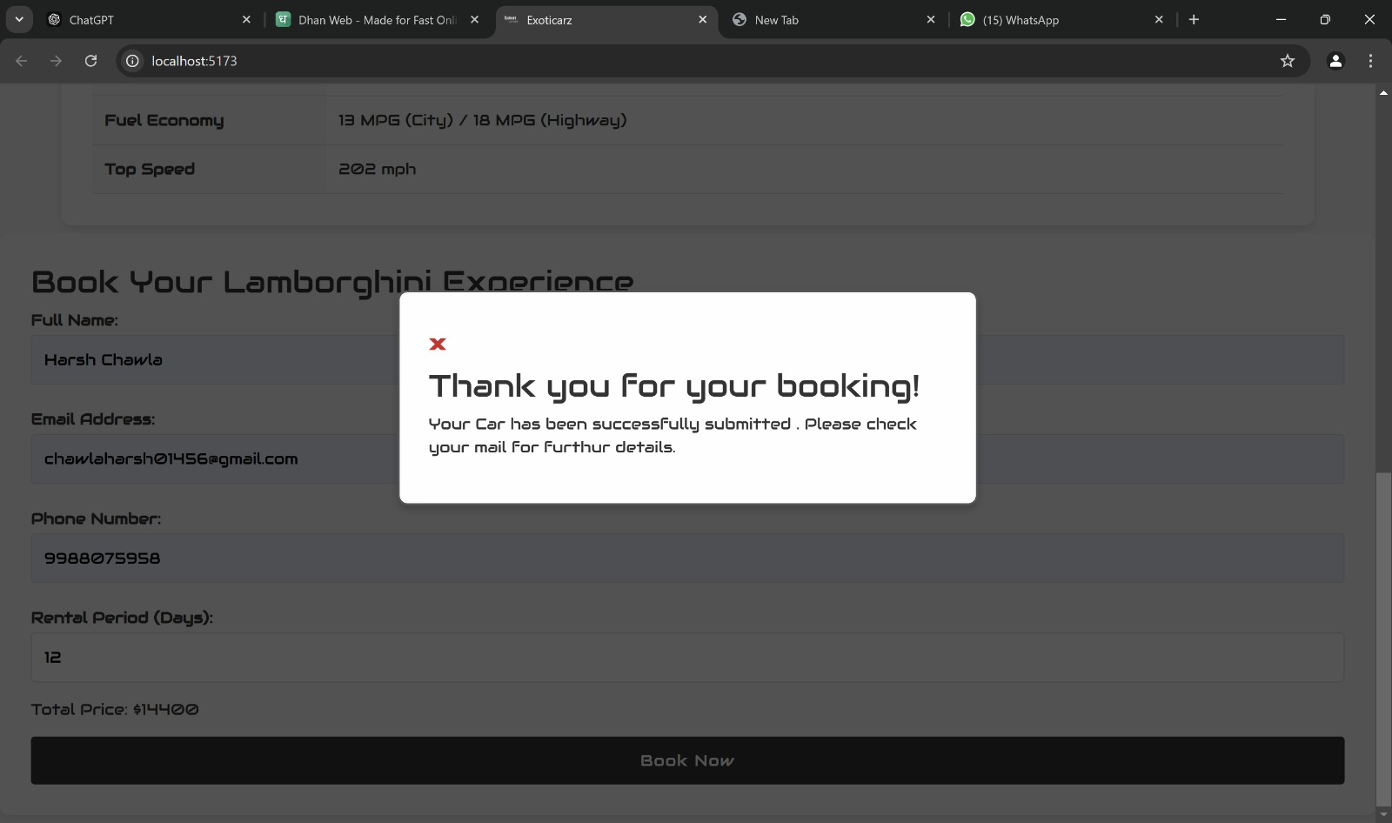

Figure 6 Confirmation Page

**4.3 Home Page**

The Home Page of website includes all the Call To Actions to book a car from Exoticarz.

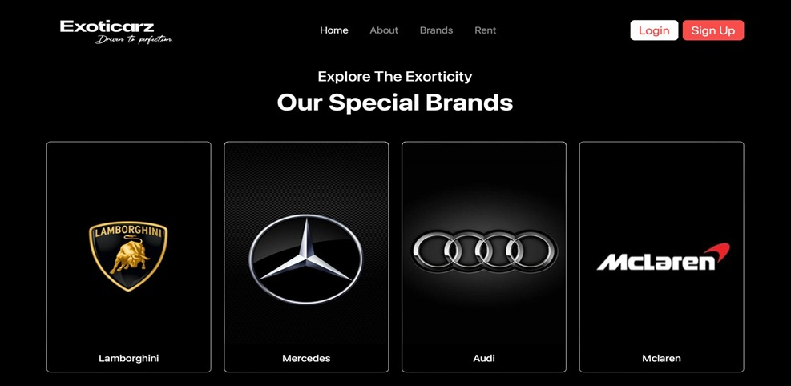

Figure 7 Featuring Brands at Home Page

Implemented a Background clip on scroll to get a premium look and feel.

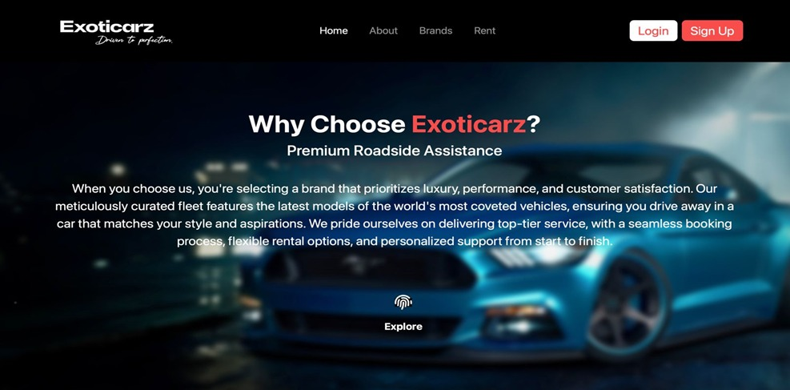

Figure 8 Background Clip on Scroll

Implemented a Slider which shows our Exotic and Top Collection.

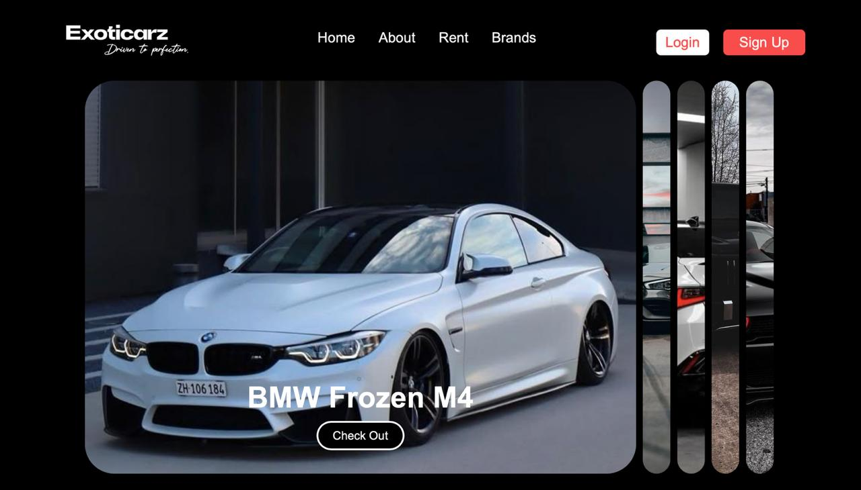

**4.4 About Page**

The About Page of the website which conveys our values of business and what we offer.

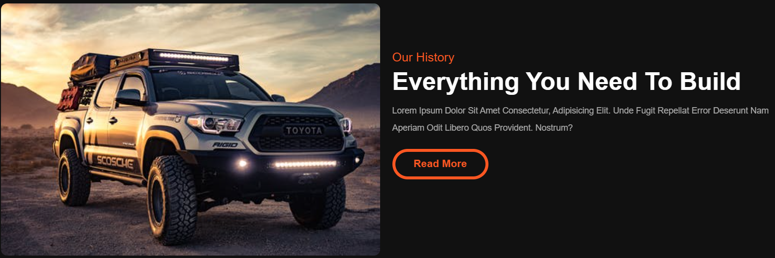

Figure 9 About Us Segment

It also tells us what we offer in our Garage.

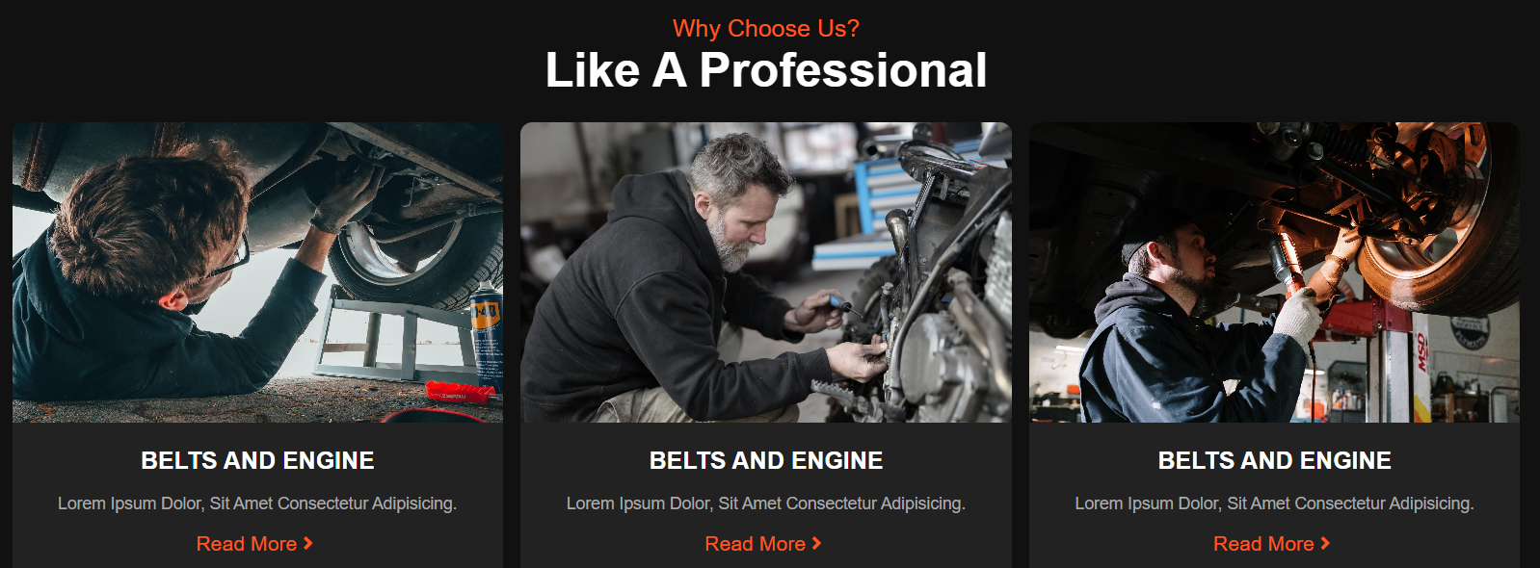

Figure 10 Our Services

About Page also shows the customer reviews for our Website.



Figure 11 Customer Reviews

**5. References**

* Bootstrap

<https://www.getbootstrap.com>

* GeeksForGeeks

[https://practice.geeksforgeeks.org](https://practice.geeksforgeeks.org/)

* Stack Overflow

<https://stackoverflow.com>

* W3schools

[https://www.w3schools.com](https://www.w3schools.com/)

* React

https://react.dev