ABSTRACT
Research into agriculture has gained speed in recent years, with indicators of substantial expansion in the field of agricultural science. The most recent player to emerge on the scene is bringing convenience to the way agriculture is carried out through the use of various computational technologies. There are numerous elements that influence agricultural yield, with seed quality ranking first on the list of important considerations. Additional knowledge about quality seed production, seed quality control, and impurity identification can be gained through the classification of seeds. Traditional methods of categorising seeds have relied on qualities such as colour, shape, and texture to guide the classification process. It is usually done by specialists who visually inspect each sample, which is a tedious and time-consuming procedure that takes a long time. This approach can be easily automated, resulting in a method of seed sorting that is substantially more efficient than having them inspected by hand utilising human labour. It has been widely used in related fields to apply computer vision technology based on machine learning (ML), symmetry, and, more specifically, convolutional neural networks (CNNs), with the result that the work efficiency has often been boosted. This paper offers a classification system for seeds that employs CNN and transfer learning, taking into account the effectiveness of computational intelligence methods in other picture classification challenges.
Chapter 1
INTRODUCTION
1.1 Introduction
A large portion of the world’s population is associated with the agriculture sector. Many developing and underdeveloped countries’ economies rely on agriculture. This sector has experienced multiple transformations with the increase in the world’s population [1]. The growth in the human population is directly related to the need to increase the world’s agricultural productivity and its sustainability. Technology was introduced to agriculture more than one century ago, and, to improve production efficiency, several studies have been conducted since the 1990s [1]. In recent times, advanced industrial technologies based on artificial intelligence (AI) have been applied in the field of agriculture to improve productivity, environmental impact, food security and sustainability. Before addressing any problems in this area, one is required to understand the basic ecosystem of agriculture and the fundamental requirements of farming. This field is considered one of the most challenging research fields, and technology has massive potential to be incorporated into it to increase the mass and quality of agricultural products. The incorporation of AI, particularly deep learning perceptions, can be used to make advances in the agricultural sector [2].
In the agriculture sector, the farming of crops relies heavily on seeds. Without seeds, there is no chance of producing or harvesting any crops. The human population has been increasing rapidly for many years. Due to this population growth, agricultural land is reducing day by day, which causes a decline in the production of food. To balance consumption rate with production rate, crop production must be increased. In this regard, people have started growing crops and vegetables in their homes. However, not everyone possessed the knowledge needed to do this. Only a person who has expertise in identifying seeds can cultivate them. To eliminate this dependency, there is the need for an automated system that can assist in identifying and classifying the different types of seeds. Several studies have been conducted in which various issues related to seeds have been addressed by using AI techniques, ranging from simple object identification-based techniques to complex texture and pattern identification. In recent studies, machine learning techniques have been observed more frequently to perform seed classification of various crops, fruits and vegetables. Most of these studies have been conducted on a single genre of seed (e.g., weed seeds [3], cottonseeds [4], rice seeds [5,6], oat seeds [7], sunflower seeds [8], tomato seeds [9] and corn [10,11]) with varying purposes. These included observing germination and vigour detection, purification and growth stages.
There are hardly any studies that apply convolutional neural networks (CNNs) [12] in their models to address seed identification/classification problems. CNNs are deep learning models consisting of several layers: convolutional, pooling and fully connected layers. The convolutional layers perform feature extractions, the pooling layers perform compression and fully connected layers are for classification. Their main use is image recognition and classification. A general representation of CNNs model can be seen in Figure 1. CNN can bring efficiency and accuracy in visual imagery analysis using precise feature extractions [12, 13].
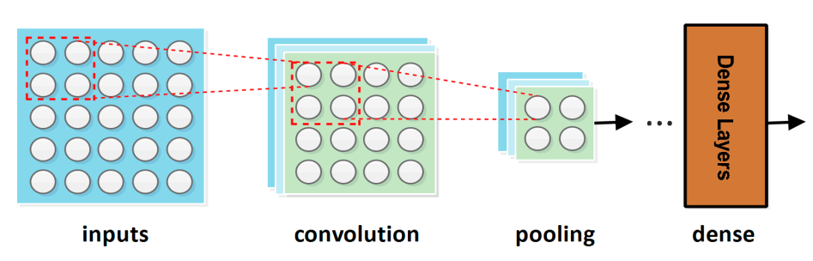
Figure 1. General Representation of CNN Model
To the best of our knowledge, there is no study that has addressed subject heterogeneity problems with regards to various kinds of seeds. Also, most of the studies incorporated only traditional machine learning techniques for feature extraction and classification. Hence, an approach that is capable of solving the problem of subject heterogeneity by incorporating deep learning techniques to bring efficiency and accuracy in identifying and classifying seeds is needed. Previously, many researchers reported their successful results by using traditional machine learning techniques. Although these traditional techniques/approaches have been successfully applied in many practical studies, they still have many limitations in certain real-world scenarios [14].
This research proposed an efficient approach for seed identification and classification based on a deep learning CNN model and the application of symmetry. The model is trained by implementing transfer learning, which focuses on transferring knowledge across domains and is considered a promising machine learning methodology. It is an important machine learning (ML) tool in solving problems related to insufficient training data, which can encourage the idea of not training the model from scratch and significantly reducing the training time [15]. In this research, a dataset comprised of symmetric images of various seeds was used to carry out the seed classification process.
Many symmetric images from each seed class were captured and then augmented to train the proposed model. Further details pertaining to the dataset are presented in Section 3. This research work adopted a VGG16-trained model in order to accomplish successful seed identification and classification [16].
However, the model was modified by adding new layers, which aimed to increase accuracy and reduce the error rate of the classification process. This modification in the VGG16 model leads to the optimisation of the classification process and eventually assists the common man in identifying and classifying the different type of seeds.
The following points summaries the contributions of this paper:
We conduct a detailed review examining the most notable work in the area of seed classification via machine learning and deep learning. We re-introduce the problem of seed classification using pre-trained VGG16 convolutional neural network architecture, where variant seeds have been classified, unlike in previously proposed models, which focused only on one kind of seed.
We propose a new model for seed identification and classification by using advanced deep learning techniques. Furthermore, dropout and data augmentation techniques have been incorporated to minimize the chances of overfitting.
We fine-tune our model by applying an adjustable learning rate to make sure that our model performs equally well on the dataset and does not miss the global minimum.
We develop an optimisation technique that monitors any positive change in the validation accuracy and validation error rate. In case of change, it takes the backup of an optimal model at the end of the iteration to make sure that the proposed model is at its highest level of accuracy with the least validation loss.
1.2 Problem Statements and Motivations
1.2.1 Problem Statement
In the agriculture field, seeds are very important for growing crops. Without seeds, there is no way to grow or harvest any crops. Humans have been getting more and more people for a long time now. There has been a lot of growth in the number of people. This means that there is less land for farming, which means less food can be made. To keep the consumption rate and production rate equal, more crops must be grown. When it comes to this, people have started growing crops and vegetables in their own homes. However, not everyone had the skills to do this. Only someone who knows how to identify seeds can grow them. To stop this, there is a need for an automated system that can help identify and classify the different types of seeds.
1.2.2 Motivation
There has been a lot of progress in agricultural research in the last few years, and this shows that it is going to keep going quickly. The most recent thing to come on the scene is making farming easier by using a lot of different computer technologies. There are a lot of things that can affect agricultural production, but the quality of the seeds is the most important. Seed classification can help you learn more about how to make high-quality seeds, how to keep them safe, and how to tell if they have impurities. The process of putting seeds into groups has been done in the past based on things like their colour, shape, and texture. Specialists usually do this by looking at each sample, which is a very long and tedious job. This process can be easily automated, which makes seed sorting a lot more efficient than having people look at them. Computer vision technology based on machine learning, symmetry, and convolutional neural networks (CNNs) has been used a lot in other fields, which has led to more efficient work.
1.3 Objectives
- Comprehensive two-stage approach based on very deep CNNs with a set of effective training schemes to ensure the performance gains of increasing network depth.
- Use of limited training data for automated melanoma recognition.
- Use of very convolution neural network for accurate seed area segmentation.
- To develop a predictive model to predict seed classes which results in high crop production.
1.4 Thesis Organization
In Chapter 1 we discussed about the background and resources related to the system. Literature review is described in the Chapter 2. Chapter 3 presents the proposed system implementation details which includes implementation of website and android app. Chapter 4 presents experimental analysis, results and discussion of proposed system. Chapter 5 concludes our proposed system. While at the end list of references paper are presented.

Chapter 2
LITERATURE REVIEW
The application of technology in farm operations has began since the early 20th century when the sector transitioned from the steam powered digger to mechanical tractors. The introduction of plant heredities, chemical inputs and agricultural production systems has turned the sector into technology enabled and data-rich environment [1].
The technical development that make up the current computer environment have led to discussion about big data yet data gathering is not new notions particularly in the aspect of public data collection. The only beginnings of more efficient mobile technologies and the digitalization of data have experiences involve enormous records be assessed and analysed in a timely and more valuable ways.
Agriculture is the most significant economic sector of many developing countries. Ethiopian agricultural operations have remained undeveloped methods because of lack of having suitable technology. The other reason of unproductive is drought, which has repeatedly hampered the counter’s agricultural activity since the early 1970s. This problem leads low production, insufficient infrastructure, low level of technology and overpopulation. For example, according to the World Bank 1980 and 1987 report, agricultural production declined at an annual rate of 2.1 percent, while the population rose at an annual rate of 2.4 percent.
Therefore the country suffered a famine that resulted in the death of over 1 million individuals from 1984 to 1986 [2]. The Ethiopian farming community is confronting several issues to increase crop yield. However, there is wide variety of information gap that existent between research and actual practise. Due to these numerous challenges, Ethiopian farmers require professional help to have more productive.
These research is intended to identify answers to difficulties in Melkassa research centre during seed classification and offered to meet research challenges in Agriculture sector. In order to take full advantage of the soil type, moisture, humidity, climate and etc. farmers need to know exactly the sort of seeds for their crops. It is extremely vital to take into account the environmental characteristics unique to each region in Ethiopia because the climate varies from one district to the next. This aids in the selection of the most suitable regions for the production of various types of seeds. A significant difference in rainfall occurs between districts, and this has a significant influence on farming since, although too little or too much rain will harm crops, the appropriate quantity of rain results in optimal agricultural productivity. When operating under the current conditions, agricultural firms are capable of generating significant volumes of data. As a result of this increase in data volume, an automated technique for extracting and analysing the relevant data is required.
Machine learning algorithms, such as ANN, are utilised to assist agricultural centre professionals in their work. Farmers control centres rely on ANN to gather and interpret data in real time in order to assist farmers in making the best decisions possible when it comes to planting, fertilising, and harvesting crops. ANN is one of the keys to this success. Agricultural firms are capable of creating and collecting significant volumes of data under the current conditions. As a result of this increase in data volume, an automated technique for extracting and analysing the relevant data is required. We suggested an automated seed class prediction model, which classifies seed datasets using an ANN machine learning tool, to classify seeds automatically. [3] The development of agricultural management systems that are easy and precise in their assessment of rice yields throughout the planning phase. An artificial neural network (ANN) [4] is a type of artificial intelligence that is composed of a large number of simple processing components, known as artificial neurons or nodes, that are interconnected by direct links, known as connections, and that cooperate to perform parallel distributed processing (PDP) operations in order to solve a particular problem. A layer in a network refers to a subset of processing components[5] that are connected together. The input layer is the lowest layer in the hierarchy, while the output layer is the highest layer. There may be extra layers of units between the lowest and highest layers, which are referred to as the hidden layer (s). The benefit of neural networks above traditional programming rests [5] in their capacity to serve as a solution for a variety of situations for which there is no algorithmic answer or for which the existing solution is either too sophisticated to be discovered. An ANN [6] is trained to perform a certain task, such as pattern recognition or data categorization, and then tuned for that task. As a result, ANN modelling is becoming increasingly popular across a wide range of agricultural applications, particularly in areas where traditional statistical modelling has proven to be ineffective.

It is used in agriculture to forecast crop yield, biomass production, sowing dates, seed physical and physiological damage, organic matter contents in soils, soil moisture estimations, aerodynamic characteristics of crops, sugar content estimation in fruits, and crop variety identification [7, 8].
Specifically, we looked at the influence of geometric characteristics on seed categorization in Ethiopia, which we discovered via our research. As a result, we developed an appropriate model with well-trained multilayer neural network classifiers for the detection of irregular wheat grain samples cultivated in diverse agro-environmental zones around the nation, taking these aspects into consideration as datasets for distinct districts.
One of our objectives is to use the variety of data available in the agriculture domain to develop predictive model to predict seed classes using machine learning tools. In order to analyze this problem better, we focus our literature review on six aspects which is done by different researchers:
1) Autonomous Wheat Seed Type Classifier System
2) Classification of Rice Grains Using Neural Networks
3) Agricultural data prediction by means of neural network
4) Agricultural Crop Yield Prediction Using Artificial Neural Network Approach
5) Seed Classification using Machine Learning Techniques
6) A Prediction Model Based on Big Data Analysis Using Hybrid FCM Clustering.
The first is [8], According to this article the researchers trying to use K-means clustering algorithm and the default Euclidean distance metric to cluster seed dataset. For this clustering, the researcher uses MATLAB as a programming environment. Kmeans function is used from statistics toolbox which is given two arguments. Those two arguments are the dataset and the number of the cluster the data going to be classified. Function k means can solve this problem by getting another argument called replicates; it is an integer number specifies how many times algorithm should be run with a new starting point. In this study, the authors propose the system which is capable of clustering approximately seeds and the profiting K-means algorithm leads to the operation.
The second is [9], this paper states Neural Networks to classify varieties of rice which contain a total of 9 different rice verities. To classify these varieties the authors uses image acquisition of seeds. They also developed to extract thirteen morphological features, six color features and fifteen texture features from color images of individual seed samples. Different neural network models were developed for individual feature sets and for the combined feature set.
Results of the paper is just designing and developing neural network models with two hidden layers in all networks using Matlab toolbox. Originally individual neural network models were created for each feature set (colour, morphology, and texture) separately. Then a combination of feature set model was implemented. In order to reduce the dimension of the input feature set, they applied principal component analysis. Finally, they combined feature model produced with an overall classification accuracy of 92%. The gap we found during the review of these paper is that they only focus on structured data with small data. The another is to identify the color or types of rice they used camera (Sony DSC-W270 digital camera) So it may have lack of quality when we compare it with X-ray technology which is new technology and best for classifying the color of seeds. The third related work is[10], according to this paper artificial intelligence approach and differentiability of the error function are used. The researcher focuses on studying the multi-layer neural network regressive model which has been used for solving the problem of the yield of onion and they recommended empirical non-linear regressive models to decide the relationship between the yield of the crop and the sowing density or the plantation density. The paper also presents a model with a multilayer neural perceptron in the configuration (1-2-1), i.e. one neuron at the input, two in the hidden layer and one at the output, along with the non-linear activation function. For the learning itself, they used the Back Propagation algorithm with the implementation of the multi-layer neural network for the prediction of the crop yield, and the comparison of the accuracy of this approach with the accuracy of the well-known regression model designed for the prediction of empirical data. Empirical non-linear regressive models are used for determining the usefulness of a neural networks prediction approach, and the options of its implementation.
In this paper there three measures are used to predict agricultural data. These measures are: Non-linear regression, Multi-layer neural network and Back propagation algorithm. After comparing the above algorithms they found that the use of a multi-layer neural network has proved to be more accurate in the case of the given task than the published regressive model. The fourth is[11], These study put forwards crop prediction by identifying various parameter like the type of soil, PH, phosphate, potassium, calcium, nitrogen, magnesium, sulfur, manganese, copper, iron, organic carbon depth, temperature, rainfall, humidity and parameter associated to the atmosphere.
The authors design a network which correctly learns associations of effective climatic factors on crop yield, it can be used to estimate crop production in long or short term and also with enough and useful data can get an ANNs. This paper shows the ability of artificial neural network technology for the
approximation and prediction of crop yields at rural area. In this paper, we shall examine one of the most common neural network architectures. Lastly, they analyze the result by using feed forward back propagation ANN model for each area and finds the most effective factors on crop yield.
The fifth is [12], this paper presents the capability and potential of machine vision with the well- trained multilayer neural network classifiers for shapes, sizes, and varietal type identification of unequal rice grain samples grown in the assorted agro-environmental zones in the country. In order to classify the seeds, they used Weka classification tools; Function, Bayes, Meta and Lazy methods. Classifiers they used from these methods are Logistics, SMO, Naïve Bayes Updateable, Multilayer Perceptron, Naïve Bayes, Bayes Net and Classifier Multi Class. According to this study, The classification seeds can be done based on three different fold cross validation i.e. 10 fold, 5 fold and 2 fold, as well as a training set method, are also used. After analysis of the data, they try to observe that, the overall performance measures decreases as we decrease the fold value except for the Multilayer Perceptron classifier that gives the highest accuracy value 97.6% using 5 fold Cross Validation. To measure the performance they used K-Fold cross-validations and Training set method. Multilayer Perceptron (MLP) using 5- Fold cross-validation gives the highest performance of 97.6% among all the Weka classifier. They also experiment that Multilayer Perceptron gives the highest accuracy value when we use Training Set method which is 99.5% and Logistics gives second highest accuracy value of 98.6%. Finally, they observed that Training Set method gives higher accuracy than Cross Validation during the classification process. This research is concluded as the unsupervised artificial neural network gives better performance with 79% accuracy as compared to the supervised artificial neural networks which give 73% accuracy.
The last one is [13], these study used FCM clustering. He shows the prediction models based on supervised learning have a high accuracy, but they have several problems such as requirement a vast amount of classified data, and difficulty in accepting the data with new patterns that wouldn't be used for learning.
Another weakness of prediction models based on supervised learning is the difficulty in gradual learning for real-time input data. On the other hand, the prediction model based on unsupervised learning is fast and need not have labelled data. However, the analysis of the prediction result is difficult, since no information for the learning data is given to us for learning. In order to lower these weaknesses, he proposes a context-aware framework for business using the hybrid FCM clustering algorithm that is a kind of unsupervised learning with the feature of supervised learning.
The implementation of conducted research combines the higher accuracy rates of supervised learning and the flexibility of unsupervised learning. Therefore, the researchers on the enhanced algorithm to improve the prediction accuracy of the system whose data set is small. It also, however, demonstrated that the proposed model is capable of taking advantage of the numerical prediction based on unsupervised learning, which can automatically categorize the input data without the manager’s intervention. So in our paper, we propose “Big data analytics framework to predict determinant factors to seeds classification” which is used to predict seed classes for seed production. The ANN model is used for prediction and it can be implemented using different ANN algorithms.

Chapter 3
METHODOLOGY
3.1 System Overview
With CNN [12], we suggested a novel model for seeds identification and classification that is efficient and may be used in a variety of applications. The entire procedure is divided into three stages: dataset creation, training, and testing (as demonstrated in Figure 2). The following subsections go into further detail on each of these three phases.
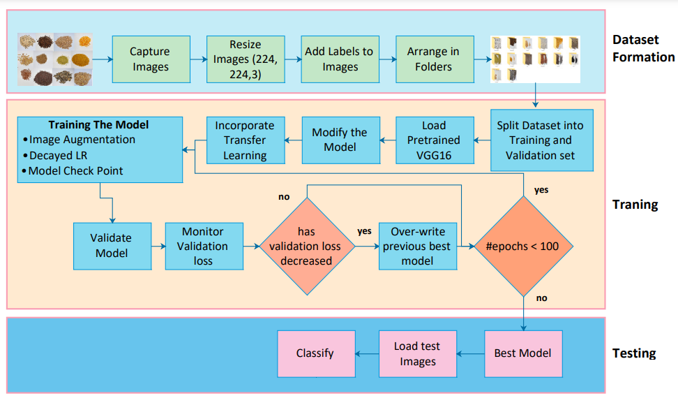
Figure 2. System Architecture
Following are the steps involved in system architecture:
• Input image dataset to the system.
• Pre-processing is performed to enhance image quality and resize the image.
• Several features are extracted from input image dataset from which training file is generated.
• Generated training file dataset and new test input images are pass to CNN classification algorithm.
• The output of CNN algorithm is seed type detection
• At the end graphical evaluation is perform to check the performance of proposed system.
According to the previous paragraph, this subsection reports the results of the proposed model's training on the dataset established in the previous subsection. The dataset was divided into two parts: a training set and a validation set, in order to train the model. The training of the model was completed in a number of phases, beginning with the selection of a previously trained model and progressing through the modification of the trained model. The adaptation of the VGG16 architecture [16] was the first step in the process. In the final layer of this design, there are 1000 nodes, each of which refers to the one of the 1000 items listed above. We eliminated the last classification layer from the VGG16 in order to make it more suitable for the dataset used in our research, which comprised of 14 different classes. Choosing the VGG16 design was primarily motivated by the fact that it makes use of three-way kernels, which aids in the generalisation of classification issues outside of the originally trained network. First and foremost, the VGG16 design, which employs a layered representation of convolution and pooling layers, results in a deeper neural network than previous models. As a result, VGG16 is both deeper and broader than the previous CNN structure. A total of five batches of convolution operations are performed, with each batch consisting of two–three neighbouring convolution layers in the same direction. It was also necessary to implement a modified version of the CNN model that included five extra layers (average pooling layer, flatten layer, densest layer, dropout layer, and softmax layer). The pool size in the average pooling layer was set to a value of (7, 7). Neurons in the flatten layer are flattened before being supplied to the dense layer, with the activation function ReLu being used to activate them. Following that, a dropout layer with a probability of 0.5 and a classification layer with 14 nodes are also added to the model to complete the process. Figure 3 illustrates the softmax function in further detail. Consequently, we have a revised version of the VGG16 architecture with 14 classification nodes, which is better suited to our issue investigation than the original.

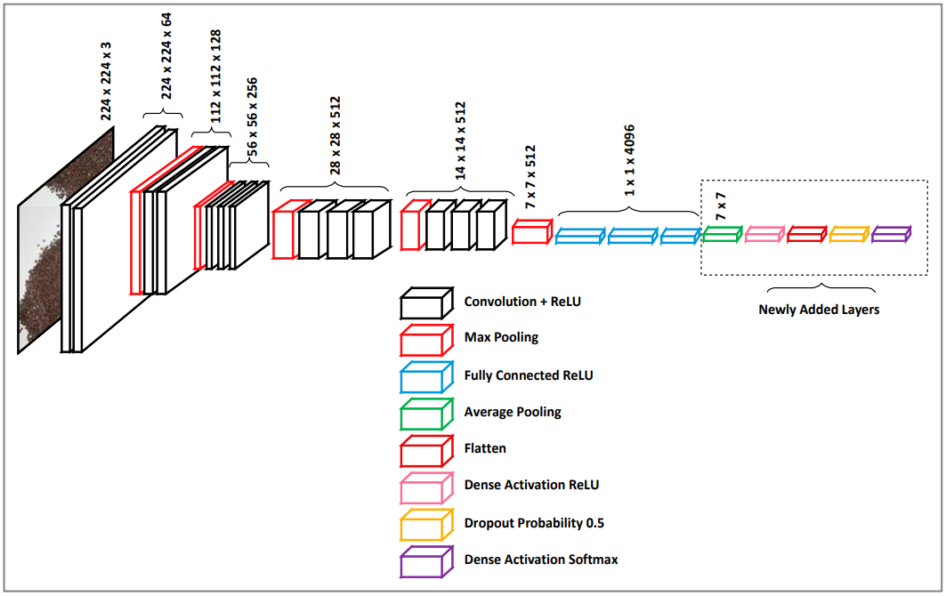
Figure 2. Proposed CNN Architecture
3.2 Mathematical Formulation
System S is represented as
S = {ID, P, F, T, CNN, M}
1. Input Dataset
ID = {i1, i2, i3…in}
Where ID is the input image dataset and i1, i2…in are the number of images.
2. Preprocessing
PR = {pr1, pr2, pr3}
PR is preprocessing and pr1, pr2 and pr3 are the steps to be carried out during preprocessing.
pr1 be the reading of input dataset
pr2 be the enhancement of image input and
pr3 be the removal of hair from image.
3. Feature Extraction
F= {f1, f2, f3…fn}
Where F is the set of features extracted from the image and f1, f2, f3… fn are the extracted features such as border, thickness, color, etc.
4. Training and Testing file generation
T = {T1, T2}
Where T is the set of Training and Testing file and T1 is Training file and T2 is Testing file both the files contains various extracted features values while training file contains class of each image as 0 or 1.
5. Convolutional Neural Network (CNN).
CNN = {C, RL, PO, FC, LS}
Where CNN is algorithm consisting of various stages as
C is convolutional operation
RL be the ReLU activation layer
PO be the Pooling layer
FC be the Full Connection layer and
LS be the Loss function.
6. Seed Type Detection
S= {0, 1}
S is the set of Class having value 0 or 1

Chapter 4
PROPOSED WORK
4.1 System Description
We require data in order to do this study; but, when we travel to a developing nation, obtaining data in an electronic format is a difficult undertaking, making any research in Africa more difficult. Data for the experimental portion of the research was gathered from https://archive.ics.uci.edu/ml/datasets/seeds, which may be found at this link.
In this technique, we use primary data sources, which include information that has been acquired and processed directly by us, such as observations, interviews, and focus groups conducted in collaboration with agronomists. Because the data is not structured, we use this method. Preexisting sources, such as related research publications found on the Internet, were used to gather information for this study, which we called secondary data sources. As previously said, the information we acquired came from a variety of sources in order to gather data for the experimentation. In the same way, there are a range of strategies that we employed to collect the primary and secondary data. The following are some of the most often utilised data collection approaches that we employed when gathering information: Interviews, observations, and document analysis are all part of the process.
Collection and organising data is utilised for analysis in order to experiment with this study. It is one of the activities that need special attention during the process of evaluating the data. It is the initial stage in the process of creating ANN models to collect and prepare sample data. In this study, the independent factors of the model are the area, the perimeter, the compactness, the length of the kernel, the width of the kernel, the asymmetry of the coefficient, and the length of the kernel grove, whereas the dependent variables of the model are Kama, Rosa, and Canadian. The constructed model is tested or tried with using datasets, such as 1882 records and 8 characteristics (7 independent attributes and 1 dependent attribute), due to the difficulties of developing a machine learning model.
Predictive modelling was the approach that we utilised to put the plan into action. In predictive modelling, data is collected first, then a statistical model is developed, predictions are made, and the model is changed when new data from other sources becomes available. Predictive modelling is used to make predictions about the future.
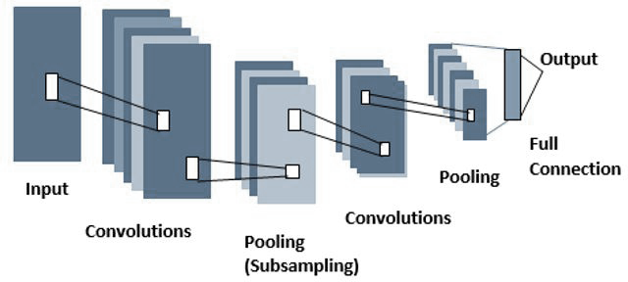
Figure 4 Convolutional neural network with its multiple layers.
Figure 5. Flow Chart for the System Using Convolutional Neural Network
The following steps are used to detect whether the given dermoscopic image has cancer or not-
• Step1: Initializing all the images and all the parameters that are needed for system.
• Step2: The system takes a training image as input and saves the images into the system.
• Step3: The system uses convolutional neural network and finds out the prediction.
• Step4: Training with the convolutional neural network that are generated in step 3.
• Step5: Save the model into the system for prediction of the test data.
• Step5: Evaluate the result with the standard evaluation metrics like accuracy, precision, recall, and f1 score.

Chapter 5
DESIGN AND IMPLEMENTATION
5.1 Software Tools
- Language: Python
- Development Tool: Anaconda and Jupiter Notebook.
- Operating System: Windows 7 & above
5.2 Hardware Tools
- System: Core i3 and above.
- Hard Disk: 40 GB.
- Ram: 2 GB
5.3 Tools Description
5.3.1 Python
Python is an interpreter, high-level, general-purpose programming language. Created by Guido van Rossum and first released in 1991, Python’s design philosophy emphasizes code readability with its notable use of significant whitespace. Its language constructs and object oriented approach aim to help programmers write clear, logical code for small and large scale projects. Python is dynamically typed and garbage-collected. It supports multiple programming paradigms, including procedural, object-oriented, and functional programming. Python is often described as a “batteries included” language due to its comprehensive standard library.
5.3.2 Anaconda and Jupiter Notebook
The easiest way for a beginner to get started with Jupyter Notebooks is by installing Anaconda. Anaconda is the most widely used Python distribution for data science and comes pre-loaded with all the most popular libraries and tools. Some of the biggest Python libraries wrapped up in Anaconda include NumPy, pandas and Matplotlib, though the full 1000+ list is exhaustive. This lets you hit the ground running in your own fully stocked data science workshop without the hassle of managing countless. Installations or worrying about dependencies and OS-specific (read: Windows-specific) installation issues. The Jupyter Notebook is an incredibly powerful tool for interactively developing and presenting data science projects. It is an open-source web application that allows you to create and share documents that contain live code, equations, visualizations and narrative text. Uses include: data cleaning and transformation, numerical simulation, statistical modeling, data visualization, machine learning, and much more.
5.4 Project Design
5.4.1 Data Flow Diagram
A data flow diagram (DFD) is a nothing but a graphical representation of the “flow” of data through an information system, which is used for modelling its Process aspects. Mostly DFD’s are very preliminary step which is used for representing overview of system which can later explain in detail. DFDs can also be used for the visualization of data processing (structured design). A DFD shows what kind of information will be input to and output from the system, where the data will come from and go to, and where the data will be stored. It does not show information about the timing of processes, or information about whether processes will operate in sequence or in parallel.
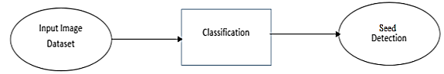
Figure 5.1 DFD Level-0
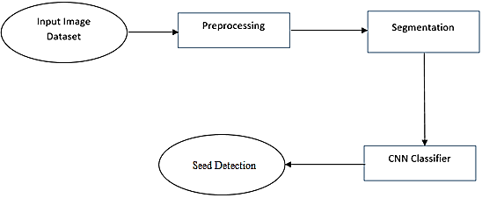
Figure 5.2 DFD Level-1
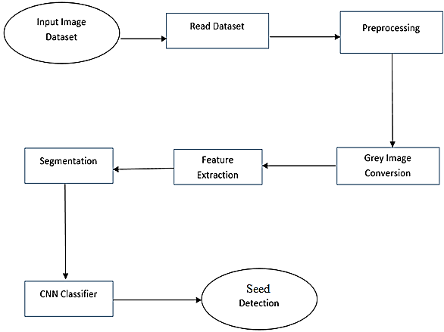
Figure 5.3 DFD Level-2
5.3.2 UML Diagrams
5.3.2.1 Use Case Diagram
Use Case diagrams identify the functionality provided by the system (use cases), the users who interact with the system (actors), and the association between the users and the functionality. Use Cases are used in the Analysis phase of software development to articulate the high-level requirements of the system.
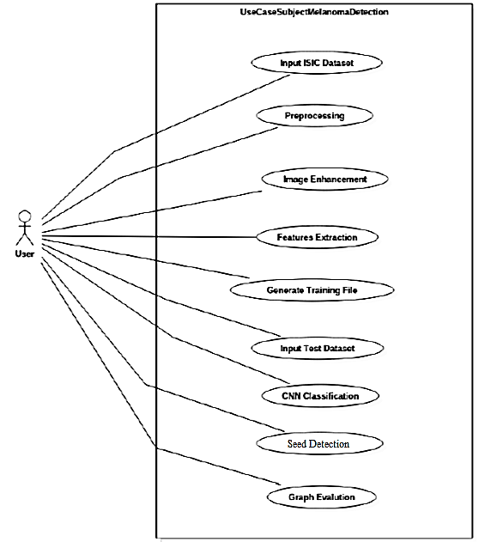
Figure 5.4 UseCase Diagram
5.3.2.2 Activity Diagram
Activity diagrams describe the work flow behavior of a system. Activity diagrams are similar to state diagrams because activities are the state of doing something. The diagrams describe the state of activities by showing the sequence of activities performed. Activity diagrams can show activities that are conditional or parallel. In general Activity diagrams is used to show different activities which are performed by the system. Following figure shows different activities.
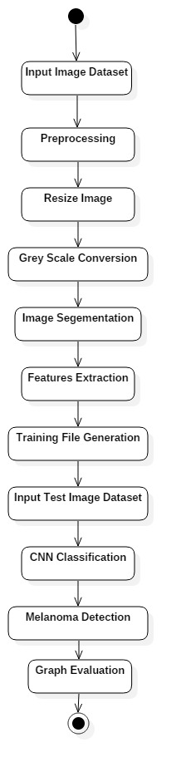
Figure 5.5 Activity Diagram
5.3.2.3 Sequence Diagram
Sequence diagrams in UML shows how object interact with each other and the order those interactions occur. It’s important to note that they show the interactions for a particular scenario. The processes are represented vertically and interactions are show as arrows. A sequence diagram shows object interactions arranged in timely sequence.
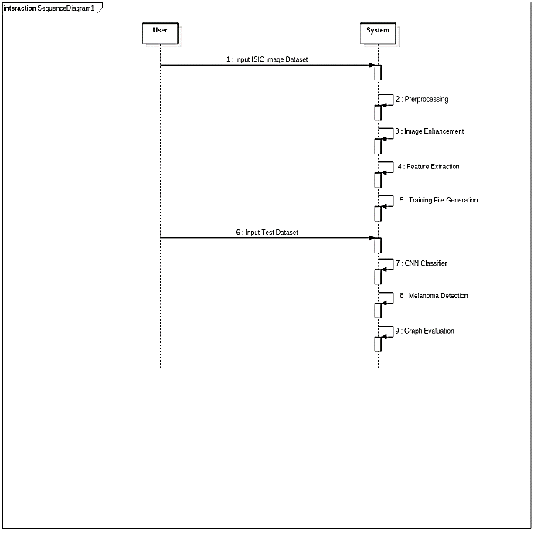
Figure 5.6 Sequence Diagram
5.4 Feasibility Study
The feasibility study comprise of an initial investigation into personnel will be required. Feasibility study will help you make informed and transparent decisions at crucial points during the developmental process. All projects are feasible given unlimited times and resources. Unfortunately, the development of computer based system is more likely to be plagued to scarcity of resources. It is both necessary and prudent to evaluate the feasibility of project at earliest possible time.
5.4.1. Technical Feasibility
The system must be evaluated from the technical point of view first. The assessment of this feasibility must be based on an outline design of the system requirement in the terms of input, output, programs and procedures. Having identified an outline system, the investigation must go on to suggest the type of equipment, required method developing the system, of running the system once it has been designed. Technical issue raised during the investigation is:
The project should be developed such that the necessary functions and performance are achieved within the constraints. The project is developed within latest technology. So there are minimal constraints involved with this project. The system has been developed using Java and the project is technically feasible for development.
5.4.2. Economic Feasibility
Economic feasibility looks at the financial aspects of the project. Economic feasibility concerns with the returns from the investments in a project. It determines whether it is worthwhile to invest the money in the proposed system. It is not worthwhile spending a lot of money on a project for no returns. To carry out an economic feasibility for a system, it is necessary to place actual money value against any purchases or activities needed to implement the project.
5.4.3. Performance Feasibility
The system provides a user friendly graphical interface and is therefore easy to use. Working with Hashing based video retrieval requires programming knowledge of any sort. The system is operationally feasible for implementation for the following reasons:
1. The system is readily acceptable by the users since it requires no special skills for them to use the system.
5.5 Project Estimating
5.5.1. Function Point Analysis
Software project estimation is form of problem solving. The complex software is hard to estimate hence it is divided into smaller of pieces. The estimation of project will be correct only when the estimation of size of the project is correct. In the context of project planning size refers to quantifiable outcome of project. Here, the direct approach is choose and hence , the size is estimated in Line of Codes.
5.5.2 Cost Estimation
The Lines of Code (LOC) is a software metric used to measure the size of a computer program by counting the number of lines in the text of the program’s source code. LOC is typically used to predict the amount of efforts required to develop a program.

Chapter 6
RESULT AND ANALYSIS
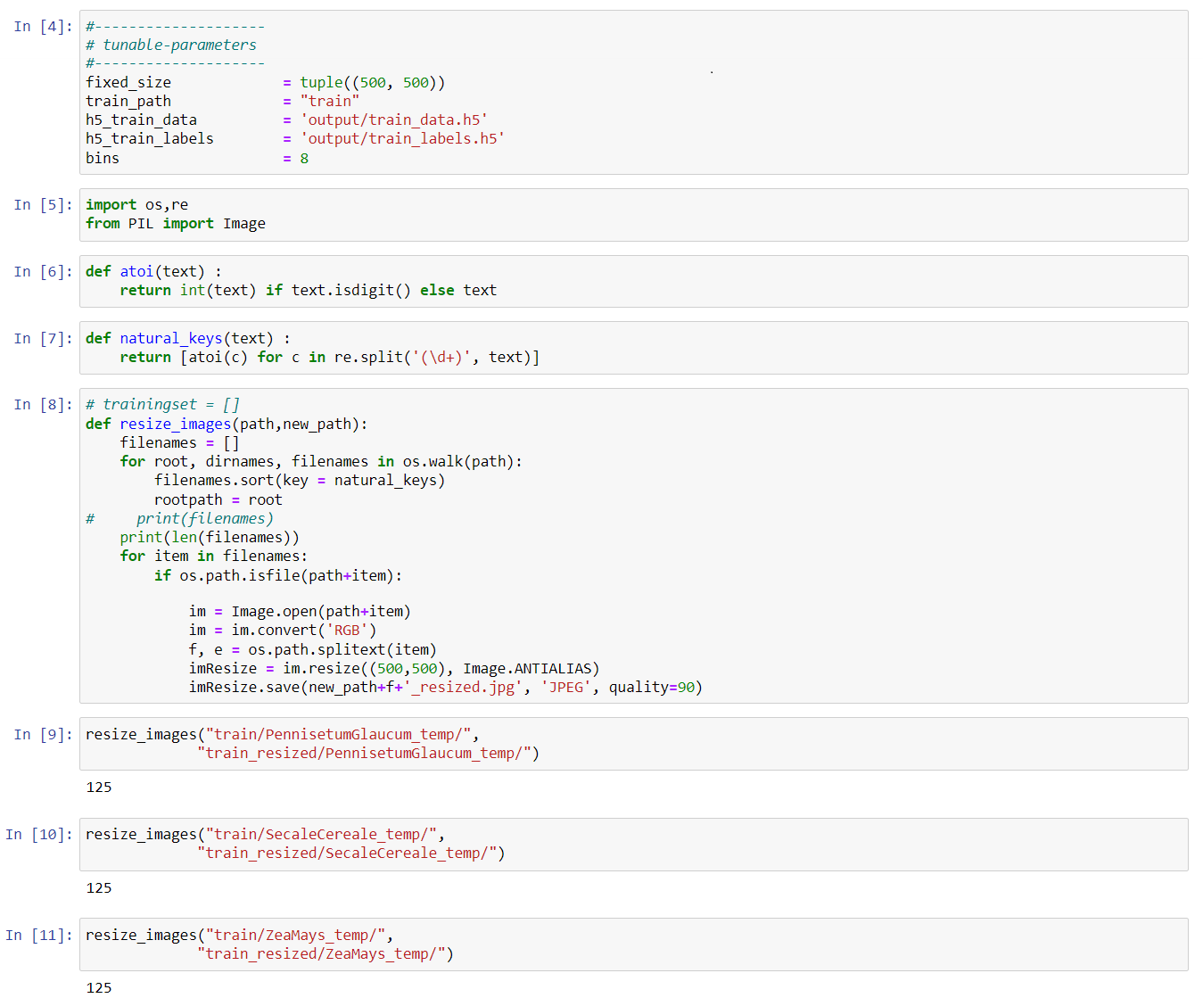
Figure 6.1 Input Dataset
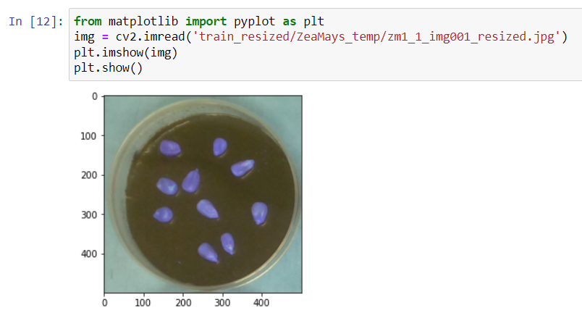
Figure 6.2 Input Seed Image
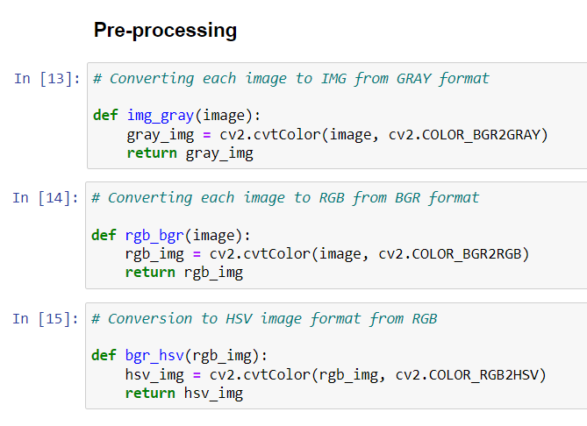
Figure 6.3 Pre-Processing of the Dataset
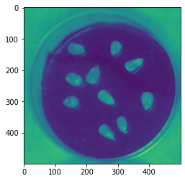
Figure 6.4 Grey Scale Converted Image after Pre-Processing
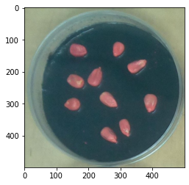
Figure 6.5 RGB Conversion
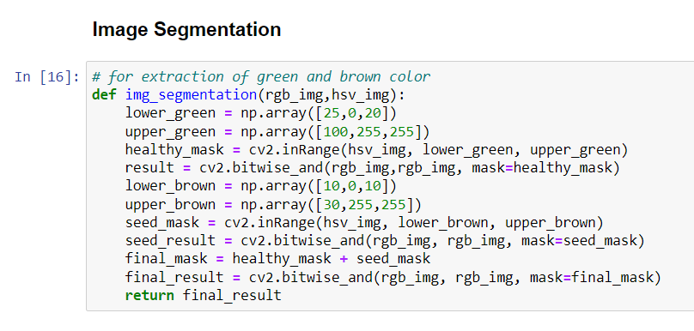
Figure 6.6 Image Segmentation
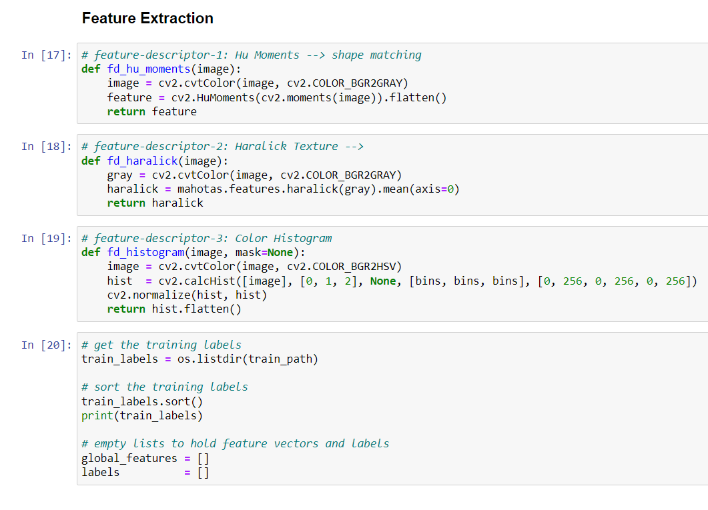
Figure 6.7 Feature Extraction

Confusion Matrix
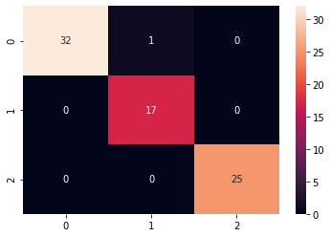
Figure 6.8 Confusion Matrix for Classification

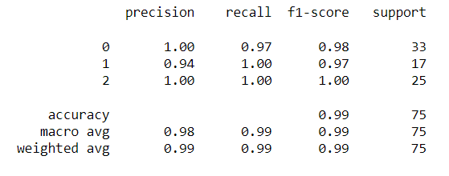
Figure 6.9 Random Forest Classification Results

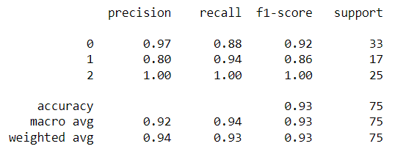
Figure 6.10 Naïve Bayes Classification Results

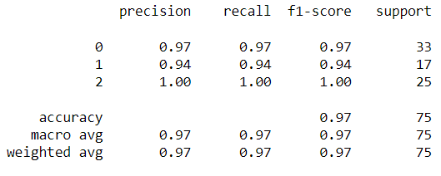
Figure 6.11 Decision Tree Classifier Results

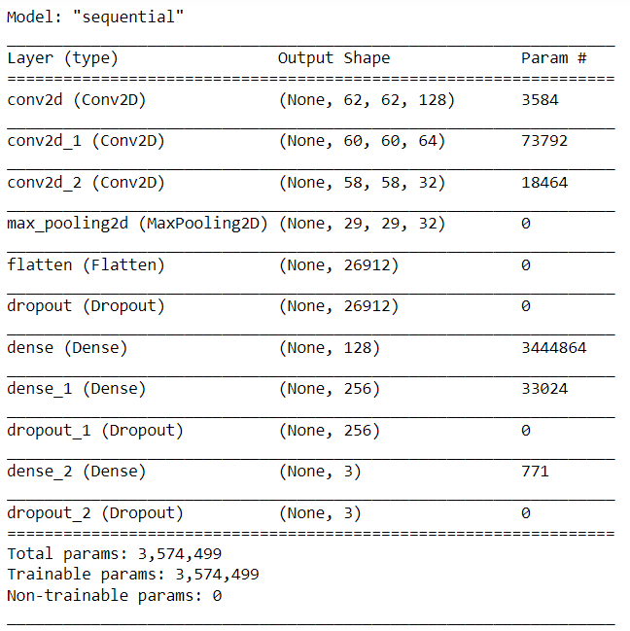
Figure 6.12 CNN Architecture for Seed Classification

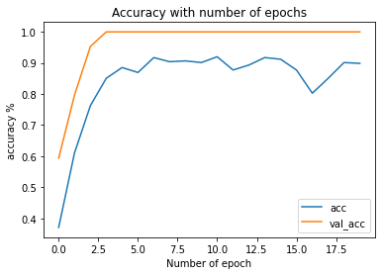
Figure 6.13 Accuracy Comparison for CNN Model

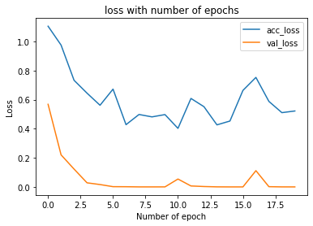

Figure 6.14 Loss Comparison for CNN Model

Chapter 7
CONCLUSION AND FUTURE SCOPE
This research provided a methodology for seed identification and classification that was both efficient and effective. The model is trained using a dataset that contains photos of 14 different seed variations. With the help of an inherent API ImageDataGenerator in Keras' library, the picture augmentation approach was employed to artificially generate extra training images for use in the training process. The enhanced photos were rescaled to a resolution of 224 224 3 pixels. The proposed model used the existing VGG16 architecture for classification, with the last layer being replaced by five newly implemented layers: the average pooling layer, the flatten layer, the dense layer, the dropout layer, and the softmax layer. The proposed model also used the existing VGG16 architecture for classification, with the last layer being replaced by five newly implemented layers: the average pooling layer, the flatten layer, the dense layer, the dropout layer, and the softmax layer. The model was fine-tuned in order to increase its categorization performance. The model was optimised and verified in order to improve the accuracy rate while simultaneously decreasing the error rate. The accuracy of the suggested model, according to the results, can reach up to 99.9 percent. In future work, we intend to build a mobile-based application that will incorporate a greater number of different seeds (than the 14 varieties that were studied in this study), with the goal of expanding the spectrum of seeds that can be classified. Because it is difficult to seek appropriate advice from agriculture experts or experienced farmers when identifying, sorting, and classifying seeds manually, this application would benefit people with limited knowledge about seeds, as it is difficult to seek suitable advice from agriculture experts or experienced farmers when identifying, sorting, and classifying seeds manually.

REFERENCES
- Santos, L.; Santos, F.N.; Dos Oliveira, P.M.; Shinde, P. Deep Learning Applications in Agriculture: A Short Review. In Iberian Robotics Conference; Springer: Cham, Switzerland, 2020; pp. 139–151, ISBN 9783030359898.
- Barman, U.; Choudhury, R.D.; Sahu, D.; Barman, G.G. Comparison of convolution neural networks for smartphone image based real time classification of citrus leaf disease. Comput. Electron. Agric. 2020, 177, 105661.
- Xinshao, W. Weed Seeds Classification Based on PCANet Deep Learning Baseline. In Proceedings of the 2015 Asia-Pacific Signal and Information Processing Association Annual Summit and Conference APSIPA ASC, Hong Kong, China, 16–19 December 2015; pp. 408–415.
- Jamuna, K.S.; Karpagavalli, S.; Vijaya, M.S.; Revathi, P.; Gokilavani, S.; Madhiya, E. Classification of Seed Cotton Yield Based on the Growth Stages of Cotton Crop Using Machine Learning Techniques. In Proceedings of the ACE 2010–2010 International Conference on Advances in Computer Engineering, Bangalore, India, 20–21 June 2010; pp. 312–315.
- Qiu, Z.; Chen, J.; Zhao, Y.; Zhu, S.; He, Y.; Zhang, C. Variety identification of single rice seed using hyperspectral imaging combined with convolutional neural network. Appl. Sci. 2018, 8, 212.
- Kiratiratanapruk, K.; Temniranrat, P.; Sinthupinyo, W.; Prempree, P.; Chaitavon, K.; Porntheeraphat, S.; Prasertsak, A. Development of Paddy Rice Seed Classification Process using Machine Learning Techniques for Automatic Grading Machine. J. Sens. 2020, 2020, 7041310.
- Wu, N.; Zhang, Y.; Na, R.; Mi, C.; Zhu, S.; He, Y.; Zhang, C. Variety identification of oat seeds using hyperspectral imaging: Investigating the representation ability of deep convolutional neural network. RSC Adv. 2019, 9, 12635–12644.
- Luan, Z.; Li, C.; Ding, S.; Wei, M.; Yang, Y. Sunflower Seed Sorting Based on Convolutional Neural Network. In Proceedings of the ICGIP 2019 Eleventh International Conference on Graphics and Image Processing, Hangzhou, China, 12–14 October 2019; Pan, Z., Wang, X., Eds.; SPIE: Bellingham, WA, USA, 2020; Volume 11373, p. 129.
- Rozman, C. Denis Stajnko Assessment of germination rate of the tomato seeds using image processing and machine learning. Eur. J. Hortic. Sci. 2015, 80, 68–75.
- Taylor, J.; Chiou, C.P.; Bond, L.J. A methodology for sorting haploid and diploid corn seed using terahertz time domain spectroscopy and machine learning. AIP Conf. Proc. 2019, 2102.
- Ali, A.; Qadri, S.; Mashwani, W.K.; Brahim Belhaouari, S.; Naeem, S.; Rafique, S.; Jamal, F.; Chesneau, C.; Anam, S. Machine learning approach for the classification of corn seed using hybrid features. Int. J. Food Prop. 2020, 23, 1097–1111.
- LeCun, Y.; Bengio, Y. Convolutional networks for images, speech, and time series. Handb. Brain Theory Neural Netw. 1995, 3361, 1995.
- Schmidhuber, J. Deep Learning in neural networks: An overview. Neural Netw. 2015, 61, 85–117.
- Zhuang, F.; Qi, Z.; Duan, K.; Xi, D.; Zhu, Y.; Zhu, H.; Xiong, H.; He, Q. A Comprehensive Survey on Transfer Learning. Proc. IEEE 2020, 1–31.
- Tan, C.; Sun, F.; Kong, T.; Zhang, W.; Yang, C.; Liu, C. A Survey on Deep Transfer Learning. In Proceedings of the International Conference on Artificial Neural Networks, Rhodes, Greece, 4–7 October 2018; pp. 270–279.
- Simonyan, K.; Zisserman, A. Very Deep Convolutional Networks for Large-Scale Image Recognition. In Proceedings of the 3rd International Conference on Learning Representations, ICLR 2015—Conference Track Proceedings, San Diego, CA, USA, 7–9 May 2015; pp. 1–14.
- Eli-Chukwu, N. Applications of Artificial Intelligence in Agriculture: A Review. Eng. Technol. Appl. Sci. Res. 2019, 9, 4377–4383.
- Agrawal, D.; Dahiya, P. Comparisons of classification algorithms on seeds dataset using machine learning algorithm. Compusoft 2018, 7, 2760–2765.

