8/18/2026
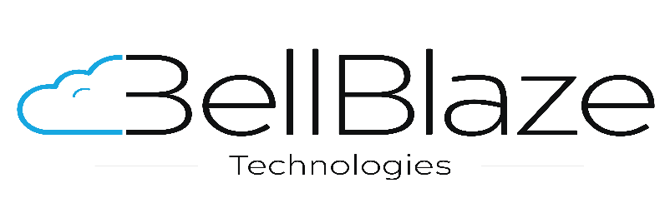


Proposal: Prospecta Software Solutions Private Limited
Data Lake Proof Of Concept

Table of Contents
1. About Bell Blaze 2
2. Our Offerings 2
3. Customer Business Overview 2
4. Executive Summary 2
5. Architecture 3
6. Scope of Work 7
7. Deliverables 10
8. Timeline & Work Breakdown Structure (WBS) 11
9. Assumptions and Exclusions 15
10. Responsibilities 16
11. Dependencies 16
12. TCO 17
13. Contact Details 17

About Bell Blaze
Bell Blaze is a technology solutions firm specializing in logistics-tech, automation, and cloud-native product development. With a strong foundation in scalable systems and enterprise software delivery, Bell Blaze is committed to digital transformation initiatives that solve real-world operational challenges.
We specialize in modernizing legacy systems, providing a seamless transition to a future-ready infrastructure. Our skilled delivery team is adept at identifying and addressing the full spectrum of our clients' needs.

Our Offerings
We provide AWS Cloud Native Development & Consultation, DevSecOps, GitOps, AIOps, Data Analytics & Machine Learning, GenAI Solutions & Managed Services including Modernization, Automation & Transformation.

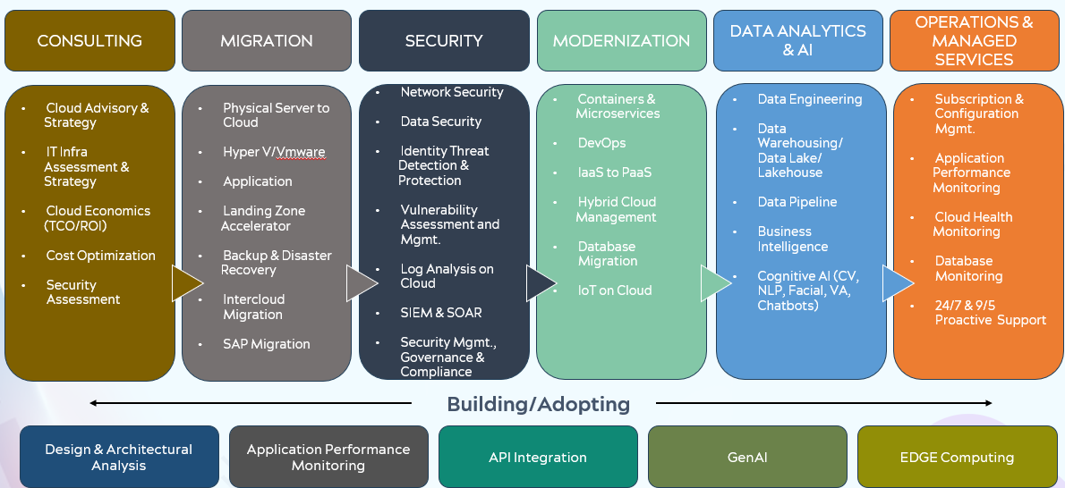

Customer Business Overview
Prospecta Software is a Sydney, Australia headquartered enterprise software company founded in 2002, specializing in Master Data Management (MDM), data quality, governance, and integration, with a strong focus on the SAP ecosystem. Its flagship MDO platform helps large enterprises manage and govern critical data such as materials, customers, suppliers, assets, and finance, supporting SAP transformations, data-quality improvement, and AI readiness. Prospecta primarily serves large organizations across industries including manufacturing, automotive, energy, mining, chemicals, pharma, and retail.
Prospecta Software Solutions Pvt Ltd can be referred to as 'Customer' or 'CUSTOMER' or 'Client'.

Executive Summary
Bell Blaze Technologies will design, build, operate and evaluate three proofs of concept (“POCs”) that each move data from Amazon RDS for PostgreSQL into a cloud analytics target, terminating in a working Power BI report. All three are delivered inside a single isolated AWS sandbox account in ap-southeast-2, with no connectivity to or dependency on Prospecta production workloads.
The three patterns evaluated are: Amazon Redshift Federated Query, which queries the source database live with no data movement; AWS DMS replication into Amazon S3 as Parquet, catalogued by AWS Glue and consolidated into Apache Iceberg tables readable by Amazon Athena and Amazon Redshift Spectrum from a single physical copy; and the Amazon RDS to Amazon Redshift Zero-ETL integration, an AWS-managed replication path requiring no pipeline to build or operate.
Every POC handles both historical and incremental data. Each performs a complete initial load of the agreed source subset and is then operated in change-data-capture mode and, separately, in a scheduled batch mode, so that both freshness models are measured on identical data. In every case the historical load and all subsequent changes are merged into a single consolidated set of target tables; no separate history or staging schema is exposed to reporting consumers.
No custom transformation code is written. Data movement uses managed replication, query federation or declarative merge only. All credentials are held in AWS Secrets Manager, encryption at rest uses AWS KMS customer-managed keys, and AWS API traffic leaves through VPC endpoints rather than the public internet.
The engagement runs for 14 business days and is phased so that the two lowest-risk patterns are proven within the first four days and the largest work package does not begin until the source configuration is confirmed. Two formal gates govern progression. The engagement concludes with a measured comparison of latency, cost and operational effort across the three patterns, and a documented recommendation identifying which should proceed to production design.
This is an evaluation exercise. It is expressly not a production implementation, and no production workload will depend on any artefact produced under this Statement of Work. The environment is provisioned to the minimum specification necessary to produce valid measurements.

Architecture
Proposed AWS Architecture Overview:
Each POC is provisioned inside a single VPC spanning two Availability Zones in AWS region ap-southeast-2. The design is least-privilege by default. A public subnet carries only the NAT gateway required for egress. Every data, replication and analytics resource sits in a private subnet with no public ingress. AWS API traffic leaves through VPC endpoints rather than the public internet.
POC build versus production design
The architecture diagrams depict the target production design. The POC is built to a reduced specification, because the components below improve availability in production but do not affect the latency, cost or portability measurements this engagement is intended to produce. They are excluded from the POC build and from all figures in Section 12, as recorded in Note 7 of that section, and are carried forward as recommendations in the final report.
Component | In POC build? | Rationale
RDS Multi-AZ standby on the analytics read replica | No | Failover protection only. The replica is disposable and can be recreated from the source in minutes.
Second NAT gateway (one per Availability Zone) | No | A single NAT gateway in one Availability Zone is sufficient for egress during a 14-day evaluation.
Redshift managed VPC endpoint for cross-AZ availability | No | Availability feature only. Does not affect query latency or cost measurement.
Two-node Power BI gateway cluster in an Auto Scaling group | No — single node | The clustered design was added in response to the Customer’s single-point-of-failure review comment and remains the production recommendation. One node is sufficient to publish and measure a report over 14 days.

  - POC 1 — Amazon Redshift Federated Query
Amazon Redshift queries the source database live over the VPC with no data movement, pushing predicates down to PostgreSQL. Left unconstrained, this pattern places every BI query directly onto the operational database, and federated queries are not eligible for Redshift concurrency scaling, so the warehouse cannot absorb concurrency spikes on federated reads. The design applies controls in depth: a dedicated analytics read replica as the federation target so no BI traffic reaches the primary; PgBouncer connection pooling in front of the replica; Redshift materialized views that collapse many concurrent BI queries into one scheduled refresh, with BI users granted access to the views only and never to the external schema; and statement timeouts with a WLM query monitoring rule on both the Redshift and PostgreSQL sides.
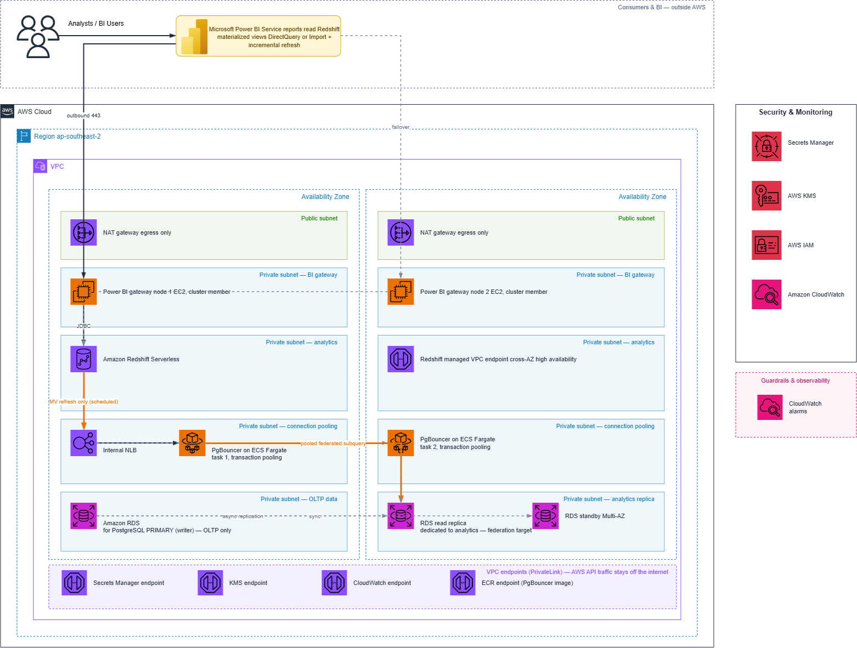

  - POC 2 — AWS DMS to Amazon S3 with AWS Glue and Apache Iceberg
AWS DMS Serverless performs a full load followed by continuous change data capture into an Amazon S3 raw landing zone as date-partitioned Parquet. An AWS Glue crawler catalogs the landing zone, and an AWS Glue PySpark job deduplicates and merges changes into a single consolidated Apache Iceberg table per source table in a separate Amazon S3 warehouse. Amazon EventBridge triggers the job on S3 object creation. The same catalogued table is then read by Amazon Athena and Amazon Redshift Spectrum from one physical copy of the data, governed by AWS Lake Formation. Compaction and snapshot expiry run as scheduled Glue jobs to prevent small-file sprawl.
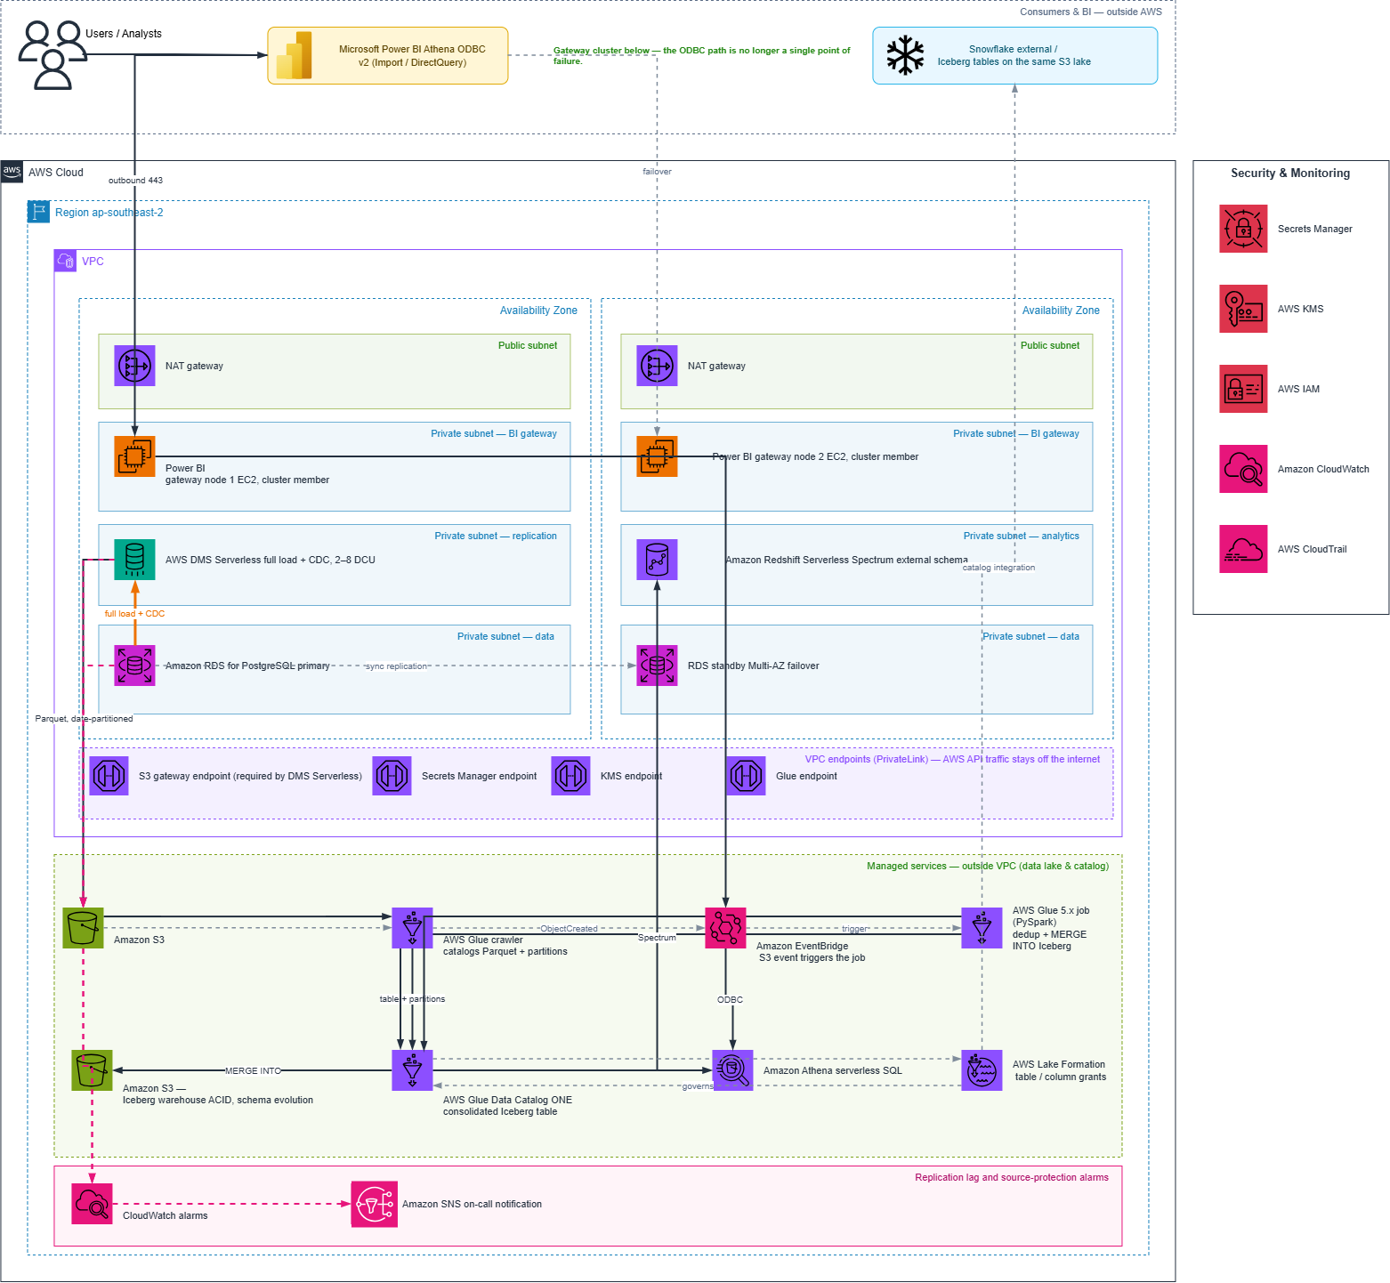
  - POC 3 — Amazon RDS to Amazon Redshift Zero-ETL Integration
The AWS-managed Zero-ETL integration reads the source write-ahead log and performs an automatic initial backfill followed by seconds-level replication, with optional data filtering per integration. There is no DMS, no Glue and no pipeline code. The destination Redshift database is read-only, so consumer-facing views and materialised views are built in a separate Redshift analytics database. Amazon EventBridge carries integration state events, and per-table synchronisation state is monitored through the Redshift system views rather than the integration status alone.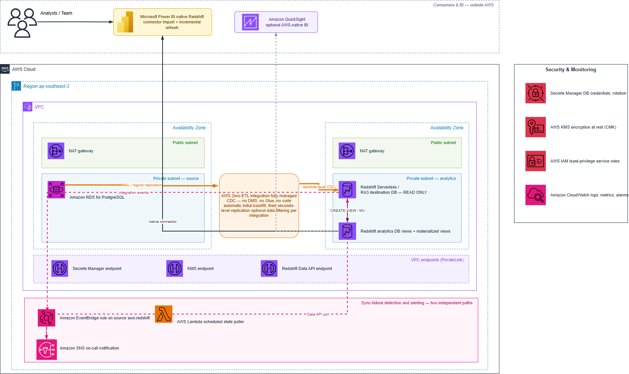

Scope of Work
The scope covers the end-to-end delivery of three proofs of concept moving data from Amazon RDS for PostgreSQL into cloud analytics targets, each validated through to a working Power BI report. Work is executed in structured phases covering source assessment and architecture design, AWS sandbox foundation provisioning, the three POC builds, the reporting layer, validation and measurement, and the comparative evaluation and recommendation.
Key Activities
- Source Assessment & POC Architecture Design
- Conduct a detailed review of the source Amazon RDS for PostgreSQL instance, confirming engine version, deployment topology and eligibility for each of the three patterns.
- Audit every in-scope source table for primary key coverage and replica identity, and identify any table that would fail to replicate or would replicate inserts only under POC 3.
- Identify source columns using data types that are unsupported by the Zero-ETL integration, including geometry types and values exceeding 64 KB.
- Agree the in-scope schema and table subset with the Customer, and confirm it is representative in structure and data-type coverage.
- Agree the POC success criteria and the Functional Threshold in writing before any deliverable is submitted for acceptance.
- Define the VPC topology and the per-POC VPC endpoint allocation set out in Section 5.2.
- Produce the custom DB parameter group change plan and agree the reboot window with the Customer.
- Produce a Source Readiness Assessment and POC Architecture Blueprint for Customer review and sign-off.
- AWS Sandbox Foundation Provisioning
- Sandbox AWS account setup and access validation in ap-southeast-2, with AWS IAM roles, policies, groups and users on a least-privilege model and MFA enforcement.
- VPC creation with public and private subnets across two Availability Zones, route tables, Internet Gateway and a single NAT gateway.
- VPC endpoint provisioning per Section 5.2, so that AWS API traffic does not traverse the public internet.
- Security Group configuration per tier, with no public ingress to any private subnet.
- AWS KMS customer-managed key creation with least-privilege key policies, and AWS Secrets Manager secrets for all source database and service credentials.
- AWS CloudTrail with log-file validation, and VPC Flow Logs delivered to Amazon CloudWatch Logs.
- Confirmation that every service in scope is available in ap-southeast-2, including the Zero-ETL integration.
- POC 1 — Amazon Redshift Federated Query (query in place)
- Provision a dedicated Amazon RDS for PostgreSQL read replica for analytics, and target the Redshift external schema at that replica instance endpoint. Federated query is read-only, so the primary carries no BI traffic.
- Create separate read-only database logins per use case — one for materialized view refresh and one for ad-hoc analysis — each with its own AWS Secrets Manager secret and its own Redshift external schema.
- Deploy PgBouncer on Amazon ECS Fargate in transaction pooling mode behind an internal Network Load Balancer, to cap backend connections to the replica and queue rather than refuse under load. Amazon RDS Proxy cannot be attached to an RDS read replica, so it is not available for this path.
- Provision the Amazon Redshift Serverless workgroup and the external schemas over the replica.
- Build Redshift materialized views over the federated tables on a scheduled refresh, and grant BI users access to the materialized views only, never to the external schema. This is the primary control that prevents every BI query reaching the source.
- Apply statement_timeout to the Redshift users, statement_timeout and idle_in_transaction_session_timeout to the PostgreSQL roles, and a WLM query monitoring rule on query execution time to abort runaway federated queries.
- Add covering indexes on the replica for the federated predicates, and where Redshift cannot push a join restriction down, encapsulate the join in a PostgreSQL view so the restriction is applied at source.
- Validate query execution including a join between a federated table and a local Redshift table, and confirm predicate pushdown from the query plan.
- Measure the load imposed on the replica during representative concurrent BI activity, and record connection count, CPU and replica lag against the concurrency ceiling.
- Publish one representative Power BI report reading the materialized views.
- POC 2 — AWS DMS to Amazon S3, catalogued and consolidated via AWS Glue
- Enable logical replication on the source instance via the custom DB parameter group and execute the agreed reboot.
- Configure AWS DMS Serverless source and target endpoints with capacity bounded at 2 to 8 DCU, with the Amazon S3 target writing Parquet using date-based partitioning, and tune batch interval and minimum file size to control small-file proliferation.
- Execute a full load followed by continuous change data capture, and confirm both land correctly in the Amazon S3 landing zone.
- Configure an AWS Glue crawler to catalogue the landing zone and register partitions in the AWS Glue Data Catalog.
- Build an AWS Glue PySpark job that deduplicates change records by primary key and commit timestamp and merges them into a single Apache Iceberg table per source table, applying a watermark guard so a replayed or late-arriving change cannot overwrite newer committed state.
- Configure event-driven job execution via Amazon EventBridge, and scheduled Iceberg maintenance covering file compaction and snapshot expiry.
- Validate that the same catalogued table is readable from Amazon Athena and Amazon Redshift Spectrum, from one physical copy of the data.
- Configure data access segregation using Amazon S3 prefixes with AWS Lake Formation grants.
- Configure replication lag and source-protection alarms: CDCLatencySource, CDCLatencyTarget, CDCChangesDisk, and on the source instance OldestReplicationSlotLag, TransactionLogsDiskUsage and FreeStorageSpace, with EventBridge task-state notification to Amazon SNS.
- Connect Power BI to the lake via the Amazon Athena ODBC driver and publish one representative report.
- POC 3 — Amazon RDS to Amazon Redshift Zero-ETL Integration
- Confirm source engine version eligibility and apply the required custom DB parameter group settings, coordinating the reboot with the Customer.
- Configure the Amazon Redshift target, including case-sensitive identifiers and the resource policy authorising the source.
- Create the Zero-ETL integration, apply table-level data filtering to the agreed POC subset, and create the destination database.
- Verify per-table synchronisation state through the Amazon Redshift system views, rather than relying on the integration status alone, and report any table that did not replicate together with the cause.
- Measure replication latency under representative source write activity.
- Build the consumer-facing views and materialised views in a separate Amazon Redshift database, since the replicated database is read-only.
- Configure two independent sync-failure detection paths: an Amazon EventBridge rule on integration state events, and a scheduled AWS Lambda function that polls SVV_INTEGRATION_TABLE_STATE through the Redshift Data API and publishes a custom Amazon CloudWatch metric. Both are required because Amazon RDS publishes no integration metrics to CloudWatch and tables can fail to synchronise without raising an error.
- Document the major-version upgrade runbook: an active integration blocks a major-version upgrade of the source, and recreating the integration triggers a full backfill rather than an incremental resume.
- Publish one representative Power BI report on the consumer database.
- Reporting Layer
- Configure Power BI connectivity to all three POC targets: the native Amazon Redshift connector for POC 1 and POC 3, and the Amazon Athena ODBC driver for POC 2, through a single on-premises data gateway node.
- Build one representative Power BI report per POC, on that POC’s target, so that the comparison is made end to end rather than at the data layer alone.
- Configure and validate scheduled refresh.
- Validation, Measurement & Evaluation
- Row count and integrity validation of each POC target against the source, including AWS DMS data validation for POC 2.
- Schema validation confirming the catalogued or replicated structure matches the source.
- Replication latency measurement per POC under representative source write activity.
- Schema-change testing, exercising column addition, removal and rename against each pattern and recording the observed behaviour.
- Measured infrastructure cost per POC, taken from the billing data, with a documented basis for extrapolation to production volumes. Any production projection is presented with its assumptions stated and is submitted for Customer review before use.
- Comparative evaluation across latency, cost, operational overhead, portability and schema-change handling, presented as a decision matrix with a documented recommendation.
- Documentation & Handover
- Architecture-as-built diagram set, one per POC, showing account boundary, region, VPC, Availability Zones, subnets, endpoints and security controls, marked to distinguish POC build from production recommendation.
- Configuration and runbook pack: parameter groups, endpoint settings, IAM policies, AWS Glue job source and alarm definitions.
- Knowledge Transfer sessions (2 × 2-hour sessions) with the Prospecta team.
- Decommissioning of all POC environments and any replicated data within ten business days of programme acceptance, confirmed in writing, unless the Customer directs otherwise

Deliverables
Ref | Phase | Deliverable | Description
D1 | 1 | Work Breakdown Structure | Detailed task, effort and schedule breakdown with gate dates
D2 | 1 | Source Readiness Assessment | Primary key coverage, replica identity audit, unsupported data types, parameter group change plan, agreed in-scope table subset
D3 | 1 | Success Criteria & Functional Threshold | Written definition of acceptance, agreed and signed off before any deliverable is submitted for acceptance
D4 | 1 | POC Architecture Blueprint | VPC topology, subnet and tier design, endpoint plan, security control set, POC build scope versus production design, for Customer sign-off
D5 | 2 | AWS Sandbox Foundation | VPC, subnets, NAT gateway, VPC endpoints, security groups, IAM, KMS, Secrets Manager, CloudTrail, Flow Logs provisioned in ap-southeast-2
D6 | 3 to 5 | Three working POC environments | Federated Query, DMS to S3 with Glue and Iceberg, and Redshift Zero-ETL, each operating in the designated sandbox account
D7 | 3 to 5 | Architecture-as-built diagram set | One diagram per POC with subnet allocation, VPC endpoints and security controls, in draw.io and PDF
D8 | 6 | Three Power BI reports | One representative report per POC, built on that POC’s target
D9 | 7 | Validation Report | Row counts, replication latency measurements, schema-change test results, per-table synchronisation state, and any table excluded with the cause
D10 | 7 | Measured Cost Report | Actual infrastructure consumption per POC across the engagement, with a documented basis for extrapolation to production volumes
D11 | 7 | Comparative Evaluation & Recommendation | Decision matrix across latency, cost, operational overhead, portability and schema-change handling, with a recommended production path
D12 | 8 | Documentation & Knowledge Transfer | Configuration and runbook pack, plus 2 × 2-hour KT sessions

Acceptance and the Functional Threshold

Acceptance mechanism. Deliverable D3 defines the success criteria and the Functional Threshold in writing and is signed off at the end of Phase 1. No deliverable is submitted for acceptance, and no deliverable is deemed accepted, before D3 is signed off. From that point, each deliverable is submitted to the Prospecta engagement owner, who has three business days to accept it or to provide written notice of specific deficiencies against the criteria in D3. Absent such notice the deliverable is deemed accepted.

A POC is accepted as successful when it achieves the Functional Threshold, defined as all of the following:
- At least 75% of the agreed in-scope source tables are usable end to end, meaning the data is present and correct in the POC target and is queryable by the reporting layer.
- The historical load has completed and the incremental mechanism is demonstrably operating, with a measured latency figure recorded.
- Historical and incremental data are confirmed to reside in a single consolidated set of target tables.
- One Power BI report renders correctly against the POC target.
- Any table that did not replicate is identified, with the cause documented.

A table that cannot replicate for a reason attributable to source data structure — most commonly the absence of a primary key, or use of an unsupported data type — is excluded from the 75% denominator, provided Bell Blaze identified and reported it in deliverable D2.
The programme is accepted when at least two of the three POCs have achieved the Functional Threshold and deliverable D11 has been accepted. Where a POC does not achieve the Functional Threshold, Bell Blaze will document the technical reason. A POC that fails for a documented and evidenced technical reason constitutes a valid evaluation outcome and not a failure of performance under this Statement of Work.

Timeline & Work Breakdown Structure (WBS)
Task | Sub Task | Effort (person days) | Role
Assessment & Planning | Identify key participants, set engagement context, agree POC success criteria and the Functional Threshold (deliverable D3) | 0.5 | Business Development
Assessment & Planning | Prepare POC strategy, phasing and governance mechanism; walkthrough with Customer | 0.5 | Business Development
Assessment & Planning | Source readiness assessment: primary key coverage, replica identity audit, unsupported data types, parameter group change plan; agree in-scope table subset; produce architecture blueprint; review and sign-off | 1.0 | Sr. Solution Architect
AWS Foundation Setup | Sandbox account setup and access validation in ap-southeast-2. IAM roles, policies, groups, users. MFA enforcement, password policy | 0.5 | Sr. Cloud Engineer
AWS Foundation Setup | VPC, subnets across two Availability Zones, route tables, Internet Gateway, single NAT gateway, VPC endpoints per Section 5.2 | 1.0 | Sr. Cloud Engineer
AWS Foundation Setup | Security Groups per tier, KMS customer-managed keys, Secrets Manager secrets, CloudTrail, VPC Flow Logs | 0.5 | Sr. Cloud Engineer
POC 1 — Federated Query | Analytics read replica provisioning, per-use-case read-only logins and secrets, IAM role, security groups and VPC routing | 0.5 | Sr. Cloud Engineer
POC 1 — Federated Query | PgBouncer on ECS Fargate: image, task definition, internal NLB, pool sizing and validation | 1.0 | Sr. Cloud Engineer
POC 1 — Federated Query | Redshift Serverless workgroup, external schemas, materialized view caching with scheduled refresh, grants restricted to views, statement timeouts and WLM query monitoring rule | 0.5 | Sr. Solution Architect
POC 1 — Federated Query | Concurrency load test against the replica, covering indexes and remote view pushdown tuning | 0.5 | Sr. Cloud Engineer
POC 2 — DMS to Iceberg | Logical replication enablement, DMS Serverless source and target endpoints, S3 Parquet target with date partitioning, CDC batch interval and file size tuning | 1.0 | Sr. Cloud Engineer
POC 2 — DMS to Iceberg | Full load execution, CDC validation, S3 landing zone verification, DMS data validation enablement | 0.5 | Sr. Cloud Engineer
POC 2 — DMS to Iceberg | Glue crawler configuration, Data Catalog registration, partition validation | 0.5 | Sr. Data Engineer
POC 2 — DMS to Iceberg | Glue PySpark job: deduplication by key and commit timestamp, watermark guard, MERGE INTO Iceberg, job bookmarks, EventBridge event trigger | 2.0 | Sr. Data Engineer
POC 2 — DMS to Iceberg | Iceberg maintenance jobs: file compaction and snapshot expiry scheduling | 0.5 | Sr. Data Engineer
POC 2 — DMS to Iceberg | Multi-engine validation from one physical copy: Athena and Redshift Spectrum; Lake Formation grants | 0.5 | Sr. Data Engineer
POC 2 — DMS to Iceberg | Replication lag and source-protection alarms: CDCLatencySource/Target, CDCChangesDisk, OldestReplicationSlotLag, TransactionLogsDiskUsage, FreeStorageSpace, plus EventBridge task-state rule to SNS | 0.5 | Sr. Cloud Engineer
POC 3 — Zero-ETL | Engine version eligibility confirmation, custom DB parameter group application, reboot coordination | 0.5 | Sr. Cloud Engineer
POC 3 — Zero-ETL | Redshift target configuration, integration creation with data filtering, destination database creation | 0.5 | Sr. Solution Architect
POC 3 — Zero-ETL | Per-table synchronisation state verification, latency measurement, consumer views and materialised views in a separate database | 0.5 | Sr. Solution Architect
POC 3 — Zero-ETL | Two-path sync-failure detection: EventBridge rule on integration events, plus a scheduled Lambda that polls SVV_INTEGRATION_TABLE_STATE through the Redshift Data API and publishes a custom CloudWatch metric | 1.0 | Sr. Cloud Engineer
POC 3 — Zero-ETL | Major-version upgrade runbook: documented delete, upgrade, recreate and full-backfill change window | 0.5 | Sr. Solution Architect
Reporting Layer | Power BI connectivity to all three targets: Redshift native and Athena ODBC through a single gateway node; refresh configuration | 1.0 | Cloud Engineer
Reporting Layer | Three representative Power BI reports, one per POC target | 0.5 | Cloud Engineer
Validation & Evaluation | Row count and integrity validation, latency measurement, schema-change test execution, per-table state reporting | 1.0 | Sr. Solution Architect
Validation & Evaluation | Measured cost report per POC from billing data, with extrapolation basis for production volumes | 0.5 | Sr. Cloud Engineer
Validation & Evaluation | Comparative evaluation, decision matrix, recommendation and closing presentation | 0.5 | Sr. Solution Architect
Documentation & Project Management | Architecture-as-built diagram set (three diagrams), configuration and runbook pack | 1.0 | Cloud Engineer
Documentation & Project Management | Knowledge transfer sessions (2 × 2 hours), environment decommissioning and written confirmation | 0.5 | Cloud Engineer
Documentation & Project Management | PMO governance — daily checkpoints, gate reviews, risk management, change control, project closure | 0.5 | Project Management
Total Efforts |  | 20.5

Phasing and Gates
Days | Phase | Activity | Gate
1 to 2 | Foundation | Sandbox account, VPC, subnets, endpoints, IAM, KMS, Secrets Manager. Source readiness assessment and Functional Threshold agreed. | —
3 to 4 | Fast path | POC 1 Federated Query and POC 3 Zero-ETL delivered in parallel. Parameter group change and reboot executed. | Gate 1 — Day 4
5 to 10 | Core build | POC 2: DMS to S3, Glue crawler, Glue Iceberg merge job, Athena and Spectrum validation, alarms. | Gate 2 — Day 10
11 to 14 | Validate & recommend | Power BI reports completed, validation and cost reports issued, comparative evaluation and recommendation presented. | Programme acceptance
Gate criteria. Gate 1 requires POC 1 and POC 3 to have reached the Functional Threshold. Gate 2 requires the consolidated Iceberg table to be readable from both Amazon Athena and Amazon Redshift Spectrum, with an update and a delete correctly reflected. A no-go at either gate triggers a scope conversation rather than an automatic extension.

Assumptions and Exclusions

Assumptions:

Client provides an isolated AWS sandbox account in ap-southeast-2 with no production connectivity.

Client provides a representative non-production Amazon RDS for PostgreSQL dataset within 5 business days of kickoff. The source instance is owned and operated by Prospecta and forms part of its existing AWS estate. It is shown in Section 12 for total workload visibility and AWS Partner Network registration purposes only, is excluded from the engagement cost subtotal, and is not chargeable by Bell Blaze.

Client approves the DB parameter group change and instance reboot required for logical replication by Day 3.

Client provides Power BI licensing and tenant access for gateway registration. Bell Blaze provisions and operates a single on-premises data gateway node on Amazon EC2 within the sandbox account for the duration of the engagement, itemised in Section 12 and decommissioned on completion. A gateway is required for all Power BI Service access to private subnets, including DirectQuery.

Client provides billing portal read access and a technical SPOC available one hour per day.

Success criteria and the Functional Threshold are agreed in writing (deliverable D3) before any deliverable is submitted for acceptance. Thereafter deliverables are reviewed within 3 business days; absent written notice of deficiencies they are deemed accepted.

Source runs an engine version eligible for Zero-ETL, with no major-version upgrade during the engagement.

Source data remediation, including adding missing primary keys, is the Client’s responsibility; Bell Blaze identifies and reports gaps in deliverable D2.

The POC is built to the reduced specification set out in Section 5.4. Availability components shown in the architecture diagrams are production recommendations and are neither built nor costed.

Measurements are taken against the agreed POC subset and are indicative, not a production capacity commitment. Any production projection is submitted for Customer review before use.

Work is performed remotely during agreed working hours; environments are decommissioned within 10 business days of acceptance.
Exclusions:
- Production implementation, cutover and operation of any evaluated pattern.
- Snowflake in all forms, including the Openflow connector and Snowflake as a reader of the Amazon S3 Iceberg lake.
- Microsoft Azure services, including Azure Data Factory and Microsoft Fabric.
- OpenShift to Amazon EKS migration and the GC logging and observability workstreams, covered by separate SOWs.
- SRE support, priority-one alert handling and on-call cover, available under a separate agreement.
- Business transformation logic, semantic or dimensional models, and reporting beyond one representative report per POC.
- Source data quality remediation, including the addition of primary keys.
- Performance tuning or capacity sizing for production data volumes.
- Databricks evaluation and Redshift streaming ingestion from Kinesis or MSK.
- Licence procurement; Power BI licensing is billed directly to the Client.
- SOC 2, ISO 27001 and HIPAA certification audits; supporting controls are implemented but audits are excluded.
- Training beyond the two included Knowledge Transfer sessions.

Responsibilities
Party | Responsibility
Bell Blaze | Source readiness assessment covering primary key coverage, replica identity, unsupported data types and the parameter group change plan; definition of the success criteria and Functional Threshold for Customer sign-off; POC architecture design and blueprint; AWS sandbox foundation provisioning in ap-southeast-2 including VPC, subnets, NAT gateway, VPC endpoints, security groups, IAM, KMS, Secrets Manager, CloudTrail and Flow Logs; build and operation of the three POCs — Redshift Federated Query with read replica, PgBouncer pooling and materialized view caching; AWS DMS to Amazon S3 with Glue crawler, Glue Iceberg merge job and maintenance jobs; and the Amazon RDS to Amazon Redshift Zero-ETL integration; configuration of replication lag, source-protection and sync-failure alarms with EventBridge and SNS notification; provisioning and operation of the Power BI on-premises data gateway node on Amazon EC2; Power BI connectivity and three representative reports; validation, latency and cost measurement; comparative evaluation and recommendation; architecture-as-built documentation, configuration and runbook pack, and knowledge transfer; environment decommissioning on completion
Prospecta Software Solutions Private Limited | Providing the isolated AWS sandbox account in ap-southeast-2 and a representative non-production source dataset; approving and scheduling the parameter group change and instance reboot; remediating source data structure including missing primary keys; providing Power BI licensing and tenant access for gateway registration; providing billing portal read access; designating a technical SPOC available 1 hour per day; approving the architecture blueprint and the Functional Threshold; reviewing and signing off deliverables within 3 business days of the Functional Threshold being agreed; identifying any personal data present in the source dataset

Dependencies
- Clear approval and sign-off on this SOW before project kickoff.
- Customer-provided isolated AWS sandbox account in ap-southeast-2, or authorisation for Bell Blaze to create one, by Day 1.
- Representative non-production source dataset on Amazon RDS for PostgreSQL, with the in-scope schema and table subset agreed, by Day 1.
- Nominated technical SPOC empowered to confirm POC format and success criteria, by Day 1.
- Written sign-off of the success criteria and Functional Threshold (deliverable D3) by Day 2, as the acceptance mechanism does not commence until this is agreed.
- Approved maintenance window for the custom DB parameter group change and instance reboot, by Day 3.
- Billing portal read access for per-POC consumption measurement, by Day 3.
- Power BI licensing and tenant access for gateway registration, by Day 8.

TCO
This section states the AWS infrastructure cost of the engagement. It is presented on three bases so that each figure can be read for the purpose it serves: the cost Prospecta will actually incur over the 14-business-day engagement; the normalised monthly run rate, which is the basis on which the three patterns are compared in deliverable D11; and the total workload footprint, which includes infrastructure already owned by Prospecta and is stated for AWS Partner Network registration and reporting purposes only. Professional services fees are stated separately in Section 13. All figures are in USD, exclusive of taxes, and are based on AWS ap-southeast-2 on-demand pricing.
Table 12.1 — Engagement cost summary
Cost group | Engagement cost (USD) | Monthly run rate (USD) | Basis
Shared services (Bell Blaze provisioned) | 325.3 | 390.36 | Itemised in Table 12.2
POC 1 — Redshift Federated Query | 745.4 | 894.48 | Itemised in Table 12.3
POC 2 — DMS to S3 with Glue and Iceberg | 823.84 | 988.61 | Itemised in Table 12.3
POC 3 — Redshift Zero-ETL | 1,212.32 | 1,454.79 | Itemised in Table 12.3
Total AWS consumption for this engagement | 3106.86 | 3728.24 | Accrues on Prospecta’s AWS account — see Note 3
Amazon RDS source instance — Prospecta-owned (reference only) | Not chargeable | 4,769.29 | Pre-existing estate — see Note 2
Total workload footprint | Not applicable | 8,497.53 | Annualised: Link $101,970.63

Table 12.2 — Shared services, itemised (Bell Blaze provisioned)
Service | Configuration basis | Monthly run rate (USD)
NAT Gateway | Single gateway in one Availability Zone, hourly charge plus data processing | 197.86
VPC interface endpoints | Eight interface endpoints across two Availability Zones (16 ENI-hours), per Section 5.2 | 197.86
Power BI data gateway node | Amazon EC2 m5.xlarge, single node, 100 GB gp3, provisioned in the sandbox account — see Note 5 | 184.80
AWS Secrets Manager | Eight secrets for source and service credentials, plus API calls | 3.20
AWS KMS | Three customer-managed keys plus request volume | 3.00
Amazon CloudWatch | Log ingestion and retention, custom metrics, alarms, VPC Flow Logs | 1.50(TBD)
Data transfer | Inter-Availability-Zone and internet egress | 00(TBD)
Shared services subtotal |  | 390.36

Table 12.3 — Per-POC cost, itemised
POC | Component | Configuration basis | Monthly run rate (USD)
POC 1 — Federated Query | Amazon RDS PostgreSQL read replica | db.m5.2xlarge, Single-AZ, 500 GB gp3 — analytics federation target, provisioned by Bell Blaze | 721.24
POC 1 — Federated Query | Amazon Redshift Serverless | Base 8 RPU, metered, materialized view refresh workload | 107.24
POC 1 — Federated Query | PgBouncer on Amazon ECS Fargate | Two tasks, 0.5 vCPU and 1 GB each, transaction pooling mode | 43.22
POC 1 — Federated Query | Internal Network Load Balancer | Hourly charge plus LCU consumption | 22.78
POC 1 subtotal |  |  | 894.48
POC 2 — DMS to Iceberg | AWS DMS Serverless | Capacity bounded 2 to 8 DCU, full load followed by continuous CDC | 624.69
POC 2 — DMS to Iceberg | AWS Glue | PySpark merge job DPU-hours, crawler runs, Iceberg compaction and snapshot expiry | 128.48
POC 2 — DMS to Iceberg | Amazon S3 | Raw landing zone and Iceberg warehouse storage, PUT and GET request volume | 58.20
POC 2 — DMS to Iceberg | Amazon Athena | Data scanned across validation and report queries | 25.00
POC 2 — DMS to Iceberg | Amazon Redshift Spectrum | Data scanned from the catalogued Iceberg tables | 102.24
POC 2 — DMS to Iceberg | Amazon SNS and EventBridge | Task-state notification and event-driven job trigger | 0.00
POC 2 subtotal |  |  | 988.61
POC 3 — Zero-ETL | Amazon Redshift Serverless | Base 8 RPU across the replicated target database and the separate consumer database | 1,454.79
POC 3 — Zero-ETL | Redshift managed storage | Replicated dataset and consumer-facing materialised views | 1,454.79
POC 3 — Zero-ETL | AWS Lambda and Redshift Data API | Scheduled poll of SVV_INTEGRATION_TABLE_STATE for the second sync-failure detection path | 0.00
POC 3 — Zero-ETL | Amazon EventBridge and CloudWatch | Integration state rule and custom metric publication | 0.00
POC 3 — Zero-ETL | Zero-ETL integration | The integration itself carries no AWS service charge | 0.00
POC 3 subtotal |  |  | 1,474.79

Notes to Section 12
Note 1 — Basis of the engagement cost. Engagement cost is calculated on 25 calendar days of environment runtime, being the 14 business days of build and operation set out in Section 8 plus the wind-down period to decommissioning. It is derived by pro-rating the monthly run rate at 25/30. Monthly run rate is shown alongside it because the comparative evaluation in deliverable D11 requires the three patterns to be compared on a common normalised basis. Neither figure is a production capacity or cost commitment.
Note 2 — Amazon RDS source instance, basis of inclusion. The source Amazon RDS for PostgreSQL instance is already provisioned, owned and operated by Prospecta and forms part of Prospecta’s existing AWS estate. It is not a new cost arising from this Statement of Work. It is shown in Table 12.1 as a separate and clearly identified line solely so that the total AWS workload footprint of the solution is stated in full, which is the basis required for AWS Partner Network opportunity registration and partner programme reporting. It is expressly excluded from the “Total AWS consumption for this engagement” subtotal, it is not chargeable by Bell Blaze under any circumstances, and no invoice issued by Bell Blaze under this Statement of Work will include it. The dedicated analytics read replica shown under POC 1 in Table 12.3 is a separate instance provisioned by Bell Blaze for the duration of the engagement and decommissioned on completion; it is not the source instance.
Note 3 — Who pays AWS charges. The POC is delivered inside the isolated AWS sandbox account provided by Prospecta under Section 11. All AWS consumption in Tables 12.1 to 12.3 therefore accrues directly on Prospecta’s own AWS account and is settled by Prospecta with AWS. Bell Blaze does not resell, mark up or pass through any AWS charge. The amounts payable to Bell Blaze are the professional services fees in Section 13 and nothing else.
Note 4 — Annualised figure. The annualised figure of USD 101,970.63 is an indicative twelve-month projection of the total workload footprint at the POC specification. It is stated for AWS Partner Network registration and for order-of-magnitude guidance only. This engagement runs for 14 business days and the environments are decommissioned on completion, so no annual charge arises under this Statement of Work. Production run rates will differ materially from this figure because production volumes, availability components excluded under Section 5.4 and the pattern selected in deliverable D11 are all yet to be determined. Consistent with Section 9 and deliverable D10, any production projection will be issued with its assumptions stated and submitted for Customer review before use.
Note 5 — Power BI data gateway node. The on-premises data gateway node is provisioned by Bell Blaze on Amazon EC2 within the sandbox account and is itemised in Table 12.2. Prospecta provides Power BI licensing and tenant access for gateway registration only. The two-node gateway cluster in an Auto Scaling group shown in the architecture diagrams is a production recommendation under Section 5.4 and is neither built nor costed here.

Commercial Terms
The fees below cover the professional services required to deliver the scope in Section 6 against the work breakdown structure in Section 8. AWS infrastructure consumption is not included in these fees and is dealt with under Section 12, Note 3.
Table 13.1 — Professional services fee
Role | Effort (person-days)
Business Development | 1.0
Sr. Solution Architect | 4.5
Sr. Cloud Engineer | 8.0
Sr. Data Engineer | 3.5
Cloud Engineer | 3.0
Project Management | 0.5
Total professional services fee | 20.5

Contact Details
S. N. | BellBlaze Technologies Private Limited | Prospecta Software Solutions Private Limited.
1 | Project SPOC: Aakash Sharma (Director CSM)  Email:aakash.sharma@bellblazetech.com  Phone: +91 8506853532 | SPOC: Shubham Bakshi  Email: shubham.bakshi@prospecta.com  Phone: +61 402497384
2 | Technical SPOC: Khushboo Pal(Solutions Architect)  Email:khushboo.pal@bellblazetech.com  Phone: +91 7720910826
3 | Escalation: Himanshu (CEO, CTO)  Email: himanshu@bellblazetech.com  Phone: +91 9810929735

- Acceptance and Signatories of the Proposal
The undersigned hereby agree to all terms and conditions herein and authorize commencing the project described in this SOW document.
Prospecta Software Solutions Pvt. Ltd. | Bell Blaze Technologies Private Limited
Address: | Address:
Signature:  (Authorised representative) | Signature:  (Authorised representative)
Name: | Name:
Title: | Title:
Date: | Date:

End of Document – Proposal prepared by Bell Blaze Technologies Pvt Ltd

