11/1/2019

Khushboo Jain

Cognizant Technology Solutions

Project Manager

Project Manager Web App Local set-up guide

Contents

Introduction 2

Software Requirements and Technology details 2

Required Software 2

Technology Details 2

Setting up the application 2

Taking checkout 2

Folder Structure 3

Client Project 3

Server Project 3

Running the application 3

# Introduction

This document describes the setup of the application “**Project Manager**” in the local machine for development and debugging purpose.

# Software Requirements and Technology details

## Required Software

These are the list of the software installed in the system to debug/develop and run the application:

1. Node JS
2. Visual Studio 2017
3. Visual Studio Code
4. SQL Server Management Studio 2017
5. GIT BASH and GIT UI (for SCM repository)
6. Google Chrome
7. VS 2017 plugin – AxoCover
8. Jenkins

## Technology Details

These are the list of the technologies used in the application:

1. Angular 4
2. HTML5
3. CSS3
4. Bootstrap
5. Typescript
6. .NET Framework
7. Web API 2.0
8. Entity Framework
9. SQL
10. NUnit Framework

# Setting up the application

## Taking checkout

1. Visit the URL https://github.com/khushboo-jain-kj/Project-Manager-IIHT where the code is checked in.  
   ­­
2. Click on the “**Clone or download**” button.  
   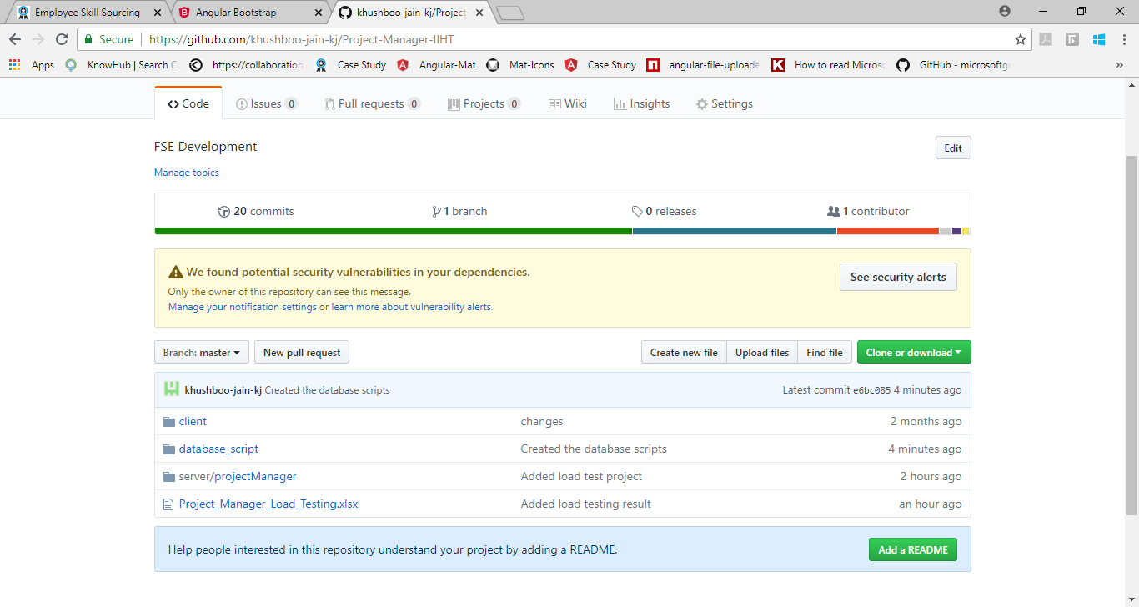
3. Once a small pop-up opens, click on the “**Download ZIP**” button.

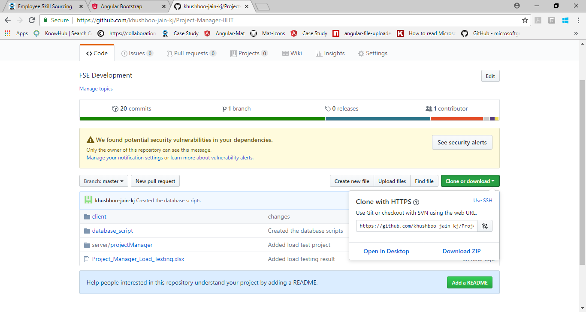

1. Open the downloaded file and extract the folder (**ProjectManager**) to some path on the system.

## Folder Structure

In the main folder **ProjectManager** there are two folders.

1. Client:   
   This folder contains the angular part of the code.
2. Server:   
   This folder contains the C# part of the code.

### Client

1. Go to the path **ProjectManager /client** where you can see the file ***angular.json***
2. Open command prompt
3. Copy the path from Step No. 1
4. Traverse to the path of Step 1 in the command prompt
5. Once you are in this path, run this command “npm install –g -f @angular/cli”
6. After this installation is done, run this command “npm install -f”
7. Let all the npm packages install in the project
8. Once the installation is done you will be able to see a folder “*node_modules*” in your system
9. Don’t close the command window yet

### Server

1. Open the folder **ProjectManager/server**/**projectManager**
2. Open the file “**projectManager.sln**” in Visual Studio 2017
3. Build the application
4. Don’t close the Visual Studio 2017 yet

### Database

1. Open the SQL Server Management Studio
2. Run the script “**Project_Manager_Create_Database.sql**”
3. Run the script “**Project_Manager_Create_Table.sql**”

# Running the application

Once the build is succeeded:

1. Open the command prompt and run the command “npm start”
2. Open the visual studio 2017 and select the “**projectManager**” project as startup project and press “**Start**” to run the application
3. Once the node modules are built after the step 1, open Google Chrome and enter the URL “**localhost:4200**”