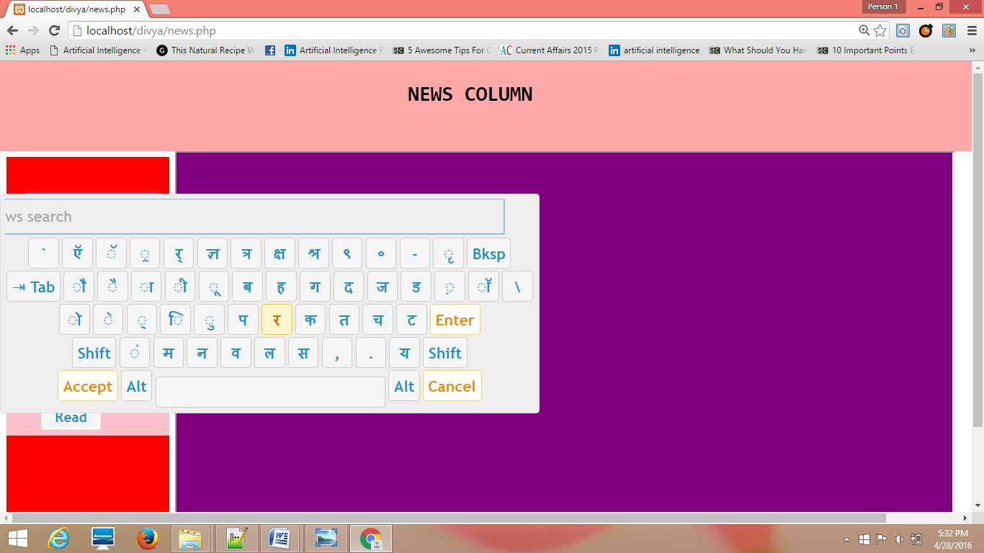

Fig. 4.17: Keybord option // user can write in hindi or English

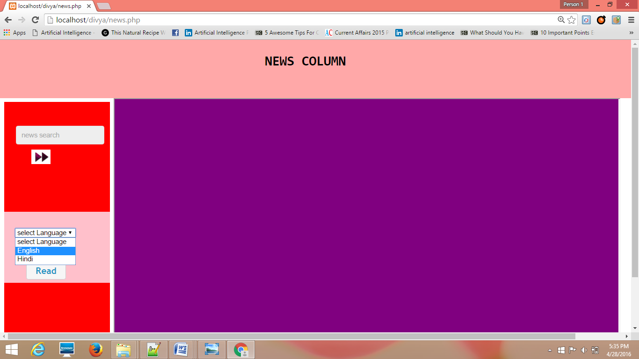

Fig. 4.18: Language selection

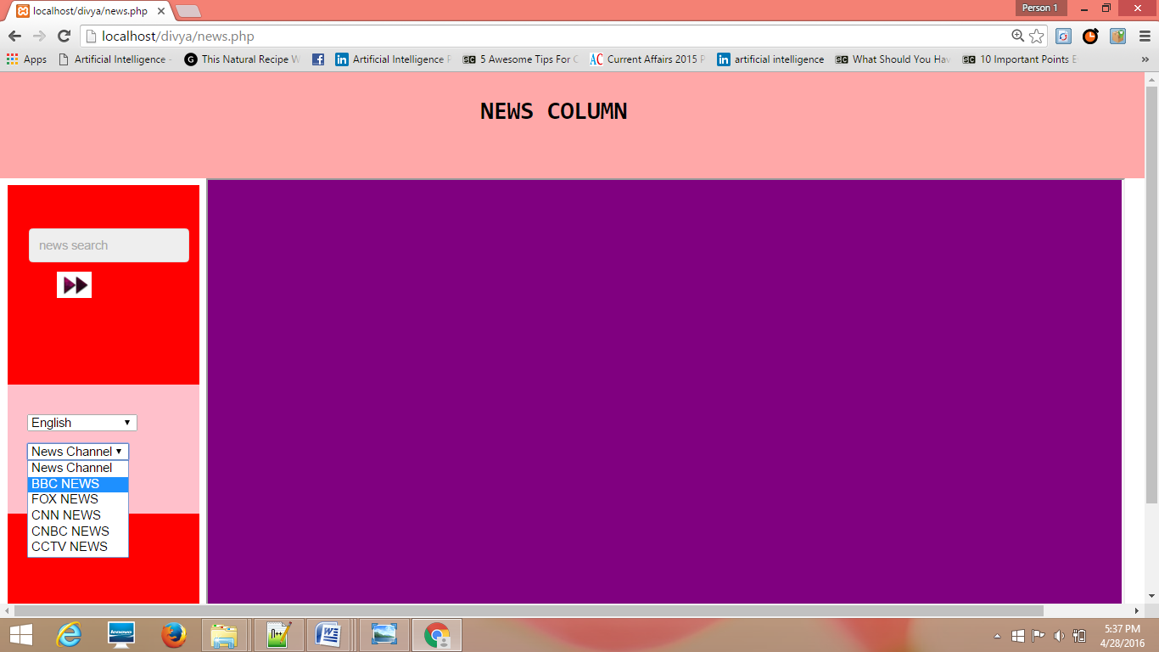

Fig. 4.19: News channel selection

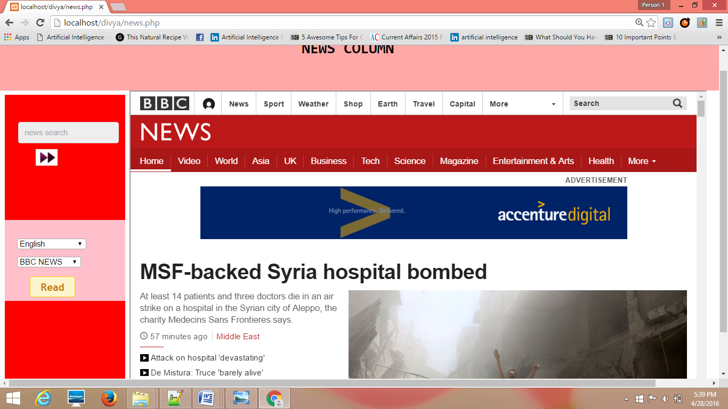

Fig. 4.20: English news display

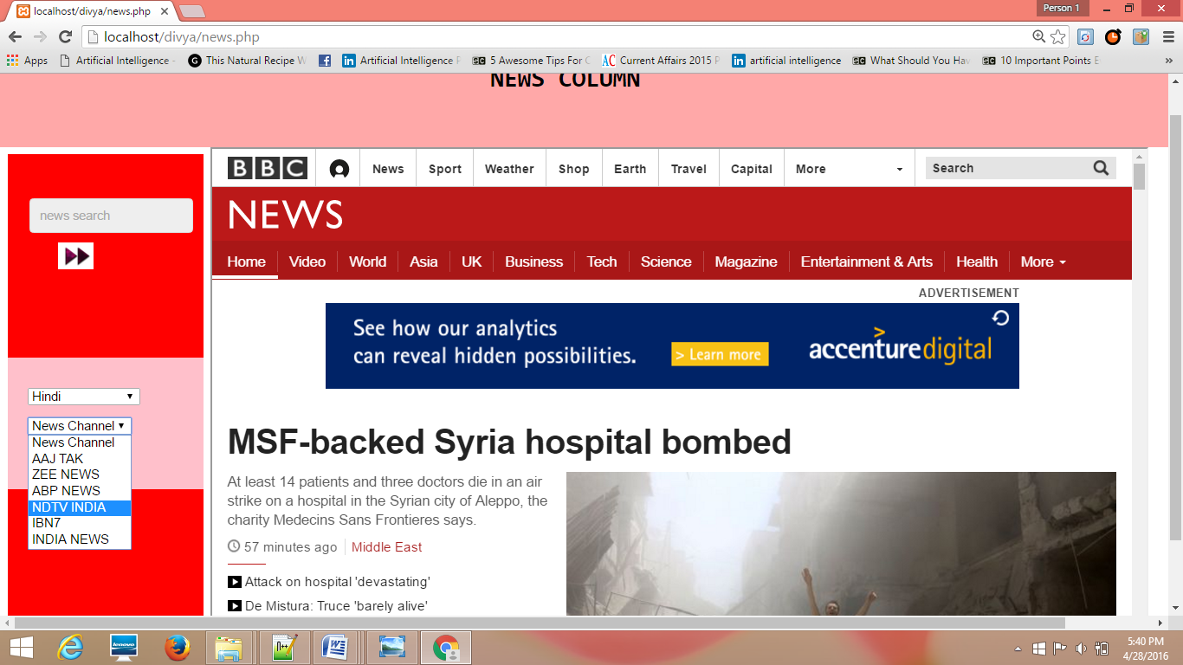

Fig. 4.21: Selecting hindi news channel

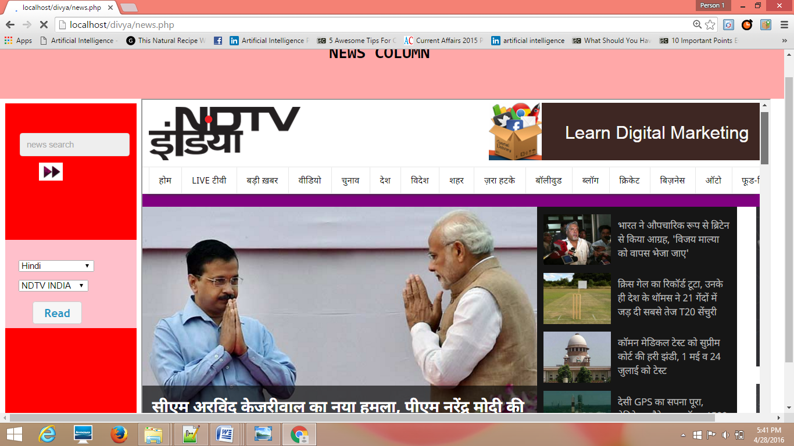

Fig. 4.22: Hindi news display