**Guru Nanak Dev Polytechnic College**

**Synopsis**

On

**Student Management System**

For partial fulfilment of the requirement for award

Of

**Diploma in Computer Engineering**



**SUBMITTED TO**

Dr. Hardeep Singh Jawanda, HOD Computer Engineering Department

**SUBMITTED BY**

Khushboo Dhiman (1053)

Harjot Singh (1063)

Naval (1064)

Ramanpreet Singh (1069)

**Batch 2017-2020**

**ACKNOWLEDGEMENT**

We express our gratitude to the Principal Er. Surinder Singh Ubhi for having providing us facilities to do the project.

We would like to express our special thanks of gratitude to our teachers Dr. Hardeep Singh Jawanda and Prog. Prabhjot Kaur who gave us golden opportunity to do this project on attendance, which also helped us in doing a lot of research and we came to know about many new things. We are really thankful to them. Secondly we are thankful to our parents and friends who helped us lot in finishing this project within limited time. We are not making this project only for marks but also to increase knowledge. We have taken efforts in this project. However, it would not have possible without the help and kind support of many individuals and organizations would like to extend my sincere thanks to all of them.

We thank our God for providing us with everything that we required in completing our project.

We would like to express our gratitude towards our parents for their kind co-operation and encouragement which help us in the completion of this project.

We would like to express our special gratitude and thanks to industry persons for giving us such attention and time.

Our thanks and appreciation also to our classmates in developing the project and to the people who have willingly help us out with their abilities.

**PROJECT ABSTRACT**

**Objective** :- Project is a series of activities taken by a programmer to practically apply and implement the knowledge gained during course of study. In general, one can say that a project is not a physical objective, nor is the end result. It has something to do with the going in between, which must be same, whether we build a high technology process plant or merely hold on election, it is termed as a project. This goal or requirement of the project decides the path and mode wise that a project is to be executed**.** It is developed for the college to simplify the Examination Form, Provisional Certificates generation and Struck-off Notices.

**INDEX**

**Sr. No. CONTENTS PAGE NO.**

1. Introduction & Objective 1-1
2. Objective
3. Project Category

1. Requirements 2-2
2. Software
3. Hardware

3. Modules 3-5

1. Login Page 3-3
2. Home Page
3. View Record
4. Exam Form
5. Fill Result
6. View Result 4-4
7. Update Result
8. Backlog
9. Insert, Update & Delete record
10. Struck-Off Notice 5-5
11. Provisional Certificate

INTRODUCTION & OBJECTIVE

The Proposed Project is named as” Student *Management*”, which works to reduce the efforts of Clerk.



* **Objective**
* Provide better efficiency
* Minimum input & maximum output
* Reduce work load
* Easy result management
* **Project Category**

Web Application

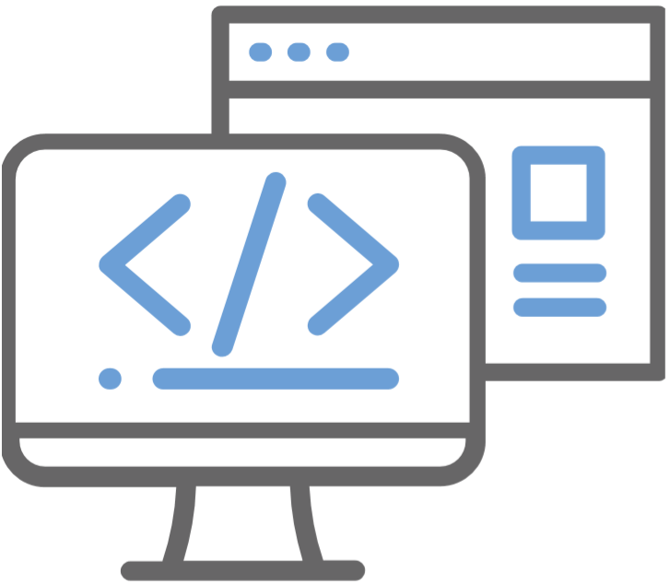

A computer program that utilizes web browsers and web technology to perform tasks over the Internet.

REQUIREMENTS



Here, we list some essential requirements to develop our web application.

* **Software**
* Operating system - Windows 7 or above
* Text Editor - Sublime Text 3
* Web Server - Apache Server
* Database - MySQL
* Languages - HTML, CSS 3, PHP 7.0

* **Hardware**
* Processor - 2.9GHz or above
* Memory - 4GB or above
* Storage - 120GB or above

MODULES

1. **Login Page**

This will be the first page which will be visible to everyone who opens the website. A unique name and password will be provided to all the clerk employees which will help them to login and use all further features of the project.

1. **Home Page**

This page will contain a background picture of Guru Nanak Dev Polytechnic College.

1. **View Record**

This is used to fetch and display the data of the student by just entering the registration number of the student. As you enter the registration number all the record regarding the student stored in the database will come in front of you.

1. **Exam Form**

The form will be automatically generated by only filling the registration number of the student for which it is going to be. All the details of the student like Name, Father’s name, Institute, Course and the most important all the subject codes of his current semester will be auto-filled along with the fee to deposit by the student.

This form will be very easily downloaded by just clicking the button to download it as a PDF file. By this all the formatting will remain exactly same.

1. **Fill Result**

Now, the whole problem of storing the result manually and difficulty faced by fetching it and removing the difficulty is solved now. The clerks have just to fill the Semester,

Branch, Examination Year of which he is going to fill the result. The next page will contain a table with the registration number of all the students of the specified semester along with the input of total marks for the students who have cleared the semester and all the subject codes with checkboxes for the students who have re-appears. The result will be stored in the database and can be seen through the next page.

1. **View Result**

The result of the whole Semester can be viewed by entering the semester, branch, and examination year.

1. **Update Result**

In case if anything goes wrong and if the result goes filled wrong accidently, then the user can easily update the marks filled but examination year, month and all other details filled cannot be changed.

1. **Backlog**

The Backlog certificate which contains the personal information of the student and the number of re-appears in every semester of the student along with the number of attempts in which he/she has cleared the subject exam. This form will be automatically generated by just entering the registration number of the student.

The number of attempts of the student for clearing the exam will be automatically calculated from the record stored in the database. This certificate can also be downloaded as a PDF by just clicking the button of Download as PDF.

1. **Insert, Update and Delete Record**

* **Insert Record: -** Clerk can add new record of the student from this interface by filling all the required details of the students.
* **Update Record: -** Record of the student registered in the college record can be easily updated by this interface.
* **Delete Record: -** Record of the whole class and also a single student if detained can be deleted easily.
* **View Record by Filter: -** Record of the students can be seen by selecting category through this interface, for example: if we want to see only General category student, thenjust select the option & the sorted results will be in front of you.

**10. Struck-off Notice**

This window is used to create a struck off notice of a student entering his/her data into the form. This form can be created very quickly. We can just press Tab to enter into the next input box. We can then print it out and circulate it rather than manually typing it.

**11. Provisional Certificate**

This is used to create a Provisional Certificate for the students who have passed the sixth semester. It is providing us various input boxes for entering the student details easily and efficiently. This certificate can also be downloaded as a PDF by just clicking the button of Download as PDF.