1.What is software? What is software engineering?

->Software is a program or set of programs containing instructions that provide desired functionality.Software engineering is the process of designing, developing, testing, and maintaining software.

software helps in providing a graphical user interface to the user to oprate computer for different functinally.

2.Explain types of software.

->1)application software

2)programming software

3)system software

4)driver software

5)middleware software

1)Application software:-

Application software is a computer software package that performs a specific function for a user,or in some cases,for another application.it can be a group of program that run for application for users.

example:-ms office,paint etc.

2)programming software:-

Programming software is a tool for creating computer code that allows computer software to operate. it is a software which helps the programmer in developing other software.

example:-linux,windos 11,google drive

3)system software:-

System software is a type of computer program that is designed to run a computer's hardware and application programs.it controls the operations of the computer hardware and provides an environment or platform fro all types of software to work in.the OS is the best example of system software.it manages all the other computer programs.

example:-notepad,calculater etc.

4)driver software:-

driver software is often considered a type of system software.every device that is connected to a computer needs at least one device driver to function.a driver is a software component that lets the operating system and a device communicate with each other.

example:-audio driver

5)middleware software:-

Middleware is software that lies between an operating system and the applications running on it.it is also used to send a remote work request from an application in a computer that has one kind of OS,to an application in a computer with a different OS.

example:-database middleware,application server.

3.What is SDLC? Explain each phase of SDLC.

->SDLC:-

The Software Development Life Cycle (SDLC) refers to a methodology with clearly defined processes for creating high quality software.

1. planning

2. Analysis

3. Designing

4. Implementation

5. Testing

6. Maintenance

4.What is DFD? Create a DFD diagram on Flipkart.

->DFD full form is Data-flow diagram.A data flow diagram maps out the flow of information for any process or system. It uses defined symbols like rectangles, circles and arrows, plus short text labels, to show data inputs, outputs, storage points and the routes between each destination.DFDs can resemble flow charts or Unified Modeling Language.

Data base-->input-->system-->output-->customer

Flipkart Diagram:-

User Registration

|

Product

|

Product Selection

|

Cart Managment

|

Checkout Process

|

Payment

|

Order Details

|

Order Processing

|

Shipment Tracking

|

Product Delivery

|

Return/Exchange

5.What is Flow chart? Create a flowchart to make addition of two numbers.

->A flowchart is a diagrammatic representation of steps that we have taken to solve the problem.

Below is the flowchart to find the addition of two number.

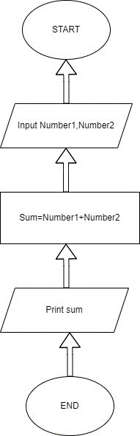

6.What is Use case Diagram? Create a use-case on bill payment on paytm.

->Use-case diagrams describe the high-level functions and scope of a system. These diagrams also I identify the interactions between the system and its actors. The use cases and actors in use-case diagrams describe what the system does and how the actors use it, but not how the system operates internally.

