**Experiment 09**

**Name**: Shaikh Mohiboddin Amanoddin

**Roll No**: 18CO54

**Aim**: Hosting the website with Domain Registration Process.

**Process Screen-Shots**:

We have hosted our website on InfityFree with th domain name of cot.rf.gd .

1: Domain Registration

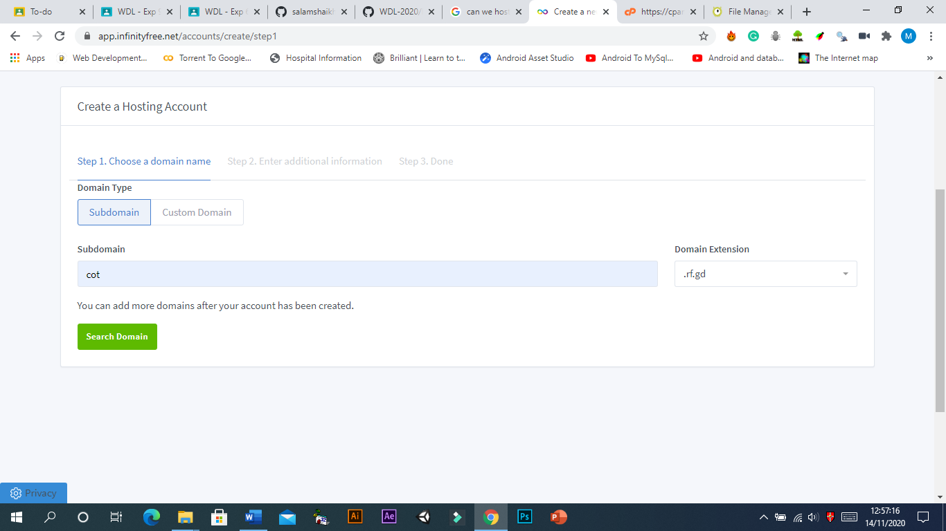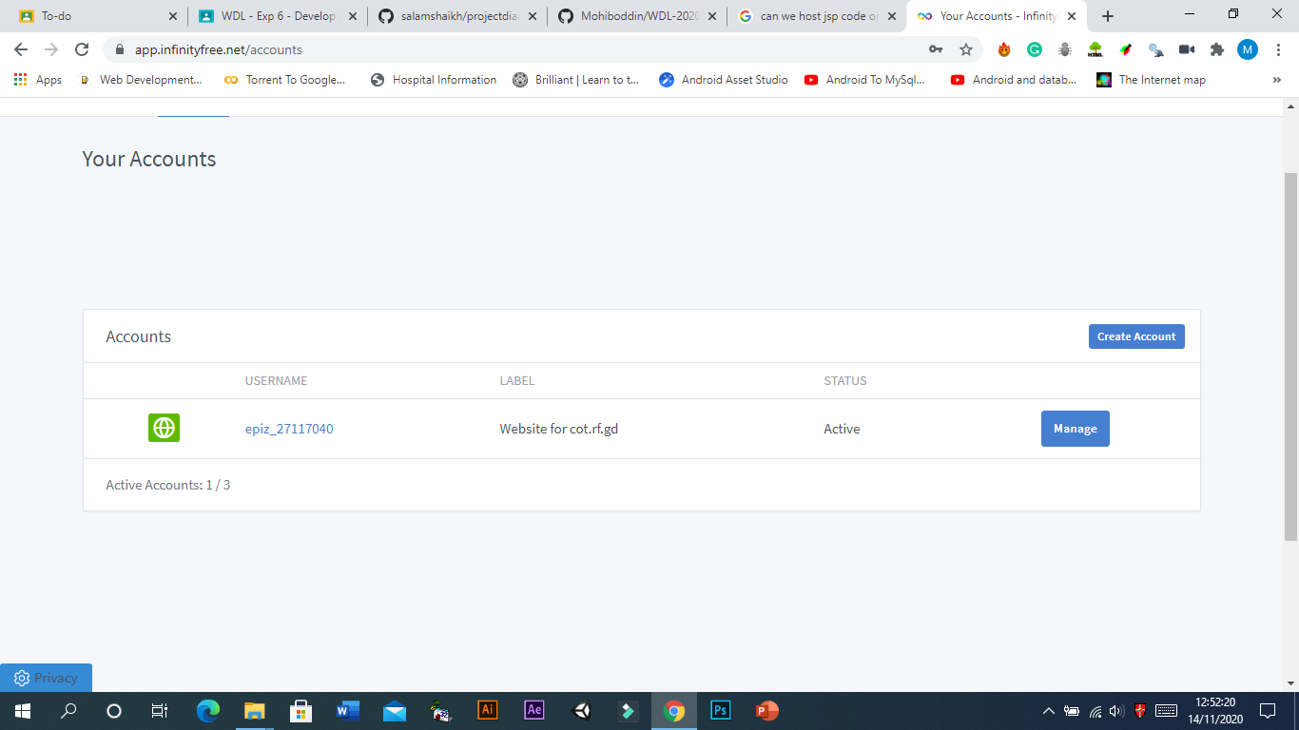

2: Hosting

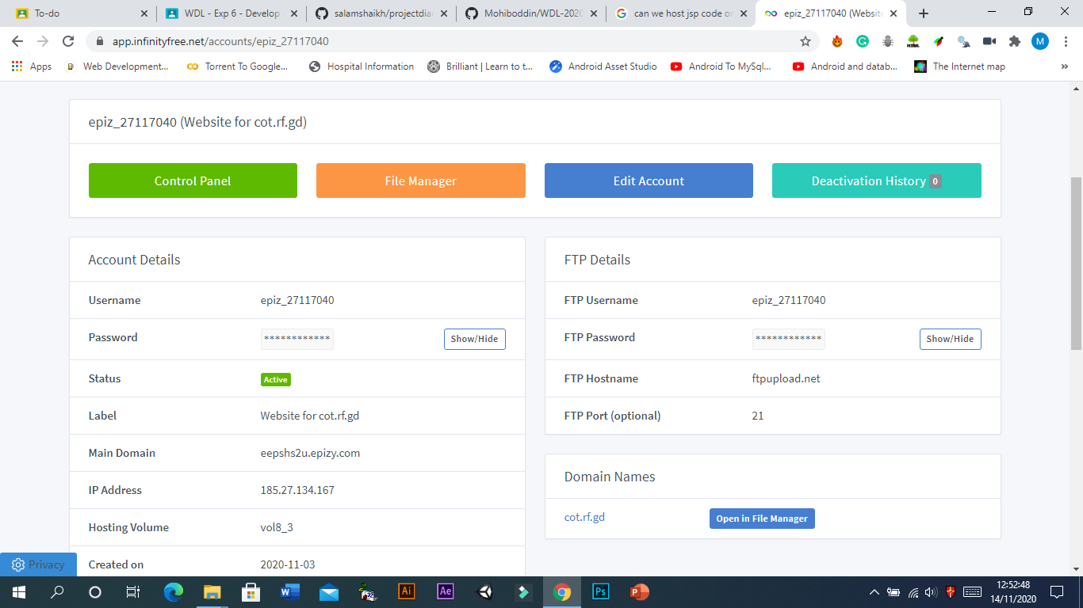

3: C panel

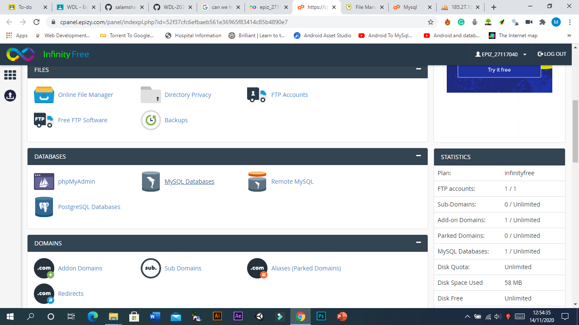

4: File Manager

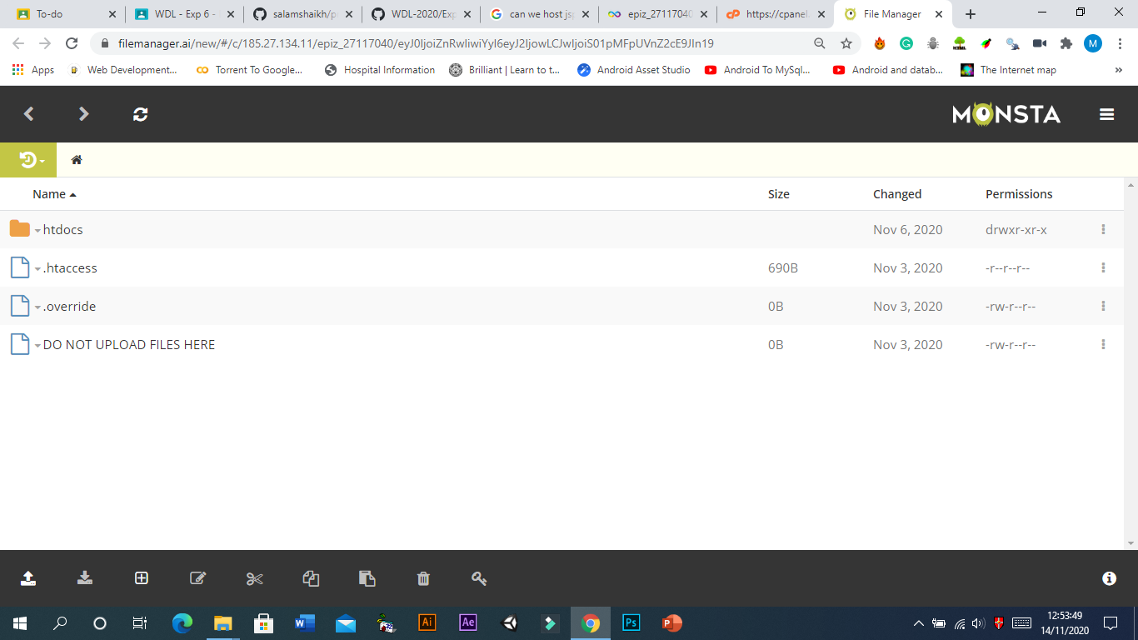

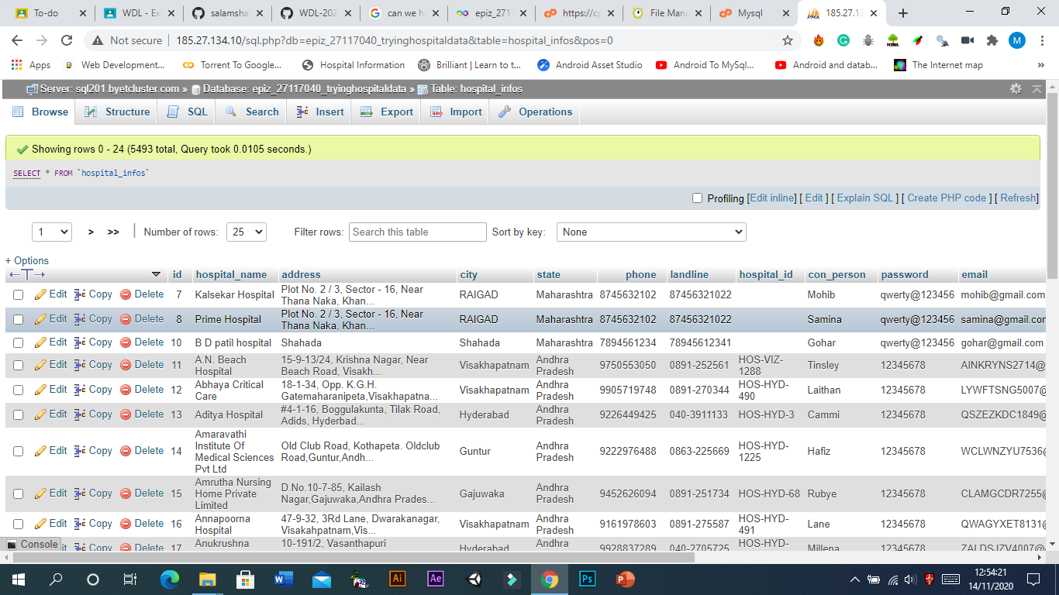5: Database

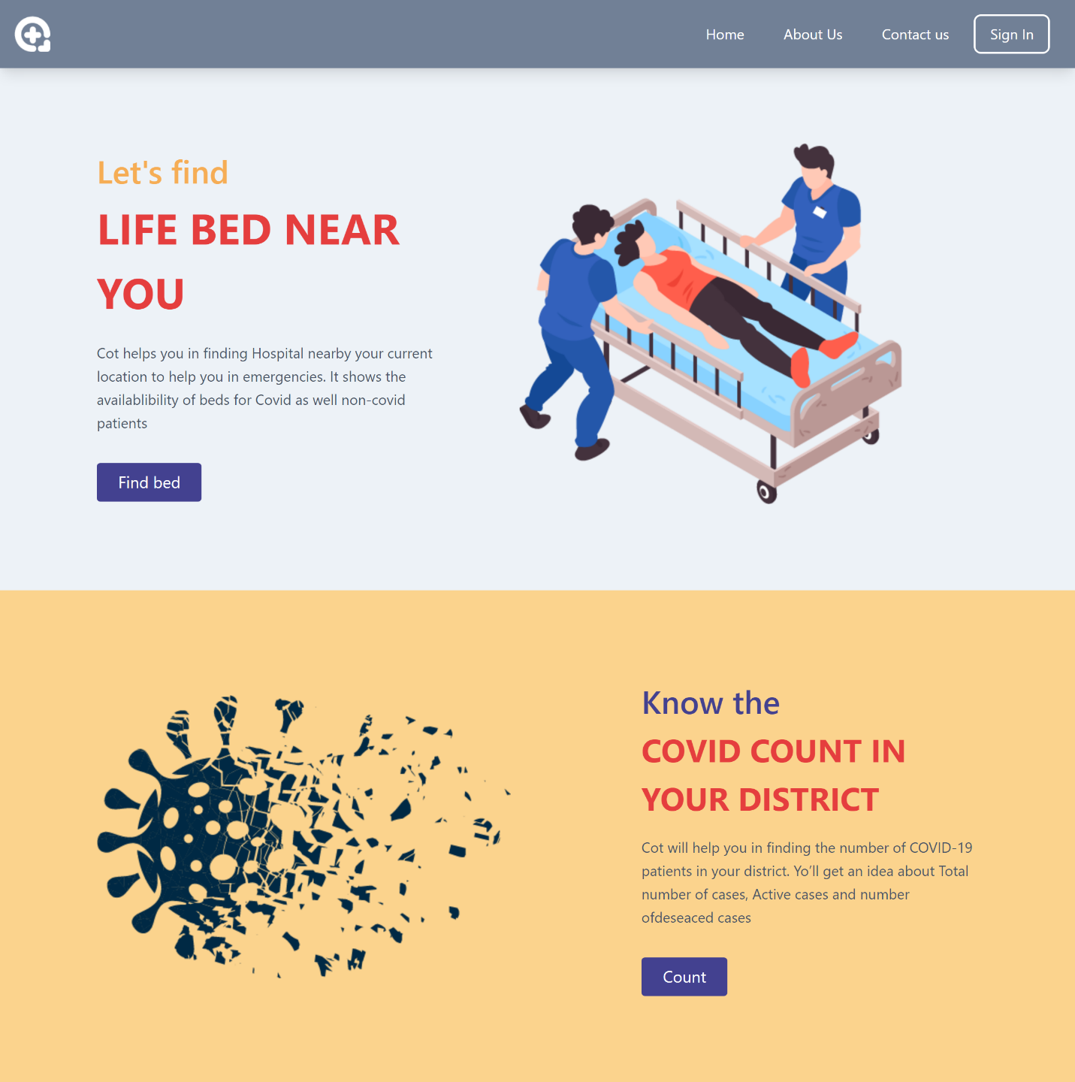6: Home Page: