**CSCI 552** (Spring 2021)

**Project #2**

**Name : Khushboo Mantri**

**Handout**: Thursday, March 18, 2021

**Due**: 11:59 pm, Thursday, April 1, 2021

**Total points**: 50

In this project, you will generate a graph visualization for the 2020 National Football League (NFL) regular season games between all 32 NFL teams. All 17 weeks of the regular season games can be found at : <http://www.nfl.com/schedules/2020/REG1>.

1. Generate a graph data set with teams as nodes and games between teams as edges.Each node contains the team name, geographic location (city), record in 2020, and the division it belongs to. Each edge contains the score of the game. If two teams played twice with each other, then the scores of both games should be stored in the edge.

I have generated the dataset from my understanding. I have created two data set, nodes and edges. Node dataset contains the information about all the teams, such as Team Name, Location of the team, Region of the team, Records, and it also has latitude and longitude of the location so that it is easy to place on the map.

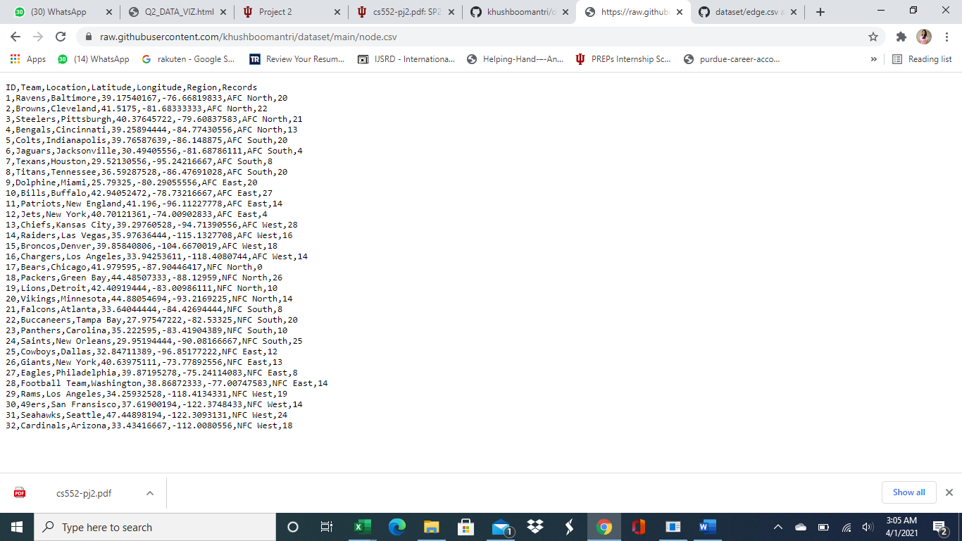

For the edge dataset, It has a source and target. The source indicated team1 in a match, and the target presents team 2 in a match; These two teams had a match between them. This way, I have created the dataset of the match from week 1 to week 17. This dataset also contains the score of the match that has been played between teams.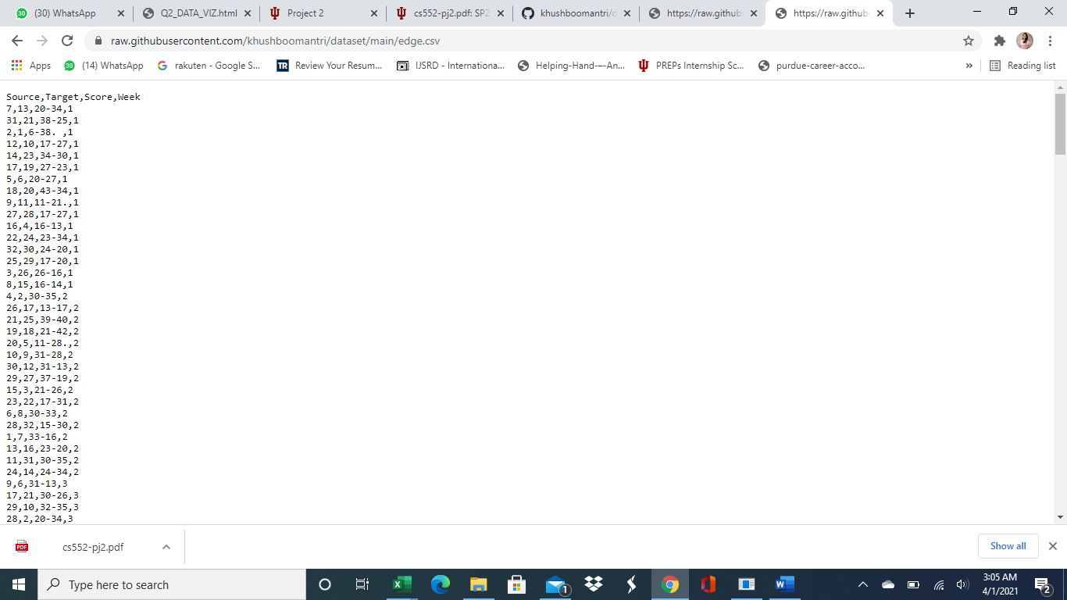

1. Use D3 to layout and visualize this graph. Each node’s initial location in a graph layout will be (or near) its geographical location on the US map. The size of the node will reflect it record, and a color can be used to represent it division. Edges will be drawn with game scores.

* In this part. I have first plotted the USA map. There was a JSON file available to plot the map of the USA. Then I plotted the nodes, which are Team. After Plotting Nodes, I plotted the edges between them. These edges indicate the match held between the Team. If I select Cowboys, the node will display the team name and the region of the Team.

Moreover, it will also point to all the other teams which it had a match. I have put a force layout in this part. I have colored all the teams according to their region. I also tried to put labels on the edge but, I was not able to. I have commented on this part of the code.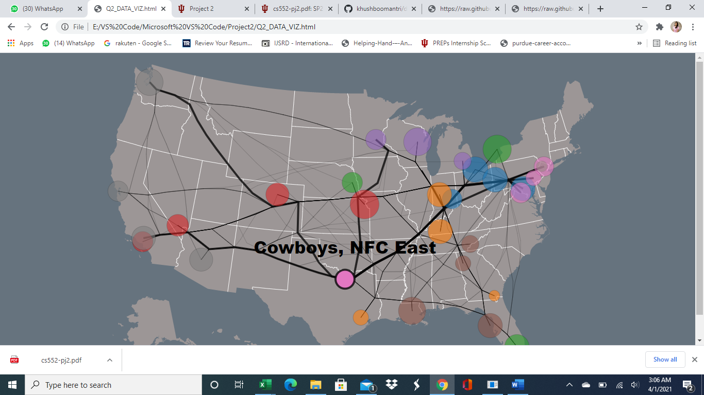

1. Generate 2 different force-directed layouts of this graph based on two different force definitions. You need to carefully define the force such that the resulting layout make sense in an intended way. Examples of possible layout criteria include: putting teams in the same division in a cluster and still maintaining their relative geographic locations; putting teams that are most similar (with some similarity definition) close to each other, etc.

* Force layout on records - For this part, I have used records of the Team to enforce force-directed layout. I have used force layout on records of the Team. The Team that has identical records will be force-directed.

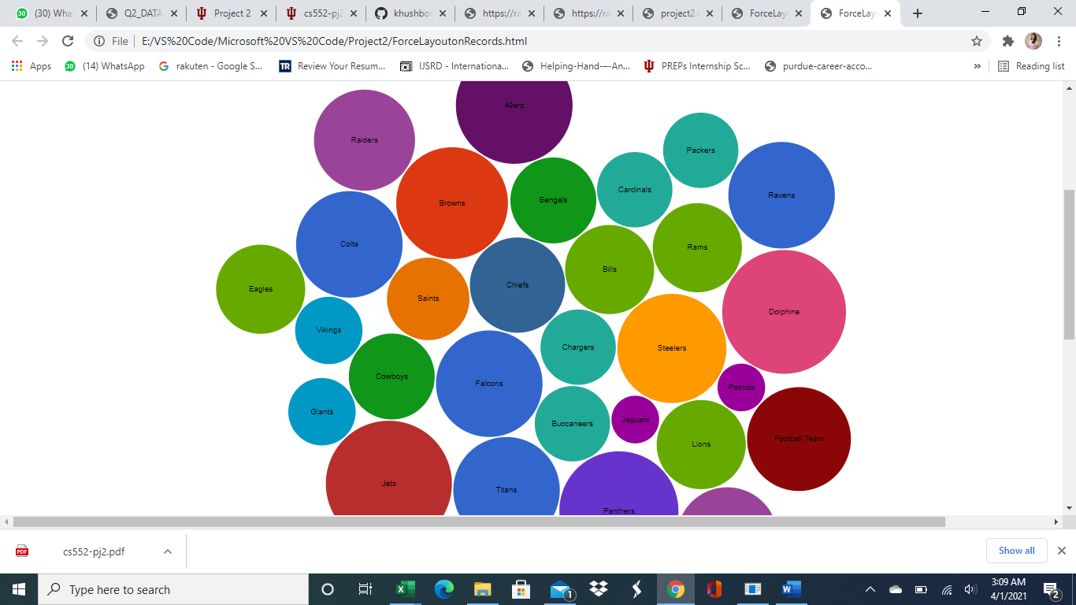

Force Layout on AFC Region and NFC Region - For this part, I have distributed the region in two parts. All the AFC team on one group and all the NFC team on another group. All the AFC team are colored in blue, and all the NFC team are in red.

