WEEK 3 – ADVANCED DATA ANALYSIS & VISUALIZATION
Exploratory Analysis of a Simulated Logistics Network
YuvaIntern – Logistics Data Analyst Internship
Prepared by: Khushboo Rawat
Date: 03 September 2026

1. Executive Summary
This Week 3 report presents an advanced exploratory data analysis and visualization workflow for a hypothetical logistics operation. Because the task requires a hypothetical dataset, a reproducible synthetic dataset of 1,200 shipments was generated using Python with a fixed random seed. Each shipment contains operational variables such as region, transport mode, priority, shipment volume, distance, delivery time, transport cost, handling cost, total logistics cost, fuel cost and weather-related delay. The purpose is not to claim real operational results, but to demonstrate how a logistics analyst can structure data, calculate descriptive statistics, examine relationships and communicate findings visually.
The analysis focuses on three decision areas: service performance, cost efficiency and operational bottlenecks. Histograms are used to understand delivery-time distribution, bar charts compare regional volume and transport-mode costs, a scatter plot evaluates the relationship between distance and total cost, a correlation matrix summarizes linear relationships among numeric variables, and a time-series chart tracks average delivery time. The resulting insights indicate where management should investigate cost drivers, capacity concentration and delivery variability. The report also provides Python code and recommendations for extending the analysis into predictive modeling and optimization.

2. Data Simulation and Dataset Structure
The dataset was created to represent a multi-region logistics network. Synthetic data is appropriate for this task because it allows the analytical workflow and visualization techniques to be demonstrated without exposing real customer or company information. A fixed random seed of 42 makes the generated data reproducible.
Variable | Type | Purpose
Shipment_ID | Categorical | Unique shipment identifier
Date | Datetime | Shipment date for trend analysis
Region | Categorical | North, South, East or West
Transport_Mode | Categorical | Road, Rail or Air
Priority | Categorical | Standard or Express
Shipment_Volume_kg | Numeric | Shipment quantity/weight
Distance_km | Numeric | Transportation distance
Delivery_Time_days | Numeric | End-to-end delivery duration
Transport_Cost | Numeric | Transportation cost component
Handling_Cost | Numeric | Warehouse/handling cost component
Total_Cost | Numeric | Combined logistics cost
Fuel_Cost | Numeric | Estimated fuel-related cost
On_Time | Binary | Illustrative on-time indicator
Weather_Delay_days | Numeric | Delay attributable to weather

3. Exploratory Data Analysis

3.1 Central Tendency and Dispersion
Metric | Mean | Median | Std. Dev. | Min | Max
Shipment_Volume_kg | 360.52 | 335.87 | 161.9 | 50.05 | 1224.76
Distance_km | 760.84 | 761.4 | 413.63 | 40.6 | 1499.3
Delivery_Time_days | 16.12 | 15.03 | 10.49 | 0.8 | 39.08
Transport_Cost | 314.56 | 209.42 | 374.49 | 4.24 | 3754.69
Handling_Cost | 317.62 | 305.16 | 99.75 | 97.68 | 839.98
Total_Cost | 632.18 | 529.22 | 415.52 | 130.12 | 4404.69
Fuel_Cost | 208.32 | 138.88 | 249.89 | 2.67 | 2397.06
The descriptive statistics provide a baseline view of scale and variability. Comparing mean and median helps identify skewed distributions, while the standard deviation indicates operational variability. In logistics, high variability is important because an average alone may hide a subset of shipments requiring intervention.

3.2 Distribution of Delivery Time
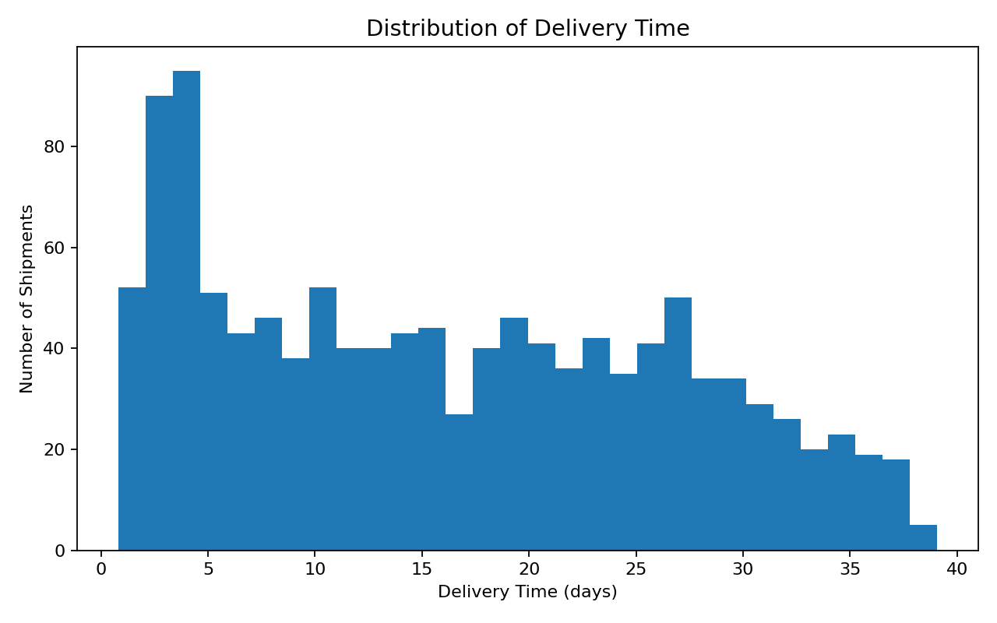
Figure 1. Distribution of delivery time across simulated shipments.
The delivery-time histogram shows the spread of shipment durations. The main concentration represents normal operations, while the right tail indicates slower shipments. Such a tail is operationally important because extreme delivery times can create customer dissatisfaction and additional handling or support costs. A logistics team could investigate shipments in the upper tail by region, mode and weather-delay status.

3.3 Shipment Volume by Region
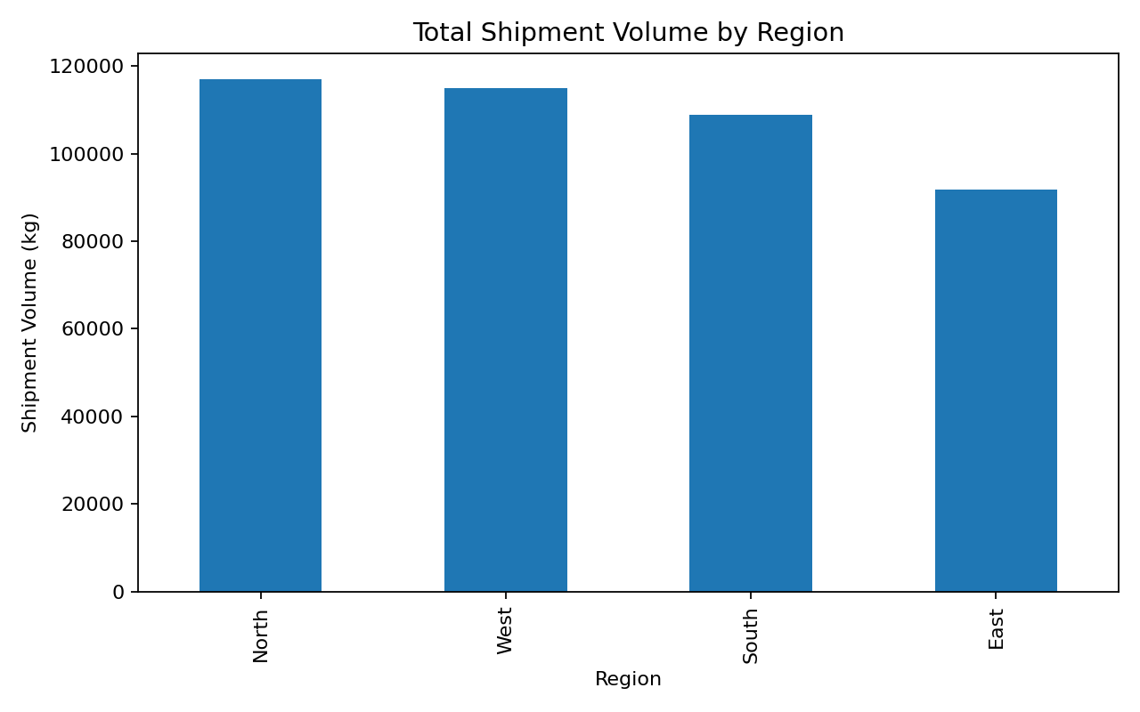
Figure 2. Total simulated shipment volume by region.
The regional volume chart shows that North has the highest simulated shipment volume. A high-volume region may require greater warehouse, carrier and transportation capacity. However, volume alone should not determine investment: it should be compared with delivery performance and cost KPIs before operational decisions are made.

3.4 Average Total Cost by Transport Mode
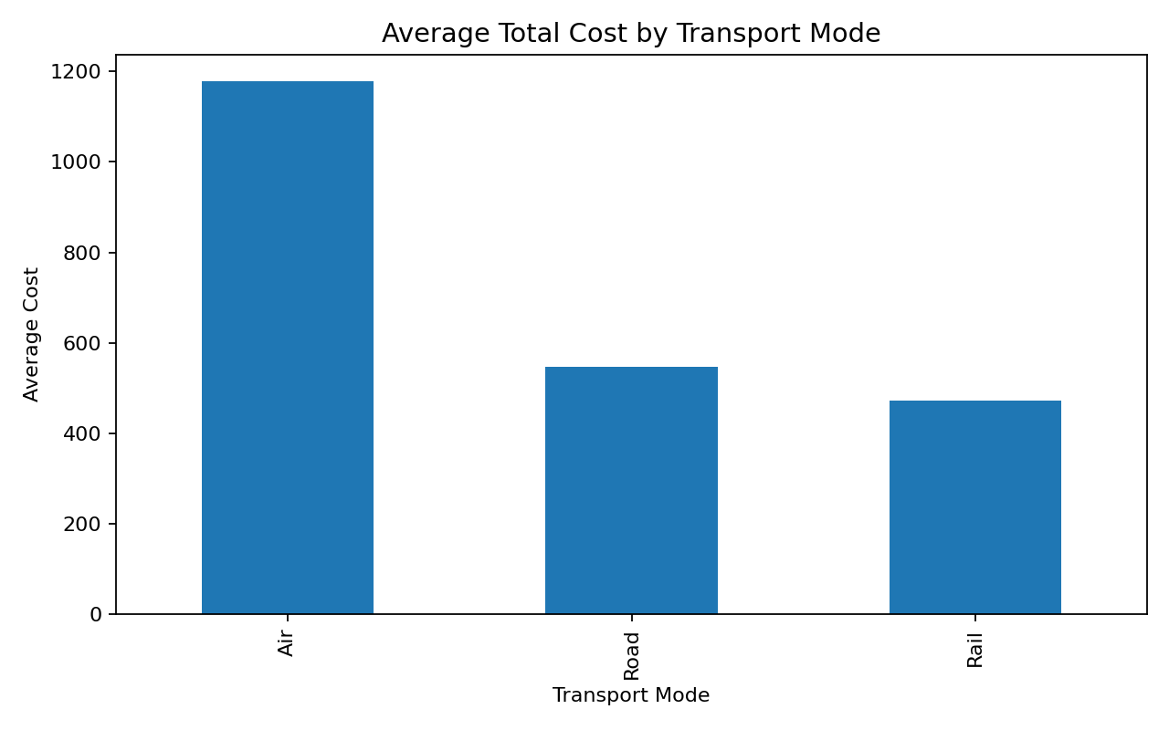
Figure 3. Average total logistics cost by transport mode.
The mode comparison indicates that Air has the highest average total cost in the simulated network. This is consistent with the cost structure used during simulation, where mode-specific transportation rates create different cost profiles. In practice, management should evaluate cost together with service time; a more expensive mode may still be justified for urgent or high-value shipments.

3.5 Distance and Cost Relationship
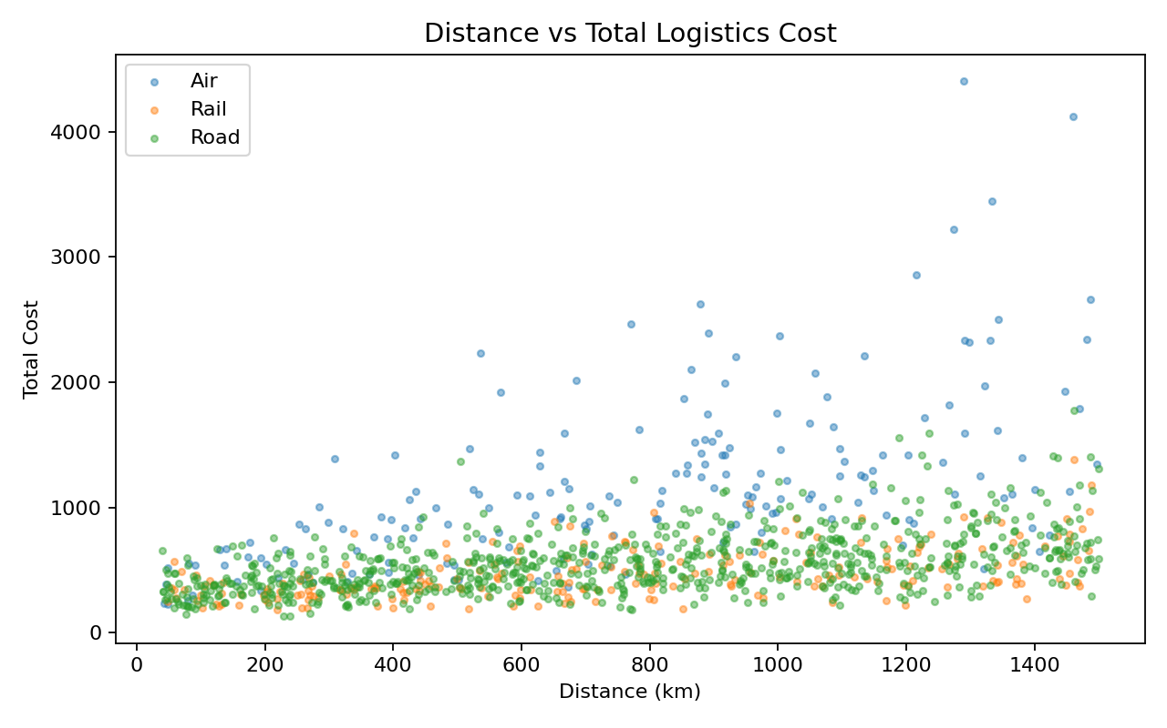
Figure 4. Relationship between transportation distance and total cost, separated by mode.
The scatter plot demonstrates the relationship between route distance and total logistics cost while retaining transport-mode information. The positive association indicates that longer routes generally require more transport resources. The different point patterns by mode highlight that distance alone is not sufficient to explain cost; the transportation mode and shipment volume also matter.

3.6 Correlation Analysis
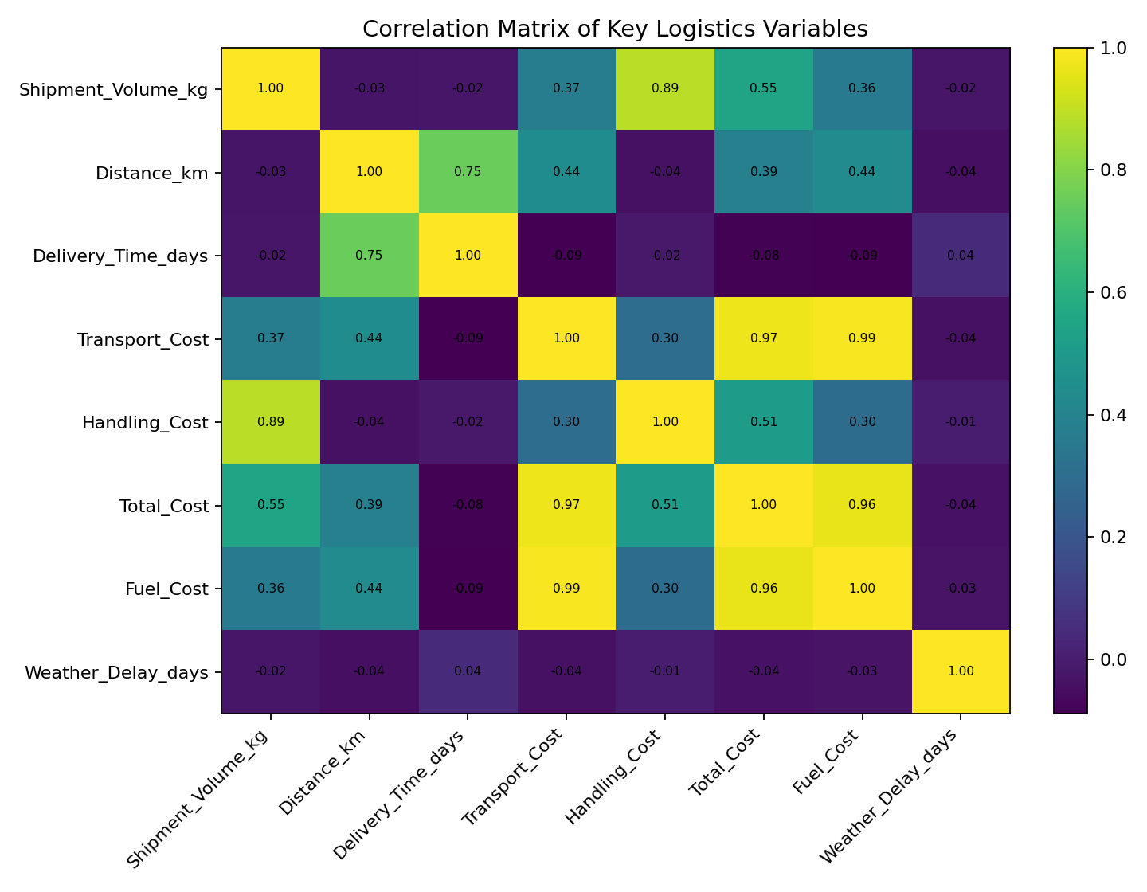
Figure 5. Correlation matrix for major numeric logistics variables.
The correlation matrix provides a compact view of linear relationships. Total cost is expected to be associated with its component costs, while transport cost is related to distance and shipment volume because these variables are part of the simulated cost-generation process. Correlation is useful for feature screening, but it does not establish causation. For predictive modeling, multicollinearity and target leakage should also be evaluated.

3.7 Delivery-Time Trend
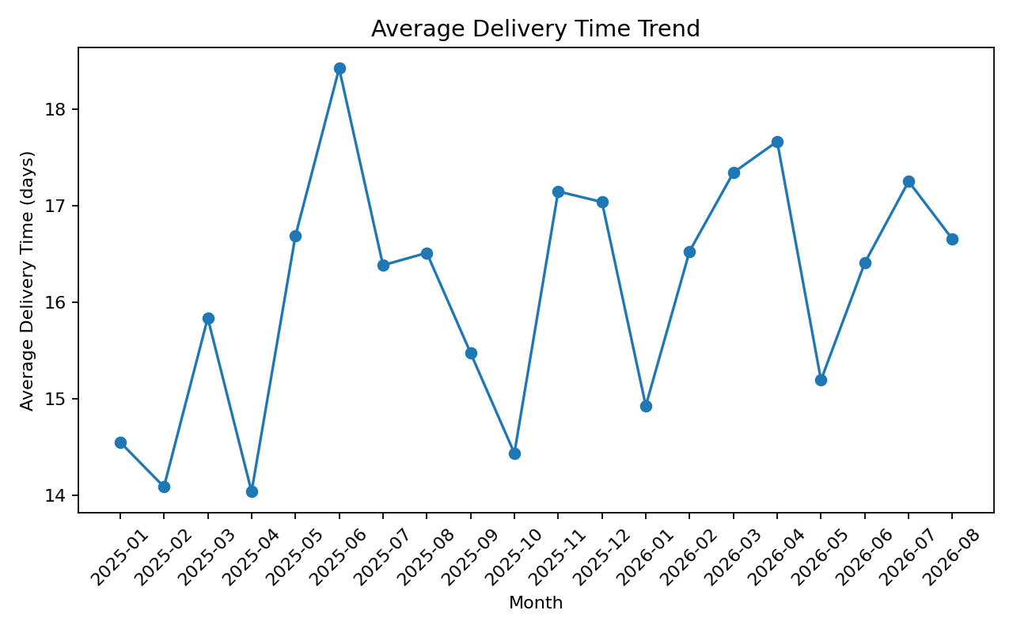
Figure 6. Monthly average delivery time trend.
The time-series visualization is designed to reveal temporal changes in service performance. In a real logistics system, unusual increases in average delivery time could trigger investigation of capacity constraints, carrier performance, weather, holidays or network disruptions. For the simulated data, the chart should be interpreted as a demonstration of the monitoring technique rather than evidence of an actual seasonal effect.

4. Key Analytical Insights
- Delivery performance has a distribution rather than a single fixed duration; the upper tail represents shipments that can require operational attention.
- North is the highest-volume region in the simulated dataset, suggesting that capacity planning should consider regional demand concentration.
- Air has the highest average simulated total cost, demonstrating why transport-mode selection should balance cost against service requirements.
- Distance and shipment volume are important cost drivers in the simulated cost structure; mode differences create additional variation.
- Weather delay is an operational risk variable and can be incorporated into diagnostic analysis or future predictive models.
- Correlation analysis helps identify candidate relationships, but causal conclusions require controlled operational analysis and domain validation.
- Time-series monitoring can provide an early-warning mechanism when average delivery time changes materially.

5. How Visualizations Support Logistics Decisions
Visualization | Question answered | Decision support
Histogram | How variable is delivery time? | Identify long-tail delays and service-risk ranges.
Regional bar chart | Where is shipment volume concentrated? | Support capacity and resource planning.
Mode cost bar chart | Which mode is more expensive? | Compare mode economics before allocation decisions.
Distance-cost scatter | How does distance relate to cost? | Identify high-cost lanes and investigate rate structures.
Correlation matrix | Which variables move together? | Guide feature engineering and diagnostic analysis.
Time-series line chart | Is service performance changing over time? | Detect emerging bottlenecks and disruptions.

6. Recommendations
- Prioritize high-volume regions for capacity review, but evaluate volume jointly with late-delivery rate and cost.
- Create a mode-selection policy that considers shipment priority, distance, service-level requirements and cost rather than minimizing cost alone.
- Monitor the upper tail of delivery time as a separate operational KPI because averages can hide severe delays.
- Build a lane-level cost dashboard using distance, volume and transport mode to identify expensive routes or carrier arrangements.
- Track weather and other disruption indicators to distinguish controllable process delays from external events.
- In the next phase, develop a late-delivery classification model and delivery-time regression model, followed by validation on held-out data.
- For optimization, add realistic constraints such as vehicle capacity, delivery windows, depot locations and route distances before applying a vehicle-routing model.

7. Python Methodology and Code
Python is used for reproducible data generation, cleaning, descriptive statistics, grouping, correlation analysis and visualization. Pandas manages tabular data, NumPy generates controlled synthetic values, and Matplotlib creates the charts. The code is intentionally simple enough to be extended into a production-style notebook or pipeline.
import pandas as pd
import matplotlib.pyplot as plt
df = pd.read_csv("logistics_simulated_dataset.csv")
# Descriptive statistics
print(df.describe())
# Correlation
numeric = ["Shipment_Volume_kg", "Distance_km",
"Delivery_Time_days", "Total_Cost"]
print(df[numeric].corr())
# Group comparison
print(df.groupby("Transport_Mode")["Total_Cost"].mean())
# Visualization
plt.figure(figsize=(8, 5))
plt.hist(df["Delivery_Time_days"], bins=30)
plt.title("Distribution of Delivery Time")
plt.xlabel("Delivery Time (days)")
plt.ylabel("Number of Shipments")
plt.tight_layout()
plt.show()

8. Limitations
- The dataset is synthetic; therefore, the numerical results are illustrative and cannot be used as real company KPIs.
- The simulation uses predefined relationships, so correlations may partly reflect the data-generation process.
- The dataset does not include real GPS trajectories, traffic, vehicle capacity, depot inventory or carrier-level contractual data.
- The current analysis is descriptive/diagnostic. Predictive and optimization claims should only be made after proper model validation.
- Real deployment would require data governance, privacy controls, monitoring and periodic model retraining.

9. Conclusion
The Week 3 analysis demonstrates how exploratory data analysis and visualization can convert logistics records into decision-support information. The simulated dataset makes it possible to examine service performance, regional volume, transportation costs, distance relationships, correlations and temporal trends in a reproducible way. The visualizations are deliberately selected according to the business question each one answers: distributions show variability, comparisons show differences between groups, scatter plots expose relationships, correlation matrices summarize numeric associations, and time-series plots reveal changes over time. The resulting framework can be extended into predictive modeling for late-delivery risk and delivery-time estimation, followed by optimization when realistic operational constraints are available.

10. References / Tools
- Python Documentation: https://docs.python.org/3/
- Pandas Documentation: https://pandas.pydata.org/docs/
- NumPy Documentation: https://numpy.org/doc/
- Matplotlib Documentation: https://matplotlib.org/stable/
- Scikit-learn User Guide: https://scikit-learn.org/stable/user_guide.html

Appendix A – Dataset and GitHub Structure
The dataset used for this report is synthetic and is included in the project package as `logistics_simulated_dataset.csv`.
Recommended GitHub structure:
- README.md
- logistics_simulated_dataset.csv
- src/logistics_visualization.py
- visualizations/01_delivery_time_distribution.png
- visualizations/02_volume_by_region.png
- visualizations/03_cost_by_mode.png
- visualizations/04_distance_vs_cost.png
- visualizations/05_correlation_matrix.png
- visualizations/06_delivery_trend.png

Appendix B – Submission Description (200+ Words)
This report presents my Week 3 YuvaIntern Logistics Data Analyst internship work on advanced data analysis and visualization. The objective of the task was to explore logistics data, calculate descriptive statistics, identify relationships between operational variables, and communicate findings through meaningful visualizations. Since the task specifies a hypothetical logistics dataset, I created a reproducible synthetic dataset containing 1,200 shipments. The dataset includes shipment date, region, transport mode, priority, shipment volume, distance, delivery time, transport cost, handling cost, total cost, fuel cost, an on-time indicator and weather-related delay.
The analysis was performed using Python with Pandas, NumPy and Matplotlib. I first examined central tendency and dispersion using mean, median, standard deviation, minimum and maximum values. I then analyzed the distribution of delivery times and compared shipment volume across regions. Additional analysis compared average total logistics cost by transport mode and examined the relationship between distance and total cost. A correlation matrix was used to understand linear relationships among major numeric variables, while a time-series visualization was created to monitor changes in average delivery time over time.
The report embeds six visualizations and explains how each one supports logistics decision-making. The findings highlight the importance of monitoring delivery-time variability, regional volume concentration, transportation cost differences, distance-related cost patterns and potential operational disruptions. I have also included Python code excerpts and a complete starter script in the accompanying GitHub project. The analysis is clearly identified as synthetic and illustrative; therefore, the numerical results are not presented as real-world company KPIs. The project can be extended in future work with predictive modeling for late-delivery risk, delivery-time forecasting and optimization using realistic route and capacity constraints.

