## How to set up Maven project in eclipse?

## How to run the code?

1. Extract zip file into folder nabCodeTest
2. In Eclipse - click on File > Import > Select Existing Maven Project

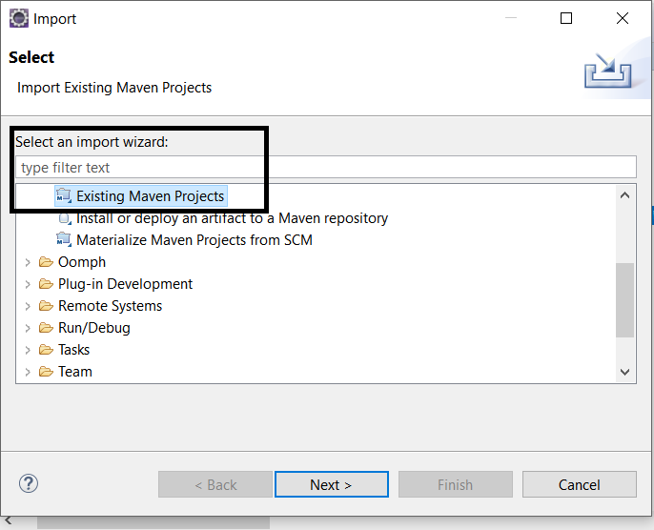

1. Browse the Root directory > select Projects > click on Finish button.

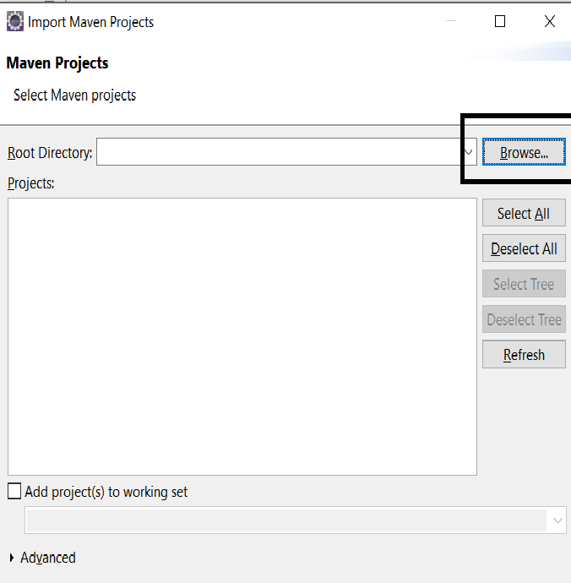

1. Right click on TradeEngineReporting.java file and select Run as Java Application to run the code.
2. Right click on the TradeReportingTest.java file and select Run as Junit test case.
3. Output csv file will be generated at location - *NAB Trade Reporting Engine code exercise\nabCodeTest\src\main\files\OutputTradeDetails.csv*