

**SIX WEEK SUMMER TRAINING REPORT**

**AND**

**MINI PROJECT**

ON

**LPU - OBJECT ORIENTED PROGRAMMING USING C++ - INTERNSHIP**

Submitted by

**KHUSHBOO SHAKYA**

**Registration Number 11907150**

**Program Name : Computer Science & Engineering**

Under The Guidance Of

**Training And Placement Co-ordinate Of LPU**

**Name Of The Industry Co-ordinate**

**EBOX**

**School Of Computer Science & Engineering**

**Lovely Professional university , Phagwara**

(June-July, 2021)

**To whom it may concern**

I, **Khushboo Shakya** **, 11907150,** hereby declare that the work done by me on “**LPU – Object Oriented Programming Using C++ - Internship**” from **May, 2021** to **July, 2021** is a record of original work for the partial fulfilment of the requirements for the award of the degree, **B. Tech (Computer Science and Engineering).**

**Name of the Student**: Khushboo Shakya

**Registration Number:** 11907150

**Signature of the student**: 

**Dated**: July 2021

**TRAINING CERTIFICATE FROM ORGANISATION**

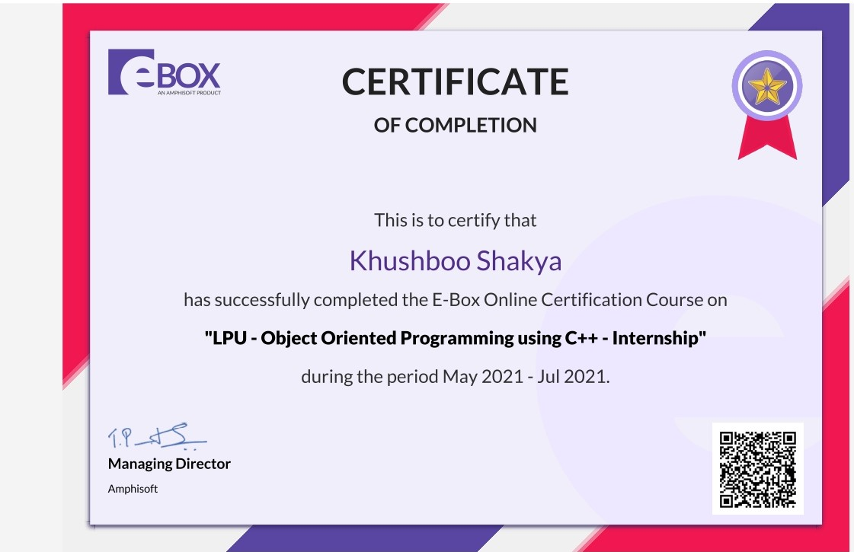

**ACKNOWLEDGMENT**

It is my pleasure to be indebted to various people, who directly or indirectly helped me to learn this course and who influenced my thinking , behaviour and acts during study. I express my sincere gratitude to Mr. Deepak Prasker Sir (Head of Department of Computer Science School) for providing me an opportunity to undergo summer training at EBOX.I am thankful tho the instructor of this course for her support and cooperation provided to me during the summer training. I also extend my sincere appreciation to mentor who provided their valuable suggestions and precious time for helping me out in completing my course.

I perceive as this opportunity as a big milestone in my career development. I will service to use gained skills and knowledge in the best viable way , and I will continue to work on their improvement, to attain desired career objective. Hope to continue cooperation with all of you in the future.



Khushboo Shakya

Registration Number :11907150

Date : 20th July 2021

|  |  |  |
| --- | --- | --- |
| **S. No** | **Title** | **Page** |
| **1.** | Declaration by the Student | 2 |
| **2.** | Training Certificate from Organization | 3 |
| **3.** | Acknowledgment | 4 |
| **4.** | List of Figures | 6 |
| **5.** | List of Abbreviations | **7** |
| **6.** | CHAPTER-1 INTRODUCTION OF THE PROJECT UNDERTAKEN | 8 |
| **7.** | CHAPTER-2 | 11 |
| **8.** | CHAPTER-3 | 14 |
| **9.** | CHAPTER-4 | 24 |
| **10.** | CHAPTER -5 | 32 |
| **11.** | CHAPTER-6 | 34 |
| **12.** | CHAPTER-7 | 43 |
| **13.** | CONCLUSION | 44 |
| **14** | REFERENCE | 45 |

**List of figures**

1. **Fig 2. a 13**
2. **Fig 3. a 15**
3. **Fig 3. b 17**
4. **Fig 3.c 19**
5. **Fig 3. d 20**
6. **Fig 3. f 21**
7. **Fig 4a 27**
8. **Fig 4. b 31**
9. **Fig 6.a 34**
10. **Fig 6. b 35**
11. **Fig 6.c 35**
12. **Fig 6. d 36**
13. **Fig 6.e 36**

**List of Abbreviations**

**C++ OOPs Concepts:**

* **1D Array**
* **2D Array**
* **Strings**
* **Function and Pointers**
* **Recursion**
* **Classes and Objects**
* **Collections**
* **Relationships between Classes**
* **Inheritance**
* **Abstract Classes and Inheritance**
* **Operator Overloading**
* **Exception Overloading**
* **Templates**
* **File Handling**

**CHAPTER 1**

**INTRODUCTION OF THE PROJECT UNDERTAKEN**

**1.1 Objective of the work undertaken**

There are various domains in which we can work but the main concern about the project

is what a person does on to produce effectivity.

Few of the objectives are discussed below:

* Actually, it is a Quiz dummy software.
* Depending upon our requirement we can use either professional or for learn.
* We can keep large number of data in arranging mode.

**1.2 Scope of the work**

* Quiz system generally have many more features.
* To became aware of new technologies, new designed dummy quiz software are building in large amount.
* Students can learn basic of the quiz working model.
* Now it will become easy for students to think quiz bank can manage their large amount of data.
  1. **Importance and Applicability**

### Engage your audience: Engage your audience in a unique and fun way and connect them to your brand or learning material. By creating a returning event, you will improve your consumer loyalty.

### Large number:Taking online quizzes makes it possible to have a large number of participants. It could be up to a number of 1000 participants (and even more!). It doesn’t matter at what kind of location they take the online quiz as long as they are connected to the Internet.

### Randomizing questions:It is significant more easy to randomize your question with just one click than to do it all manually. Randomizing questions and even answers of those questions is not a lot a of work to do with online quizzes. Besides the advantage of time saving, it also helps preventing students from [cheating](https://www.onlinequizcreator.com/knowledge-center/exam-knowledge-center/how-to-prevent-cheating-on-an-online-exams-and-tests/item10616).

### Quiz results/ gain insight in audience: Another plus of online quizzes is getting immediate results from your participants. Not only does the creator get the results, the participant itself is also possible to get his or her results. This makes it for the creator easy to identify the gaps in knowledge. The participants are able to view on what kind of section they have to improve themselves.

### Set timer : The creator is able to [set a timer](https://www.onlinequizcreator.com/features/online-test-maker-with-timer/item10236) for the whole quiz or to set a timer per question. This is possible to do with written quizzes, but is very time consuming for the instructor. Plus it’s almost impossible to do with a huge amount of participants.

### Better overview : It’s possible to show one question at the time with online quizzes. People are not able to skip a question, because you will get a reminder that you can’t leave the answer blank.

**1.4 Role and profile**

* **Instant Response** – Students do not have to wonder if their answer is correct or not as they answer a question. Nor do they have to wait until the next class, which may be 24 hours or more away. Online quiz programs provide immediate feedback to their answers.
* **Formative Assessment** – Using [online quiz tools](https://www.proprofs.com/quiz-school/lists/best-quiz-maker-software/) to deliver formative assessment can be a useful and crucial resource. Carrying formative assessments through online quizzes is a smart way to look into the areas that need to be paid heed to during training/learning.
* Quizzes let students know where they’re wrong as they provide instant results. This gives students a direction to the areas in which they ought to improve and form a strategy for the same. Students can begin to use their strategy as they encounter a problem using the same concept that they just missed, improve and then apply it during summative assessments.
* Assists in Memorizing – Quizzes that include images and pictures help in memorizing the right answers. With quizzes, students associate an answer or any useful piece of information with any image or video incorporated in that answer. It works because students are visually pegging (or “placing”) representations of what they want to remember in images or videos they can easily memorize and identify.
* **Ample Attempts to Improvise** – Students can retake a practice quiz as often as they want to improve their score. The program can be set to keep the highest score. If the practice quizzes are truly formative, then no grade will be given.  Students will demonstrate their learning in class and on summative tests.

**CHAPTER 2**

**INTRODUCTION OF THE COMPANY**

**VISION OF THE COMPANY:** career platform for students and jobseekers enabled by personalised learning paths and career coaches.

**MISSION OF THE COMPANY:** Master your Skills with Practice Oriented Learning

Be it a career transition, your first job, campus placements preparation or any career guidance. Ebox is a one-stop solution to all your career needs. We connect career aspirants with industry experts for focused learning, guidance, mentoring and support. We also prepare you and connect to relevant opportunities and help you realize your career dreams.

**ORIGIN AND GROWTH OF THE COMPANY:** Launched in 2009 by a **four-member team** comprising two teachers, **Dr R Pradeep Kumar** and **T Punitha**, and two students, **G Siva Ramakrishnan** and **D Pradeep**, the EdTech start-up now offers digital, cloud, automation, analytics, infrastructure management, and engineering services.

**Legal Name:** Amphisoft pvt. Ltd.

**Headquarters:** Coimbatore, Tamilnadu, India

**Founding Date**: 2009.

They offer IT consulting, Industrial Training Program in various technologies, Web Development and Cloud services as well. They believe in “Making of the era with professionals” in this highly competitive workplace. Their policy towards introducing new, on demand and emerging technology makes us competitive in the market as their goals are to provide the best possible value and to lead in their markets through service and innovation.

**VARIOUS DEPARTMENTS AND THEIR FUNCTIONS:**

* They offer the full spectrum of services to help organisations work better. Everything from creating standards of excellence to training students to work in more effective ways, assessing how you’re doing, and helping you perform even better in future. Very few others do this, and none have been doing it as long as they have.
* They have introduced an internship program that gives you a chance to enhance your objective learning and integrates your knowledge with the theory learned in the classroom. Their internship program has been a well-formed channel for generating a great pipeline for their team. They are generating the perspective of professionalism in their interns as they mould them from student status to professional status by introducing them to the live projects of cooperative world. So, boost your skills and get a chance to experience a formal process within a company for the first time and start your journey with them.
* They value your time so they offer online live sessions for different courses. As e-learning having benefits particularly effective for learners as they can revisit the courses as much as they want at any time. The ultimate technical goal for the instructor is to make the technology transparent during the whole session with this the learner concentration will increase their all instructor focuses on the various learning options to stimulate trainee participation by having interaction like – small group discussions, polling activities, and one-on-one query exchange.

**WHY SHOULD I CHOOSE EBOX**

**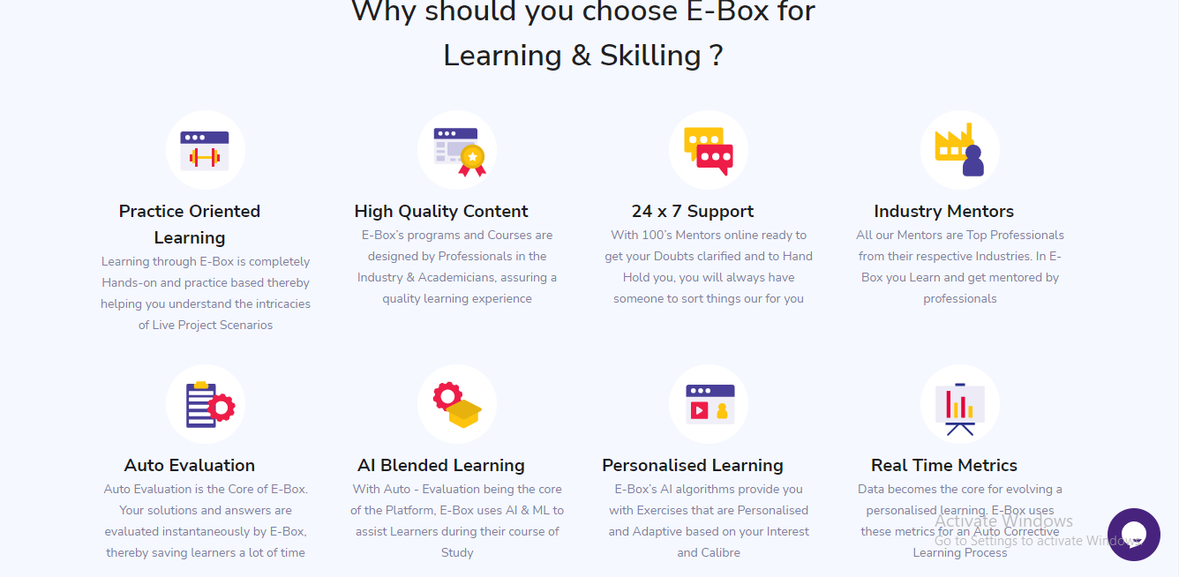**

**Figure 2.a**

* For them leading a product from concept to implementation along with customer satisfaction is their belief. Their solutions are not confined to products from a particular vendor or platform. But they render their services to vendors from different platforms. Based on their client’s requirement, they design and deliver their products accordingly. They have strategic partnerships and domain expertise with most of the well-known names in the industry.
* They offer a complete portfolio of software solutions for different services with better customer experience.

**CHAPTER 3**

**INTRODUCTION TO C++ AND OOPs**

**C++** is a general-purpose programming language that was developed as an enhancement of the C language to include object-oriented paradigm. It is an imperative and a **compiled** language.  C++ is a middle-level language rendering it the advantage of programming low-level (drivers, kernels) and even higher-level applications (games, GUI, desktop apps etc.). The basic syntax and code structure of both C and C++ are the same.

In 1979, [Bjarne Stroustrup](https://en.wikipedia.org/wiki/Bjarne_Stroustrup" \o "Bjarne Stroustrup), a Danish [computer scientist](https://en.wikipedia.org/wiki/Computer_scientist" \o "Computer scientist), began work on "C with [Classes](https://en.wikipedia.org/wiki/Class_(computer_programming)" \o "Class (computer programming))", the predecessor to C++.[[16]](https://en.wikipedia.org/wiki/C%2B%2B" \l "cite_note-invention3-16) The motivation for creating a new language originated from Stroustrup's experience in programming for his PhD thesis. Stroustrup found that [Simula](https://en.wikipedia.org/wiki/Simula" \o "Simula) had features that were very helpful for large software development, but the language was too slow for practical use, while [BCPL](https://en.wikipedia.org/wiki/BCPL" \o "BCPL) was fast but too low-level to be suitable for large software development. When Stroustrup started working in [AT&T Bell Labs](https://en.wikipedia.org/wiki/AT%26T_Bell_Labs" \o "AT&T Bell Labs), he had the problem of analyzing the [UNIX](https://en.wikipedia.org/wiki/Unix" \o "Unix) [kernel](https://en.wikipedia.org/wiki/Kernel_(computer_science)" \o "Kernel (computer science)) with respect to [distributed computing](https://en.wikipedia.org/wiki/Distributed_computing" \o "Distributed computing). Remembering his PhD experience, Stroustrup set out to enhance the [C](https://en.wikipedia.org/wiki/C_(programming_language)" \o "C (programming language)) language with [Simula](https://en.wikipedia.org/wiki/Simula" \o "Simula)-like features.[[17]](https://en.wikipedia.org/wiki/C%2B%2B" \l "cite_note-evolving-17) C was chosen because it was general-purpose, fast, portable and widely used. As well as C and Simula's influences, other languages also influenced this new language, including [ALGOL 68](https://en.wikipedia.org/wiki/ALGOL_68" \o "ALGOL 68), [Ada](https://en.wikipedia.org/wiki/Ada_(programming_language)" \o "Ada (programming language)), [CLU](https://en.wikipedia.org/wiki/CLU_(programming_language)" \o "CLU (programming language)) and [ML](https://en.wikipedia.org/wiki/ML_(programming_language)" \o "ML (programming language))

**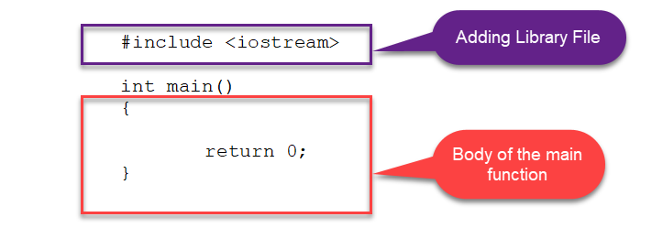figure 3.a**

<**[Iostream.h>](https://www.geeksforgeeks.org/html-html-tag/):** If the direction of flow of bytes is from the device(for example, Keyboard) to the main memory then this process is called input.

**Main()Function:**The main function is called at program start-up after [initialization](https://en.cppreference.com/w/cpp/language/initialization" \o "cpp/language/initialization) of the non-local objects with static [storage duration](https://en.cppreference.com/w/cpp/language/storage_duration" \o "cpp/language/storage duration).:

As Earlier I have discussed I have learnt many concepts during summer training as well as I have solved man questions using those concepts:

* **1D Array**
* **2D Array**
* **Strings**
* **Function and Pointers**
* **Recursion**
* **Classes and Objects**
* **Collections**
* **Relationships between Classes**
* **Inheritance**
* **Abstract Classes and Inheritance**
* **Operator Overloading**
* **Exception Overloading**
* **Templates**
* **File Handling**

**1D Array:** A 1D array is a simple data structure that stores a collection of similar type data in a contiguous block of memory. Using One Dimensional Array I have learnt many concepts by help of those concepts I have solved many questions during summer training periods.

Like: Using 1D Array I solved a Question that is called Adjacent Stick Game.

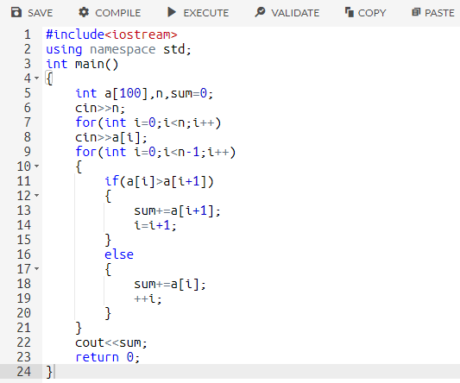

**2D Array:** 2D array can be defined as an array of arrays. The 2D array is organized as matrices which can be represented as the collection of rows and columns. Using Two-Dimensional Array I have learnt many concepts by help of those concepts I have solved many questions during summer training periods.

Like: Using 2D Array I solved a Question that is called count of numbered cell**.**

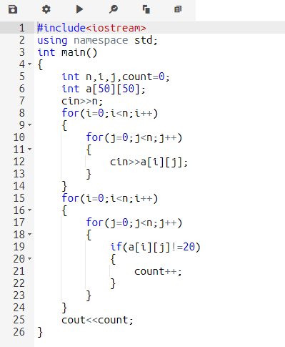

**Strings:** A string variable contains a collection of characters surrounded by double quotes.

Using the Concepts of Strings, I solved many Questions One of them is here I am showing, that is called Alternating Code.

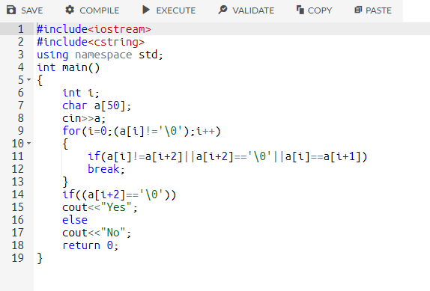

**Recursion:** When function is called within the same function, it is known as recursion in C++.

Using this concept, I solved many Questions like:

Reverse the Digits

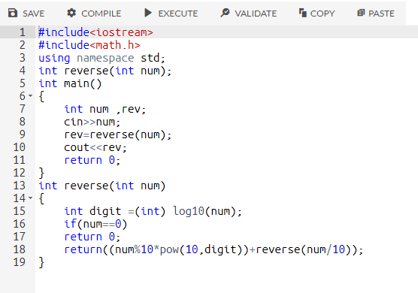

**Basic I/o and O/p Operations:** Using Basic input and output control Statement statement I have solved many Questions one of them is here.

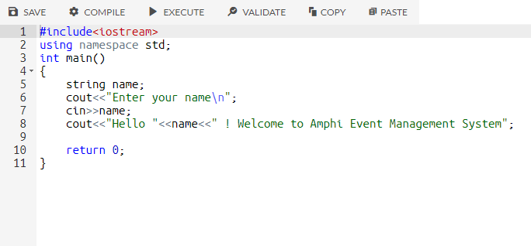

\*During Training I had participated in Many Quiz’s Where I have learned So many New things as well New Concepts.

Like:

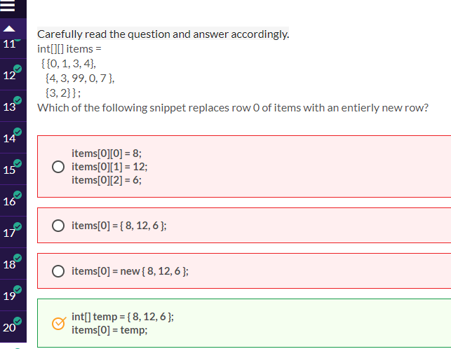

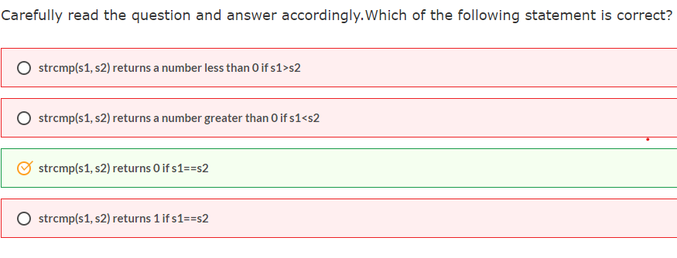

**After All the concept which I have learnt during Training Using those Concept I have made a project that is called QUIZ SYSTEM.**

**In this project I used all the concept like: Basic of Control statement, Strings, Array and many more.**

**In this Project I have made six sections.**

* Adding User Information
* Select Subject
* MCQ Sections
* Marks and percentage calculator
* Pass ,Fail status
* Exit

**Adding User Information:** In this section we need of the information of the student which likes: Name, Roll Number. After taking these details to the Student

**Subject:** We can select subject in which we want to give the quiz after giving user information to quiz system.

**MCQ Section:** There will be various kind of MCQ in this section related to the subject you have chosen .

****Marks calculator****: With this feature you can calculate the marks and percentage of that subject in which we have given the quiz.

****Status****: This feature allows users to see the pass and fail status of the quiz.

**Exit:** Its Section specially made for Quitting the Quiz Software the when do we complete with our All the activity then we can easily go out of the software after using this option.

**CHAPTER 4**

**INTRODUCTION TO C++**

**4.1 History of C++**

The C++ programming language has a history going back to 1979, when [Bjarne Stroustrup](http://www2.research.att.com/~bs/) was doing work for his Ph.D. thesis. One of the languages Stroustrup had the opportunity to work with was a language called Simula, which as the name implies is a language primarily designed for simulations. [The Simula 67 language](http://staff.um.edu.mt/jskl1/talk.html) - which was the variant that Stroustrup worked with - is regarded as the first language to support the object-oriented programming paradigm. Stroustrup found that this paradigm was very useful for software development, however the Simula language was far too slow for practical use.  
  
Shortly thereafter, he began work on "C with Classes", which as the name implies was meant to be a superset of the C language. His goal was to add object-oriented programming into the C language, which was and still is a language well-respected for its portability without sacrificing speed or low-level functionality. His language included [classes](http://www.cplusplus.com/doc/tutorial/classes/), basic [inheritance](http://www.cplusplus.com/doc/tutorial/inheritance/" \l "inheritance), [inlining](http://www.cplusplus.com/doc/tutorial/functions2/" \l "inline), [default function arguments](http://www.cplusplus.com/doc/tutorial/functions2/" \l "default_values), and strong type checking in addition to all the features of the C language.  
  
The first C with Classes compiler was called Cfront, which was derived from a C compiler called CPre. It was a program designed to translate C with Classes code to ordinary C. A rather interesting point worth noting is that Cfront was written mostly in C with Classes, making it a self-hosting compiler (a compiler that can compile itself). Cfront would later be abandoned in 1993 after it became difficult to integrate new features into it, namely C++ [exceptions](http://www.cplusplus.com/doc/tutorial/exceptions/). Nonetheless, Cfront made a huge impact on the implementations of future compilers and on the Unix operating system.  
  
In 1983, the name of the language was changed from C with Classes to C++. The ++ operator in the C language is an operator for incrementing a variable, which gives some insight into how Structure regarded the language. Many new features were added around this time, the most notable of which are [virtual functions](http://www.cplusplus.com/doc/tutorial/polymorphism/" \l "virtual), [function overloading](http://www.cplusplus.com/doc/tutorial/functions2/" \l "function_overload), references with the & symbol, the const keyword, and single-line comments using two forward slashes (which is a feature taken from the language BCPL)..

**4.2 features of C++**

* Object Oriented Programming.
* Machine Independent
* Simple
* Intermediate level Programming Language
* Compiler-Based
* Dynamic Memory Allocation
* Integration and Extendability

**4.3 Advantages of C++**

C++ is a multi-purpose programming language used widely across the world. There is no doubt that even after being a very old language, it is one of the most efficient programming languages.

Now, here at TechVidvan, we will help you know every aspect of this language before you decide to make it your go-to programming language. Let’s start with it!

### **Advantages of C++**

#### 1. Portability

C++ provides this feature of portability allowing us to develop codes without caring about the hardware. This lets us move the development of a program from one platform to another.

For example, you’re working on Windows OS and for some reason, you have to switch to LINUX, the codes from Windows OS will also run in the LINUX OS without any error.

#### 2. Mid-level programming language

Being a mid-level programming language, we can treat it as both a low-level and high-level language. Features of high-level language help to develop games and desktop applications, whereas features of low-level language help make kernels and drivers.

#### 3. Object-Oriented

The OOP concepts like polymorphism, encapsulation, inheritance, and abstraction give C++ the biggest advantage over other programming languages. It proved to be of great significance since this feature was not in C, this helped users to treat data as objects and classes.

#### 4. Multi-paradigm programming language

Paradigm refers to the planning involved in programming. It concerns the logic, the style, and the way how we proceed with the program. C++ is a multi-paradigm programming language as it follows three paradigms:

**a. Generic –** Using a single idea that serves multiple purposes.  
**b. Imperative** – Using steps that change the state of the program.  
**c. Object-Oriented** – Using methods and classes for reusability and modularity.

#### 5. Memory Management

C++ supports DMA (Dynamic Memory Allocation), which helps to free and allocate memory. Since there is no garbage collection, C++ gives the programmer total control over memory management.

#### 6. Fast and Powerful

As C++ is a compiler-based programming language; we do not require to install a special runtime while running the program. Hence, they are pre-interpreted and it makes the code faster and more powerful.

Even the compilation and execution are faster allowing it to create several kinds of programs from games to drivers to complicated GUIs.

#### 7. Similar to other languages

C++ syntax is similar to C#, C, and Java. It makes learning C++ easier if you already know one of them. It also makes switching to and from other languages easier.

This can be treated as an added benefit that C++ is compatible with C programs i.e. every running C program can be run as a C++ program. Most of the time we just need to run the program on a file .cpp extension.

#### 8. Standard Library

C++ provides a good range of built-in libraries. They help in making the software development faster and allows the user to do more with less.

#### 9. Wide Range of Applications

C++ is useful to make GUIs as well as games. C++ is also useful to develop graphics and real-time algebraic simulation. Hence, C++ is beneficial in every stream.

#### 10. Huge Community

C++ has a vast community around it. Community size is very important if you want to get supported every now and then. The larger the community size, more the help you’ll get to solve your problems.

A huge number of paid/free online courses and lectures are available, which shows how community support works.

#### 11. Scalability

One of the greatest advantages of C++ is its scalability, i.e. its program can be scaled to another level. Hence, resource-intensive applications can be built using C++, as the programs can be low-scale and high-scale.

#### 12. Big Job Market

As we know that C++ has benefits in various departments from finance to app developments, GUI to Games, C++ has a very big job market. Knowledge of C++ can help you secure a job at such departments where C++ comes in handy.

**4.4 Disadvantages of C++**

#### 1. Pointers

When it comes to pointers in C++, it is a very tough conception compared to other topics. Uninitialized pointers might result in system failure.

Memory corruption can also take place if one puts wrong values in the same. To sum up, debugging pointer bugs is very difficult and hence one of the major disadvantages of C++.

#### 2. No garbage collection

C++ doesn’t support garbage collectors, this means that the entire power to manage the data memory goes in the hands of the user. Absence of the same results in redundant data being stored in turn increasing the memory.

#### 3. Unsafe

C++ is unsafe in a strong sense. The presence of pointers, global variables, etc. is the main reason behind these security issues. It means it is possible to corrupt the entire program just by using a part of the memory as an incorrect type.

4. Complex

C++ is a Multi-Paradigm language, i.e. object-oriented programming with runtime polymorphism, templates, and static polymorphism, some support for functional programming. C++ is not useful for platform-dependent apps and hence is complex in a very huge high-level program.

#### 5. Less flexible

C++ is very strict regarding the syntax, a little mishap gives a series of errors. It generally takes more time to excel in C++ than any other programming language. It is not easy to write a C++ code in a readable way, making the language less user-friendly and less flexible for the user.

#### 6. No custom operators

In many programming languages like Java, we can define operators for specific operations. But, in C++ it is not quite possible. We can redefine existing operators using operator overloading, but nothing more.

#### 7. No built-in threads

There’s no support for built-in threads in C++. Even though it is a relatively newer concept it was later added to the newest standard of C++. But it is still far-fetched compared to programming languages like Java.

#### 8. Lack of algebraic data types

Algebraic data types like tuples and structs are not supported in C++. Because of this, we need to use libraries or our own executions if we need to use it.

#### 9. Functions are not first-class type

First-class type functions are those where:

a. Values can be passed and return, without restrictions.  
b. Functions can be created and constructed anywhere, without any restrictions.  
c. The function can be typed in such a way that an entity can be assigned to it.

While points a and c hold true for functions in C++, point b fails

### **4.5 Summary**

In this article, we highlighted various advantages and disadvantages of using C++. Hopefully, we helped you to gain a clear perspective of the advantages and disadvantages which will help you decide whether C++ would be your go-to language or not.

Regardless of the pros and cons, it would be great if you carry on with C++ as it is one of the most widely used languages.

**CHAPTER 5**

**SOFTWARE REQUIREMENT ANALYSIS**

**5.1 Software Requirements**

There are various requirements during preparation of a project. Some of the requirements like gathering images icons, data and many more.

Apart from this the main part is software, which software are you using during your project? So, some software which are required in this project are as follows:

* Dev c - It is the most suitable software for developing and organising a C++ Project. Using this, we can write complete portion of code inside one page.
* VS Code Studio - This software is used to read the code in good and organised manner. It creates a simple portable document format in which codes look neat and clean.

Software requirements deal with defining software resource requirements and prerequisites that need to be installed on a computer to provide optimal functioning of an application. These requirements or prerequisites are generally not included in the software installation package and need to be installed separately before the software is installed.

**5.2 Hardware Requirements**

* PROCESSOR 1 Ghz
* RAM 4GB
* HARD DISK DRIVE 1TB

**5.3 Testing and Maintainability Requirements**

The application should be able to meet all the possible good and bad test cases under a test environment. Application should be developed in such a way that it does not have any issues or crashes when the user is using the application. It should be able to extend itself when we expand the code or implement any new functions to the existing application.

**5.4 Design Approach**

This project is based on the functional design approach, which helps in understanding the design of the project in a simpler way by explaining its flow, use cases, and implementation more like a modular approach. For example, there are different modules in this project which have separate functionality and, other sub functionalities/modules. All the modules are designed, implemented and integrated together to make a flawless working application.

**5.5 Design and implementation**

The project design includes everything from who is responsible for completing the project to a description of the project, its goals, outcomes and objectives. It describes when these goals, outcomes and objectives will be reached, and the major deliverables, products or features that will be completed. The project design also estimates the budget and outlines how to monitor and evaluate progress.

**CHAPTER 6**

**DESIGN AND IMPLEMENTATION**

**6.1 The design of the project is explained in detail.**

Few points are noted down:

1.To kick start any project in a editor, we need first to save the project with its proper name and with its extension. Extension is required for every project.

2. Now snapshots of whole project is shown below accordingly.

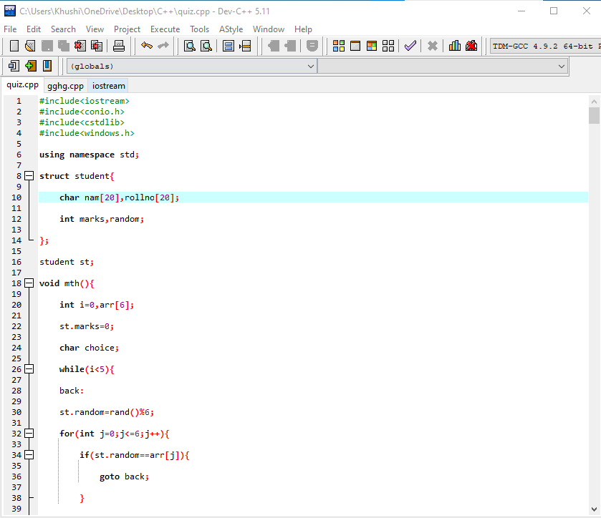

Figure 6.a

**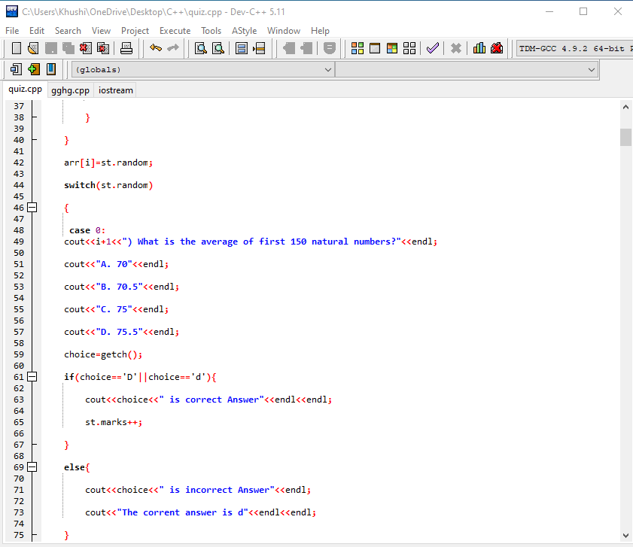**

Figure 6.b

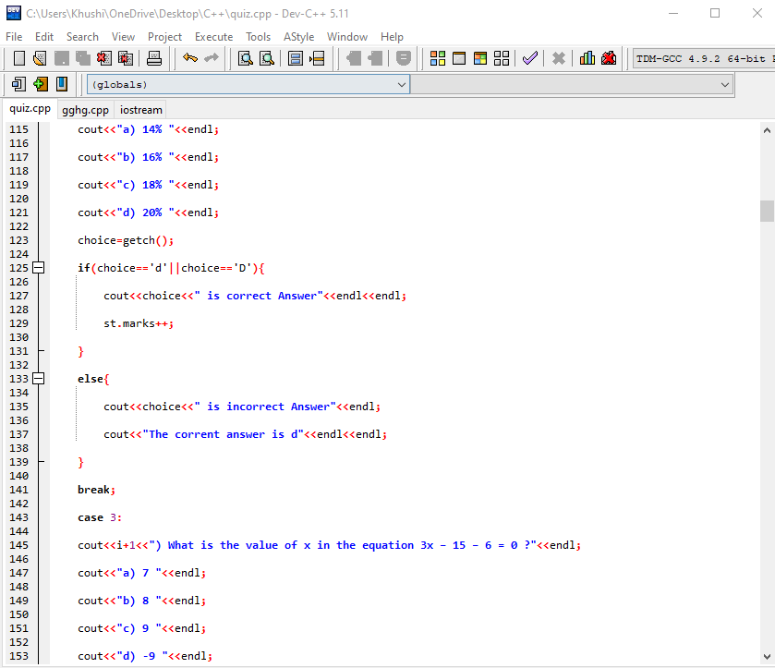

Figure 6.c

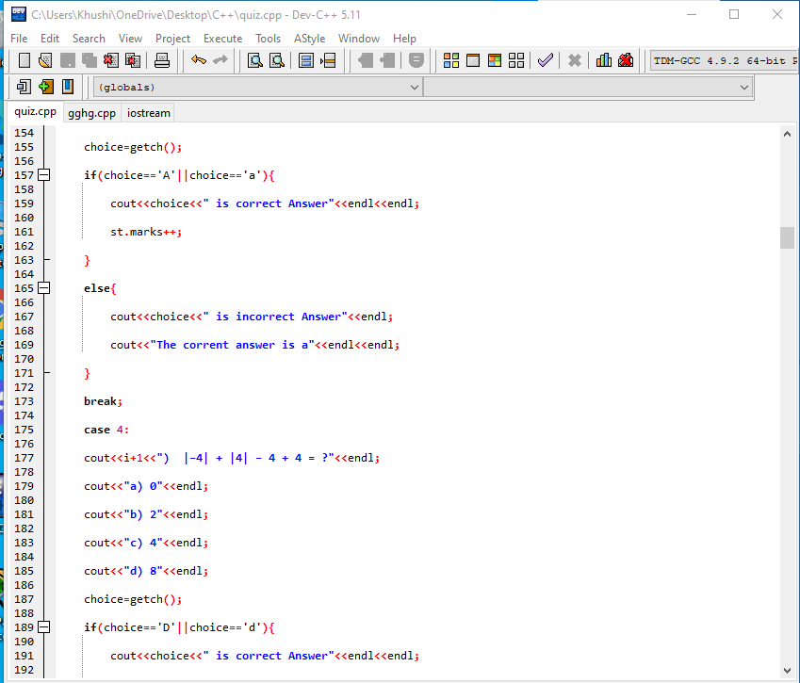

Figure 6.d

**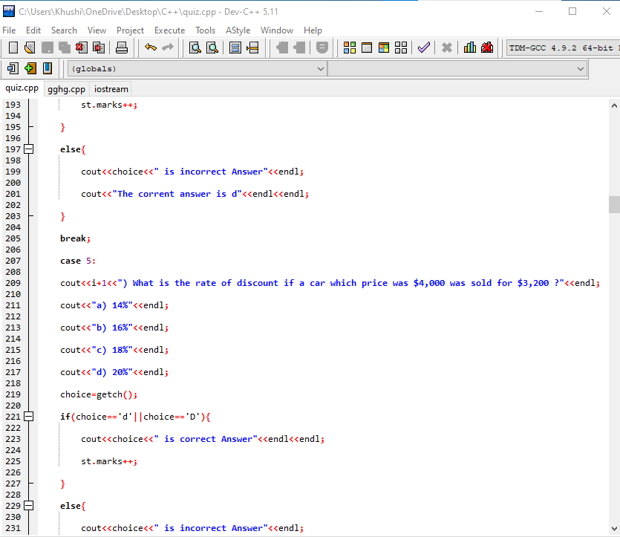**

Figure 6.e

**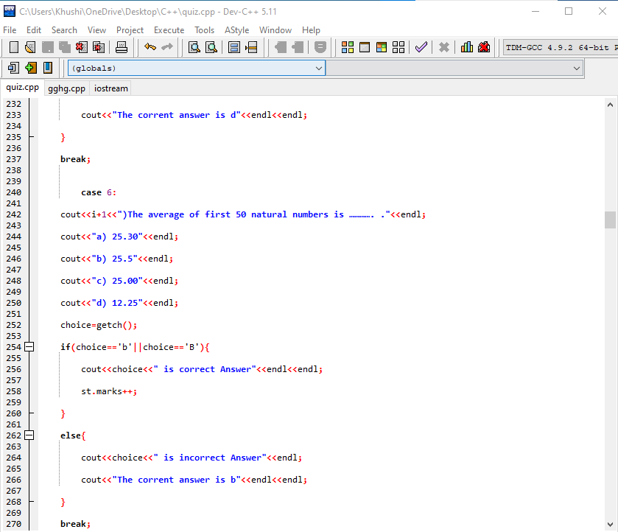**

Figure 6.f

**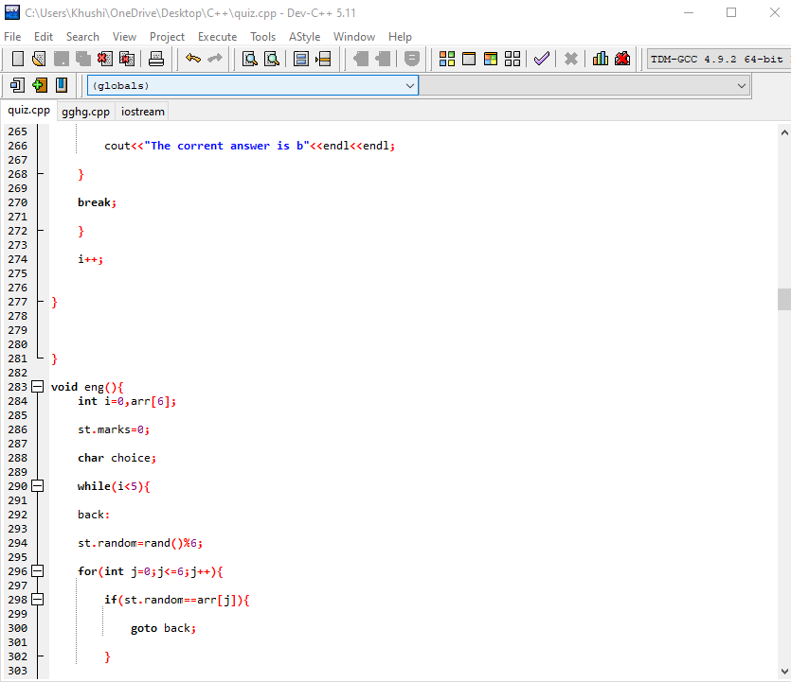**

Figure 6.g

**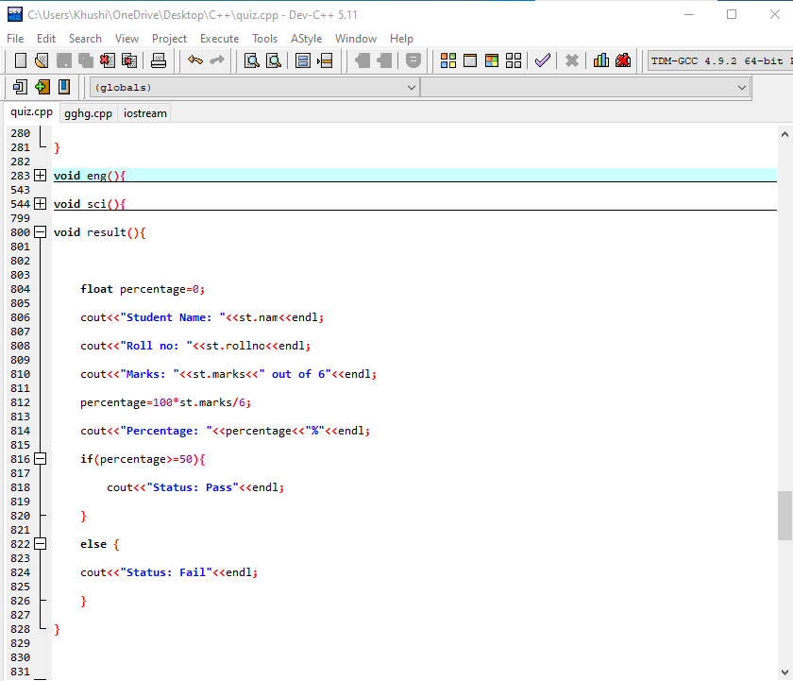**

Figure 6.i

**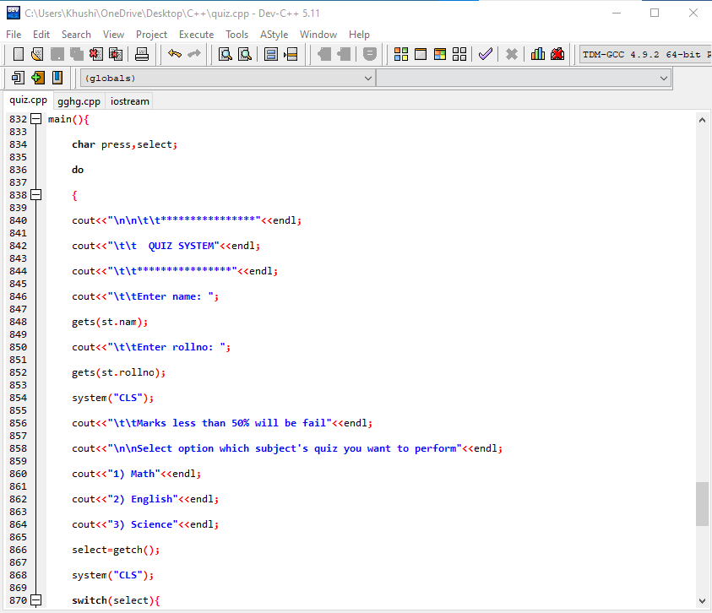**

Figure 6.j

**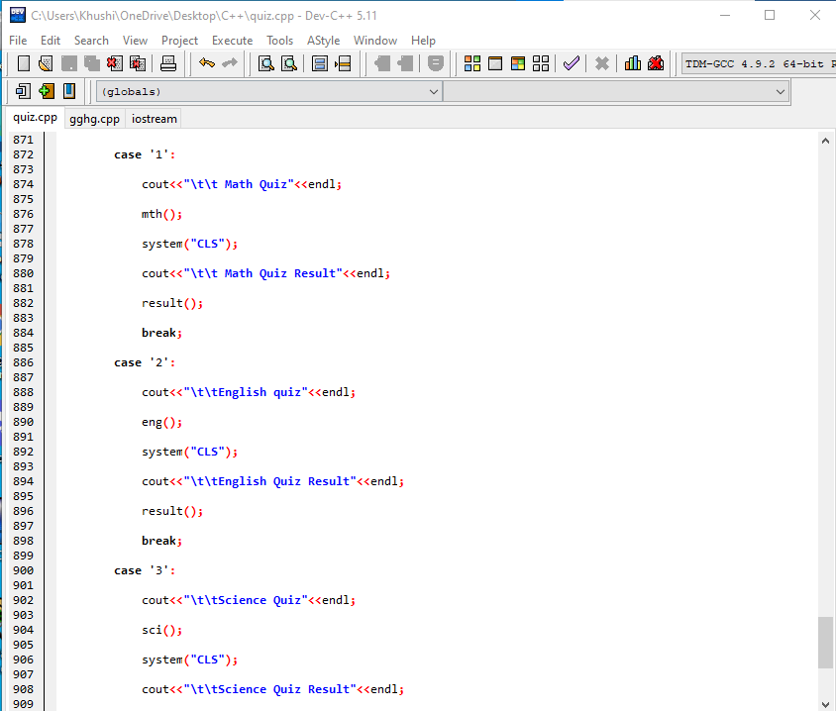**

Figure 6.k

**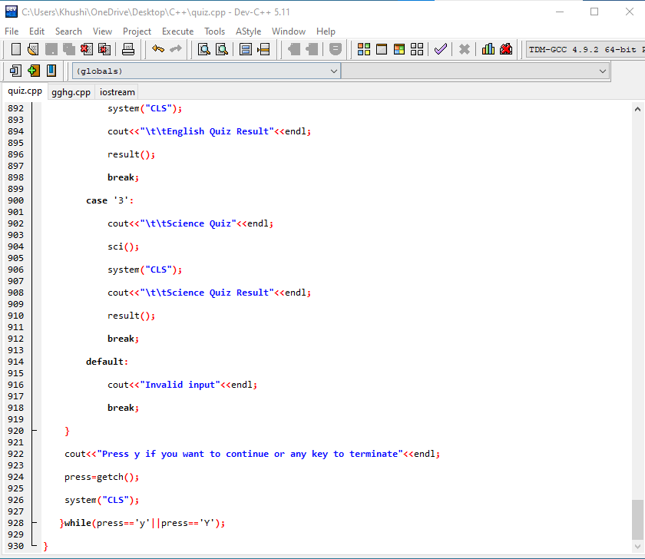**

Figure 6.l

**OUTPUTS:**

**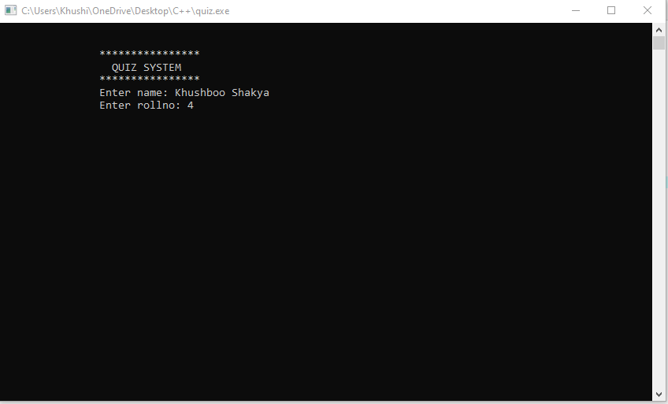** Figure 6.m (User is entering name and roll number)

**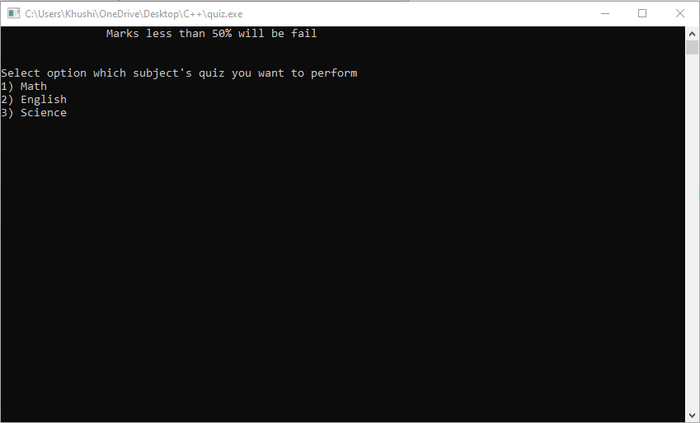**

**Figure 6.n (Asking the user to select the subject)**

**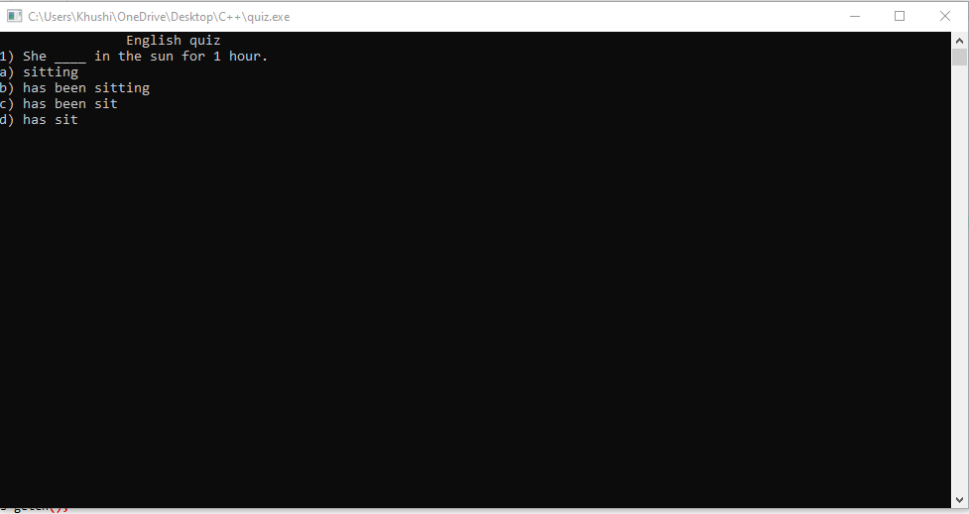** Figure:6.n(MCQ)**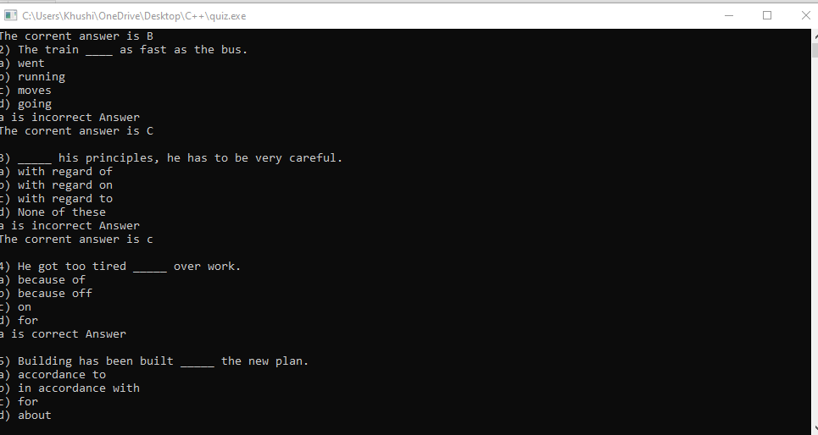**

Figure:6.o**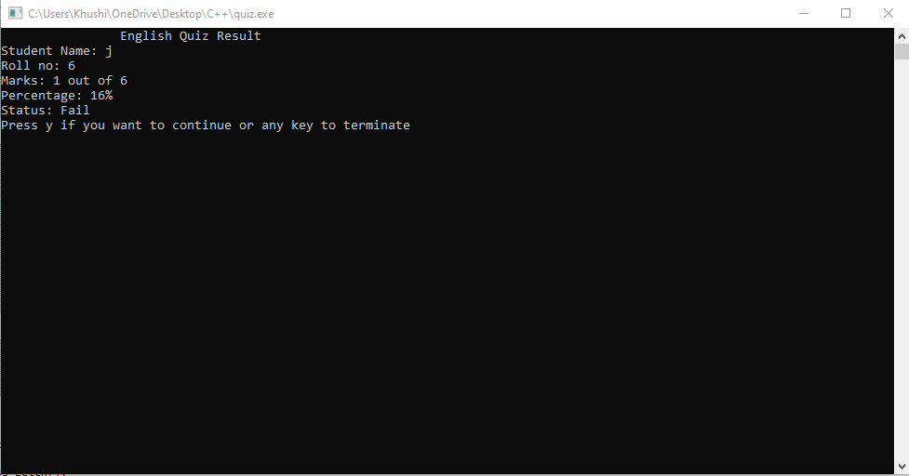** Figure 6.p(Score)

**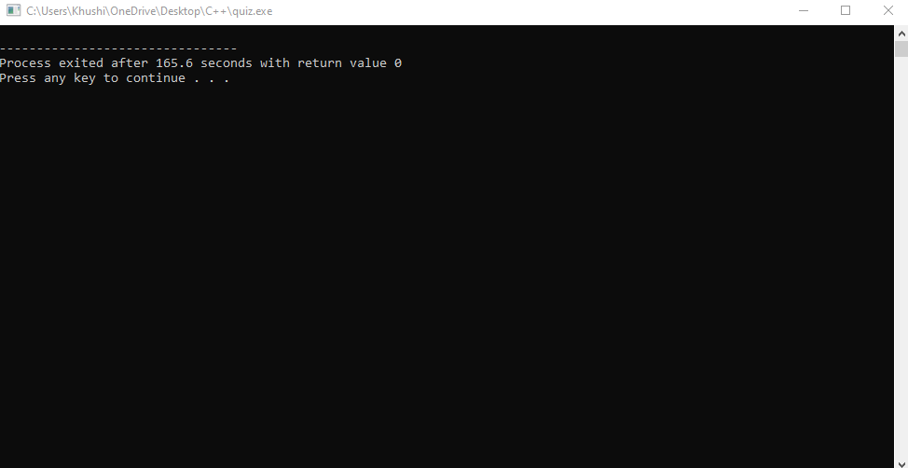**

Figure 6.q(Exit page )

**CHAPTER 7**

**BRIEF DESCRIPTION OF THE WORK DONE**

**7.1 Position of training and roles**

* Conducting job evaluation surveys
* liaising with group leader and interviewing all members at all levels to identify and assess training and development needs.
* delivering and overseeing the training of individuals or groups of members
* compiling and presenting information

**7.2 Equipment’s handled**

During completion of the project I worked on different text editors and judged myself on them that which one is best for project

**7.3 challenges faced and how these were tackled**

In the starting time I faced issues like how many functions should I put in my project. later on, with the help of my mentor as well as friends were helped me a lot in solving these issues.

Arrangement of console functions inside editor were difficult task but as time invested into the project I got understanding of all type of functions.

**7.4 Learning outcomes**

* understand the basic functions on your OOPs Concepts.
* understand what may go wrong when using concept and know how to fix them
* apply knowledge of OOPs Concept to a make Quiz Software.

**CONCLUSION**

This project gives detail knowledge of all the OOPs Concepts. However, few of the functions are shown and analysed in and few o the concept we had cleared during training which I have learnt during Project Making process.

As we know C++ is the Server-side Software Development Software.

The language is basically known as for OOPs and competitive programming Language.

C++ is used for Basically software development Project, Its is a middle Level Language which is used For Development process by the companies.

**REFERNCES**

* **https://en.wikipedia.org/wiki/Quiz\_software**
* **https://littlepinkbook.com/top-advantages-quiz-software-applications/**
* **https://yourstory.com/2020/03/startup-bharat-coimbatore-edtech-startup-upskill/amp**
* **https://e-box.co.in/**
* **https://en.wikipedia.org/wiki/C%2B%2B**
* **https://www.cplusplus.com/info/history/**
* **https://techvidvan.com/tutorials/cpp-pros-and-cons/**

**45**