PROJECT TASK-2
TASK:DATA CLASSIFICATION USING AI
1. OBJECTIVE
Build a supervised machine learning model to classify Iris flower species using their measurements. Used Logistic Regression algorithm for classification.
2. DATASET DESCRIPTION
Dataset: Iris Dataset from Scikit-learn
Total Samples: 150
Features: 4 - Sepal Length, Sepal Width, Petal Length, Petal Width
Classes: 3 - Setosa, Versicolor, Virginica
Each class has 50 samples
3. METHODOLOGY
Step 1: Loaded Iris dataset using sklearn.datasets.load_iris
Step 2: Split data into 80% Training and 20% Testing using train_test_split
Step 3: Selected LogisticRegression model from sklearn.linear_model
Step 4: Trained model using model.fit on training data
Step 5: Made predictions on test data using model.predict
Step 6: Evaluated using accuracy_score and classification_report
4. RESULTS AND OUTPUT
Accuracy Achieved: 100.0%

Classification Report:
precision recall f1-score support
Setosa 1.00 1.00 1.00 10
Versicolor 1.00 1.00 1.00 9
Virginica 1.00 1.00 1.00 11
Accuracy 1.00 30

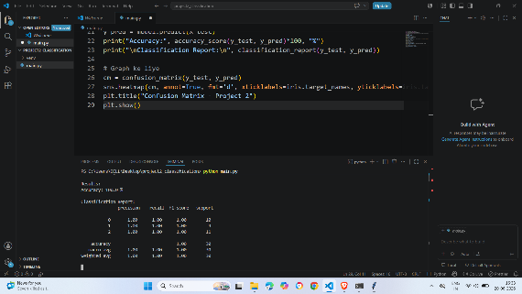
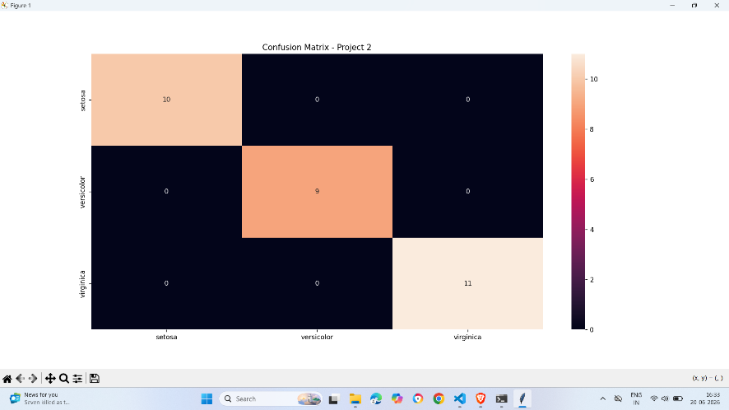
Confusion Matrix shows perfect classification. Diagonal values are 10, 9, 11. All other values are 0, meaning no wrong predictions.

5. SKILLS LEARNED
1. Python Programming and Libraries
2. Scikit-learn for Machine Learning
3. Data Splitting using train_test_split
4. Model Training and Prediction
5. Model Evaluation using Accuracy and Confusion Matrix
6. Data Visualization using Matplotlib and Seaborn

6. CONCLUSION
The Logistic Regression model successfully classified Iris flower species with 100% accuracy. This project helped understand complete workflow of supervised learning from data loading to model evaluation.

FUTURE SCOPE
This model can be deployed as a web application using Flask or Streamlit for real-time predictions..

