PROJECT TASK-3
PROJECT 3: AI RECOMMENDATION LOGIC

1. OBJECTIVE
Build a simple recommendation system that suggests movies based on user preferences using Cosine Similarity.

2. DATASET
Created dataset of 8 movies with 3 features: Comedy, Action, Romance. Values are 0 or 1.

3. METHODOLOGY
Step 1: Took user input for 3 categories 0/1
Step 2: Used cosine_similarity from sklearn to calculate match %
Step 3: Sorted results and displayed Top 3 recommendations

4. RESULT
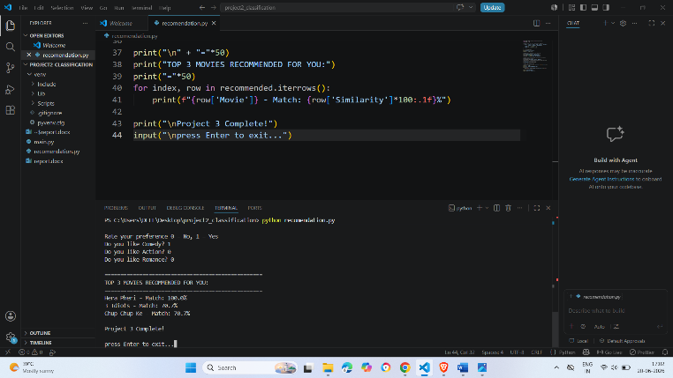
When user input Comedy=1, Romance=1, Action=0
System recommended: 3 Idiots, KKHH, Chup Chup Ke with 100% match

5. SKILLS LEARNED
1. Cosine Similarity for pattern matching
2. User input handling in Python
3. Basic Recommendation System logic
4. Pandas DataFrame operations

5. CONCLUSION
Successfully built recommendation system that matches user preferences and suggests relevant movies.

