**Facebook Data Analysis**

### Create table facebook

To see all csv files available in HDFS :

ls -l

csv file path: hdfs dfs -put /home/mavricbdhnov0433/pseudo_facebook.csv

[mavricbdhnov0433@ip-10-1-1-204 ~]$ hdfs dfs -put /home/mavricbdhnov0433/pseudo_facebook.csv

put: `pseudo_facebook.csv': File exists

[mavricbdhnov0433@ip-10-1-1-204 ~]$

Create database :

Hive> create database khusboosharma;

show databases like '*khushboo*';

hive> show databases like '*khushboo*';

OK

Time taken: 0.434 seconds

hive> use khusboosharma;

OK

Time taken: 0.04 seconds

Create fb_data table in khusboosharma database :

Hive> create table fb_data(id int, age int, day int, year int, month int, gender string, tenure int, friends int,

friend_init int, likes int, likes_recd int,mlikes int, mlikes_recd int, wlikes int, wlikes_recd int)

row format delimited

fields terminated by ',';

OK

Time taken: 0.435 seconds

**To load the data into Hive:**

LOAD DATA local INPATH 'pseudo_facebook.csv' OVERWRITE INTO TABLE fb_data;

**To see table structure:**

describe fb_data;

**To see the table data:**

select * from fb_data limit 50;

**1. Find out the total number of users in this dataset.**

select count(*) from fb_data;

Q2: Find out the no of users above the age of 25

select count(*) from fb_data where age>25;

Q3: Do male face book users tend to have more friends or female users

select gender,avg(friends) from fb_data group by gender;

### 4. How many likes do young people recieve on facebook opposed to older people.

select avg(likes_recd) from fb_data where age>=13 AND age<=25;

select avg(likes_recd) from fb_data where age>25;

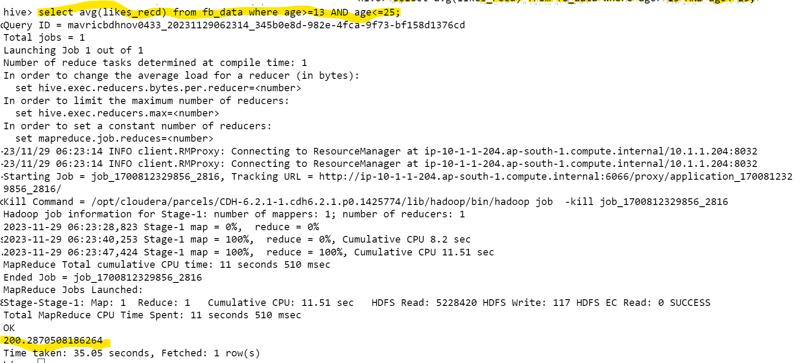

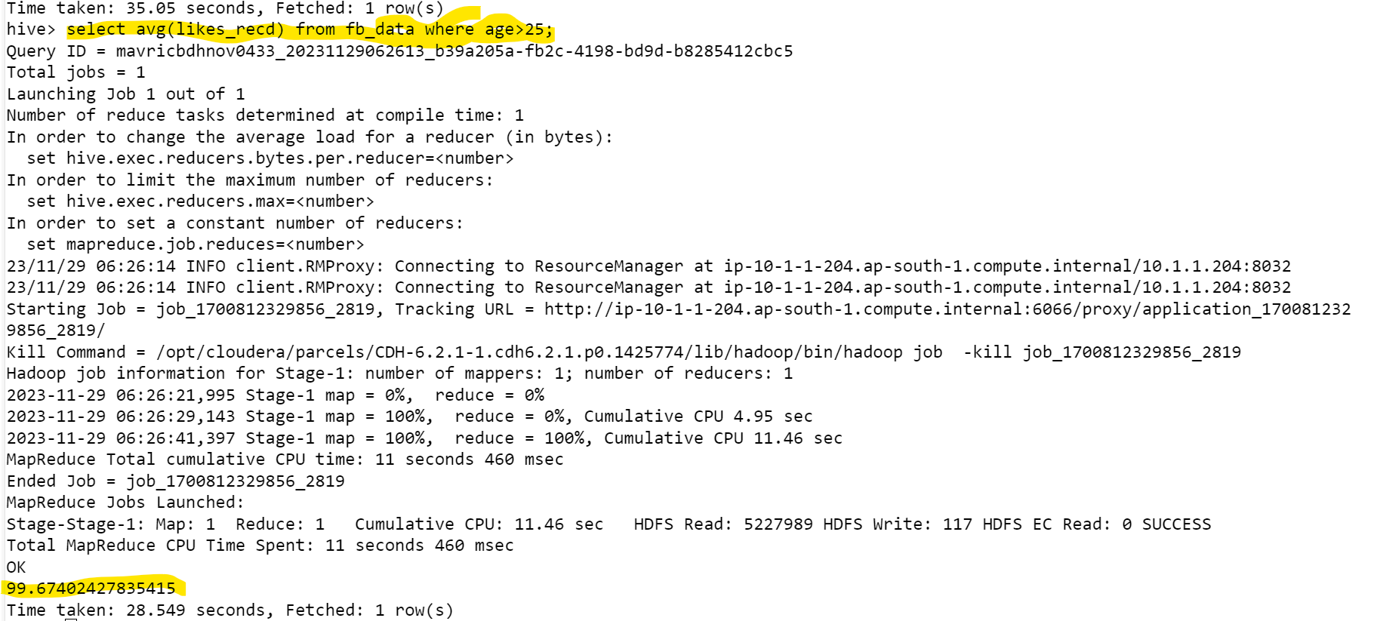

### 5. Find out the count of facebook users for each birthday month.

select month,count(*) from fb_data group by month;

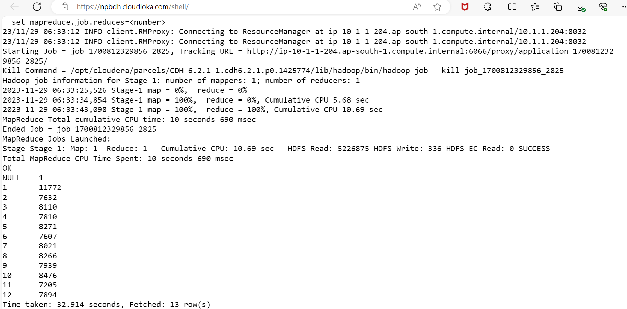

### 6. Do young members use mobile phones or computer for fb browsing?

select avg(mlikes),avg(wlikes) from fb_data where age>=13 AND age<=25;

### 7. Do adult members use mobile phones or computer for fb browsing?

select avg(mlikes),avg(wlikes) from fb_data where age>=35;

