

Care4u

INFO 5100 | Course - AED | Dr. (Prof.) Kal Bugrara | Northeastern University | Spring 2021



April 23, 2021

Team : Care4u

Khushbu Thakur (001529335), Kunal Upadhyay (001529438), Vivekkumar Singh (0015563949)

**Care4U**

**-----------------------------------------------------------------------------------------------**

**Problem Statement:**

The COVID-19 ('Coronavirus') pandemic led several countries to take lockdown measures to slow the spread of the virus and avoid placing a heavy burden on already overwhelmed healthcare systems. The lockdown has adversely affected the physical and mental well-being of people. What can be done if you are stuck at home, and want medical help without the risk of going to the hospital? Since the hospitals are already overcrowded with covid patients, you would need a platform to connect with doctors.

How about building an ecosystem that brings medical facilities to you? That is the promise of team Care4U, we want to help our users in all possible ways in terms of medical help. Care4U gives a platform to its user to consult a doctor, order medicines, book fitness sessions for a healthy lifestyle along with these features, a user can also book an emergency ambulance service from our list of services. Care4U has all the features needed during a medical service.

**Java Implementation:**

We have used java swing panels to build the UI. We have used the Advance java feature jcalendar to provide an option to the users to select the date from the calendar instead of manually inserting the date. We have used the advance java feature javax.mail to send emails to the users when their accounts get created and deleted, and also in the event of booking an appointment or creating a new order. A user can order a medicine from our list of shops and get it delivered to their doorstep with our delivery services. If the medicine needs a mandatory prescription, we provide the option to consult a doctor and get their prescription approved. Also in case, a patient does not need medicines, then they can register for our fitness training sessions which they like or as suggested by a physician to improve their health.

**Entities:**

**System:**

**Attributes:**

Business: this variable holds the information about Ecosystem

HospitalDirectory : This class object will have all the values from class HospitalDirectory.

userDirectory : This class object will have all the values from class UserDirectory

typeDirectory : This class object will have all the values from class TypeDirectory

shopDirectory : This class object will have all the values from class ShopDirectory

ambulanceDirectory : This class object will have all the values from class AmbulanceDirectory

deliveryDirectory : This class object will have all the values from class DeliveryDirectory

fitnesscenterDirectory : This class object will have all the values from class FitnessCenterDirectory

**Methods:**

getSupportedRole(): this method will fetch role object and all the values it is holding

checkIfUserIsUnique(): this method checks if the user name is unique or not

getHospitalDirectory(): this method will fetch HospitalDirectory object and all the values it is holding

setHospitalDirectory(): this method will set HospitalDirectory object value

getUserDirectory(): this method will fetch UserDirectoryobject and all the values it is holding

setUserDirectory(): this method will set UserDirectoryobject value

getTypeDirectory(): this method will fetch TypeDirectoryobject and all the values it is holding

setTypeDirectory(): this method will set TypeDirectoryobject value

getShopDirectory(): this method will fetch ShopDirectoryobject and all the values it is holding

setShopDirectory(): this method will set ShopDirectoryobject value

getAmbulanceDirectory(): this method will fetch AmbulanceDirectory object and all the values it is holding

setAmbulanceDirectory(): this method will set AmbulanceDirectory object value

getDeliveryManDirectory(): this method will fetch DeliveryManDirectory object and all the values it is holding

setDeliveryManDirectory(): this method will set DeliveryManDirectory object value

getFitnessCenterDirectory(): this method will fetch FitnessCenterDirectory object and all the values it is holding

setFitnessCenterDirectory(): this method will set FitnessCenterDirectory object value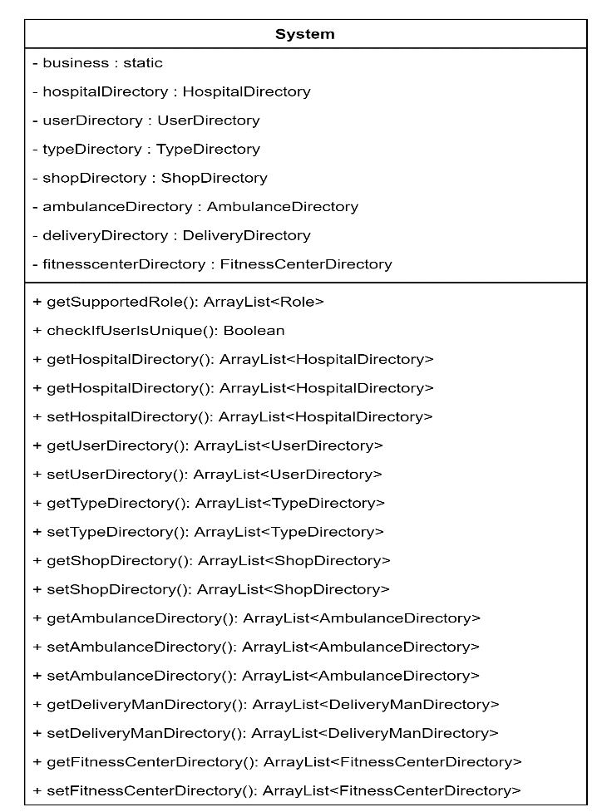

Hospital:

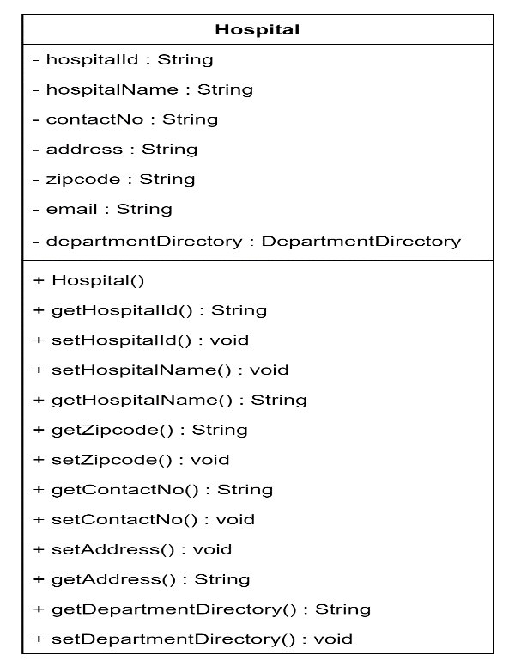

Attributes:

- hospitalId : this variable will hold the unique id for each hospital

- hospitalName : this variable will hold the name of the hospital

- contactNo : this variable will hold the contact number of the hospital

- address : this variable will hold the address of the hospital

- zipcode : this variable will hold the zip code of the hospital

- email : this variable will hold the email of hospital

- departmentDirectory : This class object will have all the values from class HospitalDepartmentDirectory

**Methods:**

+ getHospitalId() : this method will fetch the unique id for each hospital and all the values it is holding

+ setHospitalId() : this method will set the unique id

+ getHospitalName() : this method will fetch the hospital name and all the values it is holding

+ setHospitalName() : this method will set the hospital name

+ getZipcode() : this method will fetch the hospital’s zip code and all the values it is holding

+ setZipcode() : this method will fetch the hospital’s zip code

+ getContactNo() : this method will fetch the hospital’s contact number and all the values it is holding

+ setContactNo() : this method will set the hospital’s zipcode

+ setAddress() : this method will set the hospital’s address

+ getAddress() : this method will fetch the hospital’s address and all the values it is holding

+ getDepartmentDirectory() : this method will fetch the DepartmentDirectory object and all the values it is holding

+ setDepartmentDirectory() : this method will set DepartmentDirectory

Staff:

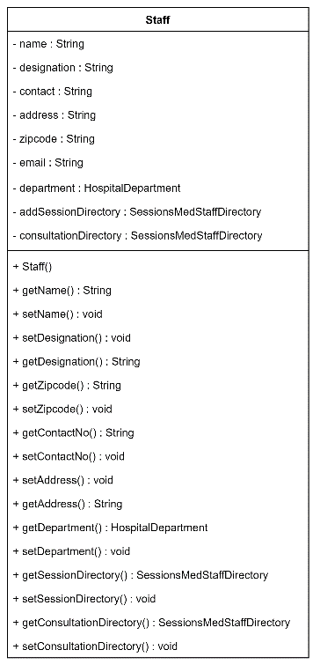

Attributes:

- name : this variable will hold the name of the Staff

designation: this variable will hold the designation of the Staff

- contact : this variable will hold the contact number of the hospital

- address : this variable will hold the address of the hospital

- zipcode : this variable will hold the zip code of the hospital

- email : this variable will hold the email of hospital

- department: This class object will have all the values from class HospitalDepartment

- addSessionDirectory : This class object will have all the values from class SessionsMedStaffDirectory

- consultationDirectory : This class object will have all the values from class SessionsMedStaffDirectory

**Methods:**

+ getDesignation () : this method will fetch the Designationfor each hospital and all the values it is holding

+ setDesignation () : this method will set the Designation of the staff

+ getHospitalName() : this method will fetch the hospital name and all the values it is holding

+ setHospitalName() : this method will set the hospital name

+ getZipcode() : this method will fetch the hospital’s zip code and all the values it is holding

+ setZipcode() : this method will fetch the hospital’s zip code

+ getContactNo() : this method will fetch the hospital’s contact number and all the values it is holding

+ setContactNo() : this method will set the hospital’s zipcode

+ setAddress() : this method will set the hospital’s address

+ getAddress() : this method will fetch the hospital’s address and all the values it is holding

+ getDepartment() : this method will fetch HospitalDepartment and all the values it holds

+ setDepartment() : this method will set HospitalDepartment

+ getSessionDirectory() : this method will fetch SessionsMedStaffDirectory and all the values it holds

+ setSessionDirectory() : this method will set SessionsMedStaffDirectory

+ getConsultationDirectory() : this method will fetch SessionsMedStaffDirectory and all the values it holds

+ setConsultationDirectory() : this method will set SessionsMedStaffDirectory

**SessionMedStaff:**

This entity will have session, appointments details which a doctor has, customers can book these sessions. These sessions will be created by staffs of Hospital. One doctor can have only one session at a time i.e. a doctor can attend only one customer at one time.

**Attributes:**

- sessionId : this variable will hold the unique id for each sessions

- name : this variable will hold the name for each sessions

- sessionDate : this variable will hold the date for each sessions

- startTime : this variable will hold the date for each sessions

- endTime : this variable will hold the date for each sessions

- Location : this variable will hold the date for each sessions

- isRemote : this variable will hold the date for each sessions

- status : this variable will hold the date for each sessions

- userIdentifier : this variable will hold the user for each sessions

- docsIdentifier : this variable will hold the staff for each session

- consultFormList : this variable will hold the object ConsultationForm class and all the values it holds

- consultDoc : this variable will hold the object ConsultFormDoctor class and all the values it holds

**Methods:**

getSessionId() : this method will fetch the unique id for each Sessionand all the values it is holding

+ setSessionId() : this method will set the unique id

+ getName() : this method will fetch the Session name and all the values it is holding

+ setName() : this method will set the Session name

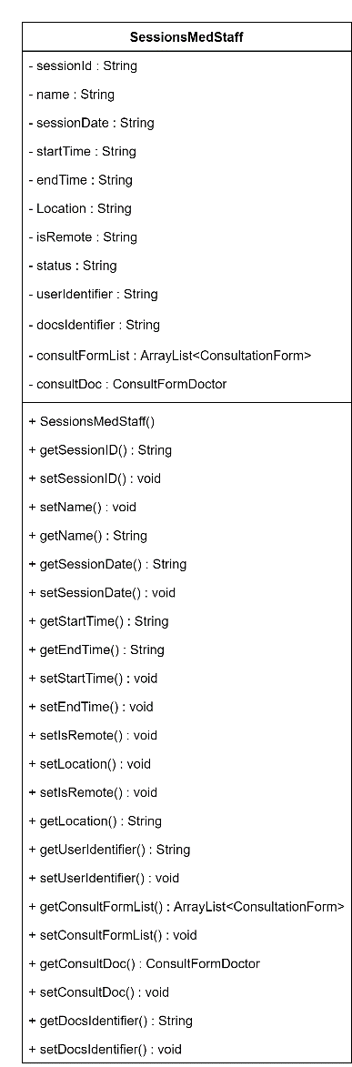

+ getSessionDate() : this method will fetch the Session date and all the values it is holding

+ setSessionDate() : this method will set the Session date

+ getStartTime() : this method will fetch the Session start time and all the values it is holding

+ getEndTime() : this method will fetch the Session end time and all the values it is holding

+ setStartTime() : this method will set the Session Start time

+ setEndTime() : this method will set the Session end time

+ setLocation() : this method will set the Session location

+ setIsRemote() : this method will set the Session isRemote value

+ getLocation() : this method will fetch the Session location and all the values it is holding

+ getUserIdentifier() : this method will fetch the Session user name and all the values it is holding

+ setUserIdentifier() : this method will set the user name

+ getConsultFormList() : this variable will fetch the object ConsultationForm class and all the values it holds

+ setConsultFormList() : : this variable will set the object ConsultationForm class

+ getConsultDoc() : this variable will fetch the object ConsultFormDoctor class and all the values it holds

+ setConsultDoc() : this variable will set the object ConsultFormDoctor class and all the values it holds

+ getDocsIdentifier() : this method will fetch the Session doctor name and all the values it is holding

+ setDocsIdentifier() : this method will fetch the Session doctor name

FitnessCenter:

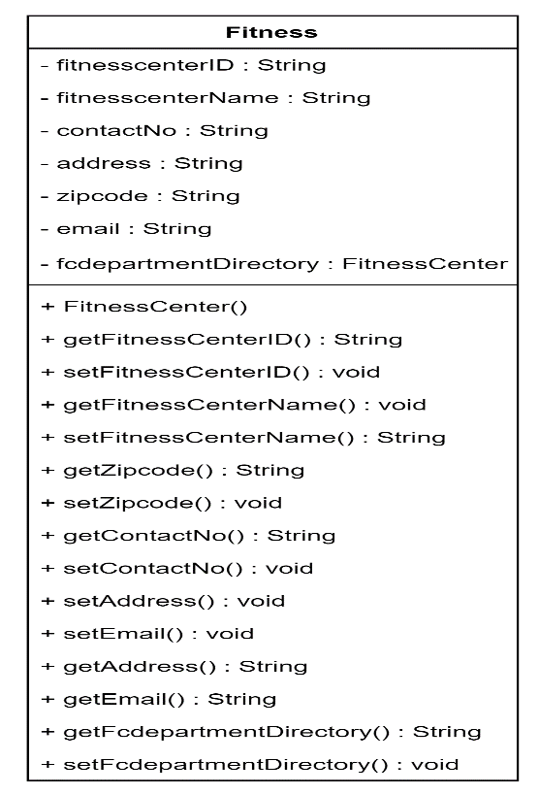

Attributes:

- fitnessCenterId : this variable will hold the unique id for each fitnessCenter

- fitnessCenterName : this variable will hold the name of the fitnessCenter

- contactNo : this variable will hold the contact number of the fitnessCenter

- address : this variable will hold the address of the fitnessCenter

- zipcode : this variable will hold the zip code of the fitnessCenter

- email : this variable will hold the email of fitnessCenter

- departmentDirectory : This class object will have all the values from class fitnessCenterDepartmentDirectory

**Methods:**

+ getfitnessCenterId() : this method will fetch the unique id for each hospital and all the values it is holding

+ setfitnessCenterId() : this method will set the unique id

+ getfitnessCenterName() : this method will fetch the hospital name and all the values it is holding

+ setfitnessCenterName() : this method will set the hospital name

+ getZipcode() : this method will fetch the fitnessCenter zip code and all the values it is holding

+ setZipcode() : this method will fetch the fitnessCenter zip code

+ getContactNo() : this method will fetch the fitnessCenter contact number and all the values it is holding

+ setContactNo() : this method will set the fitnessCenter contact number

+ setAddress() : this method will set the fitnessCenter address

+ getAddress() : this method will fetch the fitnessCenter address and all the values it is holding

+ getFcDepartmentDirectory() : this method will fetch the FcDepartmentDirectory object and all the values it is holding

+ setFcDepartmentDirectory() : this method will set FcDepartmentDirectory

FcStaff:

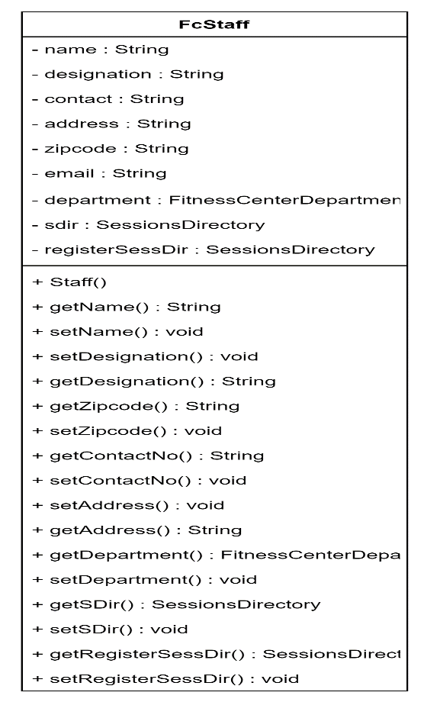

Attribute:

name : this variable will hold the name of the Staff

designation: this variable will hold the designation of the Staff

- contact : this variable will hold the contact number of the hospital

- address : this variable will hold the address of the hospital

- zipcode : this variable will hold the zip code of the hospital

- email : this variable will hold the email of hospital

- department: This class object will have all the values from class FitnessCenterDepartment

- sDir : This class object will have all the values from class SessionsDirectory

- registerSessDir : This class object will have all the values from class SessionsDirectory

**Methods:**

+ getDesignation () : this method will fetch the Designationfor each hospital and all the values it is holding

+ setDesignation () : this method will set the Designation of the staff

+ getHospitalName() : this method will fetch the hospital name and all the values it is holding

+ setHospitalName() : this method will set the hospital name

+ getZipcode() : this method will fetch the hospital’s zip code and all the values it is holding

+ setZipcode() : this method will fetch the hospital’s zip code

+ getContactNo() : this method will fetch the hospital’s contact number and all the values it is holding

+ setContactNo() : this method will set the hospital’s zipcode

+ setAddress() : this method will set the hospital’s address

+ getAddress() : this method will fetch the hospital’s address and all the values it is holding

+ getDepartment() : this method will fetch FitnessCenterDepartment and all the values it holds

+ setDepartment() : this method will set FitnessCenterDepartment

+ getSessionDirectory() : this method will fetch SessionsDirectory and all the values it holds

+ setSessionDirectory() : this method will set SessionsDirectory

+ get registerSessDir (): this method will fetch SessionsDirectory

+ set registerSessDir() : this method will set SessionsDirectory

**Sessions:**

This entity will have session details which a fitness center has, customers or doctors, can book these sessions. These sessions will be created by fitness center staff.

**Attributes:**

- sessionId : this variable will hold the unique id for each sessions

- name : this variable will hold the name for each sessions

- sessionDate : this variable will hold the date for each sessions

- startTime : this variable will hold the date for each sessions

- endTime : this variable will hold the date for each sessions

- Location : this variable will hold the date for each sessions

- isRemote : this variable will hold the date for each sessions

- status : this variable will hold the date for each sessions

- findUser : this variable will hold the user for each sessions

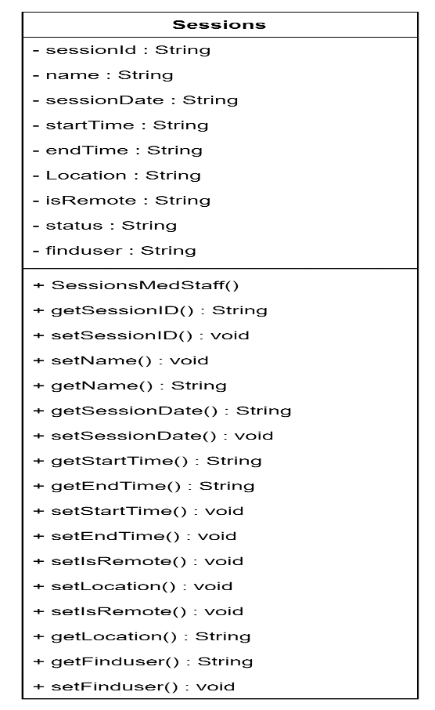

**Methods:**

getSessionId() : this method will fetch the unique id for each Sessions and all the values it is holding

+ setSessionId() : this method will set the unique id

+ getName() : this method will fetch the Session name and all the values it is holding

+ setName() : this method will set the Session name

+ getSessionDate() : this method will fetch the Session date and all the values it is holding

+ setSessionDate() : this method will set the Session date

+ getStartTime() : this method will fetch the Session start time and all the values it is holding

+ getEndTime() : this method will fetch the Session end time and all the values it is holding

+ setStartTime() : this method will set the Session Start time

+ setEndTime() : this method will set the Session end time

+ setLocation() : this method will set the Session location

+ setIsRemote() : this method will set the Session isRemote value

+ getLocation() : this method will fetch the Session location and all the values it is holding

+ getFindUser() : this method will fetch the Session user name and all the values it is holding

+ setFindUser() : this method will set the user name

**Ambulance Services:**

This entity holds the information about ambulance services. A customer can book an ambulance in case of emergency or when needed.

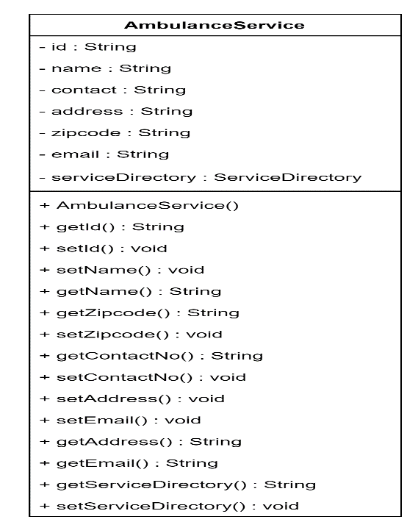

**Attributes:**

- id : this variable will hold the unique id for each Ambulance Service

- name : this variable will hold the name of each Ambulance Service

- contactNo : this variable will hold the contact number of each Ambulance Service

- address : this variable will hold the address of each Ambulance Service

- zipcode : this variable will hold the zip code of each Ambulance Service

- email : this variable will hold the email each Ambulance Service

- serviceDirectory : This class object will have all the values from class serviceDirectory

**Methods:**

+ getId() : this method will fetch the unique id for each Ambulance Service and all the values it is holding

+ setId() : this method will set the unique id

+ getName() : this method will fetch the Ambulance Service name and all the values it is holding

+ setName() : this method will set the hospital name

+ getZipcode() : this method will fetch the Ambulance Service zip code and all the values it is holding

+ setZipcode() : this method will fetch the Ambulance Service zip code

+ getContactNo() : this method will fetch the Ambulance Service contact number and all the values it is holding

+ setContactNo() : this method will set the Ambulance Service contact number

+ setAddress() : this method will set the Ambulance Service address

+ getAddress() : this method will fetch the Ambulance Service address and all the values it is holding

+ getServiceDirectory() : this method will fetch the Ambulance Service Directory object and all the values it is holding

+ setServiceDirectory() : this method will set Ambulance Service Directory

**UserAccount:**

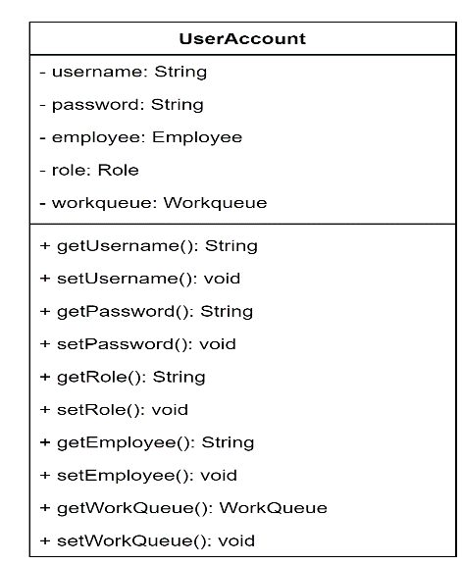

Attributes:

- username: this variable will hold the username of each user

- password: this variable will hold the password of each user

- employee: this variable will hold the Employee object class

- role: this variable will hold the class object Role

- workqueue: : this variable will hold the class object Workqueue

**Methods:**

+ getUsername(): this method will fetch userName and all the values it is holding

+ setUsername(): this method will set userName

+ getPassword(): this method will fetch password and all the values it is holding

+ setPassword(): this method will set password

+ getRole(): this method will fetch the object Role class and all the values it holds

+ setRole(): this method will set the object Role

+ getEmployee(): this method will fetch the object Employee class and all the values it holds

+ setEmployee(): this method will set the object Employee

+ getWorkQueue(): this method will fetch the object WorkQueue class and all the values it holds

+ setWorkQueue(): this method will fetch the object WorkQueue

**WorkRequest:**

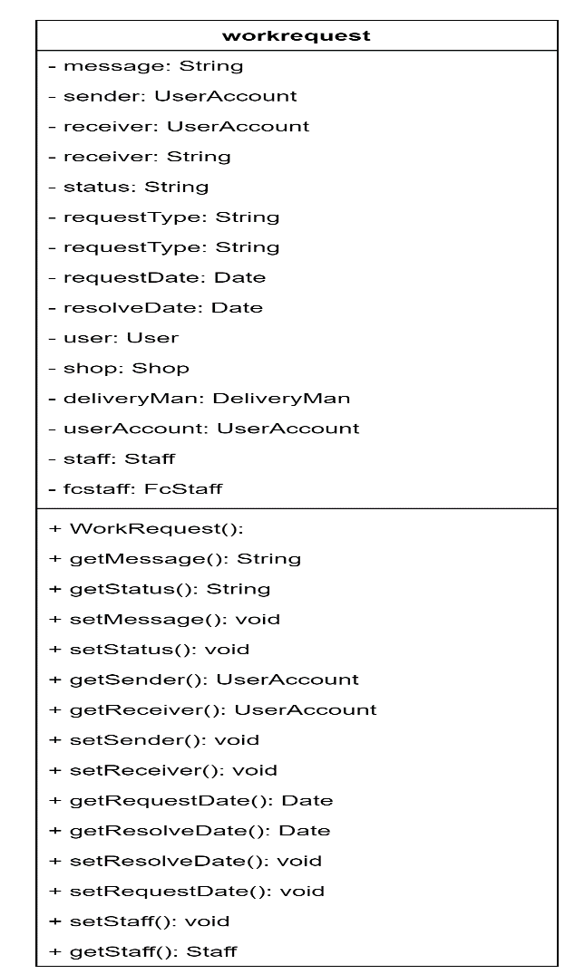

This entity holds all the work request for an order created by customer. A customer can order products from the various shops, those requests will be sent to work requests class.

Attributes:

- message: this variable holds the messages send by users while creating a work reuest

- sender: this variable holds the sender’s information

- receiver: this variable holds the receiver’s information

- status: this variable holds the work request status

- requestType: this variable holds the request type information

- requestDate: this variable holds the order request date

- resolveDate: this variable holds the order resolve date

- user: this variable holds the class object User

- shop: this variable holds the class object Shop

- deliveryMan: this variable holds the class object DeliveryMan

- userAccount: this variable holds the class object UserAccount

- staff: this variable holds the class object Staff

- fcstaff: this variable holds the class object FcStaff

**Methods:**

+ getMessage(): this method fetch the messages send by users

+ getStatus(): this method fetch the Status

+ setMessage(): this method fetch the messages send by users

+ setStatus(): this method set the Status

+ getUserAccount (): this method fetch the UserAccount

+ getUserAccount (): this method set the UserAccount

+ setSender(): this method set the sender

+ setReceiver(): this method set sender

+ getRequestDate(): this method fetch the requested Date

+ getResolveDate():this method fetch the resolve Date

+ setResolveDate(): this method set the resolve date

+ setRequestDate(): this method request the resolve date

+ setStaff(): this variable set the class object Staff

+ getStaff(): this variable fetch the class object Staff

**Shop:**

**Attributes:**

- shopid : this variable will hold the unique id for each Shop

- shopName : this variable will hold the name of each Shop

- contactNo : this variable will hold the contact number of each shop

- address : this variable will hold the address of each shop

- zipcode : this variable will hold the zip code of shop

- email : this variable will hold the email each shop

- productDirectory : This class object will have all the values from class productDirectory

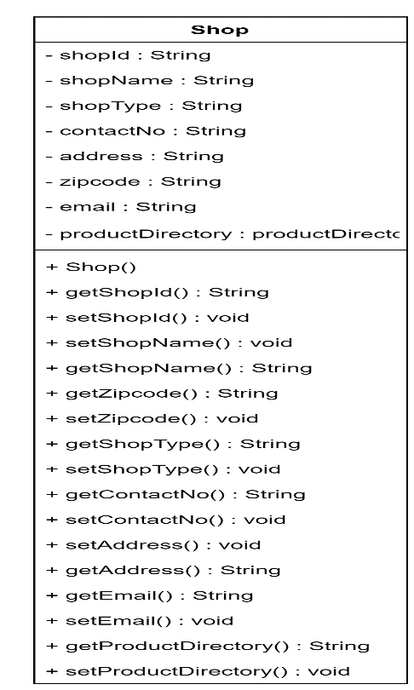

**Methods:**

+ getShopId() : this method will fetch the unique id for each shop and all the values it is holding

+ setShopId() : this method will set the unique id

+ getShopName() : this method will fetch the shop name and all the values it is holding

+ setShopName() : this method will set the hospital name

+ getZipcode() : this method will fetch the shop zip code and all the values it is holding

+ setZipcode() : this method will fetch the shop zip code

+ getContactNo() : this method will fetch the shop contact number and all the values it is holding

+ setContactNo() : this method will set the shop contact number

+ setAddress() : this method will set the shop address

+ getAddress() : this method will fetch the shop address and all the values it is holding

+ getServiceDirectory() : this method will fetch the shop Directory object and all the values it is holding

+ setServiceDirectory() : this method will set shop Directory

**Product:**

**Attribute:**

productID: this variable will hold the unique id for each product

- productName: this variable will hold the name for each product

- calories: this variable will hold the calories for each product

- price: this variable will hold the price for each product

- description: this variable will hold the description for each product

**Method:**

- isPrescriptionNeeded: this variable will hold the value if the prescription is needed for each product

+ getProductID() : this method will fetch the productId for each product and all the values it is holding

+ setProductID() : this method will set the prodctID for each product

+ getProductName(): this method will fetch the product anem for each product and all the values it is holding

+ setProductName(): this method will set the name for each product

+ getCalories(): this method will fetch the calories for each product and all the values it is holding

+ setCalories(): this method will set the calories for each product

+ getPrice(): this method will fetch the price for each product and all the values it is holding

+ setPrice(): this method will set the price for each product

+ getDescription(): this method will fetch the description for each product and all the values it is holding

+ setDescription(): this method will set the description for each product

+ setDescription(): this method will fetch the description for each product

+ setIsPrescriptionNeeded(): this method will set the prescription for each product

+ getIsPrescriptionNeeded(): this method will fetch the prescription for each product and all the values it is holding

Order:

This entity will store the data for each orders customer or doctor makes. This stores the product and quantity values for each order.

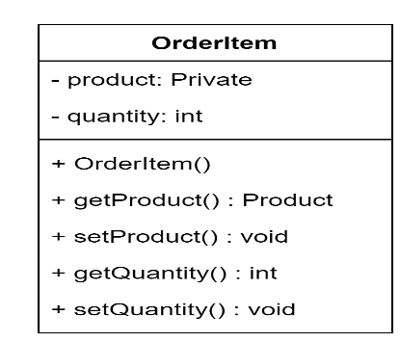

Attributes:

product: this variable holds the class product information

- quantity: this variable holds the quantity information

Method:

+ getProduct() : this method fetch the class object Product

+ setProduct() : this method set the class object product

+ getQuantity() : this method fetches the quantity

+ setQuantity() : this method set quantity of product ordered

**Extended Care4U model:**

* We are sending email to the user to inform about the sign up, appointment bookings, registrations, and orders, however this project can be extended to have a sms information system. This will allow us to inform user via text messages.
* We can use the API to integrate the map, that will allow users to track nearby hospitals, shops, ambulance services, and fitness centers.
* We can create a chat bot for the users to interact with. This will help when a doctor’s appointment is not available. A user can reach out to help center via chat bot. Users can report the issues using this chat bot.
* More number or doctors, shops, fitness centers and ambulance services can be registered to make it as a global level application.

Flow Diagram:

Shop adds a medicine form:

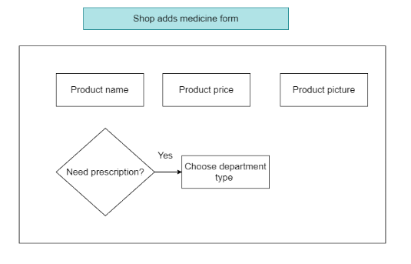

Customer Placing an order:

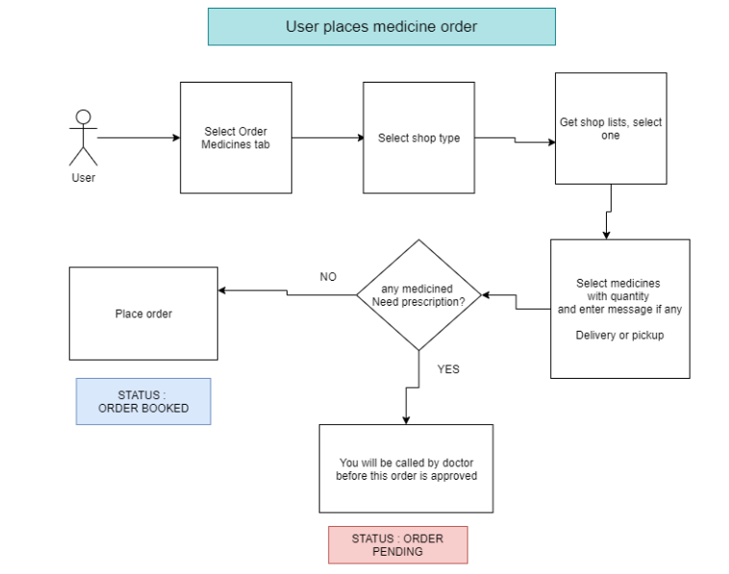

Shop managing an order:

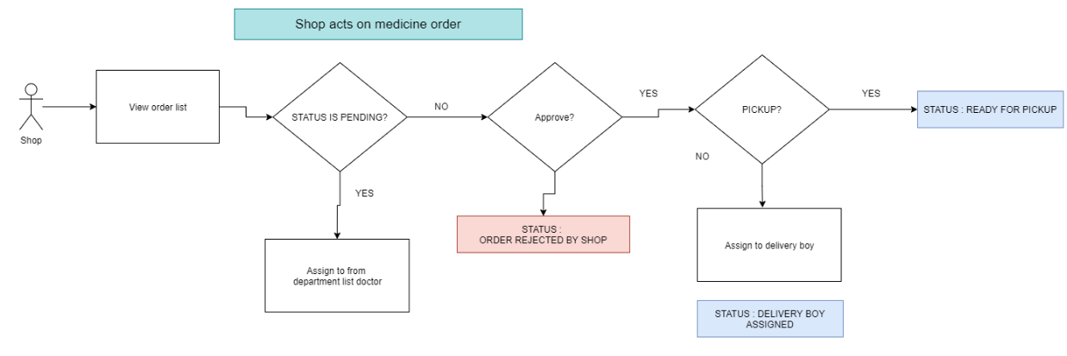

Doctors action on a request:

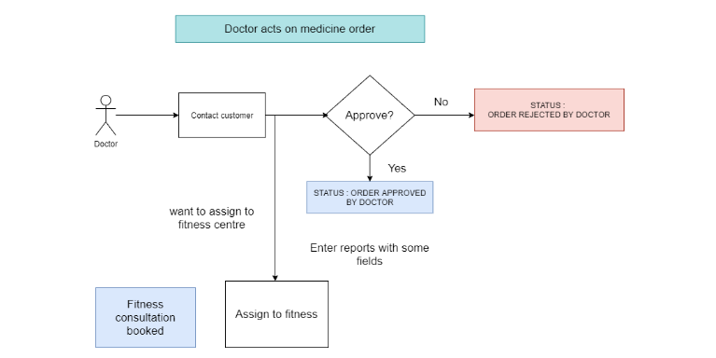

User wants to book an appointment:

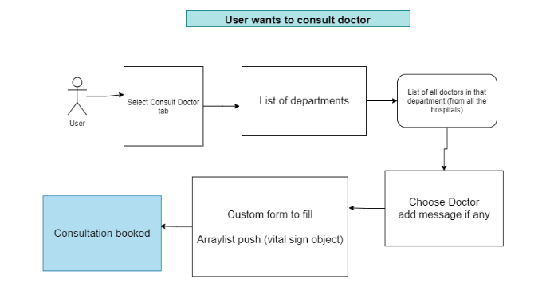

Doctors action on a request:

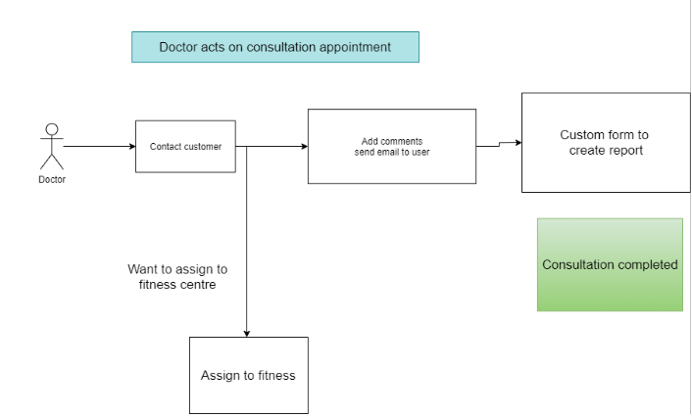

Fitness Center registration:

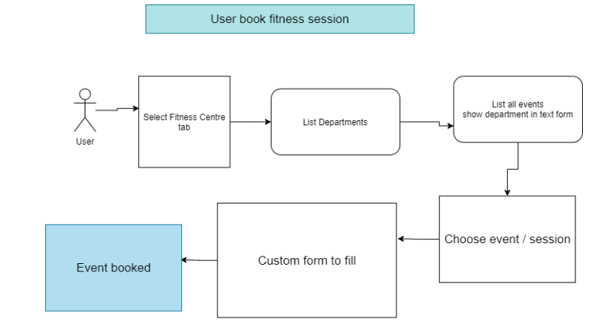

Fitness Centers action on a request:

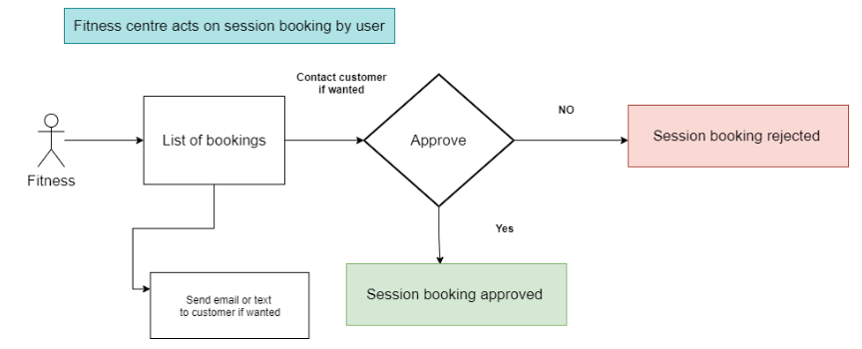

Fitness Center assigning by a doctor:

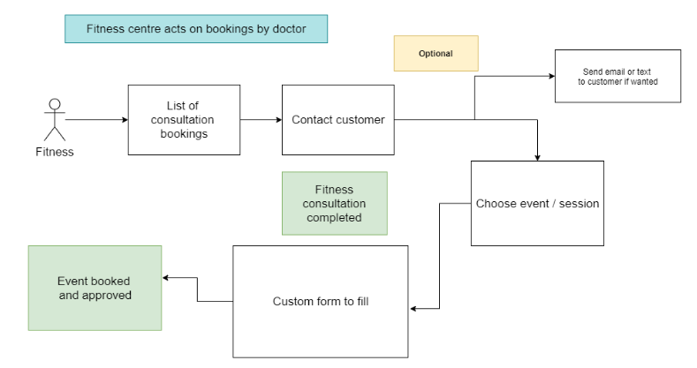

UML Diagram:

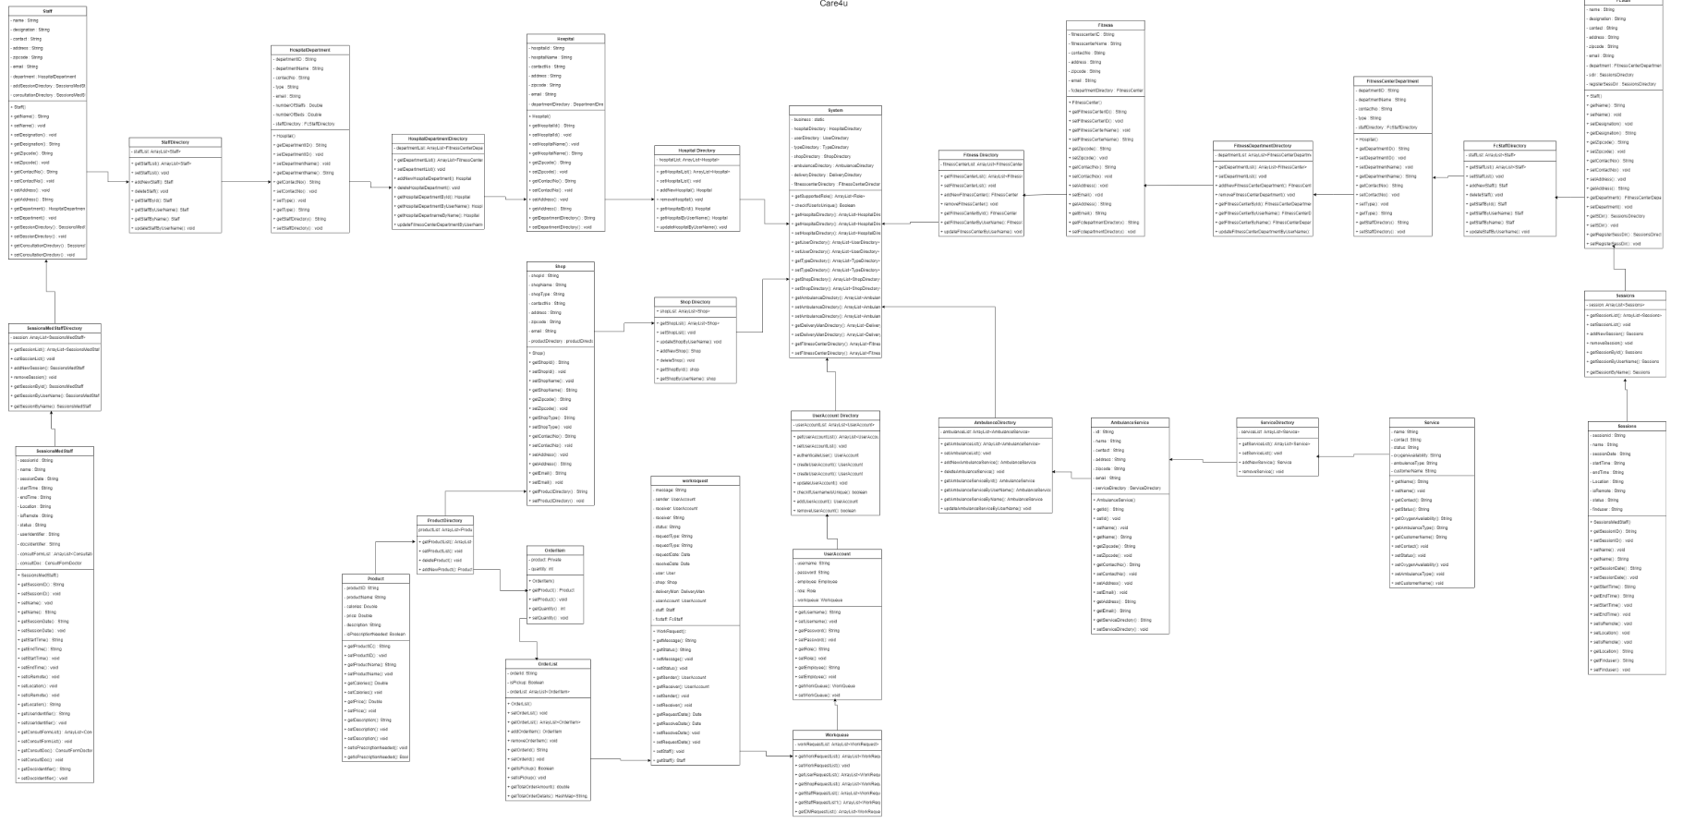

Sequence Diagram:

