**Software Testing Assignment**

**Module : 1**

**1 ) What is SDLC ?**

SDLC means SOFTWARE DEVELOPMENT LIFE CYCLE. SDLC is the series Of steps or phases that provide model for the development and life cycle management of software.

There are 6 stages of SDLC .

1. Requirement Gathering

Two types of requirement:

* Functional requirements
* None functional requirements

1. Analysis

Research Of requirements

1. Designing (developer)
2. Implementation

Web : CSS, JAVASCRIPT,HTML

App: XML

1. Testing

Web: PHP, java

App: Android, iOS

1. Maintenance

3 types of maintenance

* Corrective maintenance
* Perfective maintenance
* Adaptive maintenance

**2) What is agile methodology?**

There are no deadline

Long term project

Agile manifesto principles are:

* Individual and insraction
* Working software
* Customer collaboration
* Responding to change

**3) What is SRS?**

SRS is SOFTWARE REQUIREMENT SPECIFICATION.SRS is complete description of the behaviour of the system to be developed. It includes a set of use cases that describes all the Interaction that the users will have With the software.

There are Three types of SRS.

1. Functional Requirement Specification
2. Non Functional Requirement Specification
3. Customer Requirement Specification

4) What is OOPs?

OOP means OBJECT ORRIANTED PROGRAMING. Identifying object and assigning responsibility to these object. Object communicate other objects by sending a massages. Massages are received by the method of an object.

5) Write basic concepts of oop .

Basic concepts of oop.

* Object
* Class
* Abstraction
* Encapsulation
* Inheritance
* Polymorphism

**6 ) what is Object ?**

Any living things which has own stat and behaviour.

Ex: pen, paper, pencil.

**7) What is class?**

Collection of object.

Ex: human body

**8 ) what is encapsulation ?**

Binding of data or wrapping up data.

**9) What is Inheritance ?**

When one object acquires all the properties and behaviour of parent class.

**10) What is polymorphism ?**

Many ways to perform anything.

**11) What is RDBMS ?**

RDBMS stands for Relation Database Management System. RDBMS is the basis for SQL, and for all database system like MS SQL SERVER, IBM DB2, Oracle, MYSQL and Microsoft access.

**12) What is SQL ?**

SQL is structured query language. Which is computer language for storing, manipulation and retrieving data stored in relational database.

**13) Write SQL Commands.**

1. DDL – Data definition language

Create , Alter, Drop, truncate, rename

1. DML – Data manipulation language

Insert, update, delete

1. DCL - Data control language

Rollback, commit

1. DQL -. Data query language

Select

**14) Draw Use Case on online Book shopping.**

START

LOG IN

VERIFICATION

registration

NOT

REGISTRED

REGISTGERED

VALID

SELECT

BOOK

ADD TO CART

BUY NOW

SELECT PAYMENT

CONTINUE

PLACE YOUR

ORDER

END

INVALID LOGIN

15).Draw Use case on online bill payment system (Paytm)

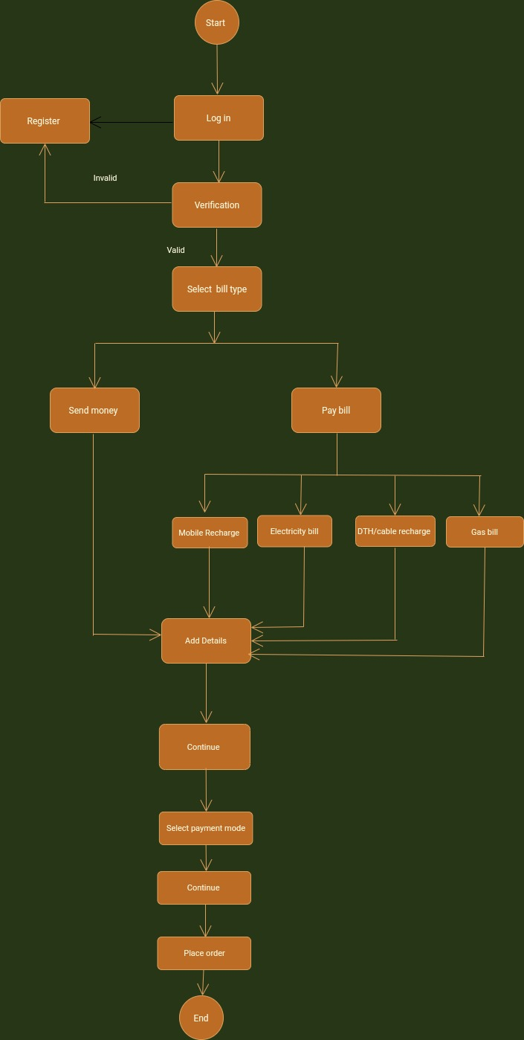

16) Write SDLC Phases with basic introduction.

1. Requirement Gathering

There are two types of Requirement

* 1. Functional Requirement
  2. Non Functional Requirement

1. Analysis

Specify the Requirement

1. Design

Specify the solution.

1. Implementation

Contract solution

1. Testing

Validate the solution against requirements

1. Maintenance

Three types of maintenance

* Corrective maintenance
* Adaptive maintenance
* Perfective maintenance

17) Explain phases of the waterfall model.

Waterfall model has 6 phases.

Requirement gathering, analysis, design, implementation, testing and maintenance.

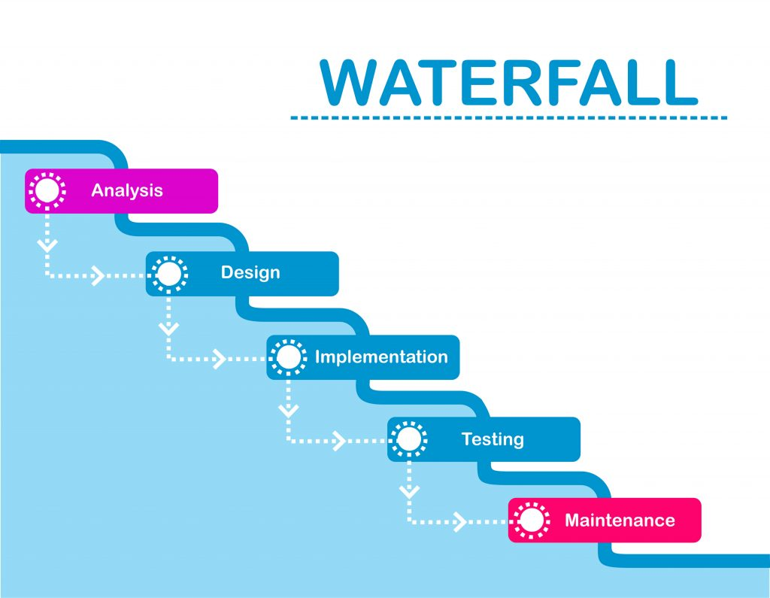

**18). Write phases of spiral model.**

* Phases of spiral model.
  + 1. Planning: Determination of objectives. Alternatives and constraints.
    2. Risk of analysis : Analysis of alternatives And identification of resolution risk.
    3. Engineering : development of next level project.
    4. Customer evolution: Assessment of the results Of engineering.

**19) write agile manifesto principal.**

1. Individual and interaction

In agile development , self organization and motivation are important as are Interaction like Co-location and pair programing.

1. Working software

Demo working software is considered the best means of Communication.

With the customer to understand their requirement Instead of just depending on documentation.

1. Customer collaboration

As the requirements cannot be gathered Completely in the beginning.

1. Responding to change

Agile document is focused on quick responses to change and continue development.

**20).What is join?**

Join used to fetch or combine data from two or more table based on the define condition.

**21). Write type of joins.**

● INNER JOIN: returns rows when there is a match in

Both tables.

● LEFT JOIN: returns all rows from the left table, even if

There are no matches in the right table.

● RIGHT JOIN: returns all rows from the right table, even

If there are no matches in the left table.

● FULL JOIN: returns rows when there is a match in one

Of the tables. DDL – Data Definition Language.

**22).Explain working methodology of agile model and also**

Write pros and cons.

● Agile Methods break the product into small

Incremental builds.

● These builds are provided in iterations.

● Each iteration typically lasts from about one to three

Weeks.

● Every iteration involves cross functional teams

Working simultaneously on various areas like planning,

Requirements analysis, design, coding, unit testing, and

Acceptance testing.

● At the end of the iteration a working product is

Displayed to the customer and important stakeholders

Pros:

● Little or no planning required

● Easy to manage

● Is a very realistic approach to software development.

● Promotes teamwork and cross training.

● Gives flexibility to developers

Cons.:

● More risk of sustainability, maintainability and

Extensibility.

● Transfer of technology to new team members may be

Quite challenging.

● There is very high individual dependency, since there

Is minimum documentation generated.

● May be not suitable for delivery management because

There is a no deadline.

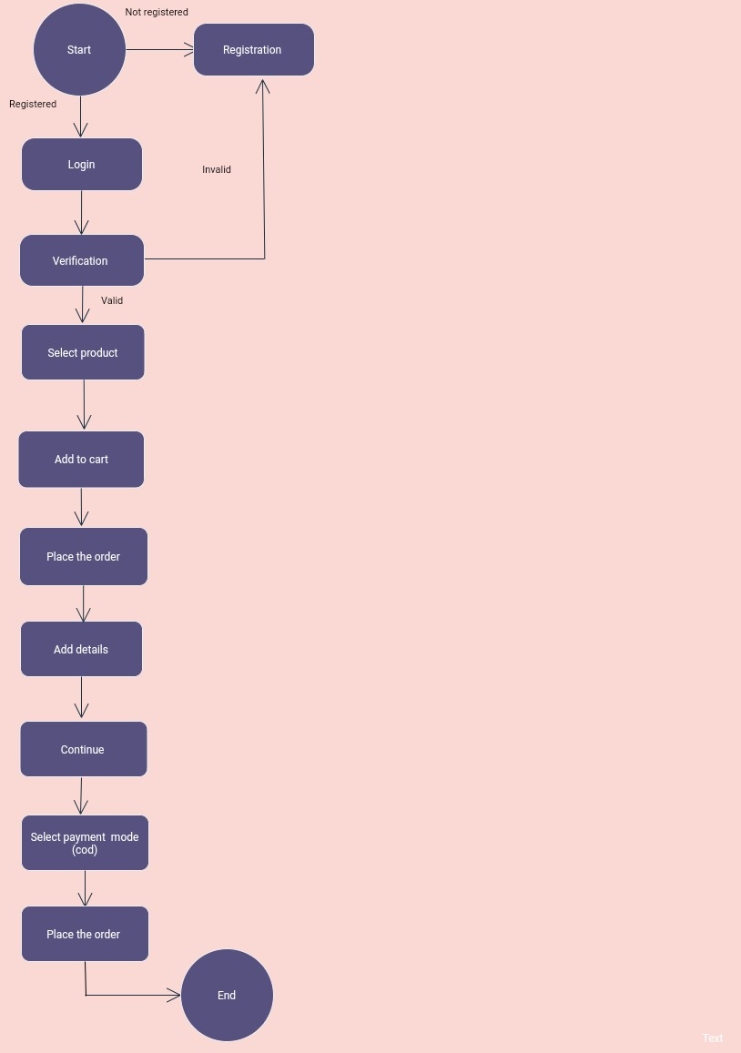**23). Draw use case on online shopping product using cod.**

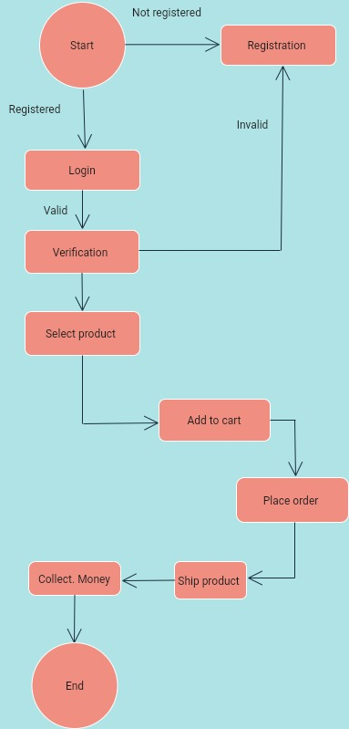**24) Draw use case on Online shopping product using payment gateway.**